# Bluedon Sentiment Analysis Solution V1.0

Table of Contents

Bluedon Sentiment Analysis Solution V1.0 1

Design Goal 1

Sentiment Analysis Applications 1

General System Workflow 3

Features 3

Typical Architecture and Layers 4

Core AI Algorithms 4

Solution Strength 5

Solution Snapshots 6

## Design Goal

Computational study of opinions, sentiments, evaluations, attitudes, appraisal, affects, views, emotions, subjectivity, etc., expressed **in text**. Text = Reviews, blogs, discussions, news, comments, feedback. Sometimes called **opinion mining**.

Sentiment analysis refers to the use of natural language processing, text analysis, computational linguistics, and biometrics to systematically identify, extract, quantify, and study affective states and subjective information. Sentiment analysis is widely applied to voice of the customer materials such as reviews and survey responses, online and social media, and healthcare materials for applications that range from marketing to customer service to clinical medicine.

## Sentiment Analysis Applications

* Businesses and organizations
  + Benchmark products and service, market intelligence
* Individuals
  + Make decisions to purchase products or to use services
  + Find public opinions about political candidates and issues
* Ad placement in social media
  + Place an ad if one praises a product
  + Place an ad from a competitor if one criticizes a product
* Opinion retrieval
  + Provide general search for opinions

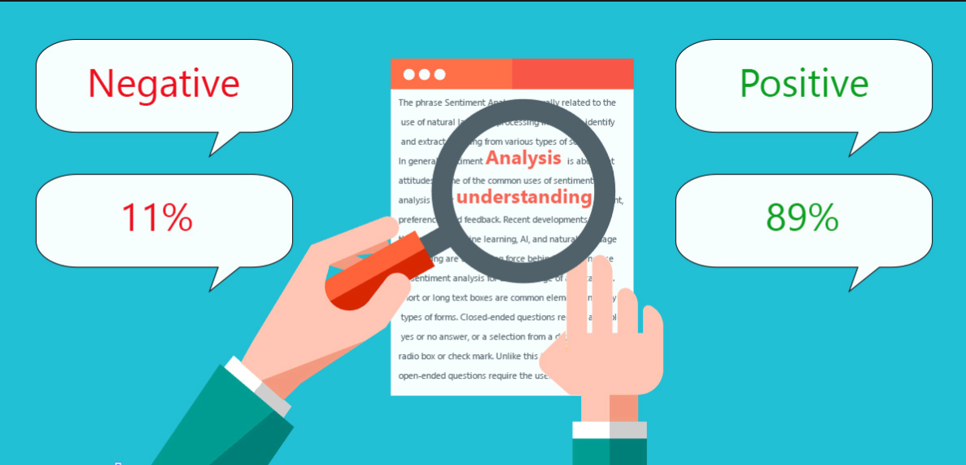

Sample 1: positive or negative opinion of certain pieces of text

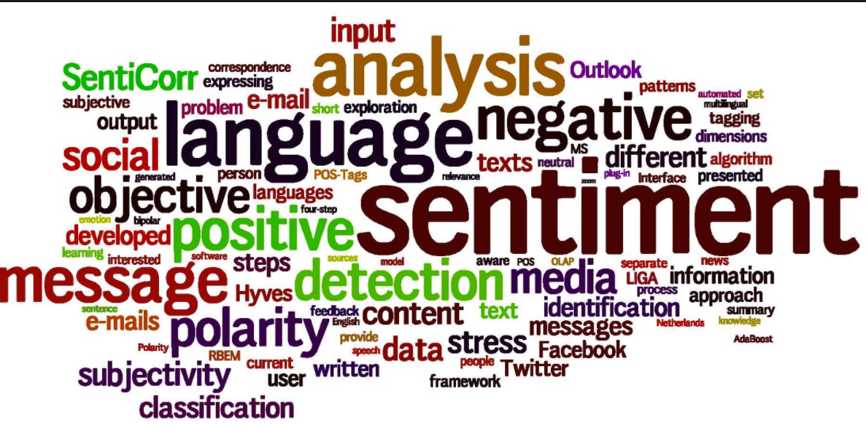

Sample 2: word cloud for social media

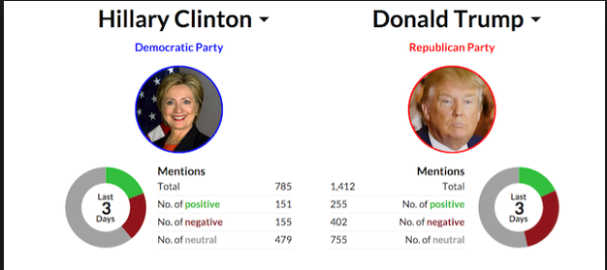

Sample 3: election sentiment analysis

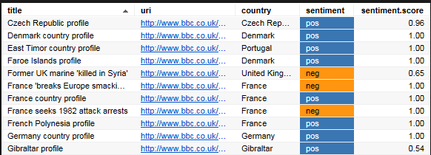

Sample 4: media positioning & standing

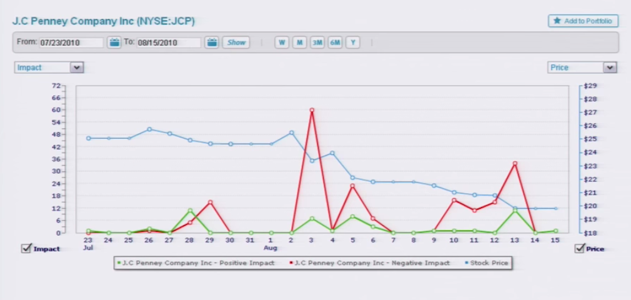

Sample 5: Stock Price Prediction using Sentiment Analysis

## General System Workflow

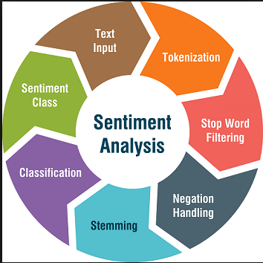

## Features

* Based on artificial intelligence including deep learning, NLP etc
* Big Data
  + Biggest global multi-language media database over 50PB in size
  + Data crawling, processing, analysis and visualization
* Easy Deployment including virtualization, private and public cloud
* Enhanced User Experience
* High Degree Customization
* Template based approach to content filtering
* Hybrid Sentiment Analysis including Events (predicted), Patterns (phrasal) and Dictionaries (lexical)

## Typical Architecture and Layers

1. User Services Layer
2. Application Layer
3. Business Logic and Processing Layer
4. Data Collection Layer
5. Source Layer

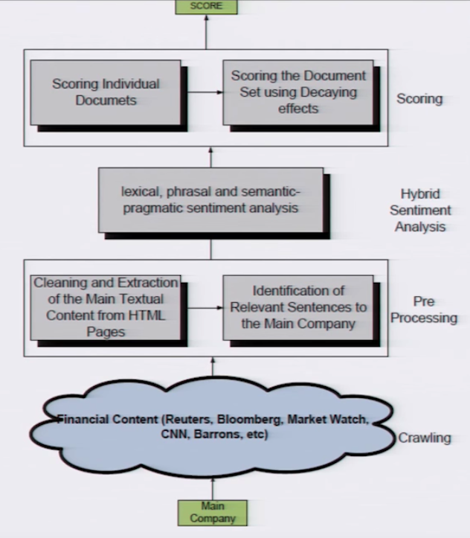

Typical Architecture

## Core AI Algorithms

* Naïve Bayes
* SVM
* Conditional Random Field
* Parsing
* Segmentation

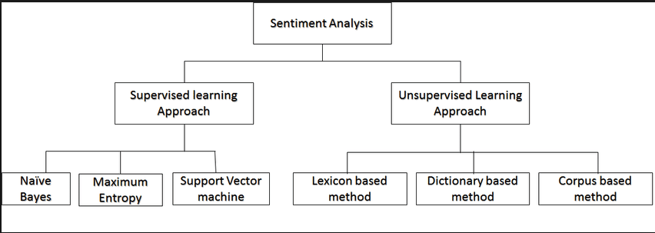

## Solution Strength

1. 24/7 dedicated operation/security team for monitoring & analysis
2. Cross Channel/Sites Data Crawling (news, forums, newspaper, social network platforms)
3. 100 Million + Pieces of information acquired everyday
4. 50PB Accumulated Data so far

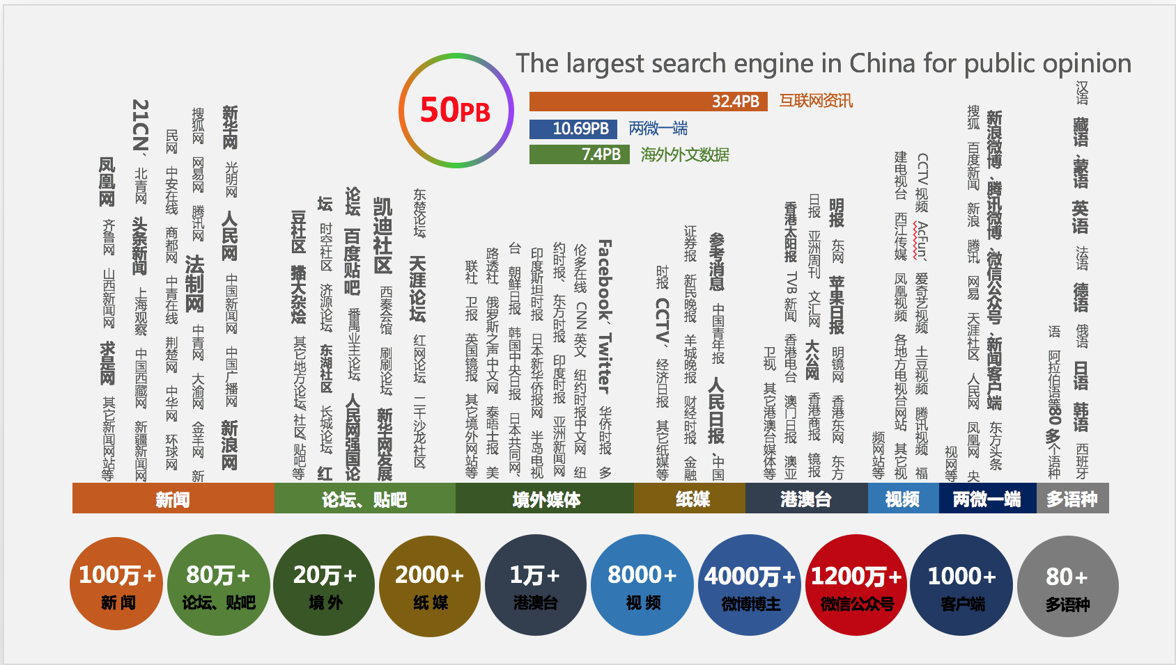

Big Data Diversity and Recency

## Solution Snapshots

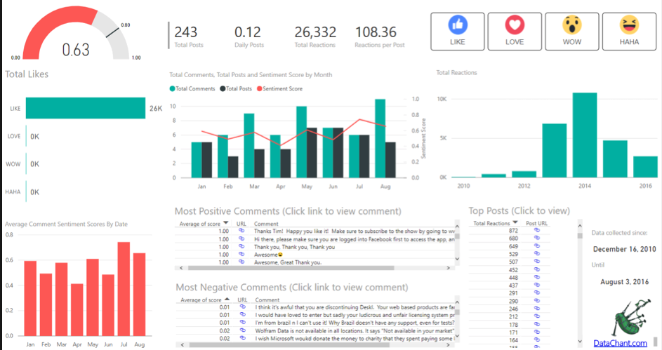

Sample 1: Sentiment Analysis based social media

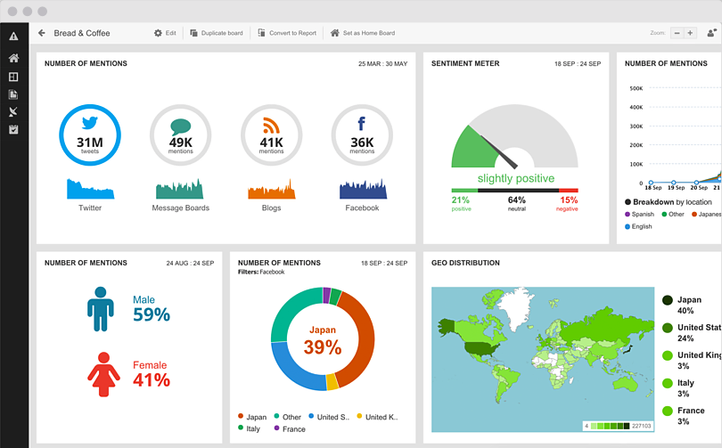

Sample 2: Sentiment Analysis based social media

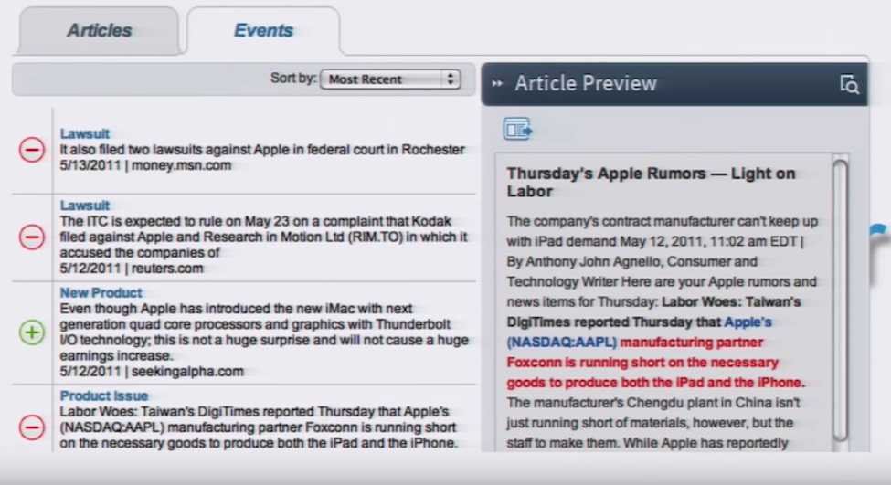

Sample 3: Better trading decisions by using sentiment analysis