HARAMAYA UNIVERSITY
COLLEGE OF COMPUTING AND INFORMATICS
DEPARTMENT OF INFORMATION TECHNOLOGY
INTERNSHIP REPORT
ON
DEVELOPMENT OF THE AMU DEDICATED STORE &
RESOURCE MANAGEMENT SYSTEM AT ARBA MINCH UNIVERSITY
ICT DIRECTORATE
An Internship Report Submitted to the Department of Information Technology,
College of Computing and Informatics, Haramaya University, in Partial
Fulfillment of the Requirements for the Internship/Practical Attachment Programme
Prepared By: | Yonas Girma
Student ID No.: | 2749/16
Department Advisor: | Mr. Taddese A.
Hosting Organization: | Arba Minch University (AMU) — ICT Directorate (ICTD)
Immediate Supervisor: | Mr. Chirotaw Kentib, Application Development Team Leader, ICTD
Internship Duration: | July 2 – September 2, 2026 (45 Working Days)
Submission Date: | Haramaya, Ethiopia
September 2026

DECLARATION
I, Yonas Girma, bearing ID No. 2749/16, hereby declare that this internship report, entitled “Development of the AMU Dedicated Store & Resource Management System,” is my own original work. It is based on my practical attachment at Arba Minch University ICT Directorate and has not been submitted, in whole or in part, for the award of any degree, diploma, or certificate at this or any other institution. All sources of information used in the preparation of this report have been duly acknowledged.

Advisor's Approval
This internship report has been submitted for examination with my approval as the university academic advisor.
Name: Mr. Taddese A.
Signature: ____________________________
Date: ____________________________

Executive Summary
This report details my 45-working-day practical attachment (July 2 – September 2, 2026) at the Arba Minch University ICT Directorate (ICTD), completed in partial fulfillment of the requirements for the Department of Information Technology at Haramaya University.
Attached to the Application Development team under Mr. Chirotaw Kentib, our intern team was tasked with replacing AMU’s manual, paper-based requisition workflow with a custom web application: the AMU Dedicated Store & Resource Management System. Using NestJS, PostgreSQL (Prisma ORM 5.19.0), React 18, and Docker Compose, we built an auditable platform that tracks stock intake, departmental requests, and manager approval and storekeeper issuance of requisitions across university departments and a dedicated central store.
The resulting prototype is designed to reduce delays associated with physical paper routing through real-time stock tracking, role-based access control combined with scope-based authorization (global, organizational, store-level), and eight automated institutional reports. Beyond full-stack development practice, the internship provided firsthand experience in working with database transactions and concurrency risks, coordinating work in Git, and translating institutional rules into working code.

Acknowledgement
I would like to express my sincere gratitude to the Department of Information Technology, College of Computing and Informatics, Haramaya University, for arranging this internship opportunity and for the academic guidance provided throughout the attachment period.
I am especially grateful to my department advisor, Mr. Taddese A., for his continuous guidance, feedback, and encouragement before and during the internship, and for his support in the preparation of this report.
My heartfelt thanks go to my immediate supervisor at the host organization, Mr. Chirotaw Kentib, Application Development Team Leader at Arba Minch University ICT Directorate, for his patient mentorship, for entrusting me with meaningful responsibilities on the AMU Dedicated Store & Resource Management System, and for creating a supportive learning environment throughout my stay at ICTD.
I also thank the staff and fellow developers of the ICTD Application Development Team for their collaboration, technical guidance, and willingness to answer my questions, as well as my family and friends for their constant encouragement and support.

List of Acronyms
Acronym | Meaning
AMU | Arba Minch University
ICTD | Information and Communication Technology Directorate
IT | Information Technology
ERP | Enterprise Resource Planning
RBAC | Role-Based Access Control
JWT | JSON Web Token; used for access and refresh tokens
API | Application Programming Interface
REST | Representational State Transfer
ORM | Object-Relational Mapping
CRUD | Create, Read, Update, Delete
UI / UX | User Interface / User Experience
SPA | Single Page Application
DB | Database
SQL | Structured Query Language
CSV | Comma-Separated Values
PDF | Portable Document Format
E2E | End-to-End (Testing)
TXN | Transaction (ledger entry code)

List of Tables and Figures

Tables
- Table 1: Departments and Store Seeded in the Demonstration Data
- Table 2: Backend Technology Stack
- Table 3: Frontend Technology Stack
- Table 4: Core Backend Feature Modules
- Table 5: Demo User Roles and Responsibilities
- Table 6: Summary of Principal Use Cases

Figures
- Figure 1: System Architecture Diagram — AMU Dedicated Store & Resource Management System
- Figure 2: Requisition Approval and Issuance Workflow
- Figure 3: Use Case Diagram — Requisition and Inventory Management
- Figure 4: Use Case Diagram — Access and User Administration
- Figure 5: Use Case Diagram — Oversight and Reporting

Table of Contents
Student's Declaration 2
Advisor's Approval 2
Executive Summary 3
Acknowledgement 4
List of Acronyms 5
List of Tables and Figures 6
Tables 6
Figures 6
Table of Contents 7
Chapter One: Introduction 1
1.1 Background of the Organization 1
1.2 Vision and Mission 1
1.3 Main Products or Services 1
1.4 Main Customers or End Users 2
1.5 Organizational Structure 2
1.6 Work Flows 3
Chapter Two: Overall Internship Experience and Specific Work 4
2.1 Reason for Selecting the Organization 4
2.2 Section Worked In and Reason 4
2.3 Work Flow in the Section 5
2.4 Informal Leadership Role Within the Team 5
2.5 Tasks and Work Pieces Executed 5
2.6 Technical Knowledge and Skills Applied from Coursework 6
2.7 Programming Languages, Tools, and Techniques Used 6
2.8 Major Challenges Faced 7
2.9 Measures Taken to Overcome the Challenges 8
Chapter Three: The Project — Selection, Design, and Execution 9
3.1 Project Title and Short Summary 9
3.2 Problem Statement and Justification 9
3.3 Objectives 9
3.4 Methodology 10
3.5 Literature Review 13
3.6 Results and Discussion 14
3.7 Recommendations Regarding the Identified Problems 15
Chapter Four: Benefits Gained from the Internship and Reflection 16
Chapter Five: Conclusion and Recommendations 18
5.1 Overall Conclusion 18
5.2 Recommendation Regarding the Hosting Company 18
5.3 Recommendations for Improving the Internship 18
References 19
Appendices 20
Appendix A: Core Backend Feature Modules 20
Appendix B: System Access Points (Development Environment) 20
Appendix C: Project Source Repository 20

Chapter One: Introduction

1.1 Background of the Organization
Arba Minch University (AMU) traces its origin to the Arba Minch Water Technology Institute, established in September 1986 to train professionals in water resources. The institute was transformed into a full university in June 2004 and has since grown into one of Ethiopia's national universities, located in Arba Minch town, South Ethiopia Regional State, approximately 435 kilometres south of Addis Ababa. AMU today comprises multiple colleges, institutes — including the Arba Minch Water Technology Institute (AWTI) and the AMU Institute of Technology (AMUIT) — and schools, spread across several campuses.
The internship was hosted by the university's Information and Communication Technology Directorate (ICTD), the central unit responsible for AMU's network infrastructure, enterprise information systems, and technical support services. Within ICTD, the Application Development Team designs, builds, and maintains custom institutional software systems used across the university's colleges, departments, and administrative directorates.

1.2 Vision and Mission
AMU's stated vision is to become one of the leading and most competitive universities in Ethiopia and Africa, and a well-recognized institution globally in teaching-learning, research, and community service, by the year 2030.
The university's mission centers on offering relevant and quality education and training, conducting problem-solving and indigenous-knowledge-integrated research, and adapting and transferring skills and technologies that support socio-economic development, alongside delivering accessible community services. The ICTD supports this mission directly by digitizing and modernizing the university's internal administrative and operational processes, of which the Store & Resource Management System is one example.

1.3 Main Products or Services
At the university level, AMU's core offerings are undergraduate and postgraduate academic programs, applied and problem-solving research, and community and consultancy services across its colleges and institutes.
At the level of the hosting unit, ICTD's core services include: campus network and infrastructure management; design, development, and maintenance of enterprise software systems (such as student information systems and internal ERP-type platforms); technical helpdesk and support services for staff and students; and digital-transformation initiatives, of which the Store & Resource Management System developed during this internship is a current example.

1.4 Main Customers or End Users
The university's principal beneficiaries are its students, academic and administrative staff, government stakeholders, and the surrounding community. For the specific system built by ICTD during this internship, the end users are internal: academic and administrative staff who file material requisitions, store managers who govern the item catalog and approve requests, storekeepers who execute physical stock movements, internal auditors who review transaction and audit trails, and system administrators who manage accounts and configuration — spanning AMU's colleges, departments, and directorates.

1.5 Organizational Structure
AMU is led by a President supported by Vice Presidents for academic affairs, administration, and research and community service, under whom the university's colleges, institutes, schools, and central directorates — including ICTD — operate. Within ICTD, the Application Development Team, led by the internship supervisor, operates alongside teams responsible for network and infrastructure, systems administration, and technical support.
The system built during the internship models AMU’s institutional structure in a deliberately simplified form. Departments are stored as a flat list; each store may be linked to an owning department, and users, employees, and requisitions are each tied to a department. Every user also carries a scope (global, organizational, or store-level) that limits which stores they can manage. A multi-level organizational tree (university → college → department) was explored in early design iterations but was simplified in the final version. Table 1 lists the departments and the store seeded in the demonstration data.
Table 1: Departments and Store Seeded in the Demonstration Data
Department / Store | Code
AMU Central & ICT Resource Store (store, owned by the STORE department) | STORE-MAIN
Computer Science Department | CS
Electrical Engineering Department | EE
Store & Inventory Management | STORE
General Administration | ADMIN
Finance & Procurement | FIN

1.6 Work Flows
At the system level, the store workflow supported by the application has two paths. In the requisition path, a requester (academic staff) files a request for materials; the Store Manager reviews it and approves or rejects it; and, once it is approved, the Storekeeper issues the items from stock, which marks the request as issued (see Figure 2 in Section 3.4). In the direct-operations path, the Storekeeper records stock-in from suppliers, direct stock-out to employees or departments, returns, stock-count adjustments, and transfers. Every stock operation writes a ledger entry and updates the stock balance, and key actions produce audit-log entries and in-app notifications. How the intern team organized its own development work is described in Section 2.3.

Chapter Two: Overall Internship Experience and Specific Work

2.1 Reason for Selecting the Organization
The internship placement letter issued by the Department of Information Technology was open, meaning I was free to choose the hosting organization rather than being assigned one. Since my home area is Arba Minch, Arba Minch University was the most realistic and best-equipped option available locally for an IT student seeking a meaningful internship.
Before settling on AMU, I explored the possibility of interning at Arba Minch Referral Hospital. However, the hospital did not have the infrastructure, dedicated IT personnel, or practical training capacity needed for a proper IT internship: it had no servers of its own, its Health Management Information System (HMIS) was configured and hosted centrally by AMU's own staff, and its “IT” presence consisted mainly of health-science and HMIS-trained students who had been taught to operate the system rather than a functioning IT department. All of the hospital's core network and system administration was, in practice, managed remotely by AMU. After weighing this option, Arba Minch University's ICT Directorate emerged as clearly the best available placement, offering real infrastructure, dedicated technical staff, and a genuine, hands-on software project to design and build.

2.2 Section Worked In and Reason
The internship was carried out within ICTD's Application Development section, I joined as an application developer / software programmer, under the direct supervision of Mr. Chirotaw Kentib, Application Development Team Leader. Rather than being added to an already-running production project, the intern cohort was given a real institutional problem as a challenge project: to design and build, from the ground up, a system to replace AMU's manual, paper-based store and requisition management. This was selected as the internship's core assignment because it offered direct, end-to-end exposure to full-stack enterprise software development — requirement analysis, database design, backend and frontend implementation, testing, and deployment — closely matching coursework in software engineering, database systems, and web technologies. I was also occasionally invited to sit in on sessions with the Networking team, which provided a basic theoretical and practical introduction to networking concepts outside the core assignment.

2.3 Work Flow in the Section
Within this challenge-project structure, the intern team followed an Agile-inspired iterative development approach: task backlog grooming and assignment, local feature development on isolated Git branches, peer code review, manual and automated testing, and production configuration with Docker Compose and Nginx reverse proxy. The supervisor, Mr. Chirotaw Kentib, actively followed the team's progress rather than leaving them to work unsupervised: he visited the lab regularly to check on status, ask questions, and clarify system requirements against the agreed use-case diagrams, and he was firm that the team follow only the specified requirements and diagrams rather than adding unrequested features or gold-plating the design. The team, in turn, regularly visited his office to ask clarifying questions and show him their progress. At the end of the internship, the team formally presented and demonstrated the completed project — its goals, functionality, and design — to the supervisor, who reviewed it against the original requirements and approved it. Consistent with the intern-driven nature of the assignment, the supervisor did not take over or require submission of the team's source code; the source code remained under the student team's repository during the internship without premature legal ownership claims.

2.4 Informal Leadership Role Within the Team
Although not the officially appointed lead, I took on an informal team-lead role among the student peers on the Application Development Team, since several teammates were less self-taught and had limited prior exposure to professional development practices. This included introducing teammates to Git and GitHub workflows (branching, committing, pull requests, and code review) and explaining a number of technical concepts they had not previously encountered. This was not without its own difficulty: it required patience in staying approachable and “on the same level” as teammates with less experience, and in explaining foundational concepts clearly without appearing condescending, while still keeping the team's overall pace and code quality on track.

2.5 Tasks and Work Pieces Executed
During the 45-day attachment, my core focus was the data layer, backend services, and key frontend requisition screens. Specifically, I:
- Designed and refined the PostgreSQL data schema using Prisma ORM, structuring models for departments, stores, users, employees, suppliers, materials and categories, stock summaries, requests, inventory transactions, notifications, and audit logs.
- Implemented NestJS controllers and services for inventory movement (Stock In, Stock Out, Returns, Adjustments, and Transfers) and real-time stock-balance updates through a per-material stock summary.
- Built client-side requisition and approval screens using React 18, TypeScript, and TanStack Query, connecting them to backend REST endpoints.
- Configured multi-service Docker Compose setups to orchestrate the NestJS API, PostgreSQL, Redis, the Vite frontend, and an Nginx reverse proxy, with separate development and production configurations.
- Executed manual integration scenarios and worked with the automated Jest unit tests and Supertest end-to-end tests covering authentication, role and scope enforcement, and core API endpoints.
- Maintained the project’s GitHub repository and drafted technical documentation and demonstration guides (README, system documentation, and a presentation guide) for system demonstrations.

2.6 Technical Knowledge and Skills Applied from Coursework
- Database Management Systems — relational modeling, normalization, and SQL, applied directly to Prisma schema design.
- Object-Oriented Programming and Software Engineering principles — applied through NestJS's modular, dependency-injected architecture.
- Web / Internet Programming — applied while building the React single-page application and REST APIs.
- Data Structures and Algorithms — applied when reasoning about efficient, real-time inventory aggregation logic.
- Computer Networks — applied in understanding client–server communication, HTTP, and reverse-proxy configuration.

2.7 Programming Languages, Tools, and Techniques Used
Tool / Technology | Role in the Project
TypeScript / JavaScript | Primary programming languages for backend and frontend
NestJS 10 | Backend application framework (modular, dependency-injected)
Prisma ORM 5 | Type-safe database access layer and migrations
PostgreSQL 16 | Primary relational database
React 18 + Vite | Frontend single-page application framework and build tool
Tailwind CSS | Utility-first frontend styling
TanStack Query | Server-state caching and data-fetching on the frontend
Zustand | Lightweight frontend state management
Docker & Docker Compose | Containerization and multi-service orchestration
Nginx | Reverse proxy for production deployment
JWT (JSON Web Tokens) | Stateless authentication (access + refresh tokens)
Swagger / OpenAPI | Interactive API documentation
Jest & Supertest | Unit and end-to-end backend testing
Git / GitHub | Version control and source hosting

2.8 Major Challenges Faced
- A steep learning curve adapting to the NestJS/Prisma ecosystem and TypeScript's strict typing, which went beyond what coursework had covered.
- Understanding the system’s authorization model — role guards combined with global, organizational, and store-level scope checks — and the rule that stock quantities change only through the inventory and request services, each of which records a ledger entry and an audit-log entry.
- Keeping received, issued, and balance figures consistent: each stock movement and its stock-summary update are written together inside a Prisma database transaction, while concurrent stock-out requests remained a risk that needs stricter locking (see Section 3.7).
- Coordinating contributions within a shared Git repository without introducing merge conflicts or regressions.
- Limited prior exposure to containerized deployment and multi-service orchestration with Docker Compose.
- Informally guiding less-experienced teammates through Git/GitHub and other technical concepts while staying patient, approachable, and “on their level” — without slowing the team's overall progress.

2.9 Measures Taken to Overcome the Challenges
- Studying the official NestJS, Prisma, and React documentation alongside the project's internal architecture notes.
- Seeking guidance and code-review feedback from the supervisor and senior developers on the Application Development Team.
- Practicing incremental, test-driven changes and using the Swagger API documentation to verify endpoint behavior before wiring up the frontend.
- Pulling and rebasing frequently, and clearly communicating task ownership with teammates to avoid conflicts.
- Setting aside dedicated self-study time to learn Docker fundamentals through official documentation and hands-on experimentation.
- Deliberately slowing down to explain concepts step by step to less-experienced teammates, using patience and relatable examples rather than assuming shared background knowledge.

Chapter Three: The Project — Selection, Design, and Execution

3.1 Project Title and Short Summary
Project Title: AMU Dedicated Store & Resource Management System.
The project is a web-based inventory and resource-management platform developed for Arba Minch University as an ICTD-assigned internship challenge project to automate the registration, real-time tracking, departmental requisition, supplier receiving, and audit reporting of dedicated institutional stores, such as the central ICT and Resource Store. Rather than being an existing ICTD system that the student joined, this was assigned by ICTD to the intern cohort as a challenge project: the team was given the underlying institutional problem, requirements, and use-case diagrams, and was responsible for designing and building the complete system from the ground up under the supervisor's guidance and periodic review.

3.2 Problem Statement and Justification
Prior to this system, store inventory and departmental requisition operations at AMU relied on decentralized, paper-based bookkeeping. This made tracking stock accurately challenging, slowed down request processing across campuses, and required substantial manual effort when compiling paper records for audits.
These problems justified the need for a centralized, web-based platform capable of enforcing institutional accountability and auditability, while still preserving the operational speed that individual departments require to acquire and transfer resources.

3.3 Objectives
General Objective: To design and build a web-based resource and store management platform that automates registration, movement tracking, requisition approval, and audit reporting for AMU's dedicated institutional stores.
Specific Objectives:
- Digitize item cataloging with real-time, dynamically computed stock balances using Prisma ORM 5.19.0.
- Implement a structured requisition → approval → issuance workflow with clear role-based accountability.
- Provide an append-oriented audit trail designed to preserve historical transaction records for complete audit traceability.
- Generate automated institutional reports required for university compliance, with CSV export (openable in Excel) and print-ready formatting for PDF output through the browser.
- Enforce an RBAC model combined with scope-based authorization (global, organizational, store-level) across five distinct operational roles.
- Containerize the system for consistent, repeatable development and production configuration with Docker Compose and Nginx reverse proxy.

3.4 Methodology
The project followed an Agile-inspired iterative development approach, structured around requirements that were derived from the institutional problem description, use-case diagrams, and workflow analysis provided by the ICT Directorate supervisor. The team was explicitly directed to build strictly to those specified requirements and diagrams rather than expand scope on their own initiative. Requirement analysis was grounded in the university’s actual store-operation pain points (see 3.2). System design followed a layered client–server architecture (Figure 1) in which departments and stores underpin a Material → Stock Summary → Inventory Transaction data model. Stock movements are recorded as typed ledger entries (stock in, stock out, return, adjustment, transfer) written together with the balance update inside a single database transaction, and requisition-driven issuance follows a request → manager approval → storekeeper issuance flow (Figure 2).
Implementation followed a modular, feature-based structure on the backend (see Table 4) and a component-based structure on the frontend. Testing combined backend unit tests with Jest and end-to-end API tests with Supertest. Deployment was containerized with Docker Compose across separate development and production configurations, fronted by an Nginx reverse proxy. Figure 1 shows the resulting architecture and Figure 2 the requisition workflow.
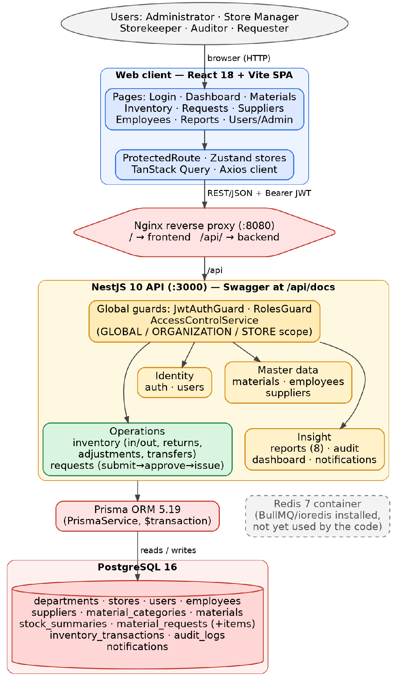
Figure 1: System Architecture Diagram — AMU Dedicated Store & Resource Management System
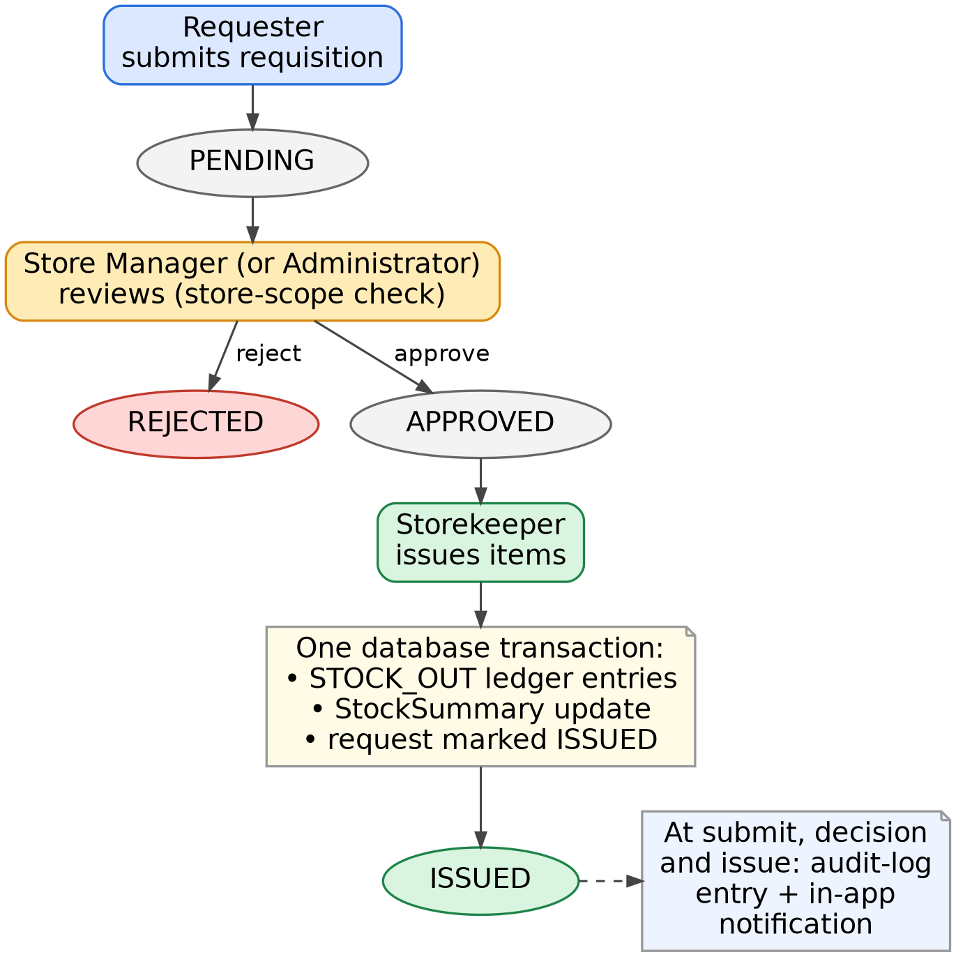
Figure 2: Requisition Approval and Issuance Workflow
Table 2: Backend Technology Stack
Technology | Version | Purpose
NestJS | ^10.4.0 | Core backend application framework
Prisma / @prisma/client | ^5.19.0 | ORM and database migrations
PostgreSQL | 16 | Relational database engine
Argon2 | ^0.40.3 | Password hashing
@nestjs/jwt / passport-jwt | ^10.2.0 / ^4.0.1 | JWT authentication (access and refresh tokens)
@nestjs/swagger | ^7.4.0 | OpenAPI / Swagger documentation
BullMQ + ioredis | ^5.12.0 / ^5.4.1 | ioredis is utilized for IP rate limiting and brute-force account lockout; BullMQ remains scaffolded
Nodemailer | ^6.9.15 | Installed for planned email alerts (not yet used in the code)
class-validator / class-transformer | ^0.14.1 / ^0.5.1 | DTO validation

Table 3: Frontend Technology Stack
Technology | Version | Purpose
React | ^18.3.1 | UI library
Vite | ^5.4.1 | Frontend build tool / dev server
TypeScript | ^5.5.4 | Static typing
Tailwind CSS | ^3.4.10 | Utility-first styling
TanStack Query | ^5.51.23 | Server-state caching and data fetching
TanStack Table | ^8.20.1 | Data-table rendering
Zustand | ^4.5.5 | Client-side state management
React Hook Form + Zod | ^7.52.2 / ^3.23.8 | Form handling and schema validation
Recharts | ^2.12.7 | Dashboard charts
Axios | ^1.7.4 | HTTP client

Table 4: Core Backend Feature Modules
Module | Responsibility
auth | Registration, login, JWT access/refresh token issuance and session refresh, and current-session profile
users | User account management
employees | Employee and department directory
materials | Item / material catalog and categories
inventory | Stock in, stock out, returns, adjustments, transfers
requests | Requisition submission, approval, and issuance workflow
suppliers | Vendor directory and supplied-material tracking
reports | Eight institutional reports; CSV export and print-to-PDF are performed in the browser
audit | Audit log of key system actions (stock operations, request decisions, and similar events)
dashboard | Aggregated operational dashboard data
notifications | In-app notifications (request events and low-stock alerts)

Table 5: Demo User Roles and Responsibilities
Role | Primary Responsibility
Store Manager | Material catalog governance, category creation, requisition review and approval
Storekeeper | Physical store operations: Stock In, Stock Out, Returns, Adjustments, Transfers, Issuance
Requester (Academic Staff) | Submits departmental material requisitions and tracks fulfillment status
Internal Auditor | Reviews transaction history and institutional reports via the Reports & Analytics module (read-only)
Administrator (System Administrator) | User management, role assignment, department setup, direct administrative-level audit log inspection, and JSON backup and restore of user records (not a full database backup)
The functional requirements were captured as a use case model. Figure 3 covers the core store processes (requisition and stock operations), Figure 4 covers account access and user administration, and Figure 5 covers oversight and reporting; Table 6 summarizes the principal use cases. The five actors correspond to the five system roles (Requester, Store Manager, Storekeeper, Auditor, and Administrator), and “Any user” stands for every registered user. In the code, the Administrator may also approve requisitions and record stock operations, and every role can use the dashboard and notifications; these links are omitted from the figures for readability.
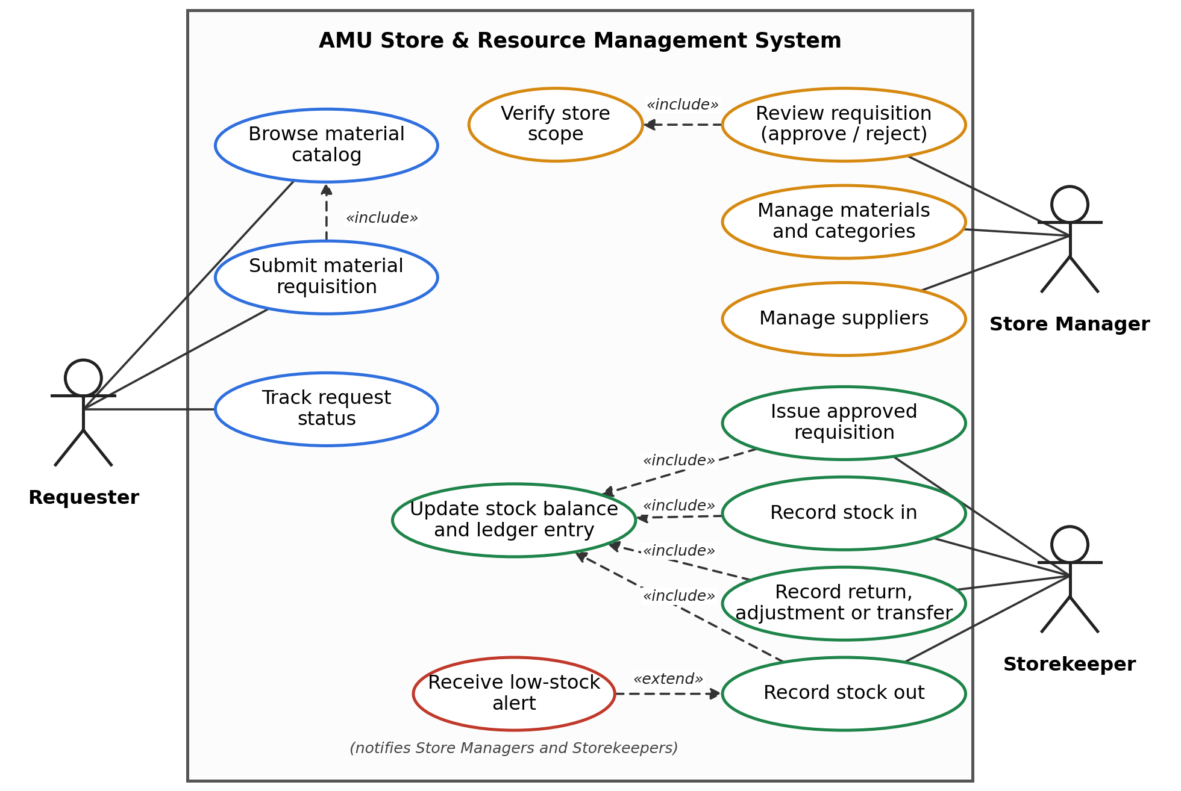
Figure 3: Use Case Diagram — Requisition and Inventory Management
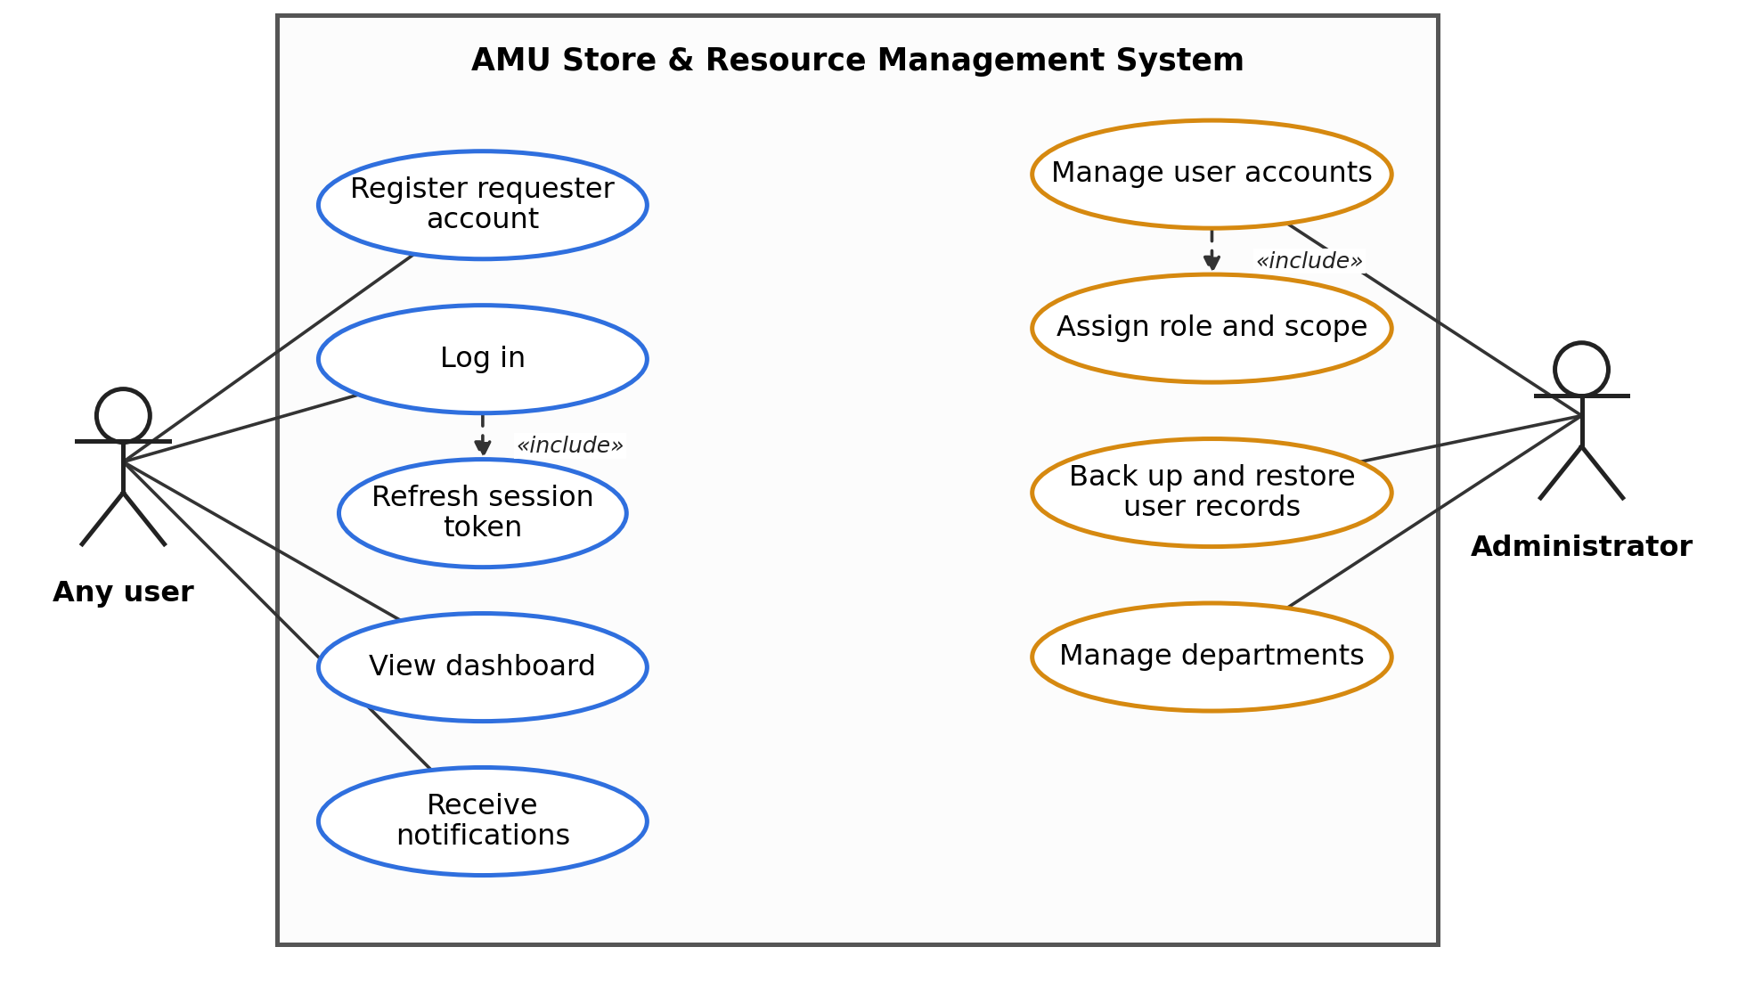
Figure 4: Use Case Diagram — Access and User Administration
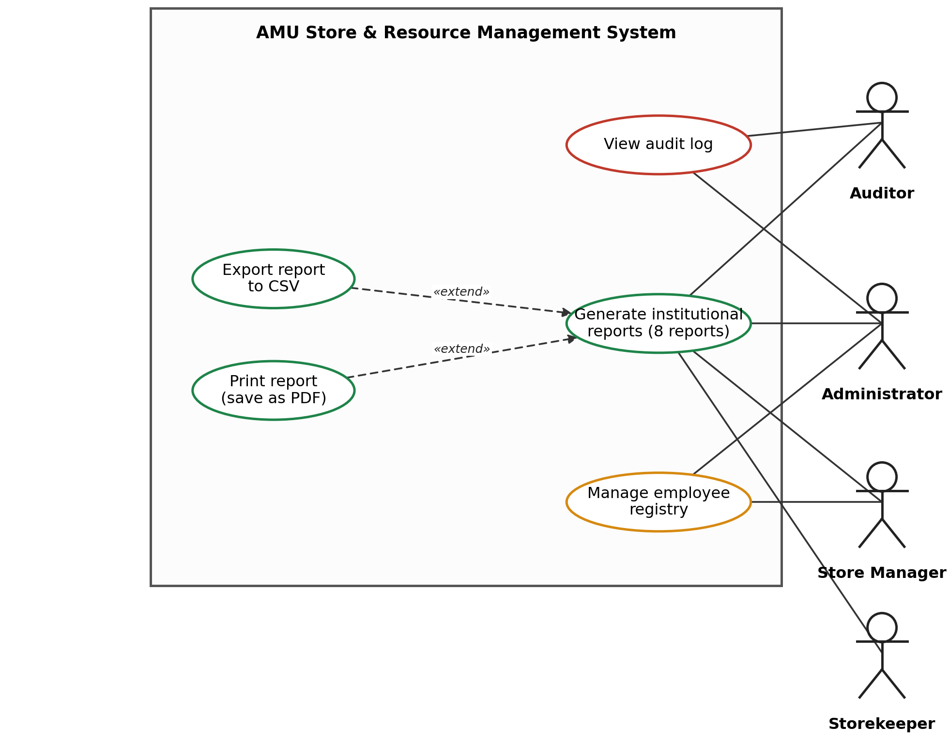
Figure 5: Use Case Diagram — Oversight and Reporting
Table 6: Summary of Principal Use Cases
Use case (actors) | Summary of the main flow
UC-01 Register and log in (Any user) | A visitor creates a Requester account from the login page, or signs in with e-mail and password. The API returns an access token and a refresh token, and the client renews the session automatically when the access token expires.
UC-02 Submit material requisition (Requester) | The requester browses the material catalog, selects materials and quantities, and submits the request. It is stored as PENDING and the Store Managers are notified.
UC-03 Review requisition (Store Manager, Administrator) | The reviewer opens a pending request; the system verifies that the reviewer’s scope covers the store, and the request is approved or rejected. The requester is notified of the decision.
UC-04 Issue approved requisition (Storekeeper) | The storekeeper issues an APPROVED request. In one database transaction the system checks availability, writes STOCK_OUT ledger entries, decreases the stock summaries, and marks the request ISSUED.
UC-05 Record stock operations (Storekeeper, Store Manager, Administrator) | Stock in from a supplier, direct stock out, return, adjustment, or transfer is recorded as a typed ledger entry together with the stock-summary update. Managers and storekeepers are notified of stock-in and low-stock conditions.
UC-06 Manage materials, categories and suppliers (Store Manager; suppliers also Administrator) | Maintains the catalog (units, minimum-stock thresholds, barcode/QR identifier, categories) and the supplier records.
UC-07 Manage user accounts (Administrator) | Creates and edits users, assigns role and scope, activates or deactivates accounts, and exports or restores user records using a JSON backup.
UC-08 Manage departments and employees (Administrator; employees also Store Manager) | Maintains the department list and the employee registry used as the recipients of issued materials.
UC-09 View audit log (Administrator) | Reviews the append-oriented record of key system actions such as user account changes, inventory stock movements, and requisition decisions.
UC-10 Generate institutional reports (Administrator, Store Manager, Storekeeper, Auditor) | The user selects one of the eight reports and views the result, then exports it to CSV or prints it from the browser (save as PDF).  Institutional Reports Generated by the System:  - Overall Inventory Status / Stock Balance Summary  - Stock Receiving (Stock In) Ledger  - Stock Issuance (Stock Out) Ledger  - Departmental Requisition and Fulfillment Log  - Low-Stock and Reorder Level Alert Report  - Inter-Store and Inter-Departmental Transfer History  - Supplier and Vendor Supply Summary  - Audit Log and System Action History
UC-11 View dashboard and receive notifications (all users) | Shows summary indicators and in-app notifications such as new requests, decisions, issues, and low-stock alerts.

3.5 Literature Review
Existing research on inventory management systems generally agrees that traditional manual and spreadsheet-based record-keeping can be error-prone and inefficient, and many recent studies focus on replacing these methods with web- or mobile-based systems offering real-time visibility into stock levels. AMU's store operations exhibited similar manual bottlenecks.
Literature on Enterprise Resource Planning (ERP) systems (e.g., Zhao & Tu, 2021) characterizes them as integrated platforms that unify departmental functions across an organization. Studies on higher education systems, such as a conceptual framework for ERP evaluation in Pakistani universities, note that research on ERP implementation and evaluation in higher education in developing countries remains limited, despite higher education institutions facing similar multi-departmental coordination challenges. This project applies established inventory-management principles, and a limited subset of ERP-style integration, to that context by addressing the operational needs of a decentralized Ethiopian public university.
Security literature on Role-Based Access Control (RBAC), such as the proposed NIST standard by Ferraiolo et al. (2001) and reviews of access control in information systems, presents RBAC as a standard approach for managing permissions. Because roles alone may not restrict a user to a particular store or organizational unit, the system combines RBAC with explicit scope values (global, organizational, or store-level); in the current implementation the scope check is applied to store-management actions such as approving a requisition.

3.6 Results and Discussion
The final version of the system (repository commit 01b0e84) provides: authentication with access and refresh tokens, and role- and scope-based access control; a material catalog with categories, units of measure, minimum-stock thresholds, and barcode/QR identifiers; stock operations (stock in, direct stock out, returns, adjustments, and transfers) with live stock summaries; a requisition workflow (request → manager approval → storekeeper issuance); supplier and employee directories; in-app notifications, including low-stock alerts; an append-oriented audit log; eight institutional reports with CSV export and print-to-PDF; an operational dashboard; JSON backup and restore of user records; and containerized development and production configurations with an Nginx reverse proxy, backed by Jest and Supertest tests. Most of this was built during the internship period (27 July – 31 August 2026); later refinements — refresh-token sessions, user-record restore, login-screen hardening, and report-export improvements — were completed afterwards, in October 2026. Larger ERP capabilities developed in earlier project phases — a configurable multi-step approval workflow engine, procurement with purchase orders and goods receipts, multi-allocation distribution, an asset registry with borrowing, custody and disposal tracking, and a multi-level organizational hierarchy — are visible in the repository history and early database migrations but were removed when the scope was simplified in the final restructuring; they are listed as future work in Section 3.7. Adhering to our scheduled check-ins kept the system focused on AMU’s core store workflow requirements.
Demonstrated operational scenarios — supplier stock receiving, department requisition with Store Manager approval, storekeeper issuance, material returns, stock-count adjustments, and inter-department transfers — showed that a process which previously required manual paper reconciliation could be completed with real-time stock updates and an append-oriented audit trail. This helps address the audit problems described in Section 3.2.
At the conclusion of the internship, the team formally presented and demonstrated the finished system — its goals, functionality, and design — to the supervisor, who reviewed it against the original requirements and use-case diagrams and approved it. The source code remained in the intern team's project repository during the internship, and formal institutional handover had not occurred by its conclusion, which leaves open the possibility of future institutional adoption if AMU chooses to pursue it (see Section 3.7).
The system was primarily validated using seeded demonstration data and controlled test scenarios during the internship, since it was built as a student challenge project rather than deployed against live institutional data. Full-scale, multi-department production rollout, real user training, formal handover of the codebase, and organizational change management fall outside the scope of the internship and remain necessary next steps before any university-wide adoption.

3.7 Recommendations Regarding the Identified Problems
- If ICTD wishes to move the project toward institutional use, it should establish a formal process for codebase handover and assign permanent maintainers within the Application Development section.
- Roll out a phased pilot within ICTD's own store before expanding the system to other colleges and departments.
- Provide structured training for storekeepers, requesters, and auditors ahead of any go-live.
- Establish a formal plan for migrating existing paper-based inventory records into the new system.
- Introduce periodic backup verification and automated alerts for low-stock conditions and audit anomalies. Low-stock alerts currently appear only as in-app notifications; while ioredis is utilized for IP rate limiting and brute-force account lockout on the auth service, Nodemailer and BullMQ remain scaffolded and could be wired in to deliver scheduled and email alerts. The current backup and restore cover user records only and should be extended to scheduled full-database backups (for example, with pg_dump).
- Consider adding barcode or QR-code scanning at physical stock points, building on the item QR metadata already scaffolded in the system, to further reduce manual data-entry errors.
- Make direct stock-out operations safe under concurrent use by performing the balance check inside the database transaction (for example, with a conditional update or row-level locking), because the current stock-out path reads the balance before the transaction begins.
- Reintroduce, as later modules, the larger capabilities explored in early design iterations — a configurable multi-step approval workflow, procurement with purchase orders and goods receipts, multi-allocation distribution, an asset registry with borrowing and disposal, and a multi-level organizational hierarchy — only after the core store workflow has been adopted and proven.
- Replace the browser-based CSV and print-to-PDF exports with server-side Excel and PDF generation, and replace the default demonstration credentials and development secrets before any real deployment.

Chapter Four: Benefits Gained from the Internship and Reflection

4.1 Technical and Practical Skills Learned
Working on a system modeled on a real university process helped me connect what I learned in class with actual software development. Putting relational database design and normalization into practice using Prisma ORM 5.19.0 and PostgreSQL made database concepts much clearer than classroom exercises alone. I also learned a lot about concurrent inventory updates in NestJS: wrapping each stock movement and its balance update in a database transaction, and recognizing where race conditions can still occur. Setting up the application with Docker Compose gave me solid experience with containerization and managing multi-service setups.

4.2 Team Collaboration, Git Workflows, and Peer Mentorship
Since some of my student teammates were less familiar with professional tools, I helped guide our team's daily development work. I organized our workflow in Git and GitHub, showing teammates how to use branches, open pull requests, and resolve merge conflicts. This experience taught me patience and how to explain technical concepts clearly without slowing down our progress or creating frustration within the team.

4.3 Professional Ethics, Institutional Context, and Career Perspective
Working under Mr. Chirotaw Kentib gave me a practical understanding of how software is built in a real organization. We focused on meeting the actual requirements rather than adding unnecessary features. Building software meant to handle university resources made me realize how critical data accuracy and proper audit logging are. Overall, the internship reinforced my goal of becoming a software engineer and showed me what it takes to work effectively on an engineering team.

Chapter Five: Conclusion and Recommendations

5.1 Overall Conclusion
The 45-working-day internship at Arba Minch University's ICT Directorate offered valuable practical experience in full-stack software development through the AMU Dedicated Store & Resource Management System project. The experience helped connect classroom learning in databases, software engineering, and web development with real-world software design, helping prepare me for professional IT work.

5.2 Recommendation Regarding the Hosting Company
Arba Minch University's ICT Directorate is recommended as a strong host for future Information Technology student placements. It offers exposure to an industry-standard technology stack, a realistic, production-oriented project built around a real institutional process, and supervision from experienced developers willing to mentor students through code review and guided problem-solving.

5.3 Recommendations for Improving the Internship
- Provide a short, structured onboarding/orientation to the specific technology stack (NestJS, Prisma, React, Docker) at the start of the internship, rather than expecting interns to ramp up entirely on their own.
- Establish a clearer, written schedule of mentorship check-ins between the intern and supervisor.
- Define intern task scope more explicitly at the outset, with a short list of concrete deliverables for each phase of the internship.
- Grant interns access to a dedicated staging environment early, to reduce time lost to local environment setup.
- Encourage interns to maintain a running personal log of tasks and challenges throughout the internship, to make final report-writing easier and more accurate.

References
Arba Minch University. (2026). About AMU — History, vision and mission. https://www.amu.edu.et
Girma, Y. (2026). AMU Dedicated Store & Resource Management System [Source code repository]. GitHub. https://github.com/YonasGr/AMU-Resource-Management-System
NestJS Documentation. https://docs.nestjs.com
Prisma Documentation. https://www.prisma.io/docs
React Documentation. https://react.dev
Zhao, X., & Tu, C. (2021). Research and development of inventory management and human resource management in ERP. Wireless Communications and Mobile Computing, 2021, Article 3132062. https://doi.org/10.1155/2021/3132062
Ferraiolo, D. F., Sandhu, R., Gavrila, S., Kuhn, D. R., & Chandramouli, R. (2001). Proposed NIST standard for role-based access control. ACM Transactions on Information and System Security, 4(3), 224–274.
A review of existing inventory management systems. (2024). ResearchGate. https://www.researchgate.net/publication/383947700
Inventory management concepts and implementations: A systematic review. (2022). ResearchGate. https://www.researchgate.net/publication/362344346
A conceptual framework for ERP evaluation in universities of Pakistan. (2014). arXiv:1402.0116. https://arxiv.org/pdf/1402.0116
Health information system role-based access control: Current security trends and challenges. PMC. https://www.ncbi.nlm.nih.gov/pmc/articles/PMC5836325/

Appendices

Appendix A: Core Backend Feature Modules
audit · auth · dashboard · employees · inventory · materials · notifications · reports · requests · suppliers · users

Appendix B: System Access Points (Development Environment)
- Web Application Portal: http://localhost:5173 (or http://localhost:8080 in production)
- API Swagger Documentation: http://localhost:3000/api/docs
- Backend API (direct): http://localhost:3000

Appendix C: Project Source Repository
The complete source code for the AMU Dedicated Store & Resource Management System, developed by the intern team as their internship challenge project, is available at: https://github.com/YonasGr/AMU-Resource-Management-System
Repository state described in this report: branch main, commit 01b0e84 (8 October 2026). The repository history contains 27 commits total at HEAD from 27 July 2026 onward.

