## **4.2 Current software architecture**

Architecture of the System

We use a 3 tier Client/Server Architecture where a client can use Internet browsers to access the system within the local area network of the school.

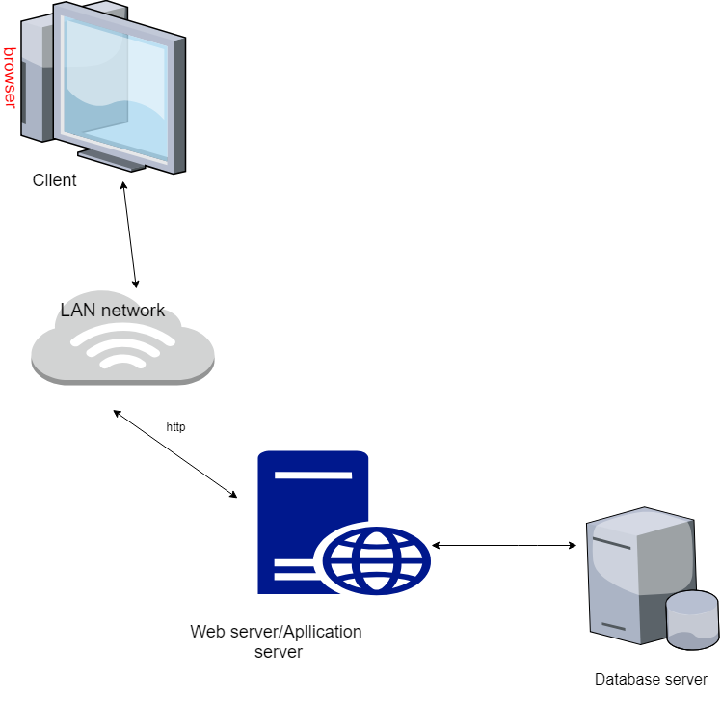

Figure 4. 1 architecture of the proposed system

The **client tier** is the applications user interface containing data entry forms. It displays data to the user. Users interact directly with the application through user interface.

The controller logic processes client requests such as requests to view student’s result, to record attendance or to retrieve data from the database. Business rules enforced by the business logic dictate how clients can and cannot access application data and how applications process data.  
The web server used in this system is IIS. HTTP is used to transfer data across  
an Intranet or the Internet.

The **middle tie**r (web/application server) implements the business logic, controller logic and presentation logic to control the interaction between the application’s clients and data.  
The **data tier** maintains the applications data such as student data, teacher data, timetable data etc. It stores these data in a relational database management system (RDBMS).

The client tier interacts with the web/application server to make requests and to retrieve data from the database. It then displays to the user the data retrieved from the server.