### **4.3.4 Persistent data management**

Information related to student and employee basic information, student’s attendance and mark, the timetable produced and other related information are persistent data and hence we use relational database management system.

In order to store information persistently we map objects/classes into tables and the attributes into fields to the specific table based on the objects we found on the system. Therefore, we identified the major tables that will be implemented on the selected DBMS.

**Mapping**

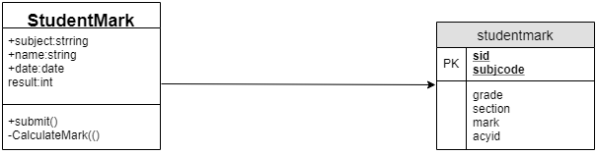

Figure 4. 4 Student mark mapping

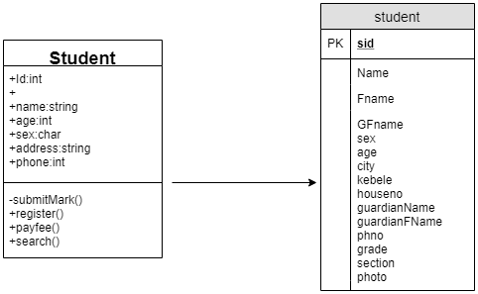

Figure 4. 5 student mapping

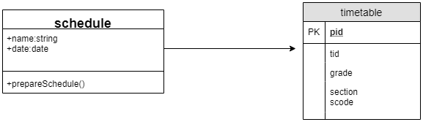

Figure 4. 6 schedule mapping

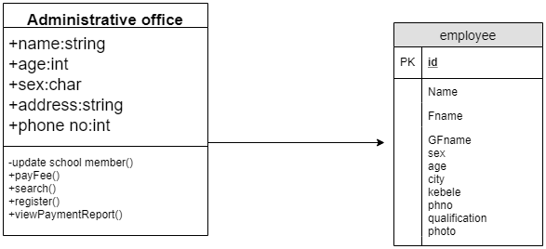

Figure 4. 7 administrative office mapping

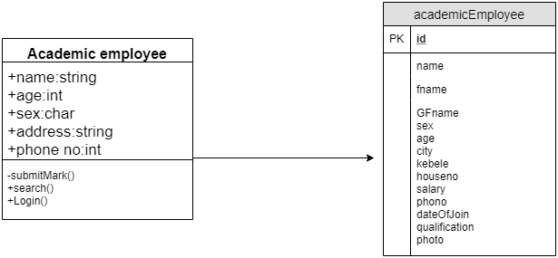

Figure 4. 8 Academic employee mapping

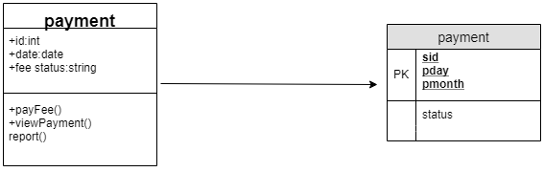

Figure 4. 9 payment mapping

**Database diagram**

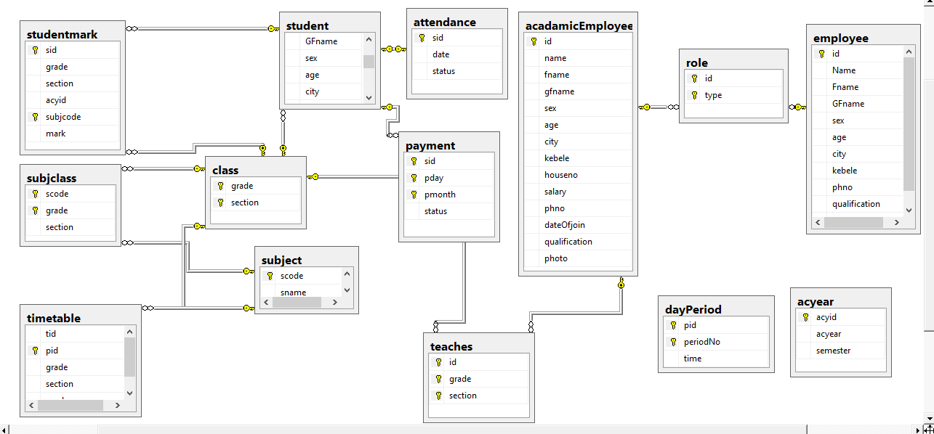

Figure 4. 10 data base diagram