Encrypted Keyboard Logger

Final Report
Yonatan Feleke
Samuel Oshin
Evan Graves
Brian Crone
Class: ECE 337
Lab: Tuesday 11:30 AM
Due: Friday, April 29, 11:59 PM
TA: Nitin

Executive Summary:

Our group plans on implementing an encrypted key logger for USB keyboards that will download data over Bluetooth protocol. The project interfaces that will be used include: a USB receiver module designed for lab 6, UART designed in lab 5 and a blue tooth protocol. The foreseeable industrial application is as a tool for monitoring and evaluating employees. Since this is a hardware implementation that is also encrypted, the possibility of employee tampering with it is minimal. Also, the Bluetooth implementation keeps our product discrete and harder to detect by a user. This feature also decreases the chance of tampering. By observing the average keystrokes per hour and looking for profanities or unprofessional use of company equipment, the company manager can better evaluate the employee.
The reason this project is unique is because it incorporates a DES encryption. When a dump signal packet is transmitted over a Bluetooth protocol this system dumps a DES encrypted log of the logged keys are. The convenient wireless implementation makes data gathering simple. This is appropriate for ASIC implementation because the project is to only achieve one task with minimal power consumption and size.
The requirements for this project are female and male USB ports for keyboard connectivity, a Bluetooth antenna for wireless transmission of logged keys, an off chip SRAM to store the logged keys and USB receiver module for receiving USB data. This is a promising project due to the low cost implementation and possible application. Within the proposal are details of the specification and overall procedure of the project.

2. Design Specifations

2.1 Interfacing specifications
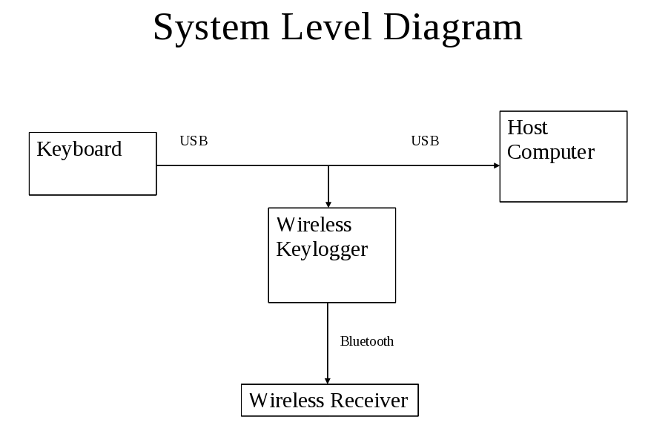
As the system level diagram shows, the key logger is pretty simple to interface with external components. The product simply connects to the keyboard on its USB line and piggybacks off of its line, leaving the raw data unchanged as it is transmitted to the host computer. The key logger follows the USB 1.1 protocol when receiving data. This includes a 12Mb/s data rate with bit stuffing and NRZI encoding. The data, after encryption and request for transmission, is sent out according to Bluetooth 1.0b standards and protocol. The method of transferring data between internal blocks is through the use of an 8 bit by 8 bit FIFO register. The transmitter will load its data onto the FIFO, and will emit a “full” signal when data is ready to be read. When this happens, the receiver will strobe its read enable signal to the FIFO and read in parallel data 8 bits at a time. As mentioned earlier, the USB receiver reads serial data from the keyboard at a rate of 12Mb/s as specified by USB 1.1 protocol. The Bluetooth transmitter sends data out at a rate of 433.9 kb/s, while the Bluetooth receiver receives data at a rate of 57.6 kb/s. The main features of the design include a USB receiver that handles bit stuffing and checks data with a CRC, a 64 bit DES encryption of data, a 4095 byte off chip SRAM, and a Bluetooth transmitter/receiver.

2.2 Operational Characteristics

Signal Name | Type  In/Out/Bidir. | Number of Bits | Description
DATA + | IN | 1 | D PLUS signal from USB line
DATA - | IN | 1 | D MINUS signal from USB line
VCC | IN | 1 | Power line to hardware
Ground | IN | 1 | Ground line to hardware
Clock | IN | 1 | Internal clock (288 MHz)
RST | IN | 1 | Asynchronous active high reset
R_ENABLE1 | IN | 1 | Read Enable to Bluetooth FIFO
DATA | IN | 8 | Data from SRAM to Bluetooth
DATAout | OUT | 8 | Output Data bus to SRAM
EMPTY_SRAM | OUT | 1 | Output from Bluetooth indicating empty SRAM
RCVING | OUT | 1 | From USB, means receiver is currently receiving packet
ADDR | OUT | 12 | Address to SRAM
RDATA | OUT | 8 | Data from Enctyption to SRAM
R_ENABLE_S | OUT | 1 | Read Enable for SRAM
R_ERROR | OUT | 1 | From USB, indicating error in packet reception
W_ENABLE_OUT | OUT | 1 | Write enable to SRAM

