# Optimization

## Assignment 3

Yonatan Simson, 015764921

Amit Kristal, 025602624

### Q1

Let's define the inverse function:

Therefore:

### Q2

Now to find :

### Q3

The normal to surface is defined as,

In our case

We can also see that:

A Surface integral is defined as

Where

So

### Q4

The Euler Lagrange equation for

The Euler Lagrange equations:

Let's deal with

Likewise for :

### Q5

Now find each part separately:

To summarize:

We still need to calculate:

Substitute in (*) and we get

Now take the equation we are trying to prove:

Substitute (**) into it:

Q.E.D

### Q6

From the previous question:

In this case so we get:

Where

From the boundary conditions:

### Q7

Using the conservation of energy principal:

The function we wish to calculate is:

Where or alternatively,

From the principle of energy conservation,

Assuming we get:

### Q8

The Euler Lagrange equation is:

Either we use the Hamiltonian of Euler Lagrange equation which is:

It is constant because of is not a function of ( because)

So

Which gives us the Hamiltonian of:

Where

The cycloid equations are:

By substituting the cycloid equation in the (*) we get:

So this gives us:

### Q9

From the previous question (Q6) we showed that:

So it can be seen that

### Q10

We have been given that

We would like to show that:

### Q11

So

### Q12

Matlab

### Q13

Matlab

Q14

Matlab



### Q15

From (9) we had:

With the taylor series for

We can approximate this expression to

The E-L equations are:

So taking each part separately:

And the E-L equation is:

### Q16

Assuming the Albedo is the same and the light direction is we write

### Q17

Matlab

### Q18

Show that:

### Q19

Matlab

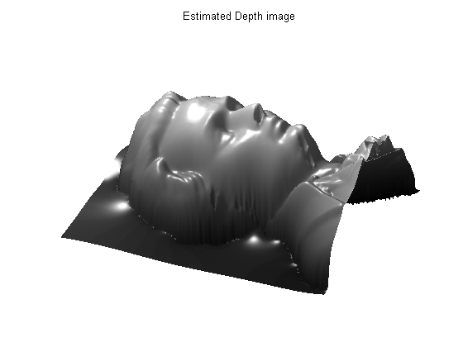

### Q20

A qualitative comparison between both methods:

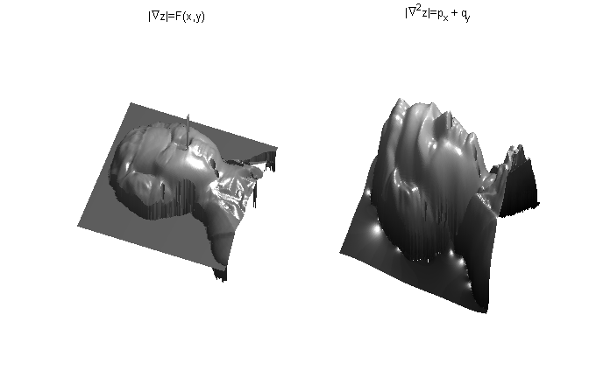

The original bust looks like this:

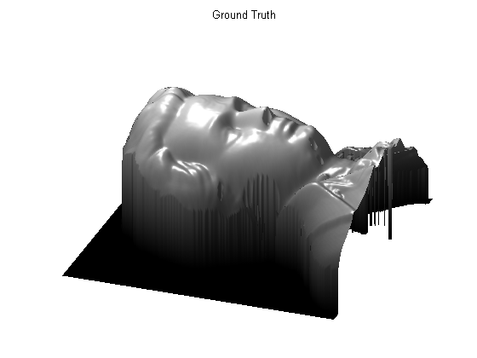

In conclusion the linear method is much better that the method based on a single light source.