**Bayesian statistics HW2**

**Yonatan Meir 203676739**

1. The function is attached.
2. Using the grid method I got the following results:

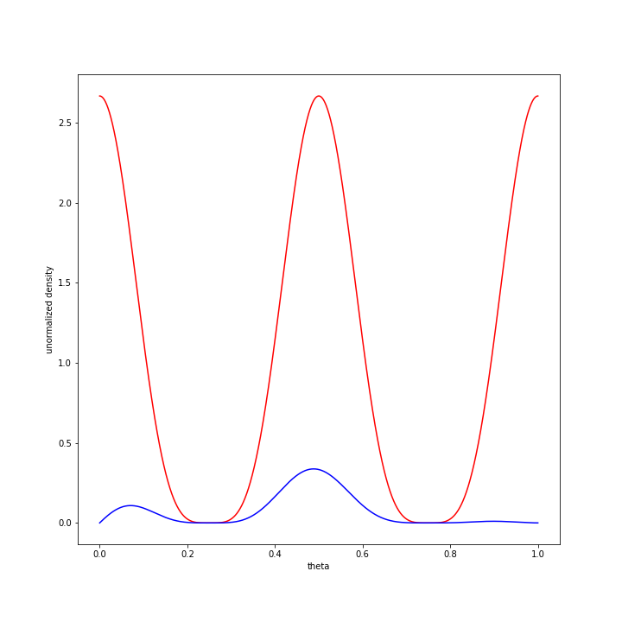

*Figure 1- The shape of the prior(red) and the posterior (blue)*

As figure 1 suggests, the prior is periodic with respect to theta, and bounded between 0 to 1 due to possible value of coin bias. Given the data, we can that the posterior is dense around a fair coin, but since there are more heads than tails, there is also credibility that the coin is bias towards a "head" coin (more chance for head).

1. Using the functions I wrote, I got the following results:

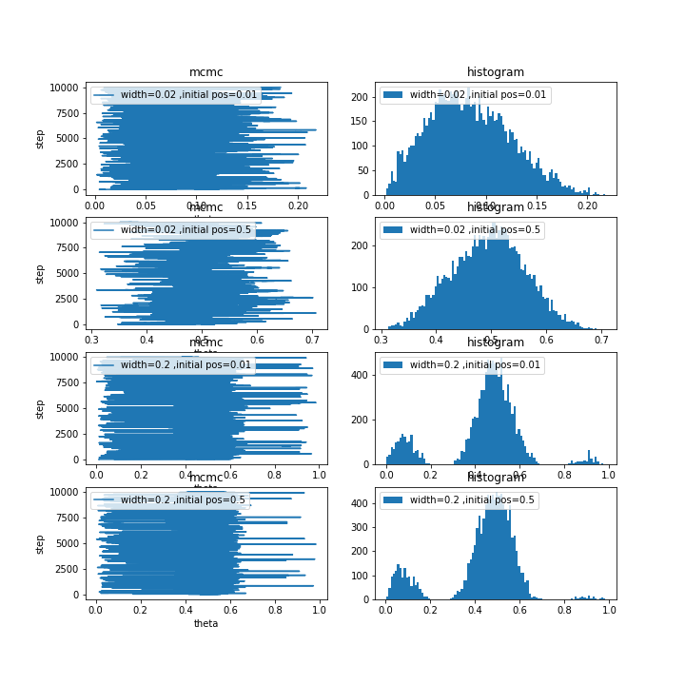

*Figure 2- Metropolis results(left) and corresponding histograms (right)*

The results of figure 2 are very interesting. In the first row, we can see an initialization $θ=0.01$ and width of $0.02$. If we look in figure 1 we can see that the metropolis algorithm is "stuck" at the local maxima. The reason for it is that the initial point is near the maxima, in adittion to a relative small gaussian width, which doesn’t "allow" a big "jump" towards the global maximum. In contrast, we can see in row 3, that for the same initial point, we get a good estimation of the posterior, because the width of the gaussian is relative big (0.2). The same discussion can be done on rows 2 and 4, where the width of the gaussian has a big effect on the estimation of the prior. To conclude, that isn’t a surprise that for a multimodal prior, a width of 0.01 doesn’t estimate the posterior well, since it is almost impossible in probability for the Metropolis algorithm to jump the another pick.

1. The function is attached.
2. 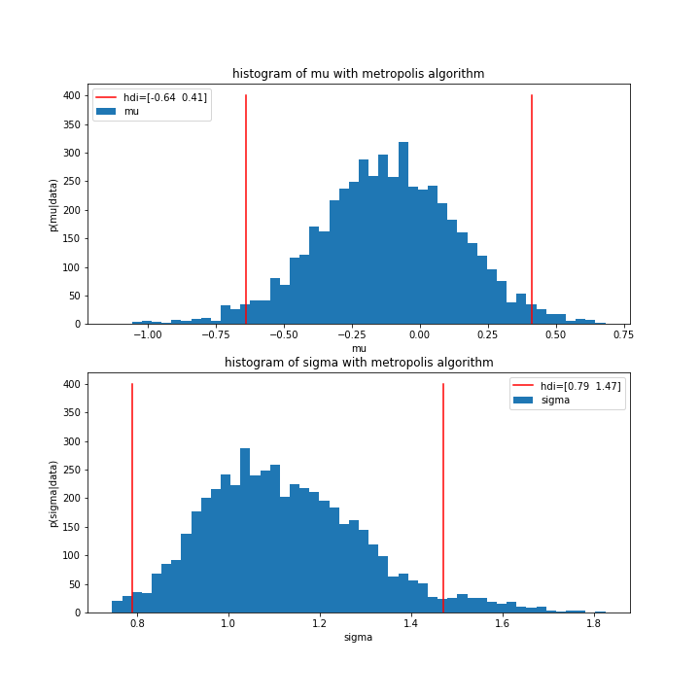After generating 20 samples from unit normal distribution, and applying the Metropolis algorithm, we got the following results:

*Figure 3-Posterior of $μ$ and $σ$ and 95 % hdi with Metropolis algorithm*

It is worth mentioning that the initial guess was the 0 for $μ$ and1 for $σ$ and for priors I used the values that are given in the exercise. As figure 3 suggests, the estimation of the parameters are good (around the true value) and included in the hdi.

1. The function is attached.
2. 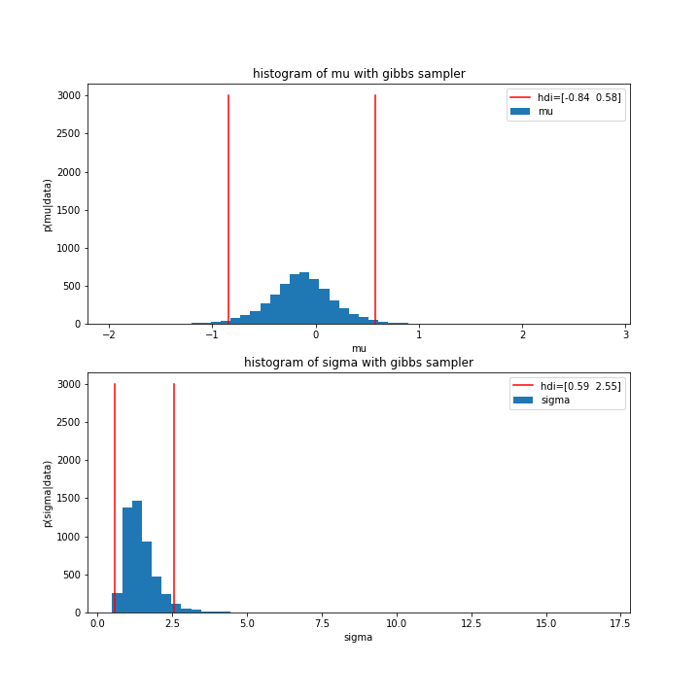Using the gibbs sampler, we got the following results:

*Figure 4-Posterior of $μ$ and $σ$ and 95 % hdi with Gibbs sampler*

In figure 4 we can see (on a different scale) that we get approximately the same result using the Gibbs sampler. Gibbs sampler is much more reliable in estimating the posterior of 2 parameters, although we cant see it in this example. In my opinion. The reason for it due to the impudence between the priors of $μ and σ$, and due to reason that the initial guess for the Metropolis algorithm was quite accurate.