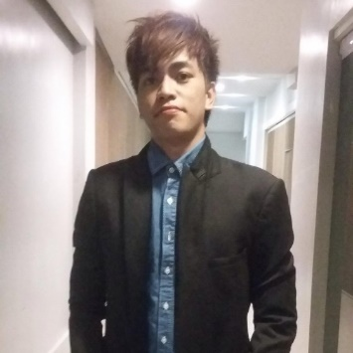

Ian Lemuel G. De Guzman

D:\Personal\Google\Google Drive\Resume\Resume Update\Address.jpg

Alsaad Street Doha 122001, Qatar

[Iandeguzman83@gmail.com](mailto:Iandeguzman83@gmail.com)

7093-6479

Profile Summary

* Strong Analytical Skills, Fast Learner and be able to do multi-tasking jobs with an orderly manner.
* Computer troubleshooting on both hardware and Software.

Professional Experience

1. **Alashbal International School**

ICT Teacher

August 2019 – Present.

**Duties and Responsibilities**

* Plan, prepare and deliver instructional activities that facilitate active learning experiences.
* Develop schemes of work and lesson plans.
* Establish and communicate clear objective for all learning activities.
* Prepare classroom for class activities.
* Prepare weekly and daily lesson plan for the student.
* Instruct and monitor students in the use of learning materials and equipment.
* Use relevant technology to support instruction
* Observe and evaluate student’s performance and development.
* Assign and grade classwork, homework and assignment.
* Encourage and monitor the progress of individual students.
* Maintain accurate and complete records of student’s progress and development.
* Manage student behavior in the classroom by establishing and enforcing rules and procedure.
* Participate in department and school meetings, parent meetings.
* Communicate Necessary information regularly to students, colleagues and parents regarding student progress

and student needs.

* Maintain all the computer’s in the computer lab

1. **Prosync / San Miguel Corp.**

IT Helpdesk

Ortigas

January 10 2018 – January 5 2019

**Duties and Responsibilities**

* Create Ticket on issues regarding the Toll Collection System from Tollways
* Dispatch ticket to IETC Technical supervisor and get the details on who and when the ticket will be serviced
* Inform Toll Operations on the details of the service (Technician Schedule)
* Conduct Follow-up call on resolve ticket as required
* Update the ticket from database
* Provide Technical Support on the client

1. **SPI-Infocom / PLDT**

Technical Support Representative

Makati

June 4 2017– December 20 2017

**Duties and Responsibilities**

* Respond to customer inquiries on technical issues.
* Resolve and troubleshoot simple or complex issues relating to customers.
* Provide technical support to team members.
* Provide qualitative services to customers on their technical problems.
* Participate in cross-functional team meetings.
* Analyze cost efficiencies in dealing with technical issues.
* Assist and support administrative staff in their day-to-day tasks.
* Provide qualitative technical services to internal and external customers.

Certification

**AMA Computer College**

* + **Cisco CCNA 1- Introduction to Network.**
  + **Cisco CCNA 2- Routing and Switching essentials.**
  + **Cisco CCNA 3- Scaling Network.**
  + **Cisco CCNA 4– Connecting Networks.**

**Alashbal International School**

* + **Certification of Appreciation.**

Skills

|  |  |
| --- | --- |
| * **Formatting and Software Installation**   *Level: Intermediate* | * **Printer Network, Setup and Configuration**   *Level: Beginner* |
| * **Server Configuration (AD, DHCP, DNS)**   *Level: Intermediate*   * **(HTML, CSS, WordPress, Plugin, Java)**   *Level: Beginner* | * **Photoshop**   *Level: Intermediate*   * **Teaching (Primary) / Microsoft Office / Scratch Program.**   *Level: Intermediate* |

Language

English : Intermediate

Tagalog : Expert

Personal Information

Birth Date : 8 August 1996

Gender : Male

Nationality : Filipino

Residence : Qatar - Doha

Visa Status : Freelancer

Marital Status : Single

Education

**Bachelor Degree, Bachelor of Science in Information Technology**

AMA Computer College Lucena City - Philippines

June 2014 - April, 2017

*I hereby certify that the above information is true and correct to the best of my ability*

Ian Lemuel De Guzman

Applicant