1. **Computer**

Class: Computer

Properties:

-Brand

-Model

-Color

-Core

Methods:

-Execute tasks ()

-Search ()

-Operate ()

Brand: HP

Model: 15s-du2131TU

Color: Silver

Core: Intel i3

Brand: Lenovo

Model: Legion 5i 15

Color: Black

Core: Intel i7

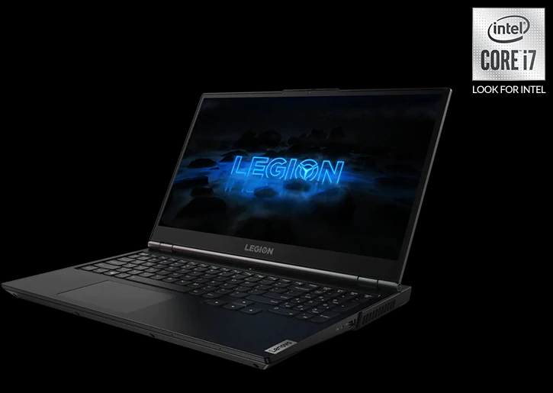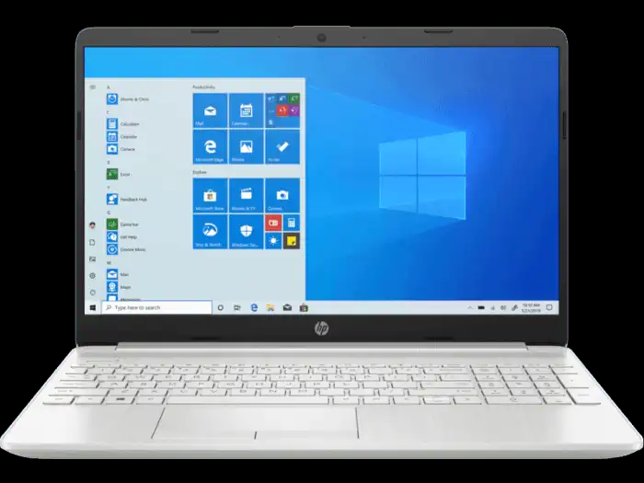

1. **Motorcycle**

Class: Motorcycle

Properties:

-Brand

-Model

-Color

Methods:

-Racing ()

-Transport ()

Brand: Yamaha

Model: Y15ZR & GP-EDITION

Color: Yellow

Brand: Honda

Model: Wave Alpha AFS110MDJ

Color: Red

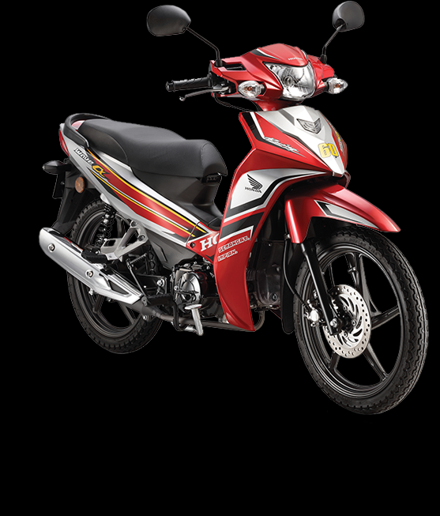 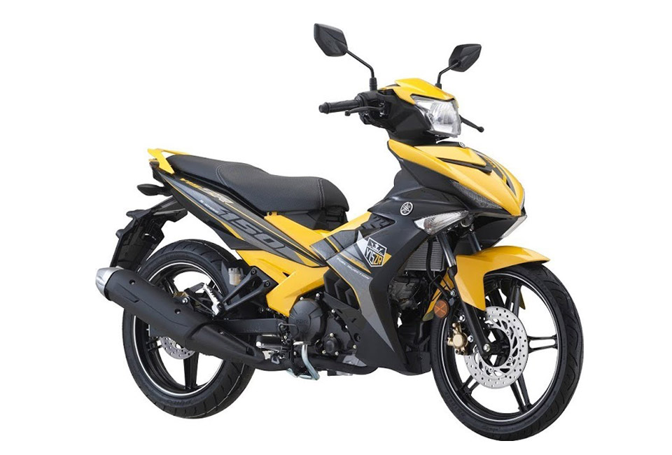

1. **Mobile Phone**

Class: Mobile Phone

Methods:

-Messages ()

-Call ()

-Selfie ()

Properties:

-Brand

-Color

-Operating system

-Ram

Brand: Oppo F9

Color: Sunrise Red

Operating system: Android 8.1

Ram: 4/6GB RAM

Brand: iPhone 11

Color: White

Operating system: iOS 14

Ram: 4GB RAM

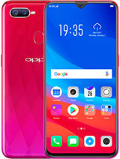 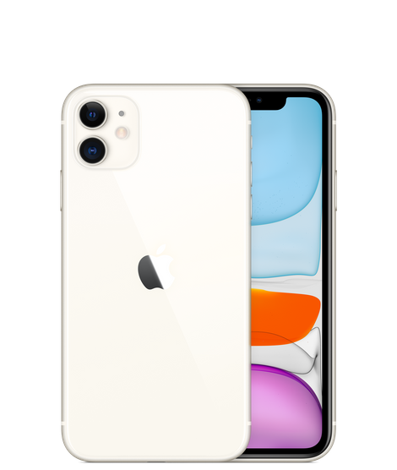

1. **Television**

Class: Television

Properties:

-Brand

-Model

-Size

-Resolution

Methods:

- Educate ()

- Advertising ()

- Entertain ()

Brand: Sony

Model: A8H

Size: 55"

Resolution: 4K

Brand: Samsung

Model: Q65A

Size: 65"

Resolution: 4K

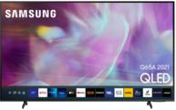 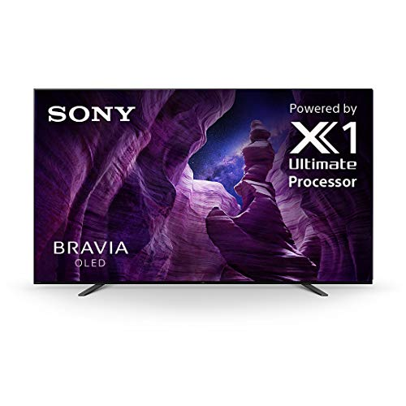

1. **Smart Watch**

Class: Smart Watch

Methods:

-Time ()

-Display ()

- Touchscreen ()

Properties:

-Brand

- Compatibility

- Onboard storage

- Charging method

Brand: Samsung Galaxy Watch 3

Compatibility: Android, iOS

Onboard storage: 8GB

Charging method: Wireless

Brand: Apple Watch SE

Compatibility: iOS

Onboard storage: 32GB

Charging method: Wireless

