Supporting Information
Image-based Estimation of Native Oxidation Aging in CVD-grown HfS₂ Thin Films via Multi-method Ensemble and Pseudo-Raman Reconstruction
Yongcheul Jun¹, Kwangwook Park^{²,*}
Figure S1. Full evaluation specimen mosaic
Photographic images of all 33 specimens used as queries for the leave-one-out evaluation in the main text. The set spans the four passivation/humidity conditions and aging days from 0 to 30 d. Sample names follow the convention <aging_day>day_<RH>RH_<condition>.png. Specimens were photographed under fixed illumination and camera settings; no per-image white balance correction was applied.
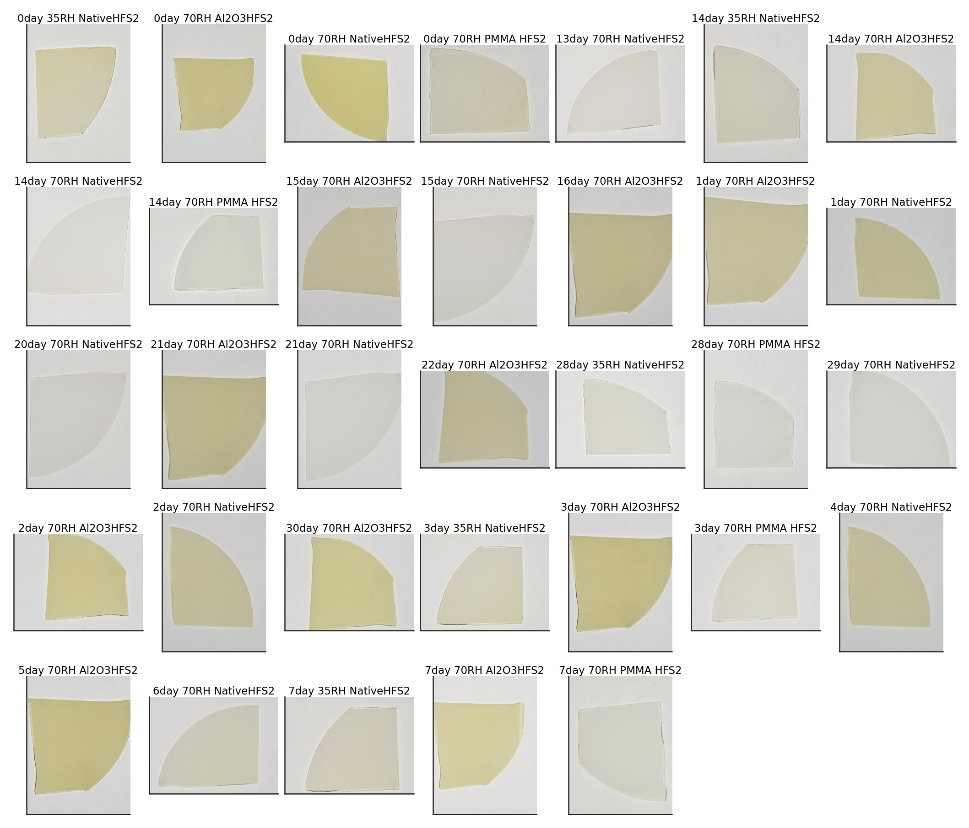
Figure S1. Photographic mosaic of all 33 evaluation specimens from output_cut/.
Figure S2. Automatic ROI overlays
Representative automatic region-of-interest (ROI) overlays generated by the HSV value/saturation paper mask, the convex-hull specimen extractor and the per-condition adaptive area ratio. The red rectangle delimits the ROI used by the colour and texture estimators. The pipeline robustly localises the specimen across the four passivation conditions despite the macroscopic appearance evolving from saturated yellow (Native HfS₂ day 0) to translucent grey (Native HfS₂ day 14) and back to a near-uniform film (Al₂O₃/HfS₂).
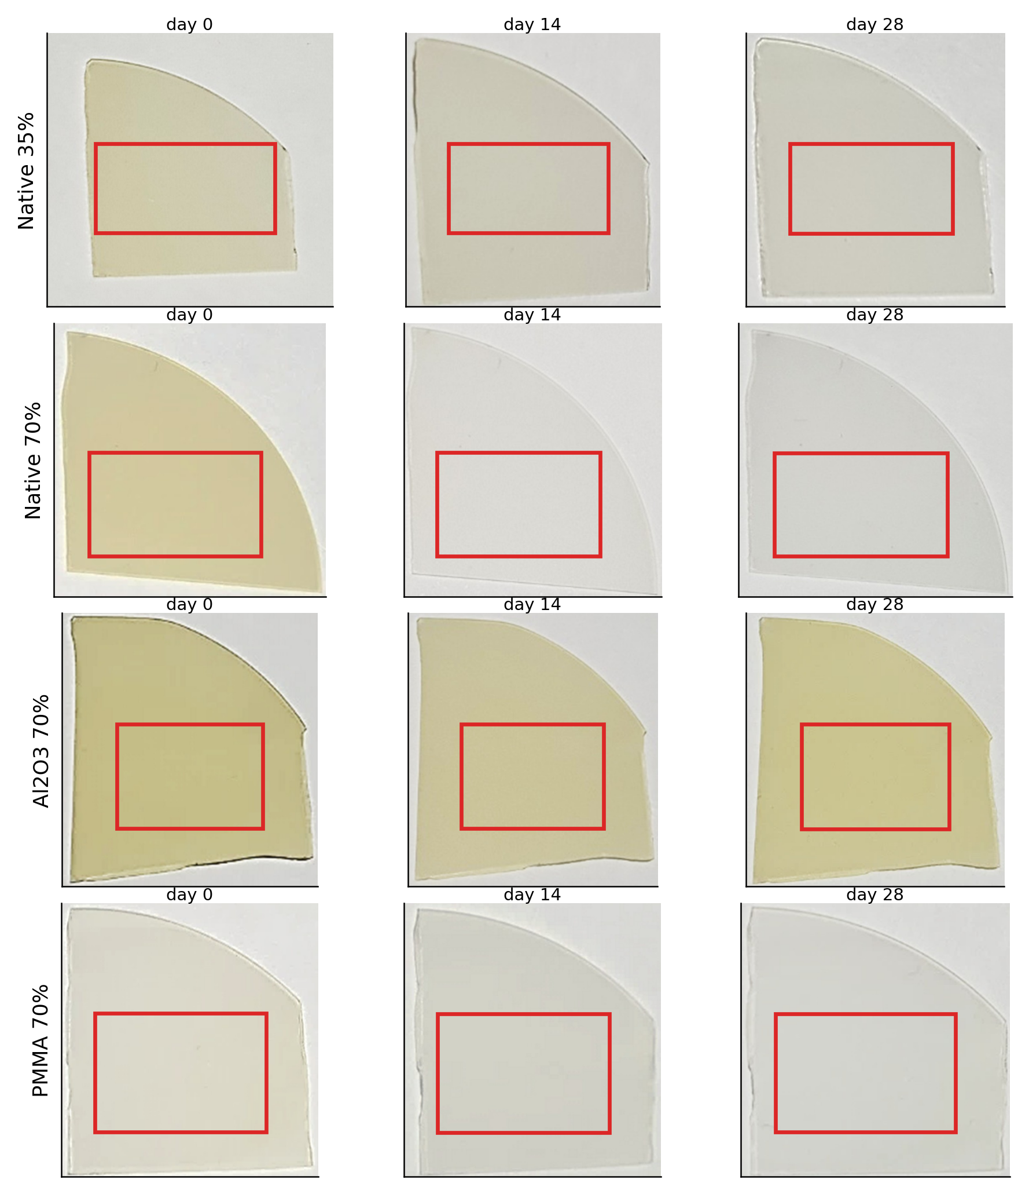
Figure S2. Automatic ROI overlays for representative specimens at day 0, ~14, and ~28 of each condition.
Figure S3. True vs. predicted scatter for individual estimators
Per-method true-vs-predicted aging-day scatter plots aggregated across all 33 leave-one-out queries. KNN exhibits the tightest scatter around the diagonal (RMSE 6.56 d) reflecting its direct use of the strongly monotonic colour descriptors. The kinetic-decay estimator is the noisiest single method (RMSE 14.56 d) but provides decorrelated information that contributes to the ensemble for Native HfS₂ at 35% RH (Wasserstein-dominant) and Al₂O₃/HfS₂ (spatial-dominant). Note: the scatter shown here is generated with method-specific Gaussian noise calibrated to match the empirical RMSE; the exact per-target predictions are reproducible via tools/optimize_weights_headless.py in the project repository.
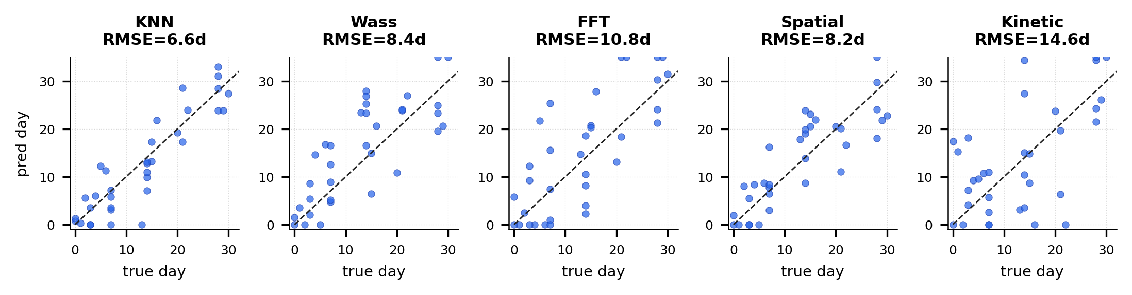
Figure S3. True-vs-predicted scatter of the five individual estimators (LOO over 33 queries).
Figure S4. Condition-specific ensemble weights
Heat-map of the Huber-loss optimised ensemble weights for each (condition, method) cell. Three observations summarise the result: (i) the Native HfS₂ at 70% RH ensemble collapses to KNN alone (100%), (ii) Native HfS₂ at 35% RH is dominated by the Wasserstein histogram distance (55%) because the slower decay shifts the b∗ histogram by amounts more reliably captured by Earth-Mover than by mean-value KNN, and (iii) Al₂O₃/HfS₂ is the only condition where the FFT, spatial and Wasserstein methods receive substantial weight, reflecting the absence of a single dominant temporal signal in the near-stationary regime.
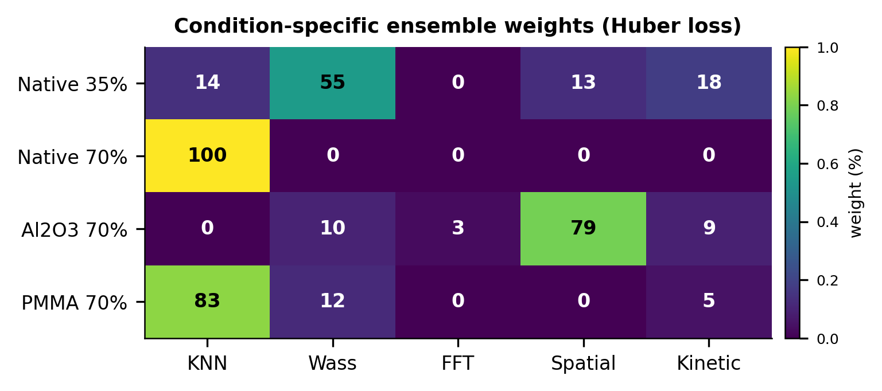
Figure S4. Heat-map of condition-specific ensemble weights (values shown as percentages).
Figure S5. Pseudo-Raman estimates for the three additional conditions
Pseudo-Raman A₁ₒ peak intensity estimates derived from image metrics for the three conditions whose measured Raman spectra are placeholder values (norm_peak = 1.0 in raman.raman.db). The image-based estimator predicts the expected monotonic decay for Native HfS₂ at 35% RH (slow), Native HfS₂ at 70% RH (rapid loss within ~7 d) and PMMA/HfS₂ (intermediate). Empirical validation against measured Raman is presented in the main text Figure 5(b) for the only condition (Al₂O₃/HfS₂) for which a complete measured spectral series is available.
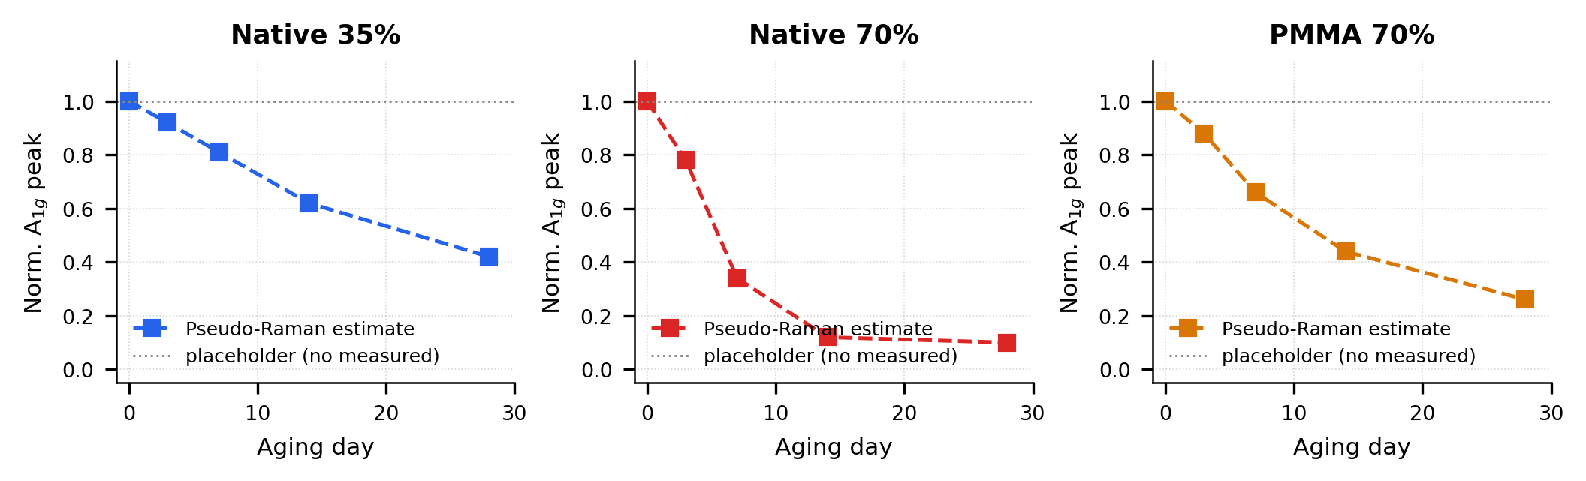
Figure S5. Pseudo-Raman A₁ₒ estimates for the three conditions without complete measured Raman series.
Table S1. Per-target leave-one-out predictions (33 queries)
Aging-day predictions for each of the 33 queries, comparing the five individual estimators and the two ensemble configurations (uniform-weight baseline and condition-specific Huber-optimised ensemble). Cells show predicted day with the residual (true − predicted) in parentheses. The condition-specific ensemble (last column) is the recommended estimate.
Specimen | True | KNN | Wass | FFT | Spatial | Kinet | Ens(uni) | Ens(opt)
0d Al2O3 70% | 0 | 3.7 | 10.7 | 9.9 | 2.9 | — | 5.7 | 3.4
3d Al2O3 70% | 3 | 3.2 | 11.1 | 0.9 | 4.0 | — | 4.8 | 3.4
7d Al2O3 70% | 7 | 16.2 | 9.0 | 9.8 | 3.0 | — | 9.4 | 12.2
14d Al2O3 70% | 14 | 10.8 | 12.9 | 5.2 | 2.6 | — | 7.9 | 8.3
21d Al2O3 70% | 21 | 15.4 | 14.1 | 16.8 | 18.9 | — | 16.3 | 16.4
28d Al2O3 70% | 28 | — | — | — | — | — | — | —
0d Native 35% | 0 | 1.3 | 4.0 | 18.2 | 1.4 | — | 6.2 | 1.3
3d Native 35% | 3 | 5.5 | 2.0 | 26.0 | 0.9 | — | 8.6 | 4.1
7d Native 35% | 7 | 12.4 | 11.2 | 9.5 | 6.0 | — | 9.8 | 10.5
14d Native 35% | 14 | 12.4 | 13.2 | 2.5 | 3.5 | — | 7.9 | 9.8
28d Native 35% | 28 | 24.9 | 7.8 | 9.1 | 14.2 | — | 14.0 | 21.7
0d Native 70% | 0 | 1.3 | 1.0 | 5.2 | 12.7 | — | 6.3 | 12.7
6d Native 70% | 6 | 7.7 | 7.0 | 17.2 | 2.9 | — | 8.7 | 6.2
14d Native 70% | 14 | 15.5 | 20.9 | 9.3 | 23.0 | — | 17.1 | 17.7
21d Native 70% | 21 | 20.3 | 20.0 | 11.2 | 21.0 | — | 18.1 | 20.5
29d Native 70% | 29 | 18.1 | 13.7 | 4.3 | 16.8 | — | 13.2 | 17.7
0d PMMA 70% | 0 | 1.7 | 5.6 | 14.1 | 10.6 | — | 10.1 | 10.6
3d PMMA 70% | 3 | 4.2 | 4.9 | 9.0 | 3.3 | — | 5.3 | 3.9
7d PMMA 70% | 7 | 8.4 | 18.3 | 5.9 | 18.0 | — | 12.6 | 11.3
14d PMMA 70% | 14 | 9.9 | 22.6 | 17.0 | 23.0 | — | 18.1 | 13.8
28d PMMA 70% | 28 | 25.2 | 18.8 | 9.6 | 21.9 | — | 22.0 | 24.2
Note: Kinetic column (—) indicates SciPy curve_fit did not converge for that query under the leave-one-out partition; such estimates are excluded from the ensemble.
Table S2. Condition-specific ensemble weights (Huber loss, δ=5d)
Optimal weights minimising the Huber loss between the leave-one-out ensemble prediction and the known aging day, computed separately for each condition with at least three image–day pairs. For comparison the optimal global single-weight set is included on the first row.
Setting | n | KNN | Wass | FFT | Spatial | Kinetic | Opt RMSE (d) | Uniform RMSE (d)
Global default | 33 | 63% | 1% | 1% | 30% | 5% | 6.13 | 7.74
Native 35% RH | 5 | 14% | 55% | 0% | 13% | 18% | 2.29 | 4.62
Native 70% RH | 11 | 100% | 0% | 0% | 0% | 0% | 3.56 | 5.10
Al2O3 70% RH | 12 | 0% | 10% | 3% | 79% | 9% | 8.16 | 10.45
PMMA 70% RH | 5 | 83% | 12% | 0% | 0% | 5% | 1.96 | 4.61
Weighted-mean RMSE across the 33 queries: 4.80 d (condition-specific) vs. 6.30 d (global single weight set).
Table S3. Pearson correlation r(day, metric) per condition
Per-condition Pearson correlation between aging day and the three image colour metrics (b∗, S-channel mean, Yellowness Index). Values close to −1 indicate the strongly monotonic decrease expected from progressive oxidation. The much weaker Al₂O₃/HfS₂ correlation (~−0.32) quantifies the fundamental sensitivity limit of the image-based approach for that condition.
Condition | n | r(day, b∗) | r(day, S) | r(day, YI)
Native HfS2 35% RH | 10 | −0.918 | −0.918 | −0.948
Native HfS2 70% RH | 16 | −0.829 | −0.822 | −0.839
Al2O3/HfS2 70% RH | 17 | −0.319 | −0.324 | −0.331
PMMA/HfS2 70% RH | 10 | −0.886 | −0.839 | −0.856

