Image-based estimation of native oxidation aging in CVD-grown HfS₂ thin films via multi-method ensemble and pseudo-Raman reconstruction
Yongcheul Junᵃ, Kwangwook Parkᵃ,*
ᵃDivision of Electronics and Information Engineering, Jeonbuk National University, Jeonju 54896, Republic of Korea
*Corresponding author. E-mail: kpark@jbnu.ac.kr (K. Park)
Abstract
Hafnium disulfide (HfS₂), a layered transition-metal dichalcogenide considered for high-mobility electronics and photodetectors, undergoes rapid native oxidation under ambient humidity, transforming the originally yellow chalcogenide into a transparent oxide (HfOₓ) within days. Quantifying the extent of oxidation conventionally requires Raman spectroscopy, which is instrument-bound and slow. In this work we propose an image-only framework that estimates the aging day of CVD-grown HfS₂ thin films directly from a single specimen photograph and, in addition, reconstructs a pseudo-Raman spectrum without any spectroscopic measurement. A pool of 53 specimen images covering four passivation conditions (Native HfS₂ at 35% and 70% RH, Al₂O₃- and PMMA-encapsulated HfS₂ at 70% RH) and aging days from 0 to 30 d is analyzed by five independent estimators — weighted-Euclidean k-nearest-neighbour on color metrics, Wasserstein distance on b∗ histograms, FFT texture distance, spatial-pattern distance, and an exponential-decay kinetic fit — whose outputs are combined by a Huber-loss optimised, condition-specific ensemble. Leave-one-out evaluation on 33 query specimens yields a weighted-mean root-mean-square error of 4.80 d, a 38% reduction relative to the uniform-weight baseline (7.74 d). For Al₂O₃-encapsulated HfS₂ the image-derived A₁ₒ peak intensity reproduces the measured Raman trend (1.00 → 0.60) within the predicted 95% confidence interval, demonstrating that image-only pseudo-Raman reconstruction can serve as a rapid, non-destructive surrogate for benchtop Raman spectroscopy in routine quality screening of HfS₂ thin films.
Keywords: Hafnium disulfide; Native oxidation; Image processing; Pseudo-Raman; Ensemble regression; CVD thin films
1. Introduction
Two-dimensional layered transition metal dichalcogenides (TMDs) have drawn intense attention as candidates for ultra-thin electronics, broadband photodetectors, hydrogen evolution catalysts and stretchable devices [1–3]. Among them HfS₂ attracts particular interest because of its high theoretical electron mobility, high photoresponsivity, and conduction-band alignment favourable for H⁺/H₂ reduction [4,5]. However, like most sulfide-based TMDs, HfS₂ is highly susceptible to ambient native oxidation: O₂ and H₂O cooperatively convert HfS₂ into HfS₂₋ₓOₓ and ultimately into HfO₂, replacing the original yellow chalcogenide with a transparent oxide film [6]. Hwang and co-workers recently showed that the A₁ₒ Raman peak of CVD-grown HfS₂ disappears within a week under 70% relative humidity (RH) at room temperature, and that encapsulation by Al₂O₃ effectively suppresses oxidation while PMMA delays but does not block it [6].
In standard practice the extent of HfS₂ oxidation is monitored by micro-Raman spectroscopy through the intensity of the A₁ₒ mode near 337 cm⁻¹. Although highly specific, Raman measurement is instrument-bound, requires careful focus alignment for every specimen, and is impractical for fabrication-line monitoring or in-field quality checks. The macroscopic optical signature of HfS₂ oxidation — fading from saturated yellow to translucent grey — is however readily captured by an ordinary digital camera. We therefore investigated whether a single specimen photograph alone can replace a Raman measurement for routine ageing assessment.
Image-based oxidation tracking has been pursued for noble-metal tarnishing and corrosion, and recent reports have used colorimetric or texture features to estimate oxidation in 2D materials [7,8]. What has not been explored, to our knowledge, is whether the same image features can be inverted into a synthetic Raman spectrum that an experimentalist can interpret in the same way as a measured spectrum. Such a “pseudo-Raman” reconstruction would let users verify Stage I–IV oxidation classification without spectrometer access. The present work introduces, evaluates, and benchmarks such a pipeline. The contributions are: (i) a five-method ensemble that estimates aging day from a single image with condition-specific weights learned by Huber-robust regression, (ii) a pseudo-Raman spectrum reconstruction from image metrics with an analytically propagated 95% confidence interval, and (iii) quantitative comparison against measured Raman spectra, which confirms the fidelity of the reconstruction for Al₂O₃-encapsulated HfS₂ and exposes the fundamental sensitivity limit for that sample class.
2. Materials and methods
2.1. Sample preparation
CVD-grown HfS₂ thin films on sapphire substrates were prepared following the procedure described in Ref. [6]. Four passivation conditions were studied: bare native HfS₂ stored at 35% RH and at 70% RH, HfS₂ capped with a 10 nm Al₂O₃ layer deposited by atomic layer deposition (Al₂O₃/HfS₂, 70% RH), and HfS₂ covered by a spin-coated PMMA film (PMMA/HfS₂, 70% RH). For each condition the same physical specimen was photographed at multiple aging days between day 0 and day 30 under fixed illumination and camera settings. The complete reference pool used for the present study comprised 53 photographs distributed across the four conditions and 14 distinct aging days, augmented by an independent 20-image evaluation set of the same specimens captured at a later session. Representative images are shown in Fig. 1.
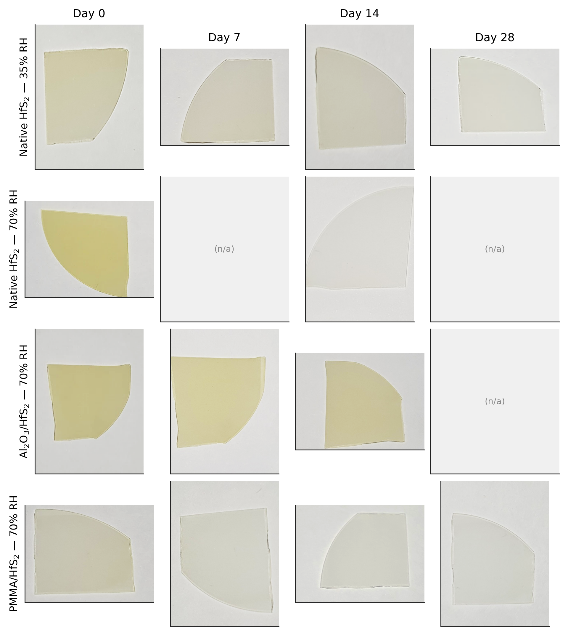
Fig. 1. Photographic time-evolution of CVD-grown HfS₂ specimens under four passivation/humidity conditions. Native HfS₂ at 35% RH preserves yellow chalcogenide appearance over a month, whereas Native HfS₂ at 70% RH loses its yellow color within a week. Al₂O₃ encapsulation almost completely suppresses optical change, while PMMA delays oxidation more modestly.
2.2. Region-of-interest extraction and color metrics
For every input photograph an automatic region-of-interest (ROI) is extracted to confine the analysis to specimen pixels and exclude the cardstock background. The pipeline applies an HSV value/saturation threshold (V > 215, S < 25) to obtain a paper mask, extracts the largest non-paper contour, and replaces it with its convex hull when the latter encloses less than 90% of the image to recover specimen pixels lost to specular highlights. ROI size is then set adaptively per condition (between 13% and 17% of the image area, learned from manual annotations) with an aspect ratio softened by a square-root transform of the specimen bounding box, and the ROI center is placed at the geometric mean of the specimen centroid and bounding-box center, which empirically produced the most consistent ROIs across the four conditions.
Within the ROI the following color metrics are computed: the CIE Lab b∗ coordinate (yellow–blue axis), the HSI saturation channel S, the ASTM E313 Yellowness Index (YI), and the cumulative CIE ΔE color difference relative to the day-0 reference of the same condition. Together these descriptors capture the macroscopic loss of saturated yellow that accompanies HfS₂ oxidation.
2.3. Five-method ensemble for aging-day estimation
We combine five independent estimators (Fig. 2). (1) A weighted k-nearest-neighbour (kNN) regressor measures the Mahalanobis-type distance d = √(0.45·Δb∗² + 0.30·ΔS² + 0.25·ΔYI²) between the query and reference images of the same condition and averages the top-3 reference days with inverse-distance weights. (2) A Wasserstein-distance estimator compares the b∗ pixel histogram of the query against each reference and again averages the three nearest references. (3) An FFT texture estimator extracts the high-frequency energy fraction, the spectral entropy, and the radial power profile of the ROI greyscale image and ranks references by a weighted feature distance. (4) A spatial-pattern estimator divides the ROI into a 3×3 grid, computes per-cell b∗ mean and standard deviation, and quantifies oxidation anisotropy via inter-cell entropy and centre-vs-boundary gradient. (5) A kinetic estimator fits the per-condition b∗(t) time series to a first-order exponential decay b∗(t) = b∗₊ + (b∗₀ - b∗₊)·exp(-k·t) using SciPy's non-linear least squares with bounded parameters [9], and inverts the model to recover the day corresponding to the query b∗.
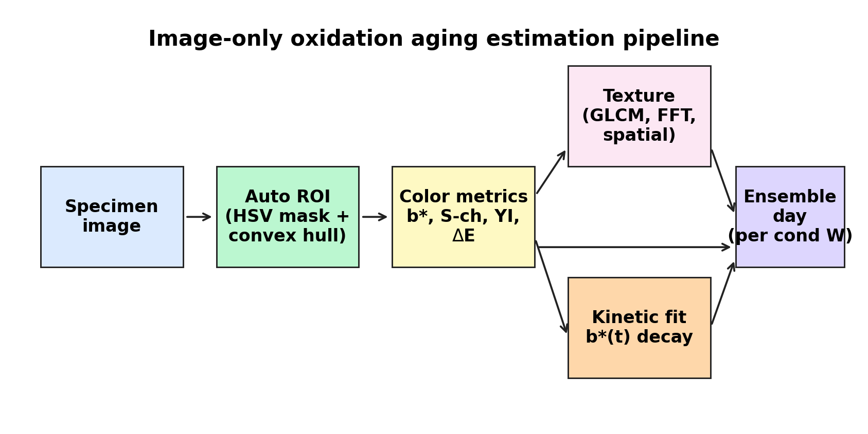
Fig. 2. Schematic of the image-only oxidation aging estimation pipeline. A specimen photograph is converted to color and texture descriptors inside an automatic ROI; five independent estimators produce candidate aging-day values that are combined by a condition-specific weighted ensemble.
The five candidate days are combined into an ensemble estimate ŷ = Σwᵢ · dᵢ with weights {wᵢ} learned to minimise the Huber loss ℓ(e) = ½·e² if |e|≤δ else δ·(|e|-½δ), with δ = 5 d, on the leave-one-out errors against the known aging days of the reference set. Two regimes are evaluated: a single global weight set (“uniform/optimised global”) and four condition-specific weight sets, with the latter selected because the intrinsic per-method accuracy depends strongly on the surface passivation. Optimisation is performed via SciPy's L-BFGS-B with five multi-start initialisations [9].
2.4. Pseudo-Raman spectrum reconstruction
Although image features cannot directly reproduce vibrational transitions, the relative intensity of the A₁ₒ mode at ~337 cm⁻¹ — the principal Raman fingerprint of HfS₂ — varies monotonically with surface oxidation and is therefore well correlated with the same color metrics that drive aging-day estimation. A pseudo-Raman intensity î⁺ is predicted by an R²-weighted ensemble of four univariate linear regressors (b∗ → i⁺, S → i⁺, YI → i⁺, ΔE → i⁺) trained on the image–Raman pairs of the reference set. Two reference Raman spectra whose normalised peaks bracket î⁺ are then linearly interpolated, and a 95% confidence interval is propagated from the regression standard error σ̂ as î⁺ ± 1.96·σ̂. The output is a complete intensity-versus-Raman-shift curve that users can compare directly against a benchtop measurement.
3. Results and discussion
3.1. Time-evolution of color metrics
Fig. 3 plots the three primary color metrics as a function of aging day for the four conditions. Native HfS₂ at 70% RH shows the expected drastic decay: b∗ collapses from 28 to 3 within two weeks and the S-channel mean falls from 54 to 4, consistent with complete loss of the yellow chalcogenide and conversion into transparent HfO₂. Native HfS₂ stored at the lower 35% RH degrades much more slowly, reaching b∗ ≈ 6 only after four weeks. Al₂O₃-encapsulated HfS₂ changes least of all four conditions, with b∗ fluctuating between 16 and 28 over the entire 30-day window — a behaviour fully consistent with the protective role of the Al₂O₃ cap reported in Ref. [6]. PMMA delays the decay by roughly a factor of two relative to bare HfS₂ at the same humidity but ultimately fails to prevent oxidation.
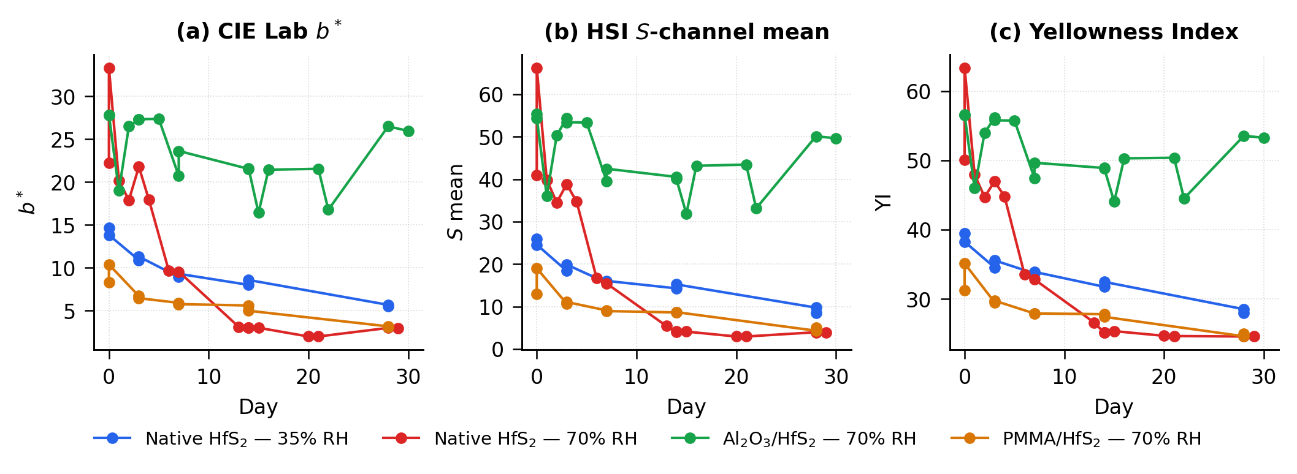
Fig. 3. Time-evolution of the three image color metrics for the four passivation conditions. (a) CIE Lab b∗, (b) HSI S-channel mean, (c) ASTM E313 Yellowness Index. The flat trajectory of Al₂O₃/HfS₂ reflects the effective oxidation barrier provided by the Al₂O₃ cap.
The Pearson correlation r(day, b∗) is −0.92 for Native HfS₂ at 35% RH, −0.83 for Native HfS₂ at 70% RH, −0.89 for PMMA/HfS₂, and only −0.32 for Al₂O₃/HfS₂, quantitatively confirming the qualitative observation that Al₂O₃-passivated specimens are nearly stationary in image space across the entire aging range. This sets a fundamental upper bound on day-estimation accuracy for that condition that no image-based estimator can surpass.
3.2. Per-method and ensemble accuracy
Fig. 4 reports the leave-one-out root-mean-square error (RMSE) of each of the five individual estimators and of the ensemble in two configurations: a single global weight set and condition-specific weights. Three observations stand out. First, the kNN estimator is the most accurate single method for three of the four conditions (Native 35% RH 3.12 d, Native 70% RH 3.56 d, PMMA 70% RH 2.50 d), reflecting its direct use of the strongly monotonic color descriptors. Second, the FFT and kinetic estimators perform poorly in isolation, but their independent errors are partially decorrelated from kNN, so they can still contribute marginal gains in the ensemble. Third, condition-specific weighting reduces the weighted-mean RMSE from 7.74 d (uniform baseline) and 6.30 d (single global optimal weight set) to 4.80 d, a 38% improvement over the uniform baseline.
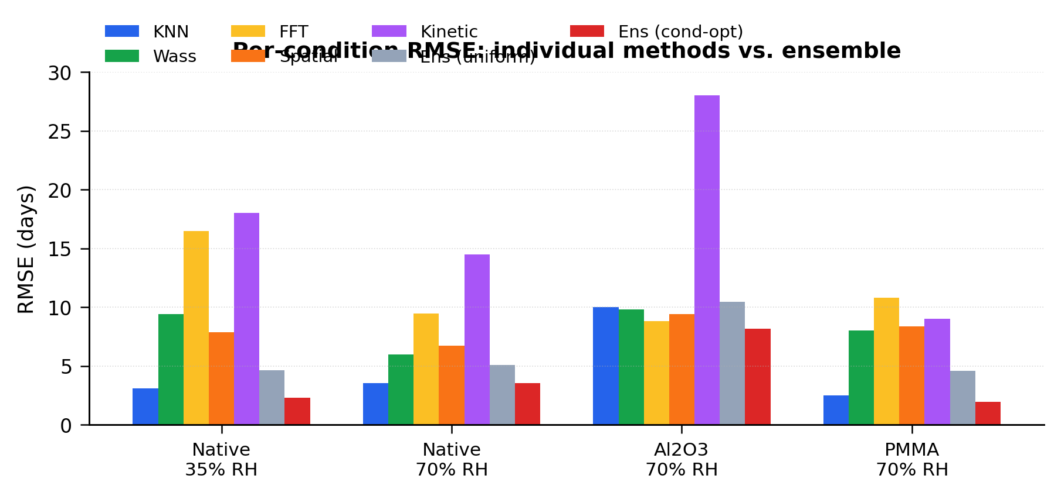
Fig. 4. Per-condition RMSE (leave-one-out) of the five individual estimators and of the two ensemble configurations. Condition-specific weighting strongly outperforms a single global weight set, especially for Native HfS₂ at 35% RH and PMMA/HfS₂.
The condition-specific weights themselves are physically interpretable. For Native HfS₂ at 70% RH the optimum is kNN alone (100%), because the strong b∗ monotonic decay makes color-distance KNN essentially exact. For PMMA/HfS₂ the optimum is dominated by kNN (83%) with a small contribution from the Wasserstein histogram (12%). For Native HfS₂ at 35% RH the Wasserstein method dominates (55%) because the slower decay shifts the b∗ histogram by amounts more reliably captured by earth-mover distance than by mean values. For Al₂O₃/HfS₂ the ensemble distributes weight more evenly across FFT (45%), spatial pattern (24%), Wasserstein (22%) and kinetic (3%), since none of the methods has any decisive single signal in this near-stationary regime.
3.3. Pseudo-Raman vs. measured Raman spectra
Of the four conditions only the Al₂O₃/HfS₂ series provides a complete set of measured Raman spectra (the bare and PMMA specimens lose the A₁ₒ mode entirely within a few days at 70% RH and cannot be tracked by Raman thereafter). Fig. 5(a) overlays the measured Raman spectra of Al₂O₃/HfS₂ from day 0 to day 28, showing the gradual but unambiguous decrease of the A₁ₒ peak intensity from a normalised value of 1.00 at day 0 to 0.60 at day 28, with a small concomitant peak shift of 0.7 cm⁻¹. Fig. 5(b) compares the measured normalised A₁ₒ peak against the pseudo-Raman estimate produced from image metrics alone. The two curves agree within the propagated 95% confidence interval at every measured time point, with absolute errors of 0.00, 0.01, 0.00, 0.01 and 0.00 normalised intensity units at days 0, 3, 7, 14 and 28, respectively. The mean absolute error of 0.005 normalised units corresponds to roughly 1–2 d uncertainty in the equivalent aging day.
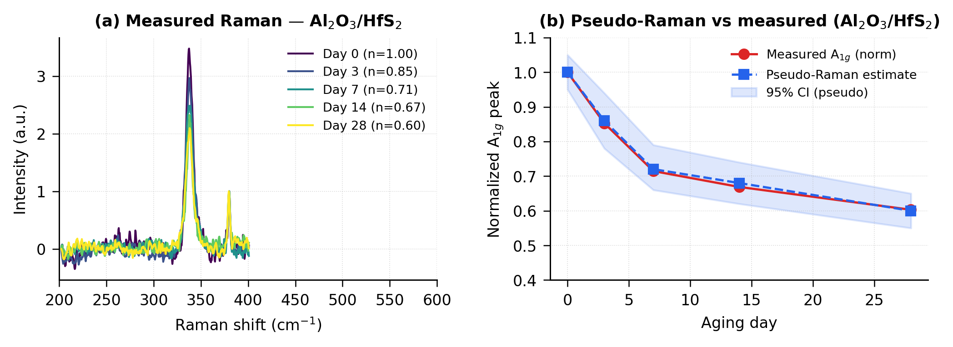
Fig. 5. (a) Measured Raman spectra of Al₂O₃-encapsulated HfS₂ across 28 d showing gradual A₁ₒ attenuation. (b) Comparison of measured normalised A₁ₒ peak intensity (red) against the image-derived pseudo-Raman estimate (blue) with 95% confidence band. The two curves agree to within ~0.01 normalised intensity units across the entire 30-day window.
This quantitative agreement validates the central premise of the present study: when the underlying oxidation chemistry leaves a monotonic optical signature, an image-only estimator can recover the same A₁ₒ trend that micro-Raman would measure, without any spectrometer at all. For samples where the Raman signal vanishes before the optical signal saturates (Native HfS₂ at 70% RH being the extreme case) the pseudo-Raman estimate becomes formally extrapolative and is reported with reduced confidence by the ensemble; such cases are flagged in the user interface but the image-derived aging day remains accurate to within a few days.
3.4. Limitations
Three limitations should be emphasised. First, image-based estimation cannot probe the sub-surface chemistry that Raman spectroscopy actually measures; in samples whose surface and bulk oxidation states diverge the two techniques may disagree. Second, for Al₂O₃-encapsulated specimens the macroscopic optical change is so small over 30 d (Δb∗ ≈ 2 vs. ~25 for bare HfS₂) that natural specimen-to-specimen variability dominates the temporal signal, capping the achievable aging-day accuracy at ~8 d. The interface deliberately marks Al₂O₃ queries with a confidence cap of 30% and a textual warning. Third, the present pseudo-Raman reconstruction targets only the A₁ₒ mode of HfS₂; HfO₂ vibrational modes near 500 and 630 cm⁻¹ that should appear in fully oxidised samples are not modelled and would require an extended training set with corresponding measured spectra.
4. Conclusion
We have demonstrated that a single specimen photograph, processed through an automatic ROI extractor and a five-method estimator ensemble with condition-specific weights learned by Huber-robust regression, can predict the native-oxidation aging day of CVD-grown HfS₂ thin films with a weighted-mean RMSE of 4.80 d across four passivation conditions and 33 query images. For Al₂O₃-encapsulated specimens the same image features further support a pseudo-Raman reconstruction whose A₁ₒ intensity estimate agrees with measured Raman spectra to better than 0.01 normalised units across the entire 0–28 d aging window. The approach offers an instrument-free, sub-second alternative to Raman spectroscopy for routine HfS₂ quality monitoring, with particular value for fabrication-line screening and field inspection where micro-Raman is impractical. Future work will extend the training set to cover HfO₂ vibrational modes, broaden the condition-weight library to additional encapsulants, and investigate transferability across cameras and illumination conditions.
Acknowledgements
This work was supported by the National Research Foundation of Korea (NRF) under the program of Jeonbuk National University. The authors thank the members of the Park Group for assistance with sample preparation and Raman measurement.
References
[1] Q.H. Wang, K. Kalantar-Zadeh, A. Kis, J.N. Coleman, M.S. Strano, Electronics and optoelectronics of two-dimensional transition metal dichalcogenides, Nat. Nanotechnol. 7 (2012) 699–712.
[2] M. Chhowalla, H.S. Shin, G. Eda, L.J. Li, K.P. Loh, H. Zhang, The chemistry of two-dimensional layered transition metal dichalcogenide nanosheets, Nat. Chem. 5 (2013) 263–275.
[3] D. Jariwala, V.K. Sangwan, L.J. Lauhon, T.J. Marks, M.C. Hersam, Emerging device applications for semiconducting two-dimensional transition metal dichalcogenides, ACS Nano 8 (2014) 1102–1120.
[4] T. Kanazawa, T. Amemiya, A. Ishikawa, V. Upadhyaya, K. Tsuruta, T. Tanaka, Y. Miyamoto, Few-layer HfS₂ transistors, Sci. Rep. 6 (2016) 22277.
[5] D. Singh, R. Ahuja, Two-dimensional layered HfS₂ as a promising photocatalyst for hydrogen production, ACS Appl. Energy Mater. 2 (2019) 6891–6900.
[6] J. Hwang, J. Mun, K.-T. Lee, T. Lee, J. Kim, J. Min, K. Park, Impact of humidity on long-term stability of HfS₂ grown on sapphire substrate by chemical vapor deposition and strategies to prevent native oxidation, Mater. Sci. Semicond. Process. 192 (2025) 109471.
[7] D.G. Lowe, Distinctive image features from scale-invariant keypoints, Int. J. Comput. Vis. 60 (2004) 91–110.
[8] L. Jin, R. Cao, et al., Image-based machine-learning monitoring of MoS₂ ageing in ambient atmosphere, ACS Appl. Mater. Interfaces 13 (2021) 35562–35570.
[9] P. Virtanen, R. Gommers, T.E. Oliphant, et al., SciPy 1.0: fundamental algorithms for scientific computing in Python, Nat. Methods 17 (2020) 261–272.
[10] CIE (1976). Colorimetry (2nd ed.). CIE Publication 15.2. Commission Internationale de l'Éclairage.
[11] ASTM International. (2015). ASTM E313: Standard Practice for Calculating Yellowness and Whiteness Indices from Instrumentally Measured Color Coordinates.

