*인턴 교육 과제*

*It is easy to analyze data of json files via JSON Viewer. You can download JsonViewerPackage on Google for free.*

**Assignment 1 - A.**

Job, Result *json file*

Identify and group actual shape(circle, rectangle, etc) corresponding to each shape ID. Identify pad ID corresponding to each shape, and sort volume of each pad corresponding to shape and classify each volume to each shape. Draw histograms using subplots in respect to volume for each shape. Use pandas (Dataframe) to open json files. imageGenerationPCB.py is given for reference.

Example)

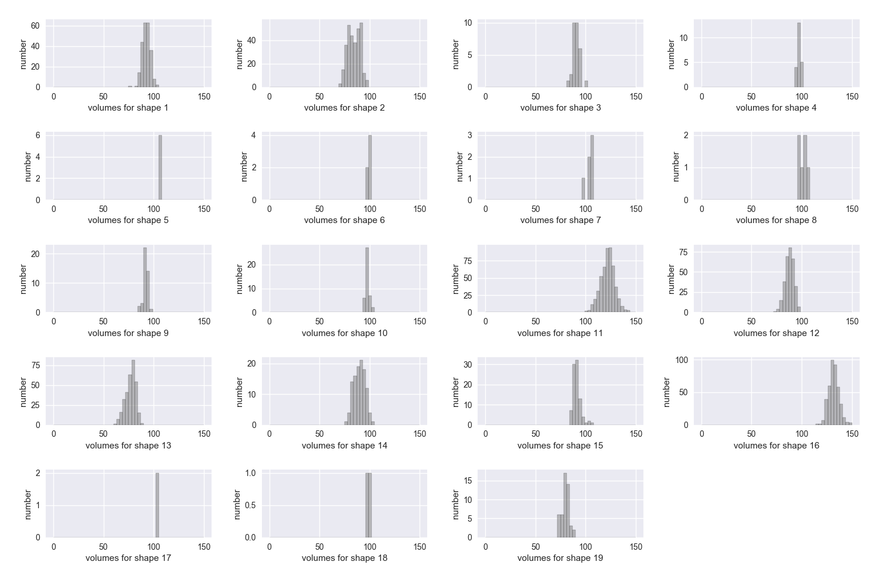

**Assignment 1 – B.**

Job, Result *file 및 folder*

Draw result subplot histogram corresponding to each pad’s volume, height, and area. Shape IDs can be neglected.

Example)

