iBrain

A multistructural feature neurodegenerative toolbox

Reference Manual for iBrain

June 2023

Beijing University of Posts And Telecommunications

# 1.Overview

iBrain toolbox is designed for multi-scale structural feature extraction and report generation for neurodegenerative diseases. The toolbox provide simplified GUI and batch script which support subject level brain report from original DICOM or NIFTI T1 image. iBrain is written by MATLAB and Python scripts which can be successfully on Window and Linux operation system.

Thank you for using iBrain. When using this package in your publicized work, **PLEASE CITE:**

XXX

Developed by Kun Zhao, Yihe Zhang, Hangmin Chi and Yong Liu

Beijing University of Posts and Telecommunications, China

Contact information:

Kun Zhao: [kunzhao@bupt.edu.cn](mailto:kunzhao@bupt.edu.cno)

Yihe Zhang: [yihe.zhang@bupt.edu.cn](mailto:yihe.zhang@bupt.edu.cn)

Hangmin Chi: [15840023205@163.com](mailto:15840023205@163.com)

Yong Liu: [yong.liu@bupt.edu.cn](mailto:yong.liu@bupt.edu.cn)

Copyright © 2017 Dr. Yong Liu’s Lab, Beijing University of Posts And Telecommunications, Beijing, China.

# 2.Prerequests

Getting started to run iBrain on your computer:

• MATLAB: A high-level numerical mathematics environment developed by MathWorks, Inc. Natick, MA, USA. iBrain requires MATLAB 2020a or later version.

• DCM2NIIX: DCM2NIIX is a utility tool included in MRICronGL, which is a software package used for converting DICOM (Digital Imaging and Communications in Medicine) image files to NIfTI (Neuroimaging Informatics Technology Initiative) format.

• NIFTI The NIFTI toolbox allows users to read, write, and manipulate NIfTI files in MATLAB. It provides functions for loading NIfTI images into MATLAB variables, accessing image metadata (such as dimensions, voxel sizes, and data type), and performing various operations on the image data, such as resampling, slicing, and statistical analyses.

• SPM12: SPM is freely available to the (neuro) imaging community andrepresents the implementation of the theoretical concepts of Statistical Parametric Mapping in a complete analysis package. Given that the names of certain functions in SPM12 are the same as those in iBrain or MATLAB, we recommend that you add only the path of the home folder of SPM12 when you use iBrain.

• CAT12: A comprehensive MATLAB toolbox specifically designed for the analysis and processing of structural brain MRI data. It provides a range of advanced tools and functions to facilitate voxel-based morphometry (VBM) and other morphometric analyses.

• Brant: A MATLAB toolbox designed for the analysis and processing of neuroimaging data. It offers a comprehensive set of tools and functions to facilitate various types of analyses and investigations related to brain connectivity and network properties.

• lib-SVM: A powerful MATLAB toolbox designed for support vector machine (SVM) classification and regression tasks

• Python: A high-level programming language known for its simplicity and readability. It is widely used in various domains, including web development, data analysis, artificial intelligence, scientific computing, and automation. iBrain also request python toolbox such as numpy, scipy, nibabel, pandas, matplotlib, antspy, argparse, nilearn, docx and docxtpl.

# 3.Installation

Since the toolbox is running on the basis of both Python and MATLAB, we recommend you to install anaconda with python 3.6+ version. You can download and install Anaconda from the its official website: <https://www.anaconda.com/>

After successfully download anaconda, you need to set environment path for anaconda and python. As for windows users, you need to add following path to your system path:

Anaconda Install Path\Scripts\

Anaconda Install Path\Library\bin

Anaconda Install Path\Library\mingw-64\bin

Run MATLAB. You can add the iBrain path to the MATLAB search path in one of two ways:

Command-line or Interface.

• Command-line

Type the following command in the MATLAB command window.

>>addpath(genpath(‘D:\...\iBrain’));

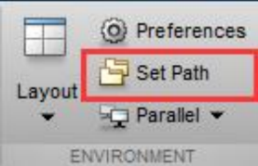where ‘D:\...\iBrain’ is the path of iBrain on your computer.

• Interface

Click ‘Set Path’ on the MATLAB panel, or type ‘pathtool’ in the

MATLAB command window.

Click ‘Add with Subfolders...’ button, and select your iBrain path, i.e. ‘D:\...\iBrain.

Click ‘Save’ to save your change. If you do not have permission to save your changes on your

computer (e.g., on the server), please save pathdef.m to another location where you will often launch MATLAB.

After setting iBrain to path, you need to run set_up.m to python dependenices.

Of Note：To install antspy in windows, you need to download compete version of .whl file from following website: <https://github.com/ANTsX/ANTsPy/actions/runs/4524955037>. Or using .whl file which only support python 3.8/3.9 in iBrain root folder.

Warning: Please make sure your iBrain path DOES NOT include blank or special character!

# 4.Running iBrain

**GUI-Running**

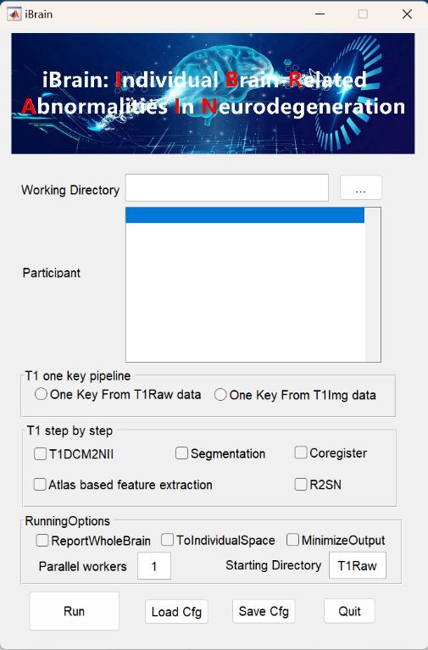

1. Working Directory is the root directory for all input files，all subject original data should be arranged within one folder named T1Raw or T1Img. For instance, you got a root folder named test_data, all subject data should be arrange as follows：test_data/T1Raw/subj1/*.dcm, test_data/T1Raw/subj2/*.dcm, ...

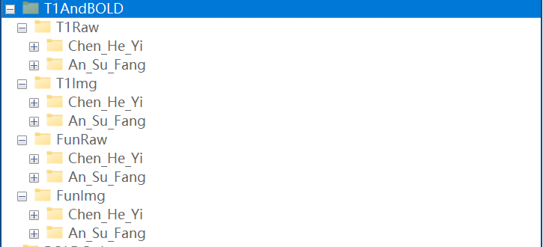

1. Considering the long time cost for full processing pipeline, iBrain provide step by step result folder generation which can be qualified by dis-select MinimizeOutput option. By selecting step by step result generation, you can run from middle steps by specifying Starting Directory. We provide different starting directory name for each processing step：

T1Raw: Original T1 dicom data storage directory；

T1Img: 3D NIFTI data storage directory；

T1ImgS:3D NIFTI data segmented by CAT12 result storage directory；

T1ImgC:3D NIFTI data Normalize to standard MNI 152 c2009 1mm space result storage directory；

T1ImgCA:BN246 atlas based feature extraction result storage directory；

Of Note：Regardless of the parameters set, you need to press Enter at the starting directory to confirm the path before clicking the Run button, in order to generate a participant list in the participant column. Additionally, after setting the initial directory, please ensure that the subsequent process directory, which is not the initial directory, is empty to ensure smooth execution. After generating the participant list, if you need to delete a specific participant, you can left-click on the participant and press the delete key.

1. This toolbox also provides a minimal output mode, can be activated by selecting MinimizeOutput option. In this mode, intermediate structural data will only be generated in the T1Img directory and will be removed after running.
2. This toolkit provides two modes: "One-Click Run" and "Step-by-Step Run". In the "One-Click Run" mode, you can choose to start from either raw DICOM data or NIFTI files. Once selected, the step-by-step process cannot be changed. If you need to switch to the "Step-by-Step Run" mode after making a selection, you need to click on the "Step-by-Step" text to activate the step-by-step operation interface. Once activated, the "One-Click Pipeline" will be disabled. Similarly, you can click on the "One-Click Pipeline" text to activate the "One-Click Run" selection.
3. This toolkit provides a parallel computing mode based on the MATLAB pool, and you can change the number of parallel workers by modifying the text in the "Parallel workers" section.
4. This toolkit offers the functionality to store and load configuration files for interface parameter selection. After finalizing the configuration, you can click the "Save Cfg" button to save the current settings, and you can load previous settings by clicking the "Load Cfg" button.

Note: After each click of the "Run" button, the current configuration will be automatically saved to the working directory based on the system time.

1. Once all the configurations are confirmed, clicking the "Run" button will display the current progress in the MATLAB command window. The "Run" button will turn red and remain so until the computation is complete, at which point it will revert to its original gray color.

**Batch Script**

In addition, this software package provides configuration files for non-interface users, with the code located in the "noGUI" folder. Among them, "iBrain_Run_T1_from_T1Raw_Cfg" and "iBrain_Run_T1_from_T1Img_Cfg" provide settings for computing only T1 data.