# SoaML元模型

### 目标模型简介

面向服务架构（Service Oriented Architecture ，SOA）是一个组件模型，它将应用程序的不同功能单元（称为服务）进行拆分，并通过这些服务之间定义良好的接口和协议联系起来。接口是采用中立的方式进行定义的，独立于实现服务的硬件平台、操作系统和编程语言。这使得构建在各种各样的系统中的服务可以以一种统一和通用的方式进行交互。，通过连接网络中能完成特定服务的独立功能实体来实现软件系统架构。通过对业务层和技术层之间的信息有效地进行沟通，让业务层和技术层相互独立起来，使得系统变得更加灵活，从而更能适应具体业务中的变化。通过服务层的独立实现，IT系统可以在不影响原有系统功能使用的同时，增加新的模块功能来满足系统发展的需要。同时，服务层也可以调用远程服务，来实现本系统的功能需求，实现了跨系统的信息共享。通过建立SOA，可以将内部IT基础设施提高到一个更高、可见性更好且可管理的级别。通过可重用服务和高级流程，能以比以往任何时候都方便的方式进行更改，而且更像是分解部件(服务)并将其重新组合为新的与业务一致的流程。这不仅提高了效率和重用，而且还提供了极强的更改和保持IT与业务一致的能力。因为更改是不可避免的，业务连续性的唯一保证就是预计变更并加以适应，这对于任何企业的来说都至关重要的。

◆服务是对构件的抽象，将对构件的复用转换为对服务的调用

◆可以根据需求通过网络对松散耦合的粗粒度应用构件进行分布式部署、组合和使用。

◆服务之间通过简单、精确定义接口进行通讯，不涉及底层编程接口和通讯模型。

◆SOA可以看作是B/S模型、XML/Web Service技术之后的自然延伸。

### 目标模型元模型

SoaML：提供了一种使用统一建模语言构建和建模 SOA 解决方案的标准方法

目标模型元模型

SoaML 元模型扩展了 UML2 元模型以支持分布式环境中的显式服务建模。 此扩展旨在支持不同的服务建模场景，例如单一服务描述、面向服务的架构建模或服务契约定义。

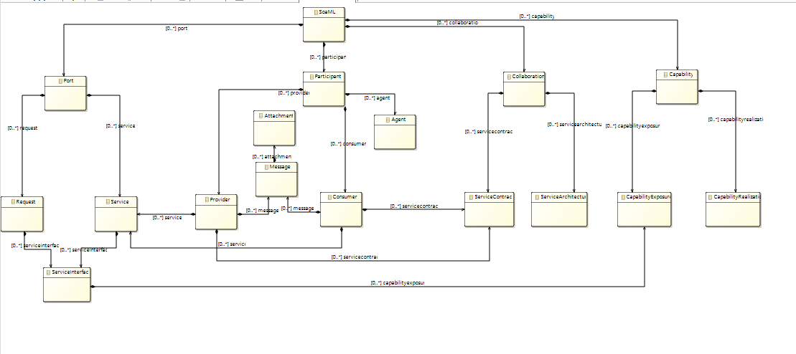

SoaML主要由port,participant,capability,collaboration四部分组成，参考了OMG文档，《SOA概念，技术与设计》，Dubbo分布式服务框架，Soa的核心是service抽象出的业务服务，provider服务提供者，暴露系统提供的服务，consumer服务消费者，调用服务。

Participant：A participant is the type of a provider and/or consumer of services. In the business domain a participant may be a person, organization, or system. In the systems domain a participant may be a system, application, or component.

Agent：An Agent is a classification of autonomous entities that can adapt to and interact with their environment.

Provider: A provider is then used as the type of a role in a service contract and the type of a port on a participant.

Consumer:A consumer is then used as the type of a role in a service contract and the type of a port on a participant.

Port: indicate whether a Connection is required on this Port or not.

Service:A Service designates a Port that defines the connection point through which a Participant offers its capabilities and provides a service to clients.

Request:A Request designates ports that define the connection point through which a Participant meets its needs through the consumption of services provided by others.

Capability:A Capability is the ability to act and produce an outcome that achieves a result. It can specify a general capability of a participant as well as the specific ability to provide a service.

CapabilityExposure: provides the ability to indicate what Capabilities that are required by or are provided by a

participant should be exposed through a Service Interface.

CapabilityRealization:provides the ability to indicate what capabilityies that are realizated by a participant.

Collaboration:A Collaboration is a description of a pattern of interaction between roles responsible for providing operations whose use can be described by ownedBehaviors of the Collaboration.

ServiceContract:A ServiceContract is the formalization of a binding exchange of information, goods, or obligations between parties defining a service.

ServiceArchitecture:The high-level view of a Service Oriented Architecture that defines how a set of participants works together, forming a community, for some purpose by providing and using services.

### 元模型和图形建模

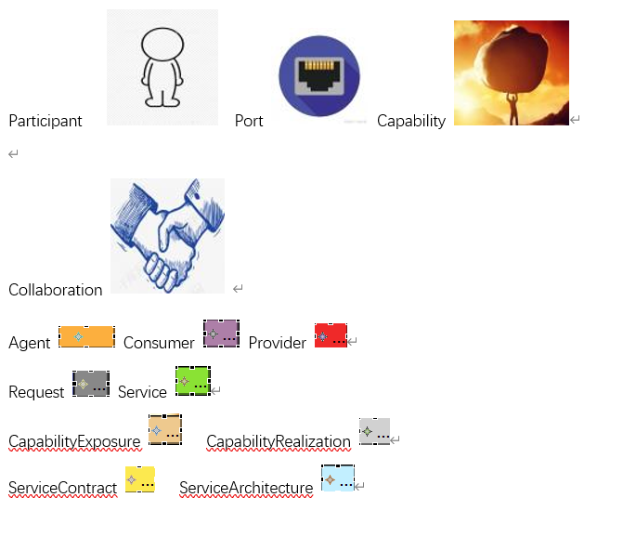

### 模型转换

#### 输入端元模型

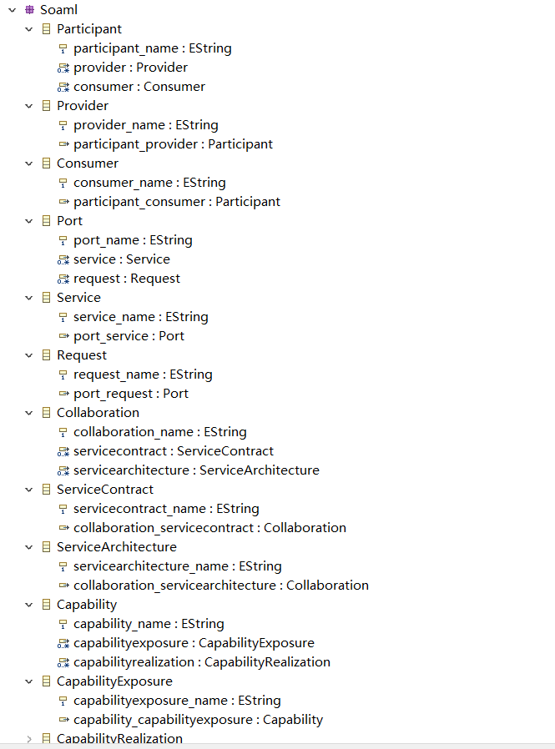

#### 输入端模型

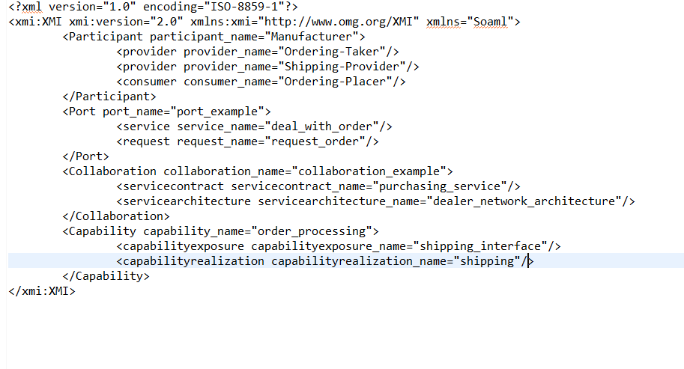

输出端元模型

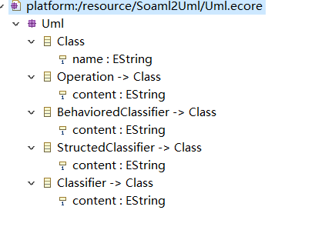

输出端模型

