NHL ELT Pipeline and Stats Dashboard

Detailed Design Document
Created by: Team Dirty Data Cleaners (Oh Yong Xiang, Justin Pek, Muhammad Syafiq)
Summary: 2
Problem Statement 2
Tech Stack: 2
Data Exploration: 3
Objective: 3
Architecture 11
Medallion Architecture: 11
Data Modelling: 11
Silver layer: Galaxy Schema 11
Gold layer: Wide Fact Tables 11
Artifacts 12
Bronze Layer 12
Silver Layer 12
Gold Layer 13
Data Pipeline 14
Pipeline Monitoring: 14
Log files: 14
Data Quality Check: 15
Why data quality checks: 15
Checks used: 15
Checks to be added as enhancement: 15
Why great expectations 15
Visualization: 16
Overall goalie dashboard 16
Overall skater dashboard 16
Insights derived 17

Summary:
This project aims to design a data pipeline for the data coming from National Hockey League. Raw data to flow through the data pipeline which validate the data quality. After which the output data then is used to build a dashboard for player statistics and analysis. Also stretch goal to include incremental load function.

Problem Statement
Create an ELT Data pipeline that:
- Ingests the CSV sources files from the NHL Kaggle dataset
- Adhere to a Medallion Architecture design
- Transforms, checks and loads the data into a data model for Silver Layer
- Aggregates, checks and loads the Silver Layer data into a data model for Gold Layer
- Uses orchestrated DAGs to run the dependencies
Visualizations should showcase:
- Normalized statistics (per 60 min TimeOnIce) for the players in the NHL data set.
- Trending of the normalized statistics.
- Filter capabilities for Season, Player Position, Team, Type of Game and more.

Tech Stack:
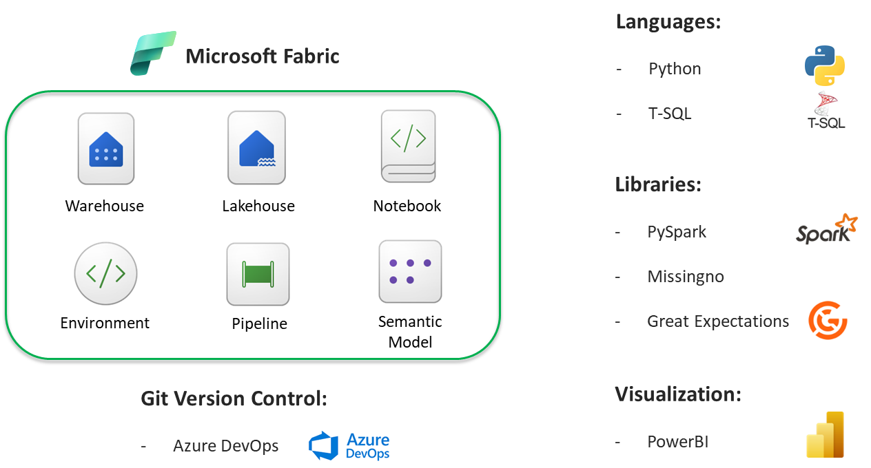

Data Exploration:

Objective:
- Understand the tables we are going to use in our ELT pipeline
- Rationalize the cleaning steps required for each table
- Propose some initial hypotheses for visualization
Identified 9 tables to focus on for the ELT pipeline:

game_skater_stats:
Notebook: data_cleaning_yx

There are 4 columns with null values in this table. The treatment for each of these field's null values are shown below and justified in the following subsections.

- For all 4 columns ('hits', 'takeaways', 'giveaways', 'blocked'), the null values are associated with the same game_ids
- This indicates that there was probably a failure to record values for these 4 statistics during particular games.
- Due to the percentage of null values (> 40%) - it would be unwise to replace these null values with mean/ median values
- There is also no method to calculate an approximation of these values.
- Since there are sufficient non-null data points for meaningful analysis, decision was made to keep the data as-is in the silver layer
- aggregations in the gold layer may choose to use the non-null values as approximation of the actual statistics.

game_goalie_stats:
Notebook: data_cleaning_yx
There are 4 columns with null values in this table. The treatment for each of these field's null values are shown below and justified in the following subsections.
decision:
- contains W, L or None.
- ~7% None values
- No clear pattern of how these None values arrived and we cannot confirm the origin from the source.
- We will most likely not be using this field for analysis
Conclusion: leave the None values as-is in Silver Layer
savePercentage:
- contains float values and NaN
- < 1% NaN values
- NaN values result from no shots taken against the goalie
- We may use this field for analysis
Conclusion: leave the NaN values as-is in Silver Layer as these are valid NaN values and not errors.
powerPlaySavePercentage:
- contains float values and NaN
- ~8% NaN values
- NaN values result from no power play shots taken against the goalie
- We may use this field for analysis
Conclusion: leave the NaN values as-is in Silver Layer as these are valid NaN values and not errors.
evenStrengthSavePercentage:
- contains float values and NaN
- < 1% NaN values
- NaN values result from no even strength shots taken against the goalie
- We may use this field for analysis
Conclusion: leave the NaN values as-is in Silver Layer as these are valid NaN values and not errors.

team_info:
data is generally clean and can be loaded into silver layer as-is.

game_plays
There are 8 columns with null values in this table. The treatment for each of these field's null values are shown below and justified in the following subsections.

x, y, st_x and st_y:
- Contains x and y coordinates for where the shot was taken
- ~20% NaN values
- Missing values can be explained by:
- Events that cause missing `team_id_for` and `team_id_against` result in some missing `x, y, st_x, st_y` values:
  - 'Game Scheduled'
  - 'Period Ready'
  - 'Period Start'
  - 'Stoppage'
  - 'Period End'
  - 'Period Official'
  - 'Game End'
  - 'Shootout Complete'
  - 'Early Intermission Start'
  - 'Early Intermission End'
  - 'Game Official'
  - 'Emergency Goaltender'

Missing coordinate values for these events make sense because no shots are expected during these events

- Timestamps (`dateTime` field) for which `periodTimeRemaining` is missing also have missing `x, y, st_x, st_y` values:
  - From 2000-10-05 00:00:00 to 2010-04-12 01:00:00
  - Missing coordinate values for these timestamps may be due to system outages or they may have not started to track these statistics as:
    - Events associated with missing `periodTimeStamps` are shooting-related and expected to have coordinates
    - The same events outside these timestamps have coordinate values
- 6388 unique timestamps between 2010-10-08 03:25:19 and 2020-09-22 03:34:02 have missing `x, y, st_x, st_y` values:
  - Missing coordinates may be due to system outages as:
    - No events associated with these timestamps fully explain the missing coordinates
    - Timestamps outside these periods (after removing nulls caused by missing team IDs and missing periodTimeRemaining) do not have missing coordinates
Conclusion:
- Missing coordinate data explained by events without `team_id_for` and `team_id_against` are valid nulls because these events do not require shot coordinates
- Missing coordinate data during the 2000-2010 period and the 6388 timestamps between 2010-2020 are not random

Decision:
- Track these values in the silver-layer as-is
  - Shot coordinates are difficult to infer or replicate, so we should not estimate them; doing so may skew analyses
  - Aggregations should only be performed on available data
- Optionally, include labels explaining why data is missing for traceability
team_id_for and team_id_against:
- Contains floats for the `team_id`s involved in the game play
- `team_id_for` → decision ruled in favor
- `team_id_against` → decision ruled against
- < 20% NaN values
- Missing values can be explained by:
  - Events that cause missing `team_id_for` and `team_id_against`:
  - 'Game Scheduled'
  - 'Period Ready'
  - 'Period Start'
  - 'Stoppage'
  - 'Period End'
  - 'Period Official'
  - 'Game End'
  - 'Shootout Complete'
  - 'Early Intermission Start'
  - 'Early Intermission End'
  - 'Game Official'
  - 'Emergency Goaltender'
Missing `team_id`s for these events make sense because these events do not necessarily rule in favor/against a particular team
- 'Official Challenge' event type has seemingly random nulls for the team IDs:
  - These nulls cannot be explained without domain knowledge
Conclusion:
- Missing `team_id_for` and `team_id_against` can be fully explained by their associated events (except 'Official Challenge') and are valid nulls
- For 'Official Challenge', we cannot be certain that the nulls are valid without domain knowledge
Decision:
- Track these values in the silver-layer as-is
- In the absence of domain knowledge, take the conservative approach of treating the nulls as valid
- Optionally, include labels explaining why data is missing for traceability

periodTimeRemaining:
- Contains string values and NaN
- <5% NaN values
- Missing values can be explained by:
- Timestamps (`dateTime` field) for which `periodTimeRemaining` is missing:
  - From 2000-10-05 00:00:00 to 2010-04-12 01:00:00
  - Missing values may be due to a system outage or they have not started tracking these statistics:
    - No events can fully explain the missing `periodTimeRemaining`
    - Timestamps with valid `periodTimeRemaining` do not overlap with the identified outage timestamps
    - The same events outside the identified timestamps have valid periodTimeRemaining values
Conclusion:
- Missing `periodTimeRemaining` values during 2000-2010 are not random
Decision:
- Track these values in the silver-layer as-is
  - `periodTimeRemaining` is an in-game generated fact that cannot be easily replicated
- Optionally, include labels explaining why data is missing for traceability

secondaryType:
- Contains string values and `None`
- ~75% None values
- Missing values exist for multiple event types except Goal, Shot, and Penalty events
- Only Penalty events definitely have values for `secondaryType`
- Goal and Shot events have no clear pattern for why `secondaryType` values exist for some records and not others
- All other event types do not have `secondaryType` values:
  - Likely an optional column that the system inputs for events
  - Not possible to determine without domain knowledge
Conclusion:
- Missing `secondaryType` values for all events other than Goal, Shot, and Penalty are valid nulls
- Missing `secondaryType` values for Goal and Shot events are random
- `secondaryType` values for Penalty events are compulsory
Decision:
- Track these values in the silver-layer as-is
- Optionally, include a check for `secondaryType` when the event is Penalty
- Optionally, include labels explaining why data is missing for traceability

game_play_players:
- Notebook: Game_play_player_clean_check
- Contains links the game play event to the players involved. Esp useful when gameplay has multiple players involved.
- Duplicate values of 1223800 of the entire row
- No nulls observed
- For primary key, composite key of the combination of game_id and player_id can be used. There is only 3 duplicate values of resulting composite key which can be further enhanced by adding a running number behind to make it unique.
Decision:
- 1223800 duplicated values of the entire row to be removed

game:
- Notebook: games_justin_explore
- Contain game dimension data, using game_id as the primary key
- Missing the entire 20042005 season which is supposed to be since the entire 20042005 is cancelled
- 1196 (=4.5%) nulls in column home_rink_side_start which has otherwise category values of left, right
- Analysis shows its missing at random
- Does not affect our analysis as its not important variable
- 2570 duplicate values of the entire row
Decision:
- Decision to leave the null as it is as we cannot input it
- 2570 duplicated values of the entire row to be removed

game_teams_stat:
- Notebook: game_teams_stats_key
- Contains no nulls and exact duplicates of 5140 rows
- 5140 rows are exact duplicate rows
- Identified that there were no nulls within the columns
- One row = one team’s stats in one game
- Each game has two teams (Home and Away) = two rows per game
Decision: Table is not used for our project, leave it as is in the silver layer.
- Each record is uniquely identified by game_id, team_id with 0 duplicate records after dropping duplicates.
- Dataset is not used for the silver layer.

game_shifts:
- Notebook: game_shift_keys
- Contains string value and Nulls
- Each row represents one player shift
- A shift records:
  - When the player entered the ice (shift_start)
  - When the player left the ice (shift_end)
  - The period of play (period)
- These records form the foundation for:
  - Time-on-ice calculations
  - Player workload analysis
  - Shift-based performance metrics

Nulls are only present in the shift_end column which can be explained by:
- The shift begins but the player’s exit was not captured
- The period/game ends before the shift are completed
- The raw feed truncates the final record shift

player_info:
- Notebook: player_info_keys
- Contains nulls with no exact row duplicates
- Identified 1162 nulls spread across the columns
  - 8 players missing nationality
  - 5 players missing birth city
  - 1123 players missing in the birthStateProvince
  - 3 players missing height, height_cm and weight
  - 17 players missing in the shootCatches column
- No exact duplicate rows.
Decision: player_id can be used as the Primary key for this table.

Architecture

Medallion Architecture:
Allows segregation of the different process into parts so that errors in one process will not affect the other.

Data Modelling:

Silver layer: Galaxy Schema
Galaxy Schema chosen to mimic the source data as closely as possible to avoid ingestion issues. Source schema follows the grain (per game per player) desired for silver layer as well.
- Fact Tables:
  - game_skater_stats
  - game_goalie_stats
  - game_plays
  - game_teams_stats
  - game_shifts
- Dimension Tables:
  - Game
    - Primary key: game_id
  - player_info
    - Primary key: player_id
  - team_info
    - Primary key: team_id
- Bridge Tables:
  - game_plays_players

Gold layer: Wide Fact Tables
Wide Fact Table Schema chosen for ease of querying for the consumer.
- Fact Tables:
  - fact_skater_stats_per_60
  - fact_goalie_stats_per_60

Artifacts

Bronze Layer
- Purpose:
Serve as landing area for incoming NHL csv files and logs for transformations and checks performed on the bronze files prior to loading into Silver Lakehouse
- Fabric Items:
  - nhl_bronze_lh (lakehouse)
    - historical (folder)
      - landing – for any new CSVs marked for historical load
      - processed – for all processed CSVs without any issues
      - quarantine – for all processed CSVs with issues
    - silver_logs
      - contains the logs for the steps performed on the CSV data prior to loading into Silver layer

Silver Layer
- Purpose:
Contains the notebooks required to transform the bronze CSVs into the schema identified for Silver Tables in the silver lakehouse.
Contains the data quality checks required for silver tables
Contains the silver lakehouse that stores the cleaned silver table
- Fabric Items:
  - nhl_silver_lh (lakehouse)
    - each run of the pipeline will create a new schema within the lakehouse tables
    - silver tables created as part of the pipeline run will be stored in the schema
    - gold_logs
      - contains the logs for the steps performed on the silver tables prior to loading into gold layer
  - silver_transformation (pyspark notebook)
    - general notebook for transformation steps of each bronze CSV file
    - deduplicates the rows
    - ensures headers for each CSV are expected
    - ensures data types for each column from the CSV read is expected
    - writes the cleaned dataframe to the staging schema
  - silver_cross_check_load (pyspark notebook)
    - general notebook for primary key checks and referential integrity checks of the staging tables prior to loading into silver
    - ensures that fact and dimension table relationships are verified
    - ensures that identified indexes for the dimension tables are unique
    - quarantines the rows that do not pass the checks in a quarantine table in the staging schema
    - removes the quarantine rows from the working dataframe
    - loads the cleaned working dataframe into the silver lakehouse’s silver tables
    - checks if data is loaded into the silver tables

Gold Layer
- Purpose:
Contains the notebooks required to transform the silver tables into data model for gold tables in the gold warehouse
Contains the data quality checks required for gold tables
Contains the gold warehouse that stores the cleaned gold tables
- Fabric Items:
  - nhl_gold_wh (warehouse)
    - each run of the pipeline will refresh the gold tables in the warehouse
  - gold_aggregate_check_stage (pyspark notebook)
    - general notebook for transformation steps of each silver table
    - joins the required tables to create the gold data model
    - calculates the normalized statistics for the gold tables
    - performs data quality checks on the cleaned dataframe
    - writes the cleaned dataframe to gold schema
  - check_load_wh (pyspark notebook)
    - checks if data is loaded into the gold schema

Data Pipeline
- Purpose:
  - To orchestrate the steps required from bronze to gold layer
- Fabric Items:
  - nhl_pipeline_2 (Fabric Data Factory Pipeline)
    - Activities:
      - check_for_files (Get Metadata)
      - filter_by_file_name (Filter)
      - silver_transform (ForEach)
        - silver_transformation (Notebook)
        - store_staging_schemas (Append Variable)
      - silver_cross_check_load (Notebook)

Pipeline Monitoring:

Log files:
- Summarizes if steps in the pipeline executed successfully
- In the event of an outage/ exception, stores the steps that the data has undergone for troubleshooting

Data Quality Check:
- Player metrics used: Goals_per_60, Shots_per_60
- Context: season 20152016 - 20192020

Why data quality checks:
- Build trust with stakeholders by detecting data issues before them
- Saves compute by stopping downstream processes instead of rerunning the entire pipeline
- Serves to separate the good and bad data and filter off data issues before the next process
- Segregation of the processes in the transformation for easy trouble shooting

Checks used:
Silver layer: Check function custom function in pyspark notebook
- Function to return the table name present as well as the count of the table
- Check positive across aggregate
- Referential integrity check to see if foreign key exists
- Index check for primary key

Gold layer: Great expectations function in pyspark notebook
- ExpectColumnValuesToBeBetween- Check for reasonable range of numerical values
- ExpectTableColumnCountToEqual- Check for categorical values

Checks to be added as enhancement:

- ExpectColumnValuesToNotBeNull – check for important numerical values
- ExpectColumnValuesToBeUnique – check for primary key values
- ExpectColumnValuesToMatchRegex – to check for datetime columns

Why great expectations
- its ability to define, document, and validate data expectations in a human-readable and executable manner
- helps in catching data quality issues before they lead to model failures or incorrect data in production. The library's use of expectation suites and checkpoints allows for comprehensive validation of data, ensuring that only valid data proceeds

Visualization:

Overall goalie dashboard
- Calculates averaged normalized stats per 60min for each filter selected
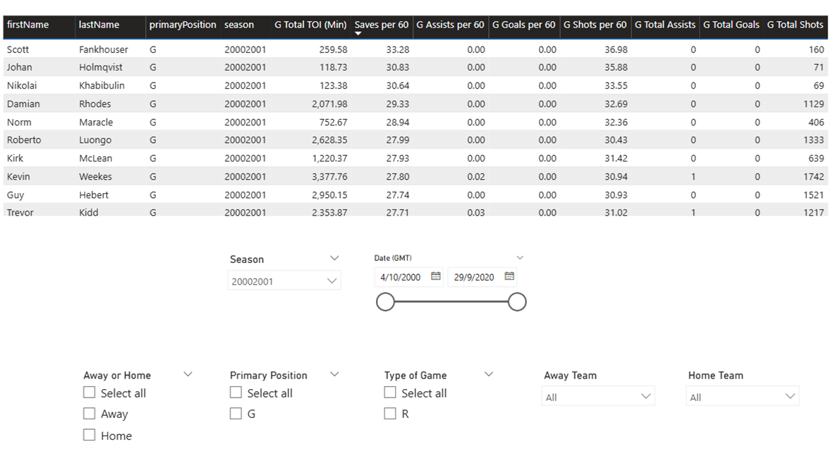

Overall skater dashboard
- Calculates averaged normalized stats per 60min for each filter selected
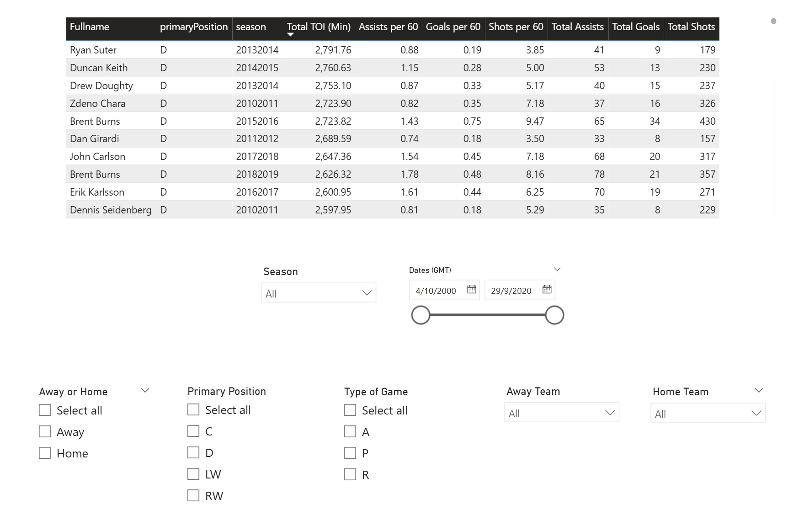

Insights derived
Total shot versus totals goals: how does top players fare?
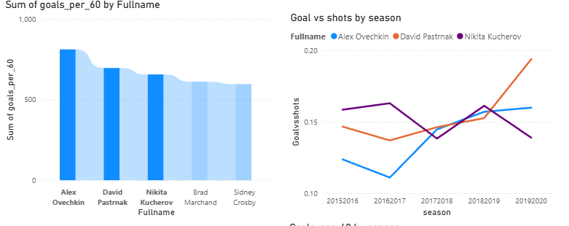
Top Player performance based on goals per 60
Top scorer: Alex Overchkin
Most efficient player: David Pastrnak
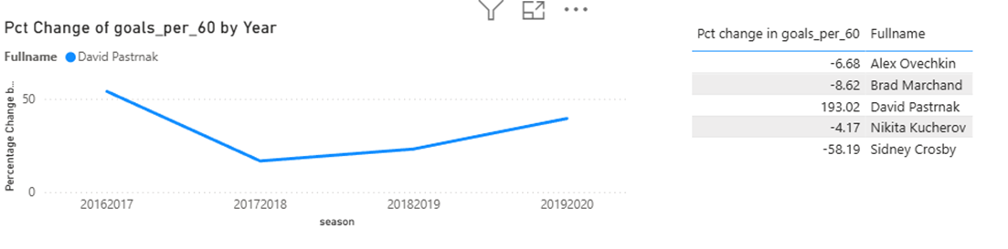•Most improved player from 2015-2020 based on the percentage change of goals_per_60 : David Pastrnak
Left visual shows the year on year change in terms of percentage from 2015-2020
Right visual shows the total percentage change from base number in 2015 to 2020

