AI Chip Center for Emerging Smart Systems

Project: CoDesign
Micro-Architecture Document: XXXX
Version 0.1
Abstract:
This document provides detailed descriptions of function spec, micro-architecture, interface signals, config register and protocols of the xxxx module in CoDesign ASIC project.

Confidential

Revision History

Version | Date | Author(s) | Description
0.1 | July.07, 2022 | xxxx | Initial draft

Contents
Revision History 2
1. Overview 4
1.1 Function List 4
1.2 Acronyms 5
2. I/O Signal List 6
3. Timing Diagram and Configuration Register 8
3.1 BUF_MGR timing diagram 8
3.2 GPIF timing diagram 8
3.3 Configuration Registers 9
3.3.1 Register Definition 9
3.3.2 Register Description 10
4. Module Micro-architecture 12
4.1 GPIF2MMGR (Rx Port) 12
4.2 MMGR2GPIF (Tx Port) 13
4.3 XXXX 13

1. Overview

The Function of IB module is to control the transition between DDR MMGR/BUF_MGR interface and GPIF interface. GPIF interface is a FIFO interface for data transaction. The IB module’s block diagram and connection with other modules is shown in Figure 1-1.

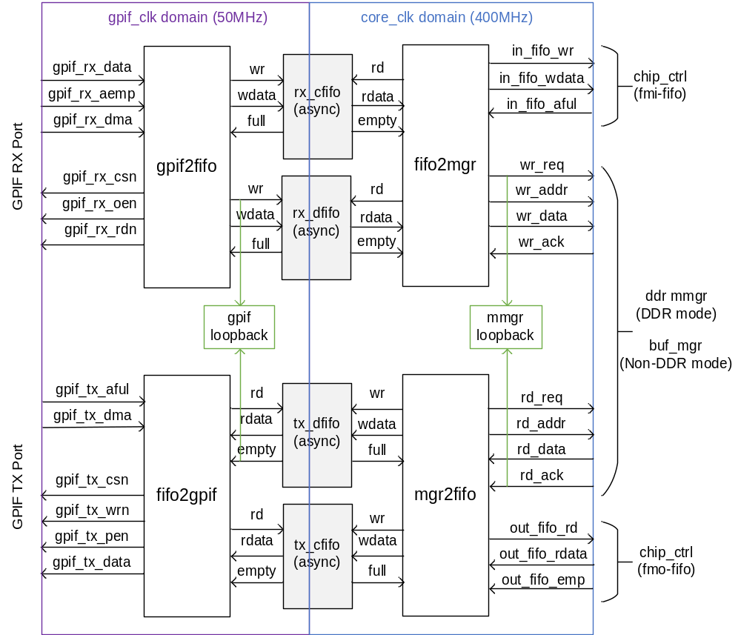
Figure 1-1. IB block Diagram

1.1 Function List

- IO port physical feature
  - IO port typical frequency 50Mhz, up to 100MHz;
  - One set of GPIF input port;
  - One set of GPIF output port;
- Block size and bandwidth
  - Support configurable data block size (FX3 firmware may require the packet size should be multiples of 1KB, range 1~6172 KB);
  - Support bandwidth up to 150MB/s with maximum block size;
- Data Transform
  - Support MMGR port to GPIF port protocol transform;
  - Support GPIF port to MMGR port protocol transform;
  - Cross clock via async FIFOs
- Loop back scheme for testability
  - Support GPIF interface loop back test;
  - Support MMGR interface loop back test;
- Error detect
  - Support FIFOs underflow and overflow detection;
  - Support CRC check in GPIF interface;

1.2 Acronyms

Acronyms | Meaning
APB | AMBA Peripheral Bus
BM | Boot mode:  0: DDR mode;  1: Non-DDR mode
GPIF | General Purpose Interface
MMGR | Memory management
I2CS | I2C slave
CHIP_CTRL/  CCTRL | Chip Controller
IB | Interface Block
CCODE | Configure Code field in each package
DB | Data Block field in each package

2. I/O Signal List

Signal Name | I/O | Bit Width | Descriptions
Global signals
clk | Input | 1 | IB system clock
rst_n | Input | 1 | reset input, active-low
cfg_rst_n | Input | 1 | Configure reset, active-low
gpif_in_clk | Input | 1 | GPIF Rx port clock
gpif_out_clk | Input | 1 | GPIF Tx port clock
gpif_in_rst_n | Input | 1 | GPIF input clock domain reset, active low
gpif_out_rst_n | Input | 1 | GPIF output clock domain reset, active low
ddr_mode_sel | Input | 1 | 1: DDR mode;  0: Non-DDR mode
APB Slave Signals
apb_s_psel | Input | 1 | APB3 slave select
apb_s_penable | Input | 1 | APB3 slave enable
apb_s_paddr | Input | 16 | APB3 slave address bus
apb_s_pwrite | Input | 1 | APB3 slave write/read
apb_s_pwdata | Input | 32 | APB3 slave write data bus
apb_s_pready | Output | 1 | APB3 slave ready
apb_s_prdata | Output | 32 | APB3 slave read data bus
apb_s_pslverr | Output | 1 | APB3 slave error
Interface with DDR MMGR read bus
mmgr_ib_rd_ack | Input | 1 | DDR_MGR read acknowledge
mmgr_ib_rd_vld | Input | 1 | DDR_MGR read data valid
mmgr_ib_rd_data | Input | 256 | DDR_MGR read data bus
mmgr_ib_rd_end | Input | 1 | DDR_MGR read data end
ib_mmgr_rd_req | Output | 1 | DDR_MGR read request
ib_mmgr_rd_size | Output | 10 | DDR_MGR read size; 0 means data size is 1
ib_mmgr_rd_addr | Output | 26 | DDR_MGR read address
Interface with DDR MMGR write bus
mmgr_ib_wr_ack | Input | 1 | DDR_MGR write acknowledge
mmgr_ib_wr_rdy | Input | 1 | DDR_MGR write ready
ib_mmgr_wr_req | Output | 1 | DDR_MGR write request
ib_mmgr_wr_size | Output | 10 | DDR_MGR write size; 0 means data size is 1
ib_mmgr_wr_vld | Output | 1 | DDR_MGR write enable
ib_mmgr_wr_addr | Output | 26 | DDR_MGR write address bus
ib_mmgr_wr_data | Output | 256 | DDR_MGR write data bus
ib_mmgr_wr_end | Output | 1 | DDR_MGR write data end
Interface with BUF_MGR read bus
bufmgr_ib_rd_ack | Input | 1 | BUF_MGR read acknowledge
bufmgr_ib_rd_vld | Input | 1 | BUF_MGR read data valid
bufmgr_ib_rd_data | Input | 256 | BUF_MGR read data bus
bufmgr_ib_rd_end | Input | 1 | BUF_MGR read data end
ib_bufmgr_rd_req | Output | 1 | BUF_MGR read request
ib_bufmgr_rd_size | Output | 8 | BUF_MGR read size; 0 means data size is 1
ib_bufmgr_rd_addr | Output | 16 | BUF_MGR read address
Interface with BUF_MGR write bus
bufmgr_ib_wr_ack | Input | 1 | BUF_MGR write acknowledge
bufmgr_ib_wr_rdy | Input | 1 | BUF_MGR write ready
ib_bufmgr_wr_req | Output | 1 | BUF_MGR write request
ib_bufmgr_wr_size | Output | 8 | BUF_MGR write size; 0 means data size is 1
ib_bufmgr_wr_vld | Output | 1 | BUF_MGR write enable
ib_bufmgr_wr_addr | Output | 16 | BUF_MGR write address bus
ib_bufmgr_wr_data | Output | 256 | BUF_MGR write data bus
ib_bufmgr_wr_end | Output | 1 | BUF_MGR write data end
Interface with Chip_Ctrl (frame_in_fifo)
fmi_fifo_afull | Input | 1 | Frame in FIFO almost full flag
fmi_fifo_wr | Output | 1 | Frame in FIFO write enable
fmi_fifo_wdata | Output | 73 | Frame in FIFO write data bus  [72]: init_end  [71]: init_start  [70]: init_marker  [69:68]: frame_cnt  [67:52]: out_img_step  [51:32]: db_out_size  [31:24]: frame_id  [23:0]:db_out_addr
fmi_fifo_eof | Output | 1 | Frame input end of frame indicator
Interface with Chip_Ctrl (frame_out_fifo)
fmo_fifo_empty | Input | 1 | Frame out FIFO empty flag
fmo_fifo_rdata | Input | 176 | Frame out FIFO write data bus  [175:70]: chip_ctrl status  [69:68]: frame_cnt  [67:52]: out_img_step  [51:32]: db_out_size  [31:24]: frame_id  [23:0]: db_out_addr
fmo_fifo_rd | Output | 1 | Frame out FIFO read enable
fmo_eof | Output | 1 | Frame out end of frame indicator
Interface with Chip_Ctrl (Header Buffer)
ib_cctrl_hd_wen | Output | 1 | Header Buffer write enable
ib_cctrl_hd_waddr | Output | 3 | Header Buffer write address
ib_cctrl_hd_wdata | Output | 256 | Header Buffer write data
GPIF Input Interface
gpif_in_data | Input | 16 | GPIF input port data bus
gpif_in_aemp | Input | 1 | GPIF input port almost empty flag, water marker with 12Byte data remain, active low  1’b0: almost empty  1’b1: ready to read
gpif_in_dma | Input | 1 | GPIF input DMA ready
gpif_in_csn | Output | 1 | GPIF input port chip select, active low
gpif_in_oen | Output | 1 | GPIF input port output enable, active low
gpif_in_rdn | Output | 1 | GPIF input port read enable, active low
GPIF Output Interface
gpif_out_aful | Input | 1 | GPIF output port almost full flag, water marker with 12Byte space remain, active low  1'b0: almost full  1'b1: ready to write
gpif_out_dma | Input | 1 | GPIF output DMA ready
gpif_out_csn | Output | 1 | GPIF output port chip select, active low
gpif_out_wrn | Output | 1 | GPIF output port write enable, active low
gpif_out_pen | Output | 1 | GPIF output port packet end, active low
gpif_out_data | Output | 16 | GPIF output port data bus

3. Timing Diagram and Configuration Register

3.1 BUF_MGR timing diagram

IB receives header and instructions packet from Host and sends to on-chip BUF_MGR.
In Non-DDR mode, IB also receives input frame data packet from Host and sends data to BUF_MGR. For frame result, IB read data from BUF_MGR and sends to external Host.

BUF_MGR write timing

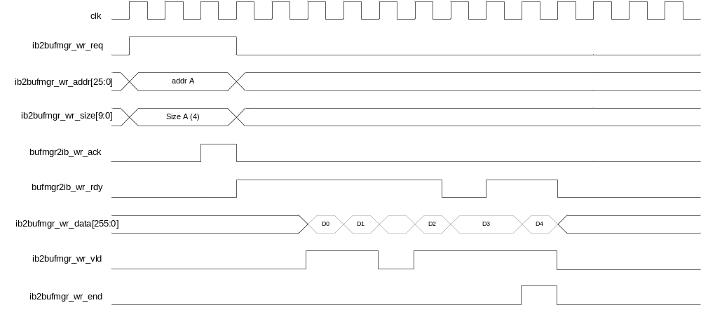

BUF_MGR read timing

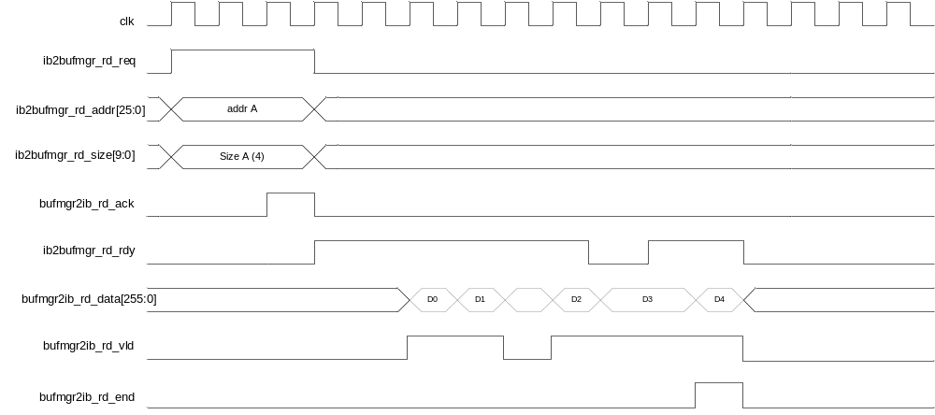

3.2 GPIF timing diagram

GPIF read timing
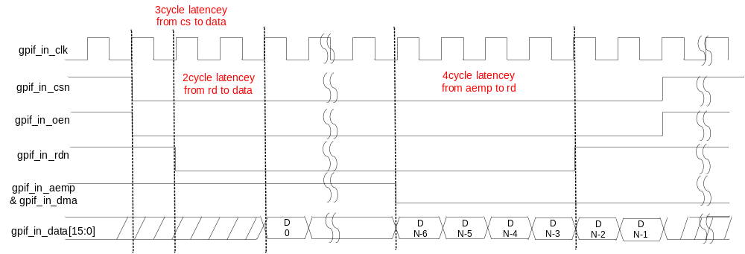

GPIF write timing

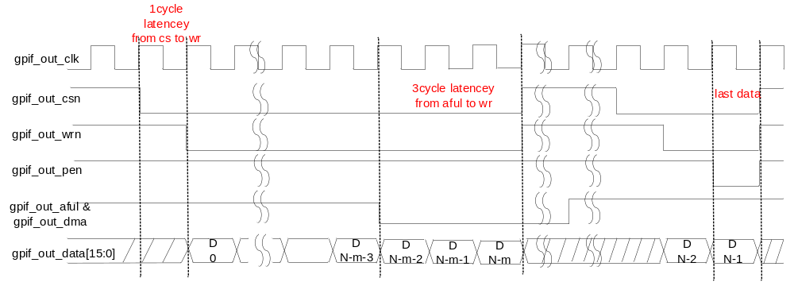

3.3 Configuration Registers

3.3.1 Register Definition

Offset | Name | Mnemonic | Reset Value
0x000 | GPIF Status Register | GPIF_STATUS | 0x0
0x004 | GPIF Preamble field size | GPIF_PRMB_SIZE | 0xF
0x008 | GPIF RD/WR MMGR maximum size | GPIF_MSIZE | {0xF, 0xF}
0x00C | GPIF Control Register | GPIF_CTRL | 0x0
0x010 | GPIF Threshold Register | GPIF_TH | 0x0
0x014 | GPIF Frame Queue | FRAME_QUEUE | 0x0
0x018 | GPIF Preamble double word 0 | GPIF_PRMB_DW00 | 0x01234567
0x01C | GPIF Preamble double word 1 | GPIF_PRMB_DW01 | 0x89abcdef
0x020 | GPIF Preamble double word 2 | GPIF_PRMB_DW02 | 0x76543210
0x024 | GPIF Preamble double word 3 | GPIF_PRMB_DW03 | 0xfedcba98
0x028 | GPIF Preamble double word 4 | GPIF_PRMB_DW04 | 0x01234567
0x02C | GPIF Preamble double word 5 | GPIF_PRMB_DW05 | 0x89abcdef
0x030 | GPIF Preamble double word 6 | GPIF_PRMB_DW06 | 0x76543210
0x034 | GPIF Preamble double word 7 | GPIF_PRMB_DW07 | 0xfedcba98
0x038 | GPIF Status Register 1 | GPIF_STATUS1 | 0x0
 | Reserved | Reserved

3.3.2 Register Description
- GPIF_STATUS offset 0x000
Field Name | Bits | R/W | Default | Description
Reserved | 31:18 | RO | 0x0 | Reserved
crc16_data_err | 17 | W1C | 0x0 | gpif input data CRC16 check error
crc16_head_err | 16 | W1C | 0x0 | gpif input head CRC16 check error
gpif_cfifo_rerr | 15 | W1C | 0x0 | gpif configure FIFO read error
gpif_cfifo_werr | 14 | W1C | 0x0 | gpif configure FIFO write error
gpif_lfifo_rerr | 13 | W1C | 0x0 | gpif loopback data FIFO read error
gpif_lfifo_werr | 12 | W1C | 0x0 | gpif loopback data FIFO write error
mmgr_cfifo_rerr | 11 | W1C | 0x0 | mmgr configure FIFO read error
mmgr_cfifo_werr | 10 | W1C | 0x0 | mmgr configure FIFO write error
mmgr_lfifo_rerr | 9 | W1C | 0x0 | mmgr loopback data FIFO read error
mmgr_lfifo_werr | 8 | W1C | 0x0 | mmgr loopback data FIFO write error
mmgr2gpif_cfifo_rerr | 7 | W1C | 0x0 | mmgr2gpif configure FIFO read error
mmgr2gpif_cfifo_werr | 6 | W1C | 0x0 | mmgr2gpif configure FIFO write error
mmgr2gpif_dfifo_rerr | 5 | W1C | 0x0 | mmgr2gpif data FIFO read error
mmgr2gpif_dfifo_werr | 4 | W1C | 0x0 | mmgr2gpif data FIFO write error
gpif2mmgr_cfifo_rerr | 3 | W1C | 0x0 | gpif2mmgr configure FIFO read error
gpif2mmgr_cfifo_werr | 2 | W1C | 0x0 | gpif2mmgr configure FIFO write error
gpif2mmgr_dfifo_rerr | 1 | W1C | 0x0 | gpif2mmgr data FIFO read error
gpif2mmgr_dfifo_werr | 0 | W1C | 0x0 | gpif2mmgr data FIFO write error

- GPIF_PRMB_SIZE offset 0x004
Field Name | Bits | R/W | Default | Description
Reserved | 31:5 | RO | 0x0 | Reserved
prmb_size | 4:0 | RW | 0xF | GPIF preamble size -1, 16bit based. Preamble size = (gpif_prmb_size+1) *16bit

- GPIF_MSIZE offset 0x008
Field Name | Bits | R/W | Default | Description
Reserved | 31:20 | RO | 0x0 | Reserved
mmgr_rd_msize | 19:10 | RW | 0xF | MMGR read maximum size -1
mmgr_wr_msize | 9:0 | RW | 0xF | MMGR write maximum size -1

- GPIF_CTRL offset 0x00C
Field Name | Bits | R/W | Default | Description
Reserved | 31:8 | RO | 0x0 | Reserved
crc16_data_adden | 7 | RW | 0x0 | CRC16 Data part add enable
crc16_head_adden | 6 | RW | 0x0 | CRC16 Head part add enable
crc16_data_chken | 5 | RW | 0x0 | CRC16 Data part check enable
crc16_head_chken | 4 | RW | 0x0 | CRC16 Head part check enable
Reserved | 3:2 | RO | 0x0 | Reserved
mmgr_lpb_en | 1 | RW | 0x0 | MMGR interface loopback enable
gpif_lpb_en | 0 | RW | 0x0 | GPIF interface loopback enable

- GPIF_TH offset 0x010
Field Name | Bits | R/W | Default | Description
Reserved | 31:13 | RO | 0x0 | Reserved
gpif_aful_th | 12:8 | RW | 0x0 | GPIF output port almost full threshold, actual value will be (gpif_aful_th+4)
Reserved | 7:5 | RO | 0x0 | Reserved
gpif_aemp_th | 4:0 | RW | 0x0 | GPIF input port almost empty threshold, actual value will be (gpif_aemp_th+4)

- FRAME_QUEUE offset 0x014
Field Name | Bits | R/W | Default | Description
Reserved | 31:10 | RO | 0x0 | Reserved
out_queue_depth | 9:8 | RW | 0x0 | Output frame queue depth -1
Reserved | 7:2 | RO | 0x0 | Reserved
in_queue_depth | 1:0 | RW | 0x0 | Input frame queue depth -1

- GPIF_PRMB_DW00 offset 0x018
Field Name | Bits | R/W | Default | Description
prmb_dw00 | 31:0 | RW | 0x01234567 | Preamble double word 0

- GPIF_PRMB_DW01 offset 0x01C
Field Name | Bits | R/W | Default | Description
prmb_dw01 | 31:0 | RW | 0x89abcdef | Preamble double word 1

- GPIF_PRMB_DW02 offset 0x020
Field Name | Bits | R/W | Default | Description
prmb_dw02 | 31:0 | RW | 0x76543210 | Preamble double word 2

- GPIF_PRMB_DW03 offset 0x024
Field Name | Bits | R/W | Default | Description
prmb_dw03 | 31:0 | RW | 0xfedcba98 | Preamble double word 3

- GPIF_PRMB_DW04 offset 0x028
Field Name | Bits | R/W | Default | Description
prmb_dw04 | 31:0 | RW | 0x01234567 | Preamble double word 4

- GPIF_PRMB_DW05 offset 0x02C
Field Name | Bits | R/W | Default | Description
prmb_dw05 | 31:0 | RW | 0x89abcdef | Preamble double word 5

- GPIF_PRMB_DW06 offset 0x030
Field Name | Bits | R/W | Default | Description
prmb_dw06 | 31:0 | RW | 0x76543210 | Preamble double word 6

- GPIF_PRMB_DW07 offset 0x034
Field Name | Bits | R/W | Default | Description
prmb_dw07 | 31:0 | RW | 0xfedcba98 | Preamble double word 7

- GPIF_STATUS1 offset 0x038
Field Name | Bits | R/W | Default | Description
Reserved | 31:4 | RO | 0x0 | Reserved
out_frame_cnt | 3:2 | RO | 0x0 | Output frame counter
in_frame_cnt | 1:0 | RO | 0x0 | Input frame counter

4. Module Micro-architecture

4.1 GPIF2MMGR (Rx Port)

Based on the DDR or non-DDR mode selection, the MMGR could be DDR_MGR or BUF_MGR.

For GPIF2MMGR direction, host will send frame through GPIF interface based on the frame format. The GPIF2MMGR module will do the steps:
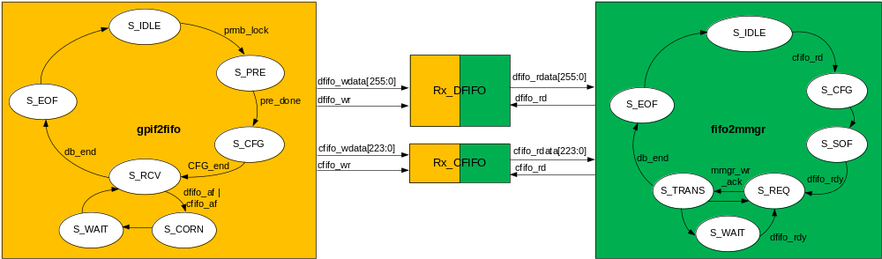
Figure 4-1 GPIF2MMGR process schematic

1st step: gpif2fifo module will search the preamble. When the preamble been locked, it will jump to state S_PRE. In this state, it will extract data been pre-read in preamble locking state. Then it jumps to S_CFG, extract the remain configure head for whole 256bit and push the bit[223:0] into Rx_CFIFO (bit[255:224] is not used). If the CRC16 function is switched on, it will process CRC16 check with the last 16bit data of configure code.

2nd step: based on the configure db_in_size, gpif2fifo will read the correspond size data from GPIF interface. The gpif2fifo will packet the data with 256bit width and push it into Rx_DFIFO. If the CRC16 function is switched on, it will process CRC16 check with the last 16bit data of data block.

3rd step: when the Rx_CFIFO is no empty, fifo2mmgr module will read configure data from Rx_CFIFO. Meanwhile, if the fmi_fifo_afull is de-assert which means there is enough space for data saving, fifo2mmgr will jump to 4th step, otherwise it will jump to 6th step.

4th step: when the Rx_DFIFO has enough data to transmit to MMGR, fifo2mmgr will request MMGR_TOP for data transmission. When the MMGR write is been accept by MMGR_TOP, fifo2mmgr will read data from Rx_DFIFO and transmit to MMGR_TOP;

5th step: based on the configure data read from Rx_CFIFO, MMGR will transmit db_in_size data to MMGR_TOP and generate fmi_eof pulse when all the data is transmitted.

6th step: when the fmi_fifo_afull is assert which means there is no space for data saving, fifo2mmgr will wait for fmi_fifo_afull been de-assert, meanwhile backpressure gpif2fifo.

4.2 MMGR2GPIF (Tx Port)

For MMGR2GPIF direction, CHIP_CTRL will trigger the transmission by fulfill the FMO_FIFO. The mmgr2gpif module will transmit the frame to host through GPIF interface. The MMGR2GPIF module will do the steps:

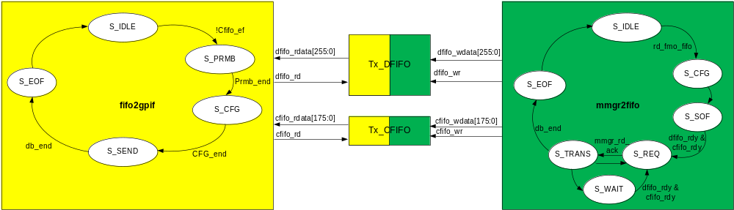
Figure 4-4 MMGR2GPIF process schematic

1st step: when fmo_fifo_empty is de-assert, which means there are several data blocks need to transmit to host. The mmgr2fifo module will read configure data from FMO_FIFO and write it into Tx_CFIFO to acknowledge fifo2gpif that there are data blocks to transmit.

2nd step: when the Tx_DFIFO has enough space for data saving, mmgr2fifo module will request MMGR_TOP for data transmission. When the MMGR read is been accept by MMGR_TOP. mmgr2fifo will read data from MMGR_TOP and push it into Tx_DFIFO.

3rd step: when the Tx_CFIFO and Tx_DFIFO are both non-empty, fifo2gpif module will read configure head from Tx_CFIFO, and start GPIF interface; fifo2gpif module will read data from Tx_DFIFO when gpif_de is valid.

4th step: based on db_out_size, mmgr2fifo will read enough data from MMGR_TOP and write enough into Tx_DFIFO, while fifo2gpif will read these data and packet them into gpif_data bus.

5th step: during transmission period, CRC16 will be calculated automatically. If the CRC16 add is been switched on, the last 16bit of configure head and data block will be replace by the output of CRC16.

4.3 XXXX
[Other sub-modules’ micro-architecture and memory buffer usage & data format description]

