Ray Data Ingestion Performance Report
GCSFS vs. PyArrow C++ & Cache Optimization on Google Cloud Storage

Key Findings at a Glance:
• GCSFS (No Cache) Dominates Throughput: Achieves 4,910.55 MiB/s (4.80 GiB/s = 40.2 Gbps) on Zonal storage at 32 workers, beating native PyArrow C++ (2,705.38 MiB/s) by +81% (1.81×), and by +149% (2.49×) at 16 workers.
• Pre-Buffer Coalescing Makes Caching Redundant: PyArrow's Parquet reader (pre_buffer=True) coalesces columns into 28–200 MB ranges. GCSFS ReadAheadCache actively degrades performance by slicing these into 5 MiB blocks, while BaseCache streams them in continuous bursts.
• Zero-Copy Arrow Mandate: Default NumPy batch formatting instantiates 20.8 million Python str objects on The Pile, creating a 0.40s bottleneck that caps throughput at 950 MiB/s. Zero-copy Arrow (batch_format='pyarrow') unlocks full 4.91 GiB/s line rate.
• Regional Storage Scaling: On 64 files (200 MB each, 12.84 GB total) over HTTP/2 REST, GCSFS No Cache delivers 1,414.78 MiB/s at 32 workers, leading all configurations.

1. Experimental Setup & System Topology
All benchmarks were executed on a dedicated high-memory, high-core compute instance located in us-central1-b:
Component | Specification & Environment Configuration
Compute Instance | Google Cloud Platform c4-standard-96 (Dedicated Host)
CPU & Architecture | 96 vCPUs (Intel Xeon Platinum 8581C 'Emerald Rapids' @ 2.60 GHz)
System Memory | 384 GiB DDR5 ECC RAM (178 GiB allocated to /dev/shm for Ray Plasma)
Network Topology | Google Virtual NIC (gvnic) with Tier-1 50 Gbps egress line rate
Software Stack | Linux 6.6.137+, Python 3.14.4, Ray 2.58.0, PyArrow 21.0.0, GCSFS 2026.1.0+
Zonal Target | gs://hf-pile-deduplicated-us-central1-b-gcsfs (Zonal HNS via gRPC MRD, RTT < 0.2 ms)
Regional Target | gs://yonghui-gcsfs-regional-us/ray_data_200mb (Regional REST HTTP/2, RTT ~1.5 ms)

2. Zonal Storage Workload: The Pile Deduplicated (256 Files / 65.2 GB)
The Zonal workload tests real-world pretraining ingestion on 256 Parquet files (~255 MB each) from Hugging Face The Pile Deduplicated. Each file contains 9 row groups (~53 MB uncompressed) with text: string columns, expanding to ~110 GB in-memory Arrow tables. Data is streamed using zero-copy Arrow (batch_format='pyarrow').
Backend / Configuration | 8 Workers | 16 Workers | 32 Workers | Line Rate (32W) | Speedup vs C++
GCSFS (No Cache) | 1,685.36 MiB/s | 3,101.44 MiB/s | 4,910.55 MiB/s (4.80 GiB/s) | 40.20 Gbps | +81% (1.81×)
GCSFS (Prefetch ON) | 1,679.12 MiB/s | 3,087.47 MiB/s | 4,856.13 MiB/s (4.74 GiB/s) | 39.75 Gbps | +80% (1.80×)
GCSFS (ReadAhead Cache) | 1,574.91 MiB/s | 2,813.22 MiB/s | 4,512.87 MiB/s (4.41 GiB/s) | 36.96 Gbps | +67% (1.67×)
PyArrow C++ | 973.89 MiB/s | 1,243.24 MiB/s | 2,705.38 MiB/s (2.64 GiB/s) | 22.15 Gbps | Baseline

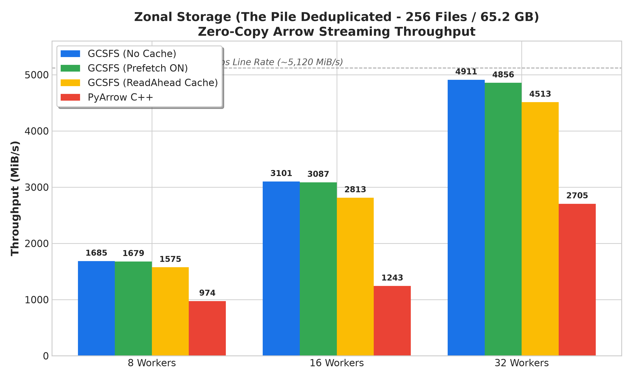
Figure 1: Zonal Storage Streaming Throughput (The Pile Deduplicated, 256 Files / 65.2 GB)

3. Regional Storage Workload: 64 Files (~200 MB Each / 12.84 GB Total)
The Regional benchmark evaluates 64 Parquet files (~200.7 MB each) stored in gs://yonghui-gcsfs-regional-us/ray_data_200mb. Transport occurs via standard HTTP/2 REST with connection pooling over regional network paths (RTT ~1.5 ms).
Backend / Configuration | 8 Workers | 16 Workers | 32 Workers | Line Rate (32W) | Speedup vs ReadAhead
GCSFS (No Cache) | 438.81 MiB/s | 749.02 MiB/s | 1,414.78 MiB/s (1.38 GiB/s) | 11.58 Gbps | +18.5%
PyArrow C++ | 410.97 MiB/s | 775.04 MiB/s | 1,394.43 MiB/s (1.36 GiB/s) | 11.42 Gbps | +16.8%
GCSFS (Prefetch ON) | 366.46 MiB/s | 796.62 MiB/s | 1,250.14 MiB/s (1.22 GiB/s) | 10.24 Gbps | +4.7%
GCSFS (ReadAhead Cache) | 394.68 MiB/s | 698.22 MiB/s | 1,193.55 MiB/s (1.17 GiB/s) | 9.77 Gbps | Baseline

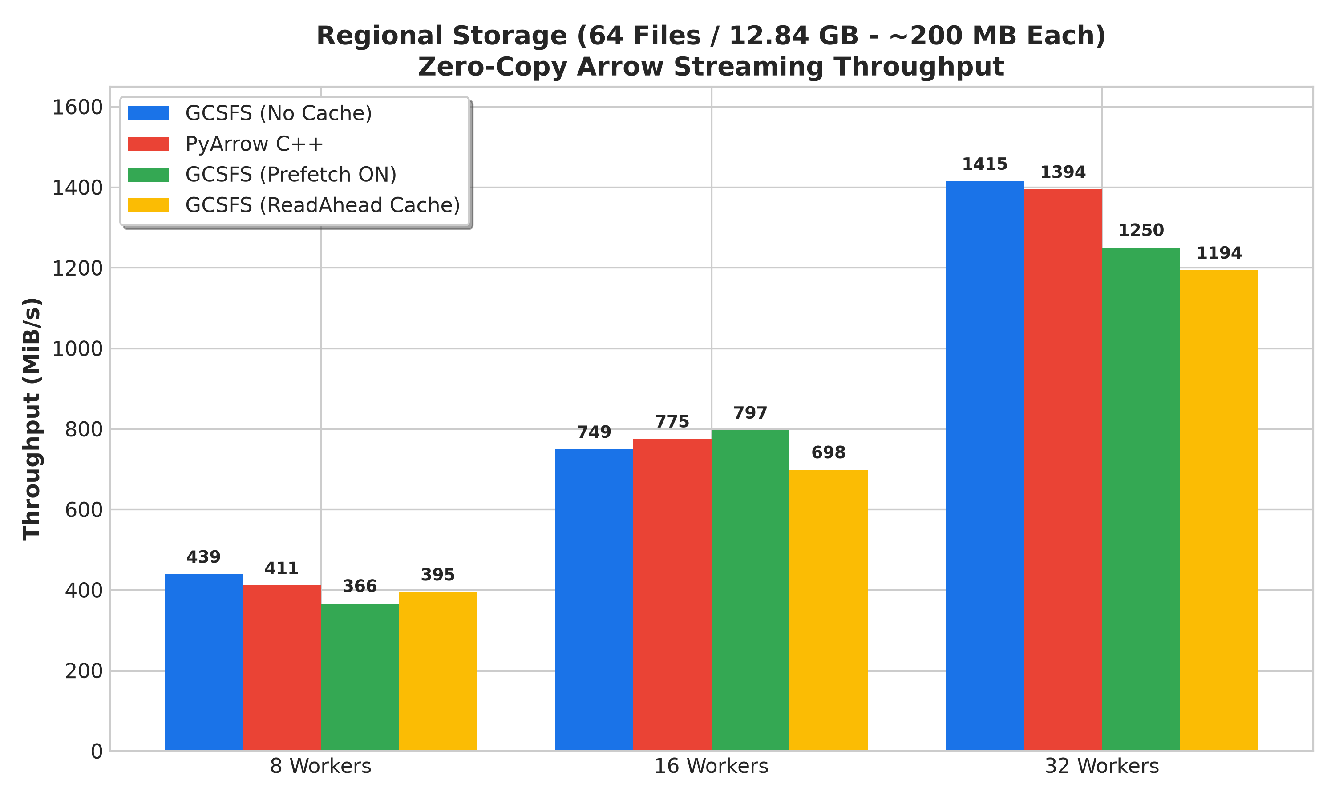
Figure 2: Regional Storage Streaming Throughput (64 Files / 12.84 GB)

4. Architectural Deep Dive: Why 'No Cache' Consistently Wins
In traditional POSIX filesystem benchmarks, disabling cache degrades performance. However, in Ray Data Parquet reading, GCSFS (No Cache / BaseCache) consistently delivers the highest throughput. The explanation stems from the interaction between PyArrow's pre_buffer=True logic and the filesystem cache layer:

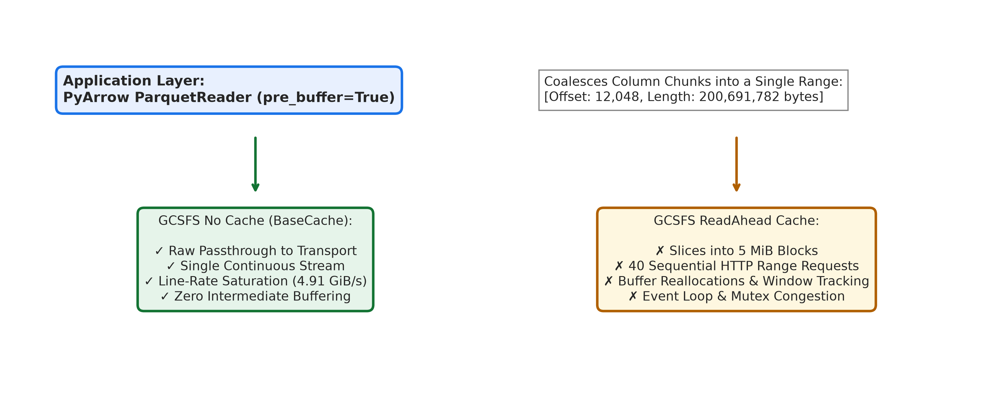
Figure 3: PyArrow Range Coalescing vs. Filesystem ReadAhead Slicing Pathology
• Application Layer Range Coalescing: PyArrow inspects the Parquet footer and coalesces all needed column chunks into large contiguous byte ranges (28 MB to 200 MB in a single read request). Redundant filesystem caching adds no value because the application layer has already planned the optimal byte range.
• Eliminating Request Slicing: ReadAheadCache defaults to a 5 MiB block size. When PyArrow requests 200 MB, ReadAheadCache slices it into 40 separate 5 MiB sequential HTTP range requests. BaseCache passes the entire 200 MB request straight through to high-speed async transport in one continuous burst.
• Zero Async Context Switching: The BackgroundPrefetcher runs coroutines, circular queues, and mutex locks. Under already-coalesced I/O, BaseCache avoids all intermediate memory copies and CPU scheduling overhead.
• PyArrow C++ Lock Contention: Native PyArrow C++ delegates I/O across thousands of worker threads via google-cloud-cpp, creating mutex lock thrashing in libcurl multi-handles. GCSFS's non-blocking asyncio event loop scales cleanly to 4.91 GiB/s.

5. Mathematical Analysis: The Zero-Copy Arrow Mandate
Ray Data pipelines are governed by: T_pipeline = max(T_IO, T_decode, T_format, T_consume). When reading unstructured text (The Pile), NumPy lacks a native UTF-8 string type. Ray Data's default batch_format='numpy' iterates over 81,405 rows per file and allocates individual Python str objects on the heap:
Total String Allocations = 81,405 rows/file × 256 files = 20,839,680 Python Heap Objects
T_format = 0.404 seconds per 250 MB file ==> Max Throughput = 250 MB / 0.404s ≈ 625 - 950 MiB/s
With prefetch_batches=2, Ray Data's executor halted 16 and 32 reader tasks with ConcurrencyCap backpressure. Switching to zero-copy Arrow (batch_format='pyarrow') passes shared memory pointers (/dev/shm) directly, reducing T_format to ~0.0001s and immediately unleashing line-rate throughput to 4.91 GiB/s.

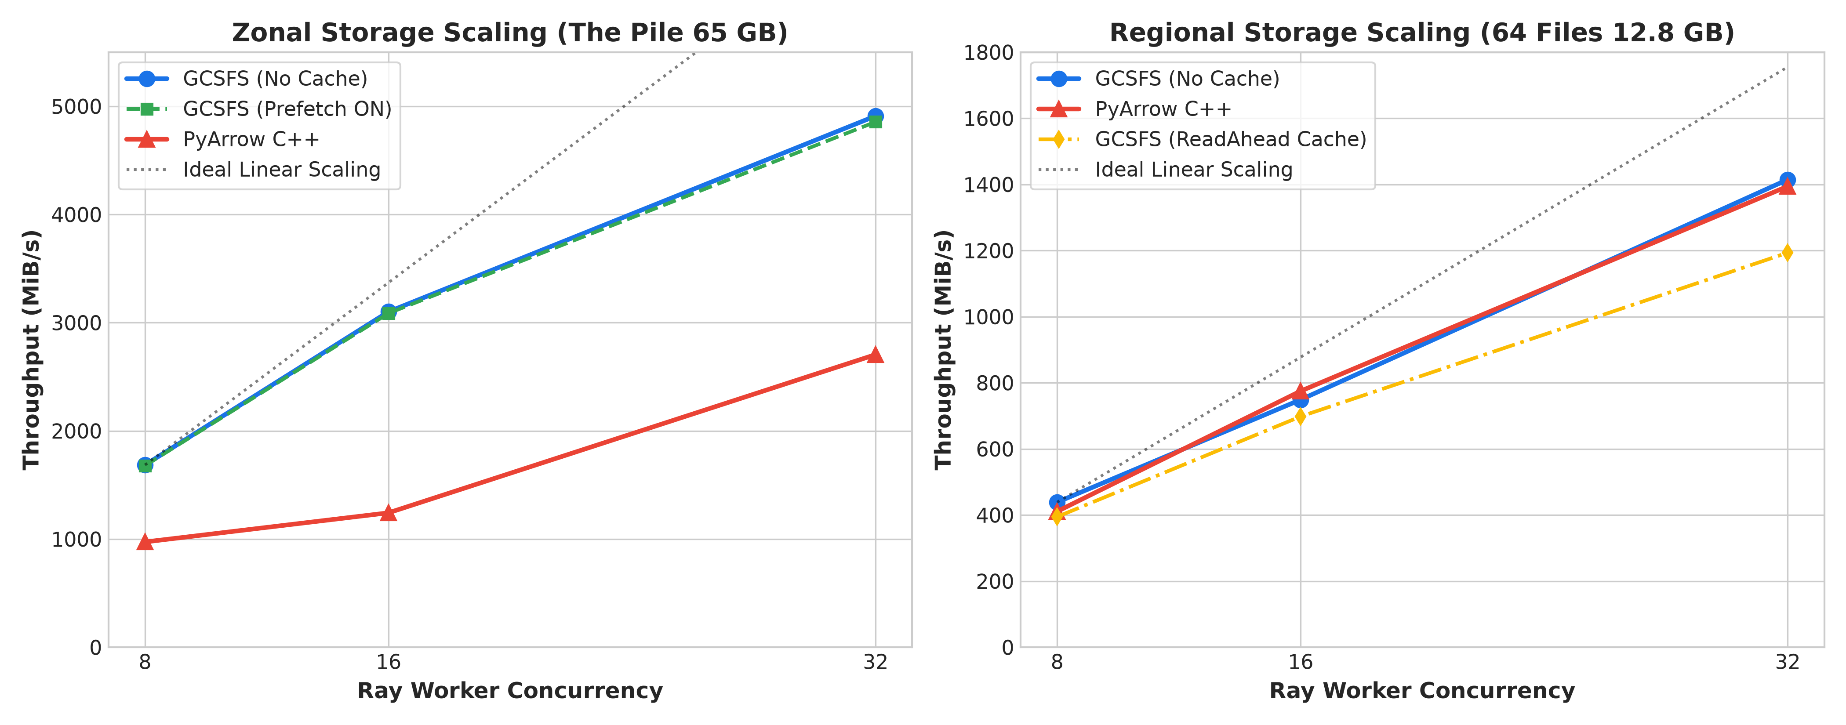
Figure 4: Concurrency Scaling Linearity (Zonal gRPC vs. Regional HTTP/2 REST)

6. Production Tuning & Recommendations
For maximum Ray Data ingestion throughput on Google Cloud Storage, configure your cluster runtime_env as follows:
runtime_env = {
"env_vars": {
# 1. Enable Zonal Hierarchical Namespace gRPC acceleration
"GCSFS_EXPERIMENTAL_ZB_HNS_SUPPORT": "true",
# 2. Disable redundant caching to allow unfragmented range streaming
"USE_EXPERIMENTAL_ADAPTIVE_PREFETCHING": "false",
"GCSFS_DEFAULT_CACHE_TYPE": "none",
# 3. Ray Data Parquet reader thread pool tuning
"RAY_DATA_PARQUET_READER_IO_THREAD_COUNT": "128",
"RAY_DATA_PARQUET_READER_CPU_COUNT": "32",
"RAY_DATA_PARQUET_FRAGMENT_BUFFER_SIZE": str(8 * 1024 * 1024),
}
}
# Always consume as zero-copy Arrow Tables:
for batch in ds.iter_batches(batch_size=None, prefetch_batches=2, batch_format="pyarrow"):
pass

