1

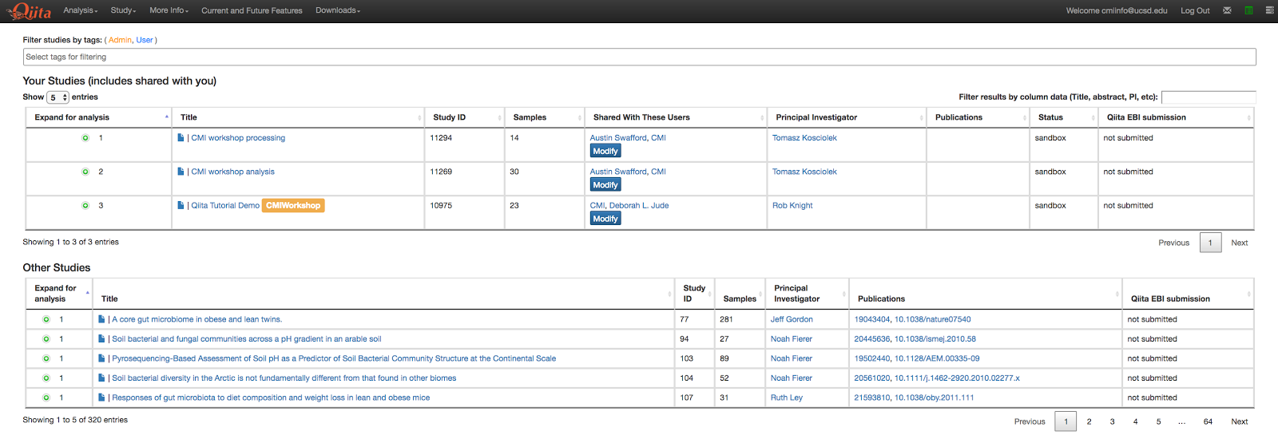

2

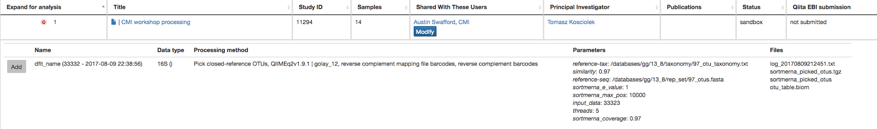

3

https://lh4.googleusercontent.com/bUaUnqm2whtgXp4tt6Mh9Tlu1vhbxL1iw0X5yS2WVy_XWEkKyi_3xo3H237SobQW-ySYT8PYpe45Hf7P9H442k0hltEOOPYqgom-L-AHOMIuBf0CCv6cu4Uj6bGF7NZjH0zVIc3R

4



5

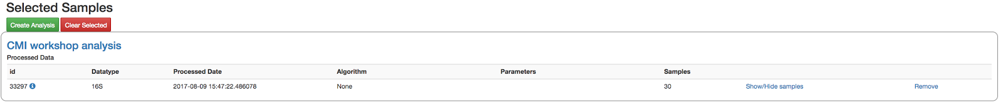

6

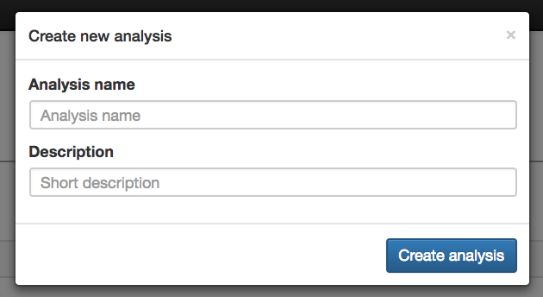

7

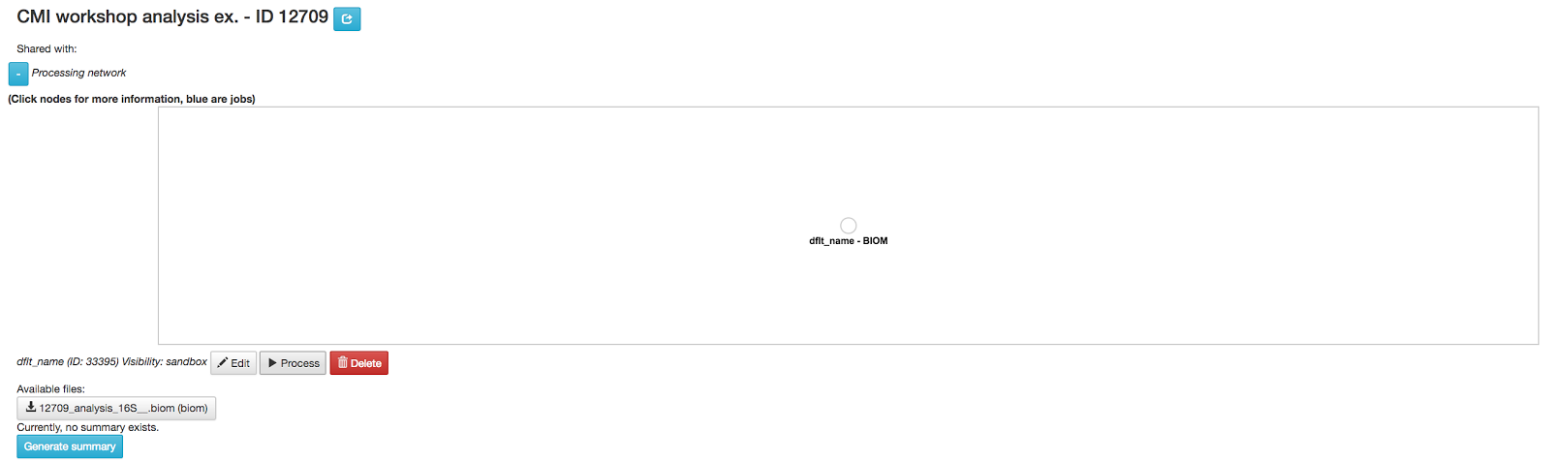

8

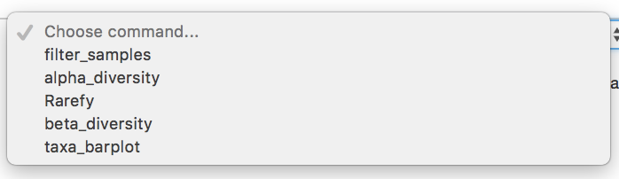

9

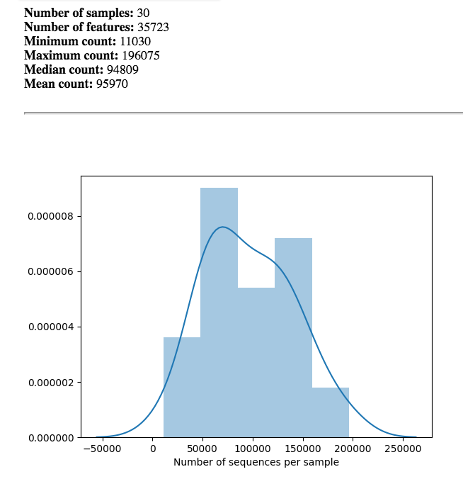

10

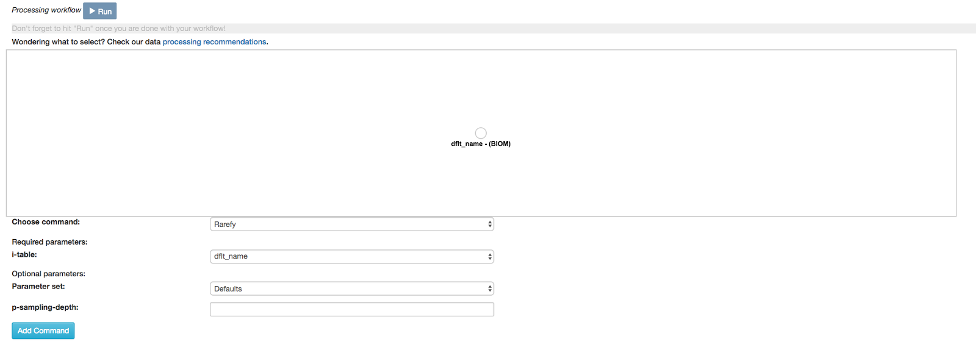

11

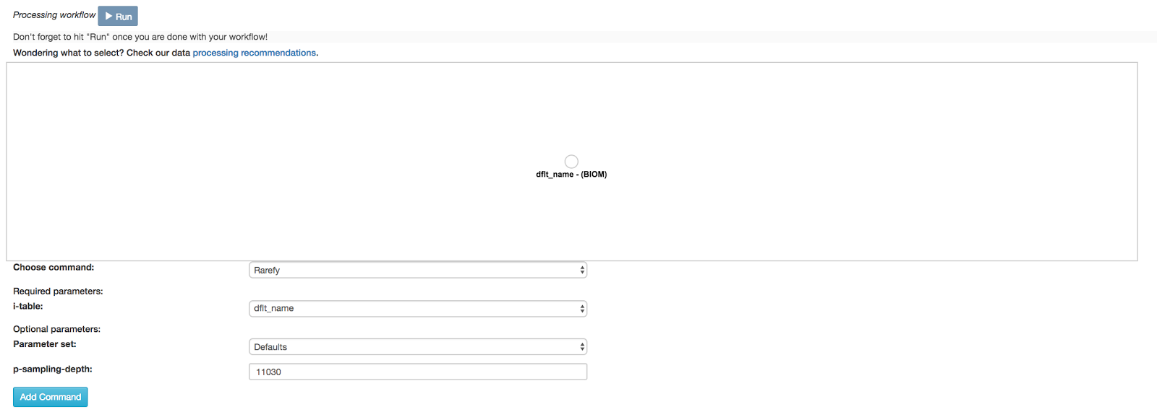

12

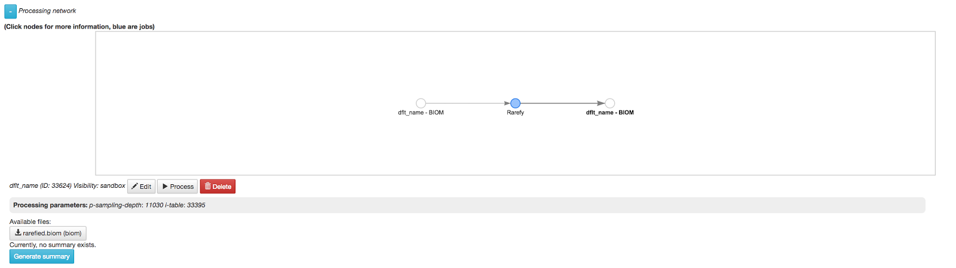

13

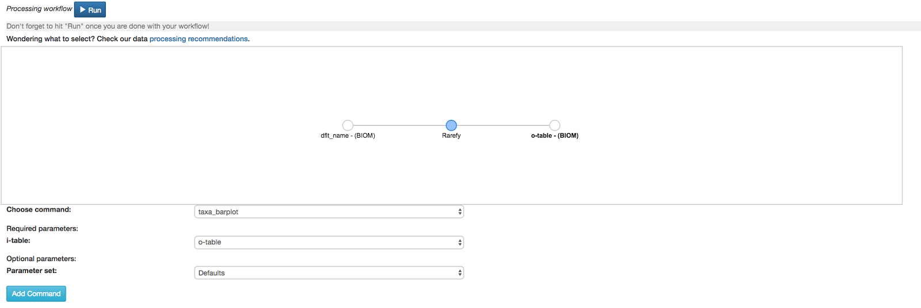

14

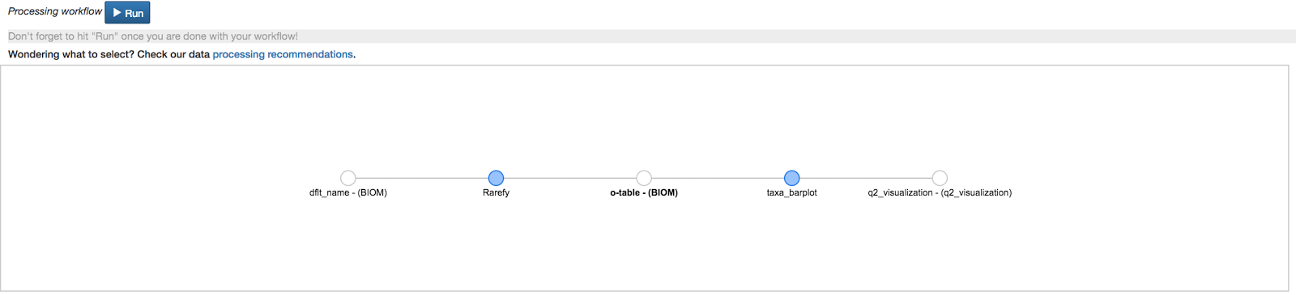

15

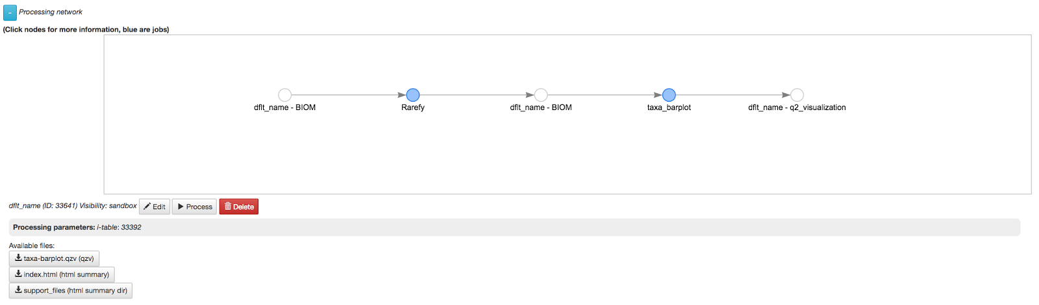

16

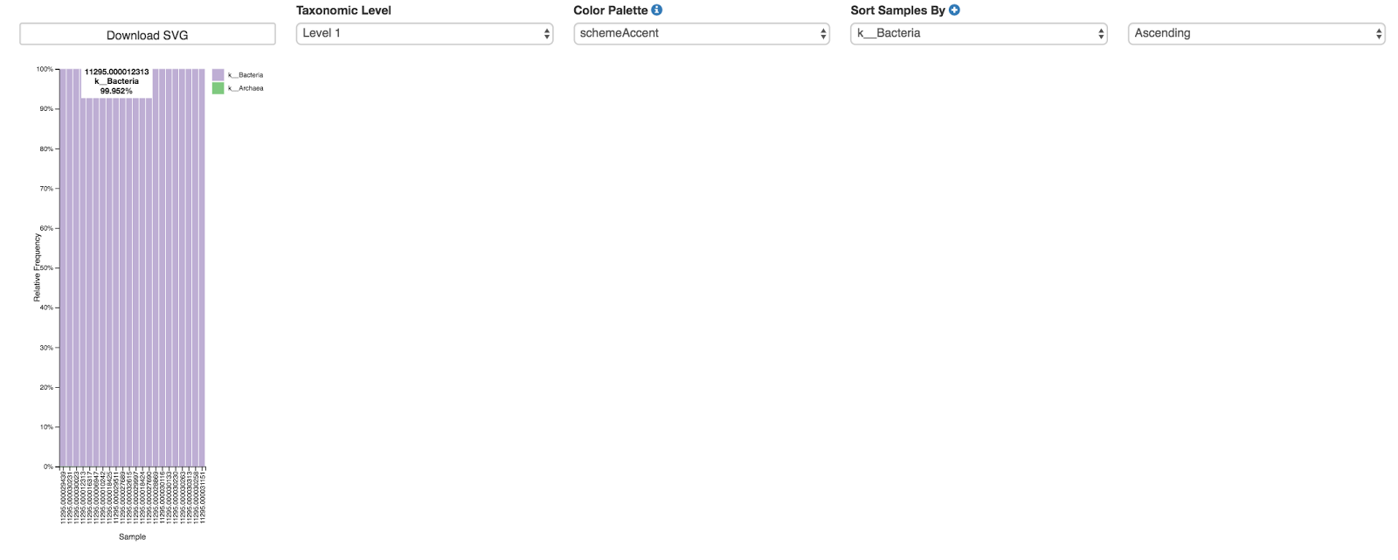

17

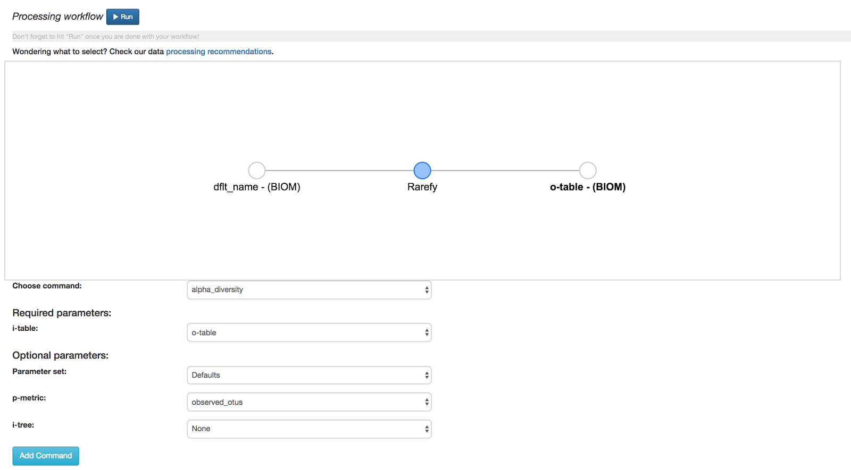

18

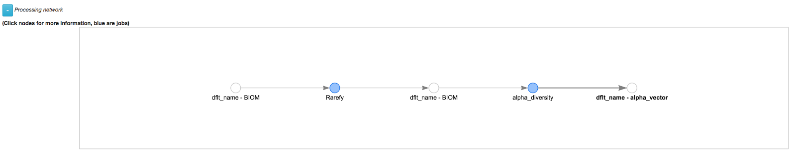

19

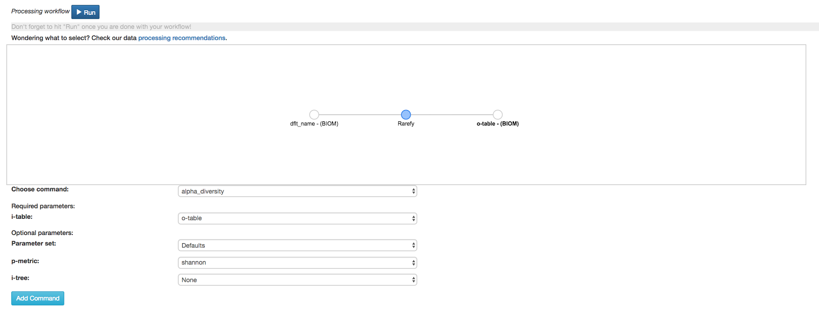

20

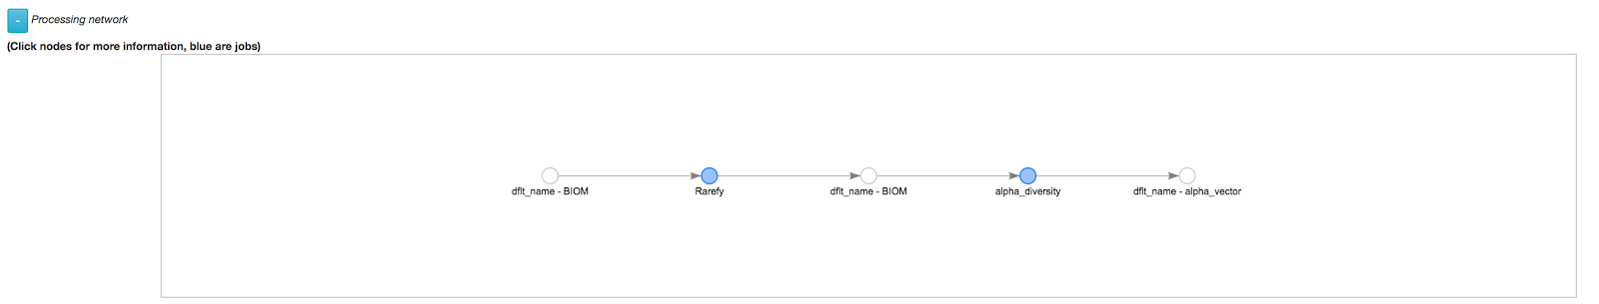

21

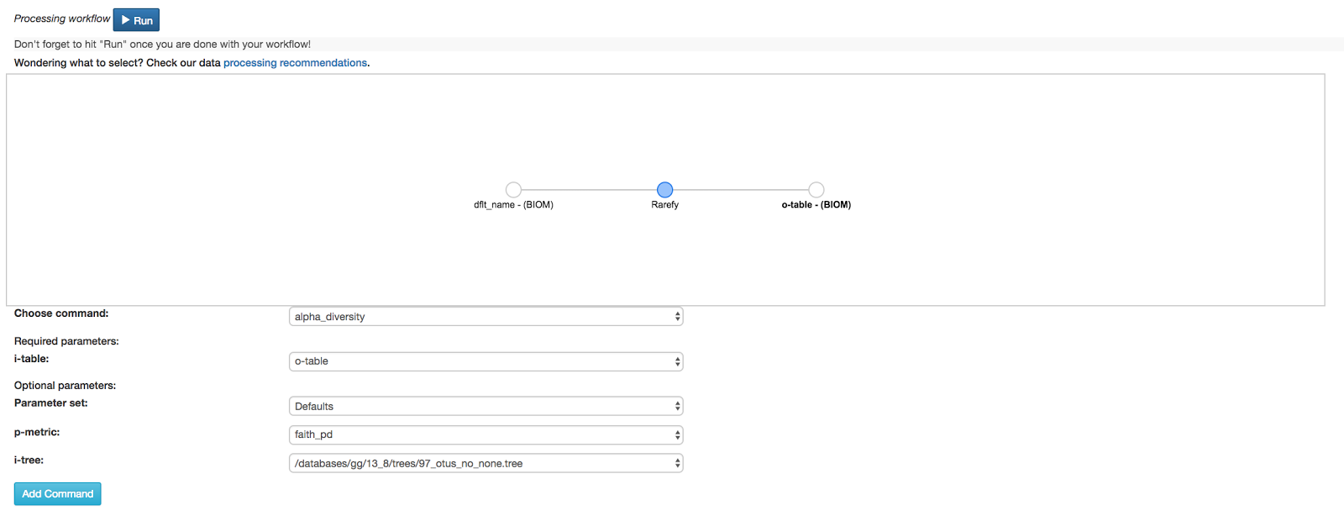

22

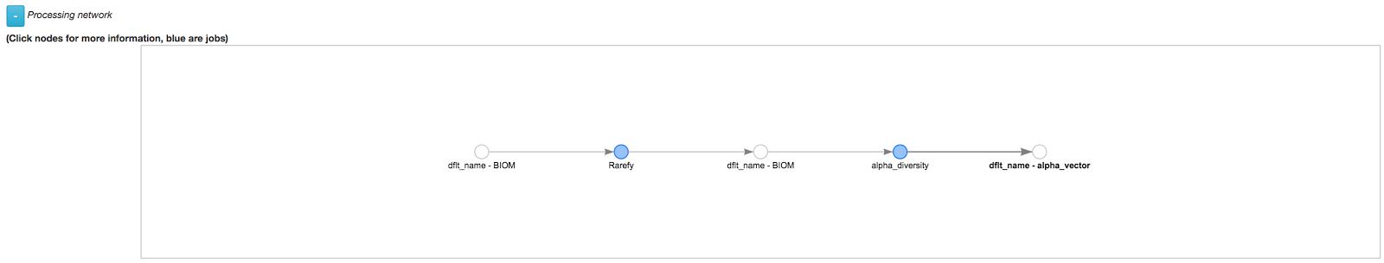

23

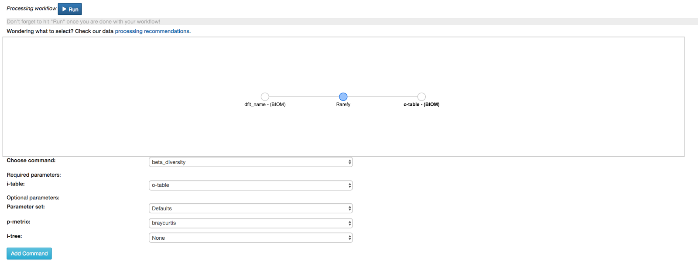

24

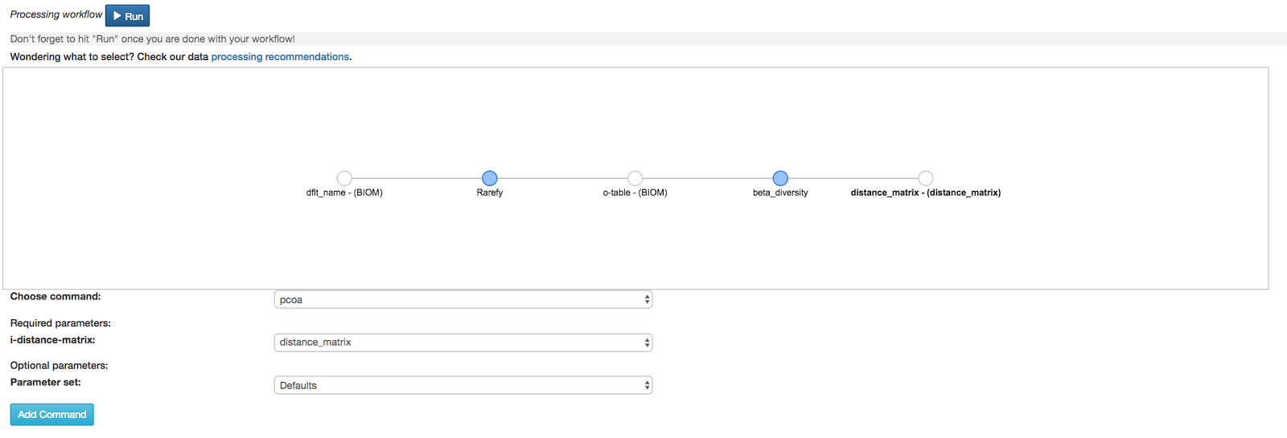

25

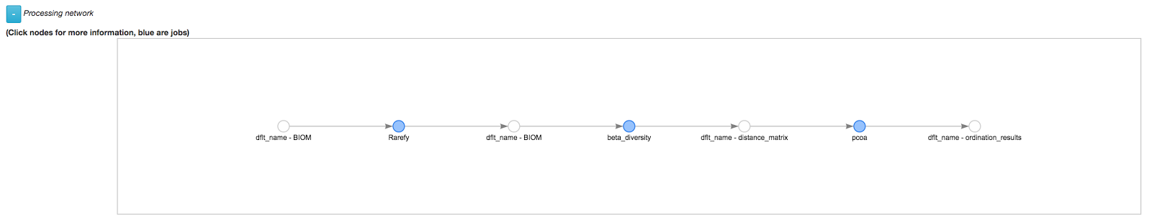

26

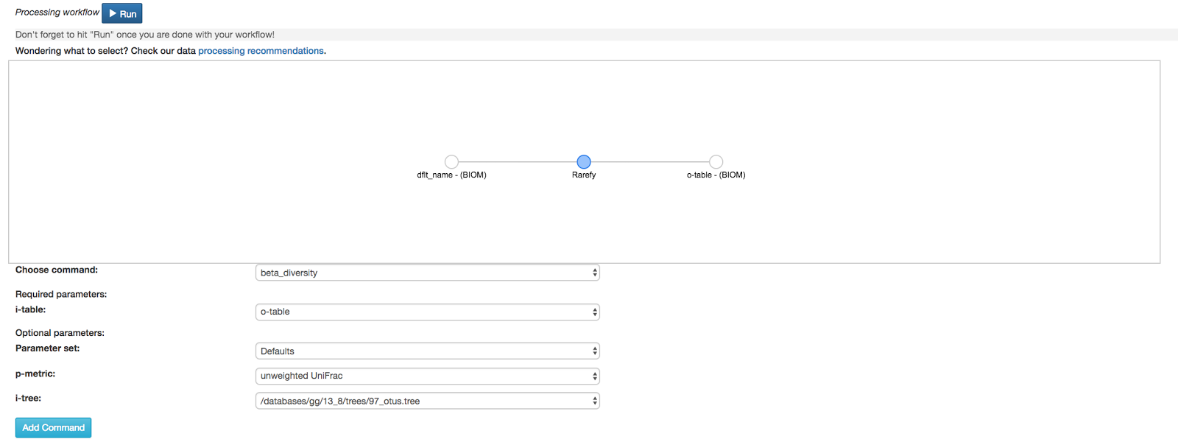

27

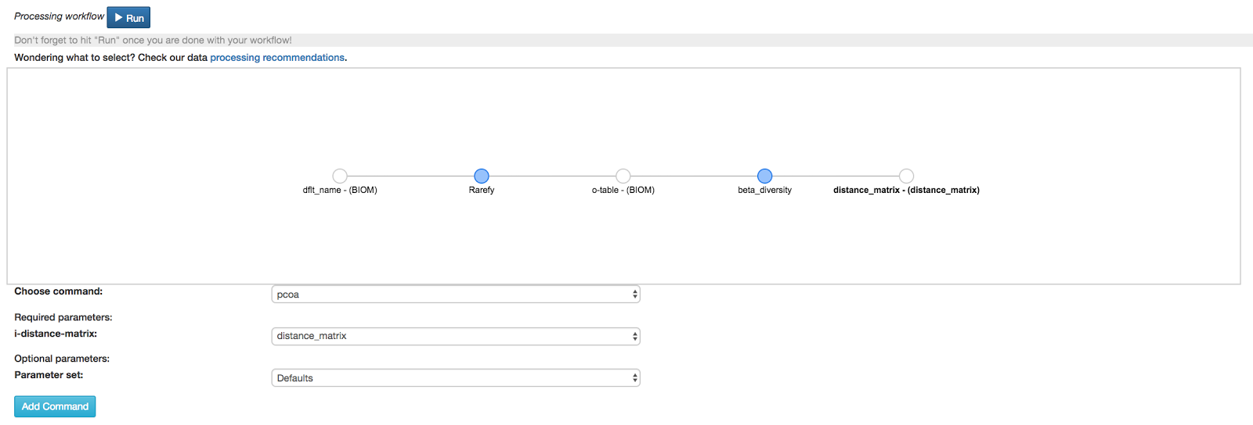

28

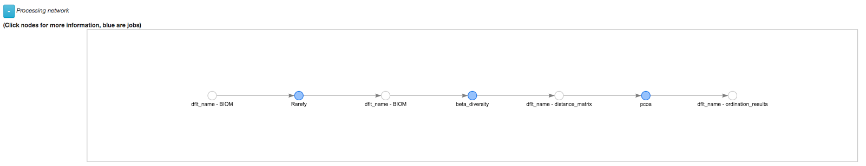

29

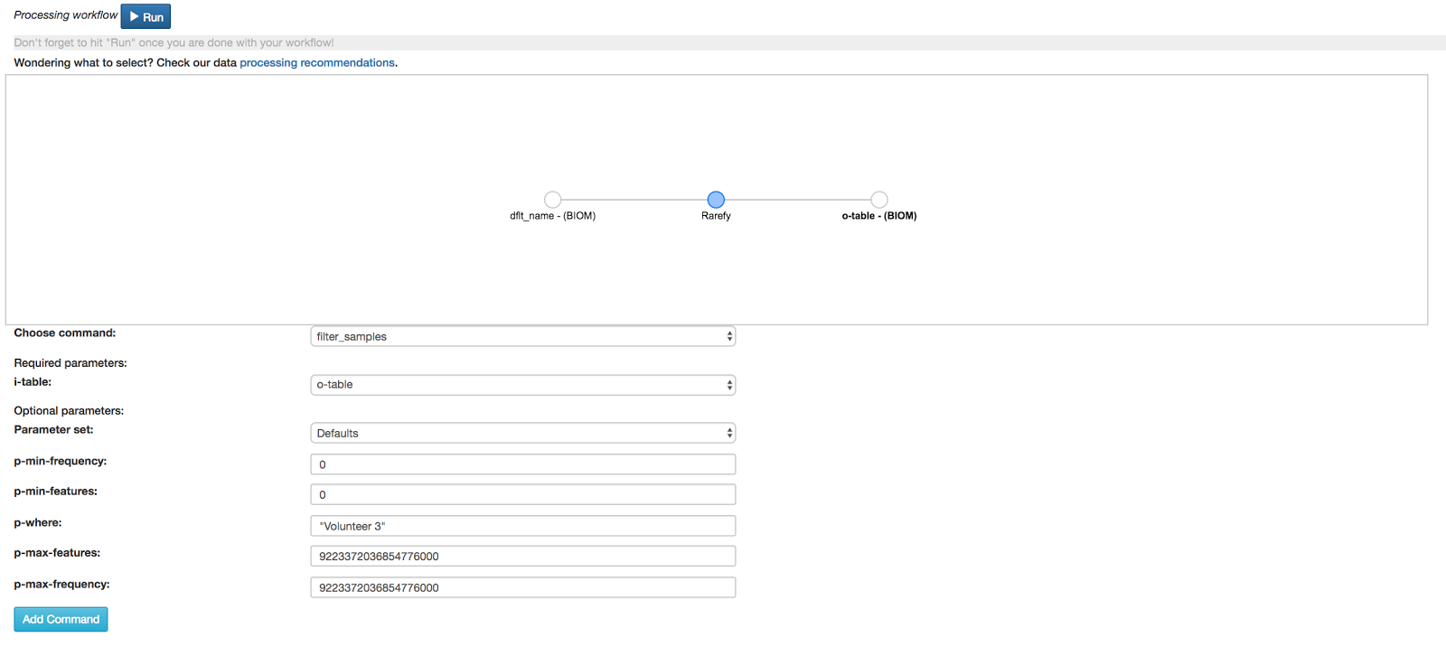

30

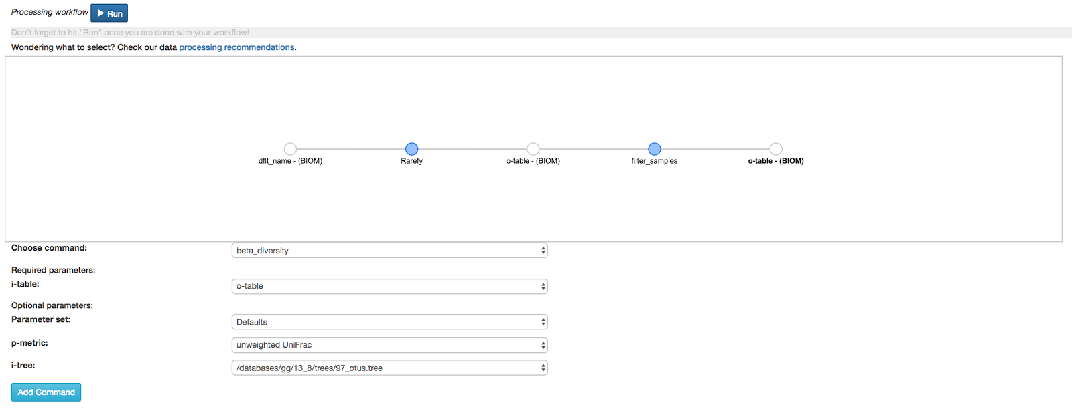

31

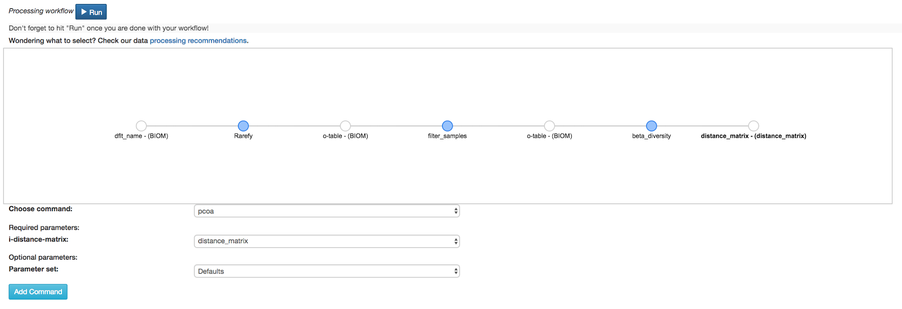

32

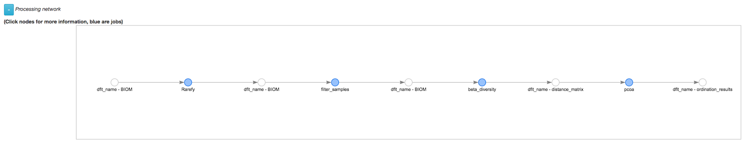

33



34

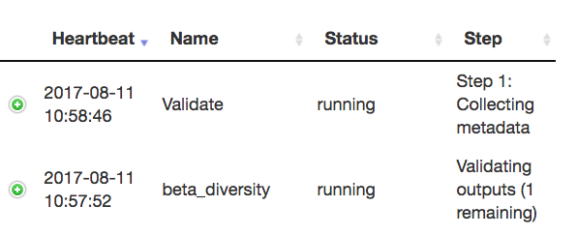

35

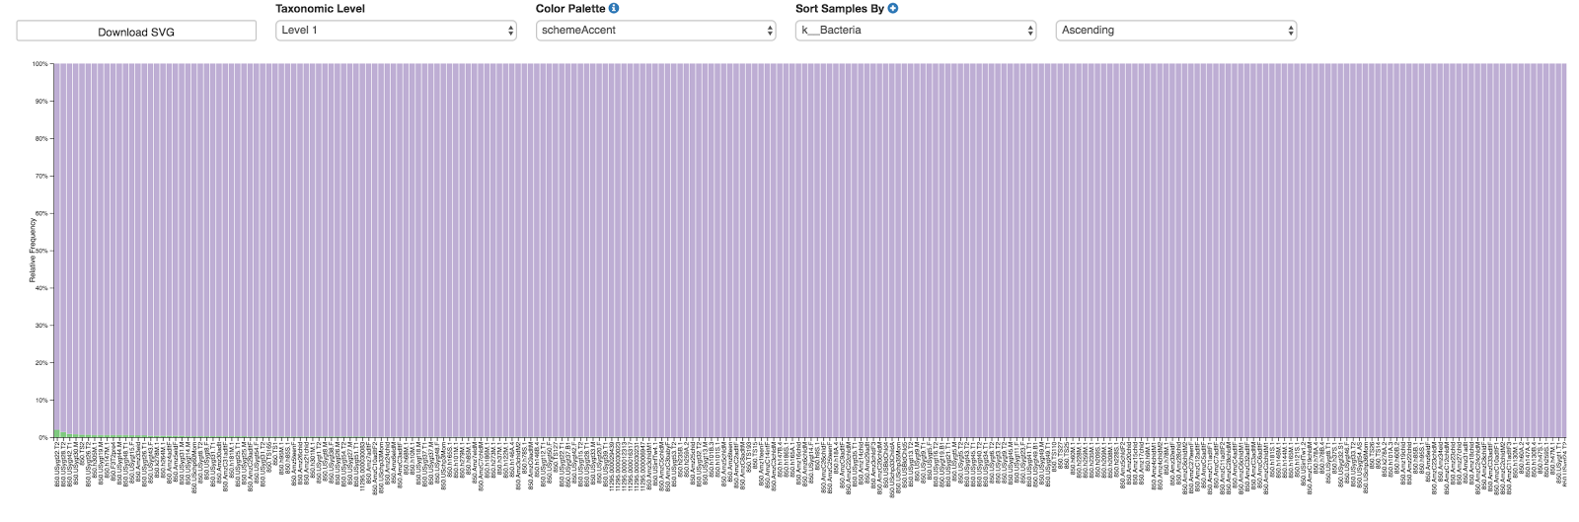

36:

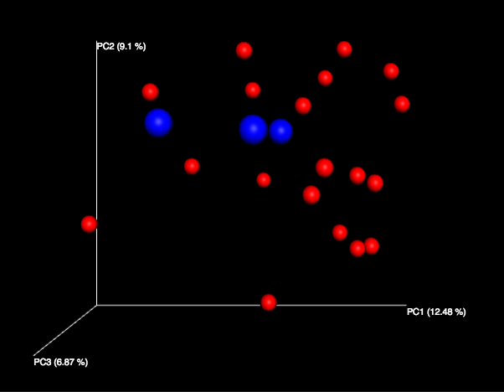

37

https://lh6.googleusercontent.com/tBZhHm-mNU-9Wa3QQpSzWUCGtM3df2M7MOyjtlwXlgL9bna4Y_sAQEtWj2OB8lbnT5-5N_8d8xabLh8D68MjrSzQo0TJC8nZrfbR42dOtUY5LfzpZEjBkRF0wEwRUxxmYpJEevUi

38

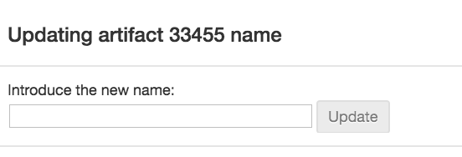

39

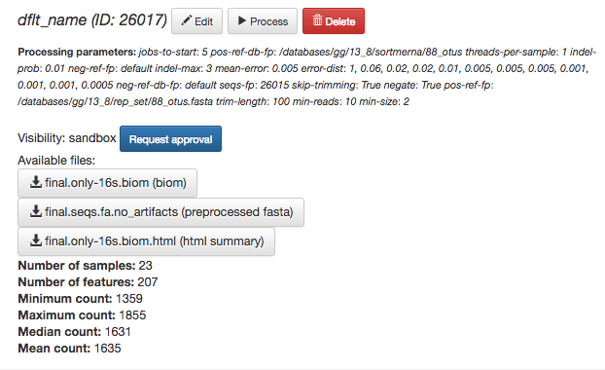

40

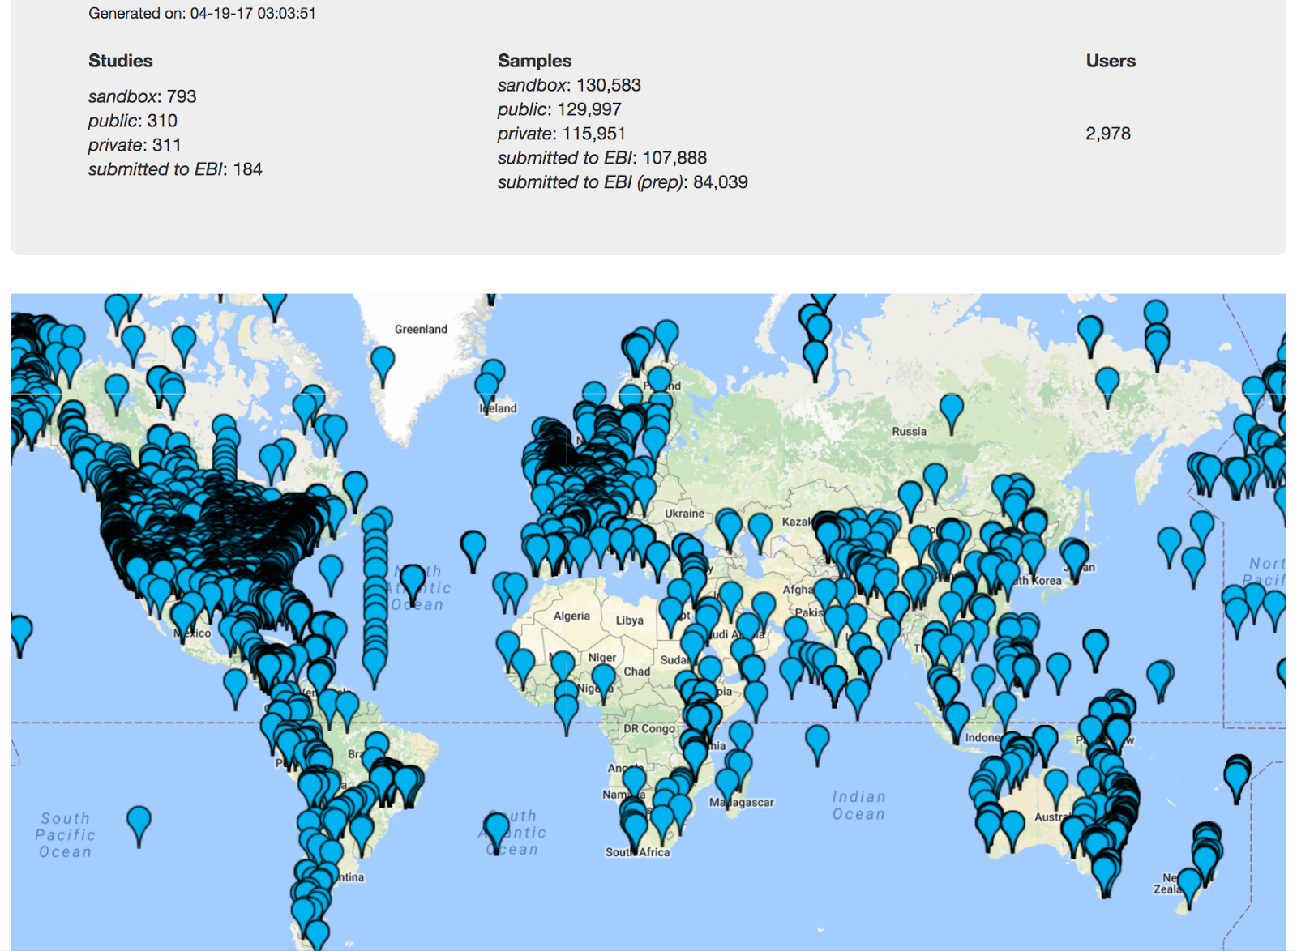

41



42

https://lh3.googleusercontent.com/-kFJSFXfmMMoVxa30eVLxp0vDNcBsDTJsw02ApexY6KxjOQ9JCIZq4WCzyAPrTBe13X0xY-0RKBImsfz4krVORiu1BZc7cRTxPBP0_4lvoYNF26_AP8swrPe3dwEKxIjK4LQ2Dyk

43

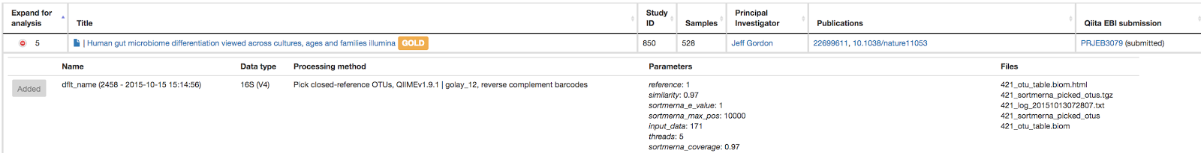

44

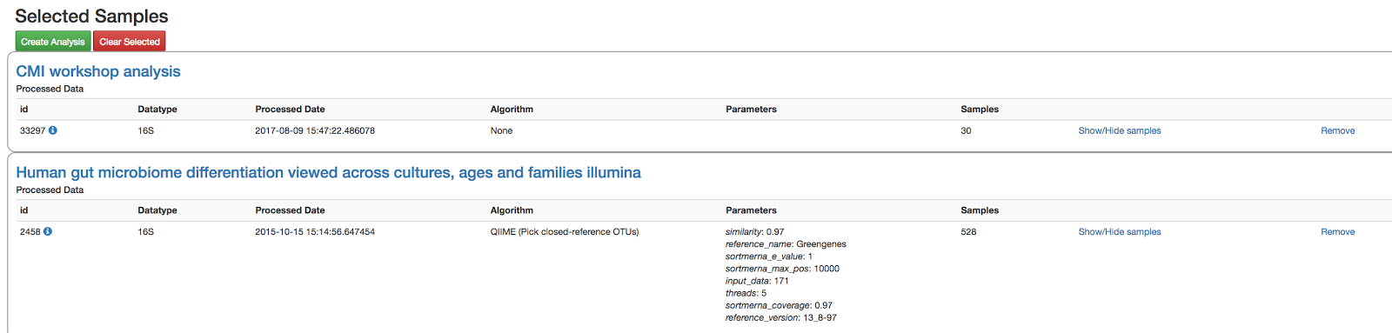

45

