Checklist for environment of the fluorescence python toolkit

Author: Yongmin Hu ([Yongmin.Hu@eawag.ch](mailto:Yongmin.Hu@eawag.ch), yongminhu@outlook.com)

Last update: 2021-03-07

1. Install Anaconda 3 individual version:

<https://www.anaconda.com/products/individual>

1. Open Anaconda Navigator:
   1. Install Jupyter notebook (use the default settings)
   2. Check the “Environment” tab:

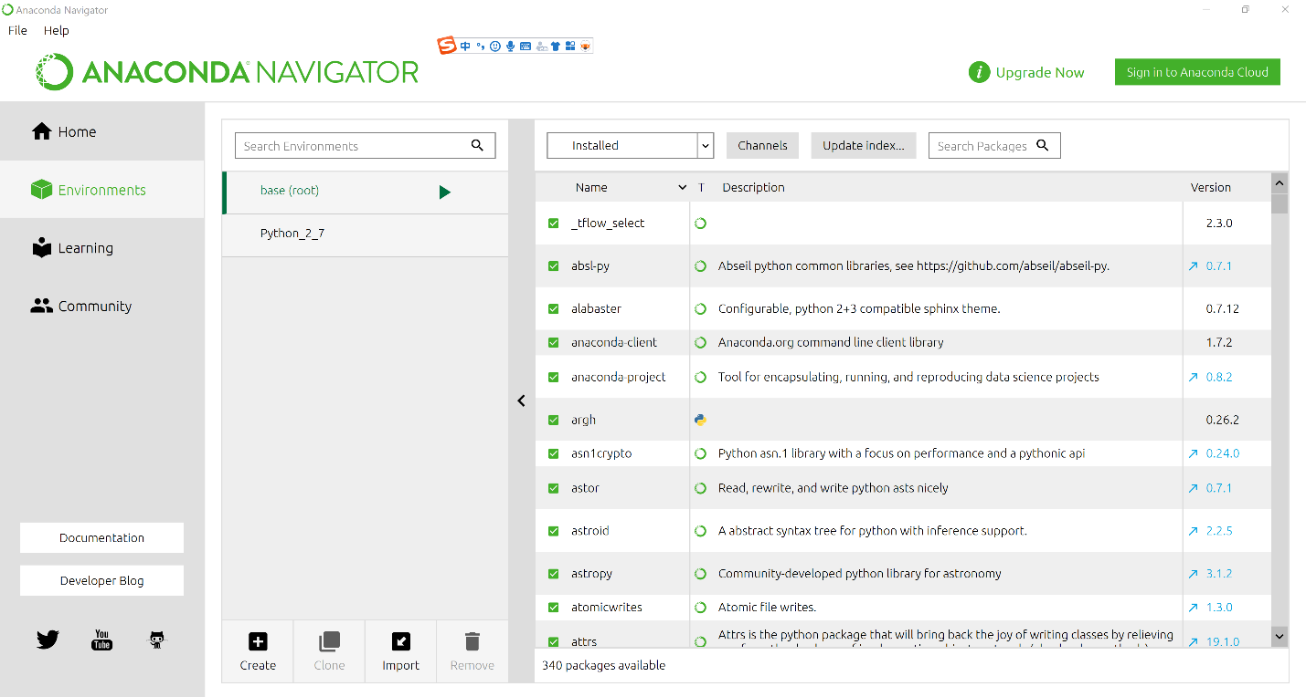

The default environment is “base”, which uses python 3.8 by default.

You can see all the packages installed in the environment. The user can update or install some of the packages here, but I personally recommend installing the packages via pip (See step 3).

You can define your own environment with different python version, but the base environment is suitable for the fluorescence analysis

1. Install necessary packages:
   1. Open Anaconda Prompt

Make sure you are in the correct environment (e.g. base). To change the environment, enter “conda activate your_environment_name”

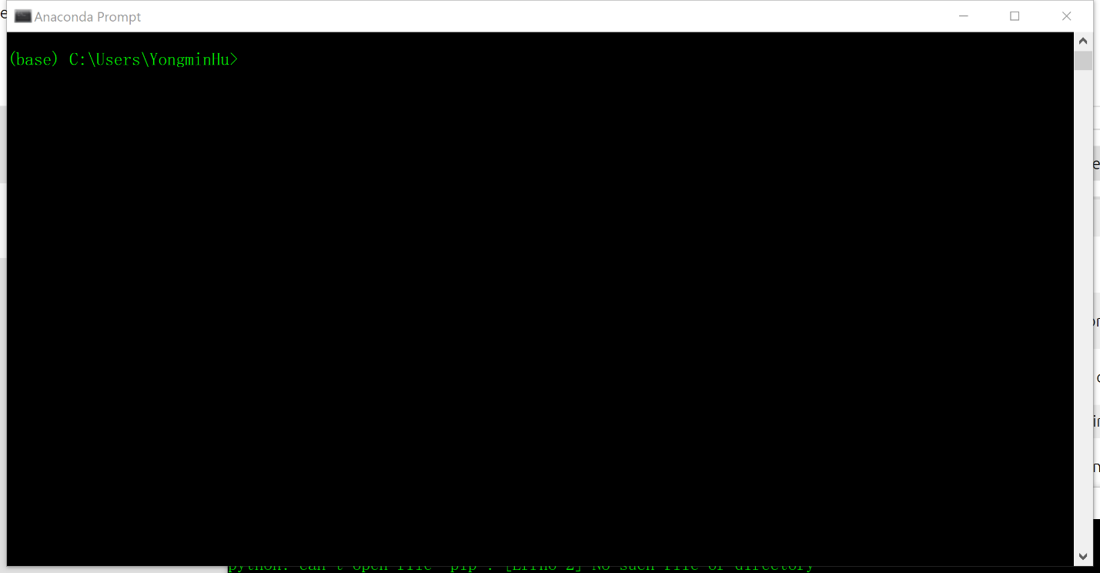

* 1. Install or update necessary packages
     1. Install or update pip

Enter “conda install pip”.

pip is a package-management system written in Python used to install and manage software packages.

* + 1. Install packages via pip

Enter “pip install package_name”. Here the necessary packages needed for the fluorescence analysis:

|  |  |
| --- | --- |
| Package name | Description |
| numpy | Basic calculation and statistics |
| scipy |
| sklearn | Basic statistical analysis/machine learning |
| opencv-python | Image processing |
| tensorly | Tensor algebra/machine learning |
| matplotlib | Plotting |
| pandas | Data structure tool |
| ipywidgets | Interactive interface for Jupyter notebook |

1. Change the default browser for Jupyter notebook

On chrome, some interactive components of notebook have large response delay. So it is recommended to use Microsoft Edge (which is installed by default in Windows 10):

* 1. Launch PowerShell or CMD (type “cmd” in the windows start menu)
  2. Type the command jupyter notebook --generate-config
  3. Locate the generated configuration file in the path "C:\Users\XXXX.jupyter\jupyter_notebook_config.py" and open it with notepad/any text editor.
  4. Find the line *#c.NotebookApp.browser=’’* . Change it to c.NotebookApp.browser = 'C:/Program Files (x86)/Microsoft/Edge/Application/msedge.exe %s'. (To the right of the equal sign is the installation location of Microsoft edge)

1. Run the scripts on Jupyter notebook
   1. Ensure you put “EEMprocessing.py” and “read_data.py” together with “EEM_python_toolkit.ipynb” together in the same folder.
   2. Open Jupyter notebook from the windows start menu (or any other shortcut, no need to open Anaconda Navigator first).
   3. Open “EEM_python_toolkit.ipynb” in the Jupyter notebook explorer window. You would see that the script is divided into blocks. Run the first modular, if you see error like this, it means package is missing. You should go back to step 3 to install the necessary packages:

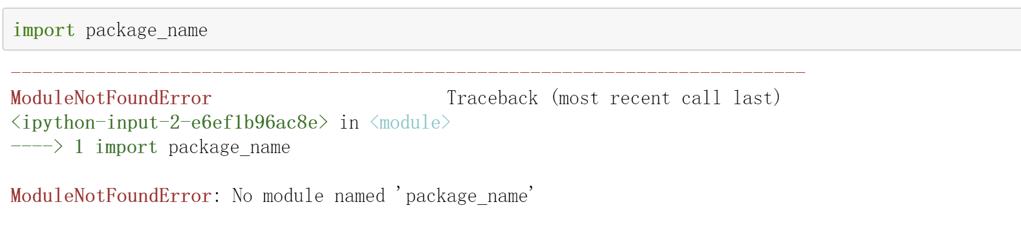

* 1. If you modify the file to import (e.g. EEMprocessing.py, utils.py), please restart the kernel by clicking “restart”. This is because the system would automatically ignore the imported external modules if the names of these modules do not change.