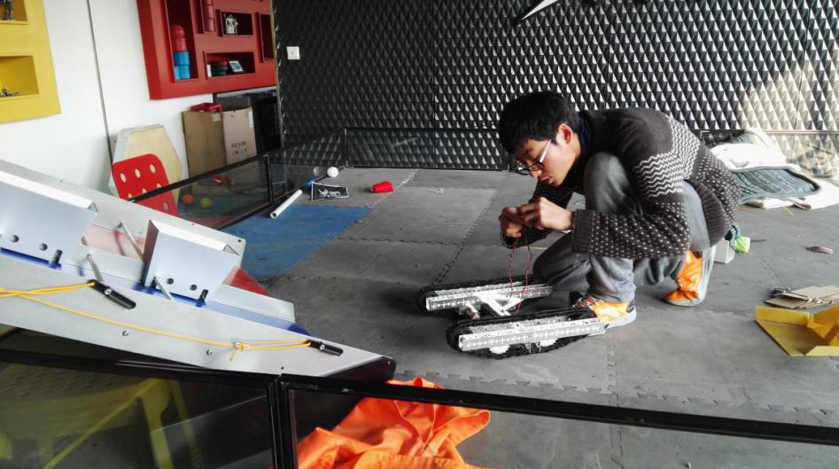 I learned from the basic chassis and connect electric strings by hands for the lack of programming.

(2015.11)

As the captain, I needed to learn all the required skills including sketching, measuring and programming.(2016.1)

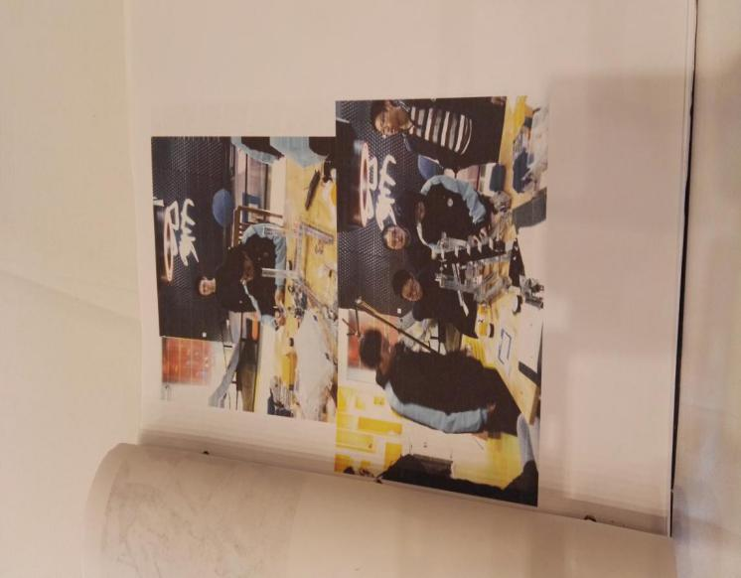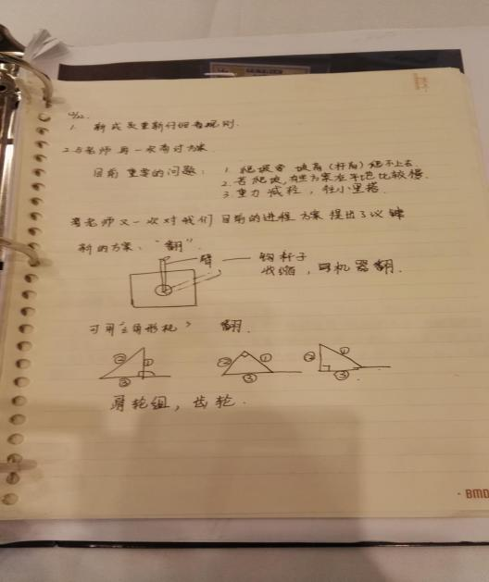

My first time using programming to bestow lifeless machines the abilities to solve real problems.(2016.2)

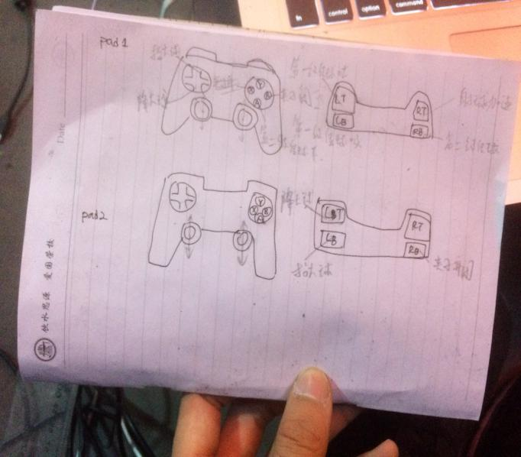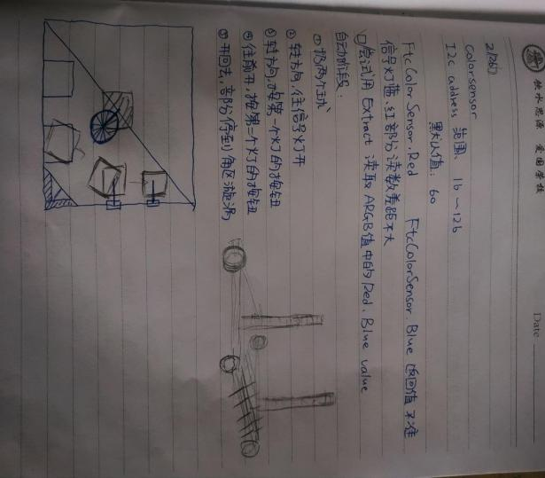

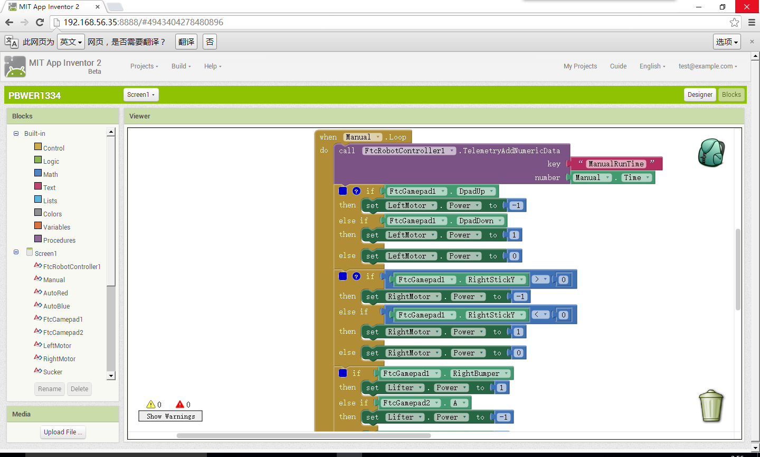

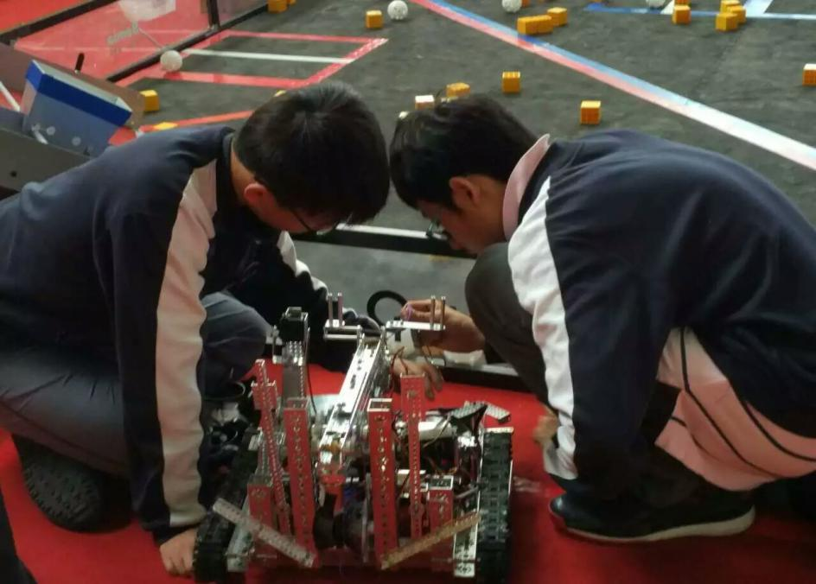

Persistent practice makes the batman’s mechanical hook come true, but the efficiency of it is not optimal so though we are reluctant, we have to find new ways.

(2016.4)

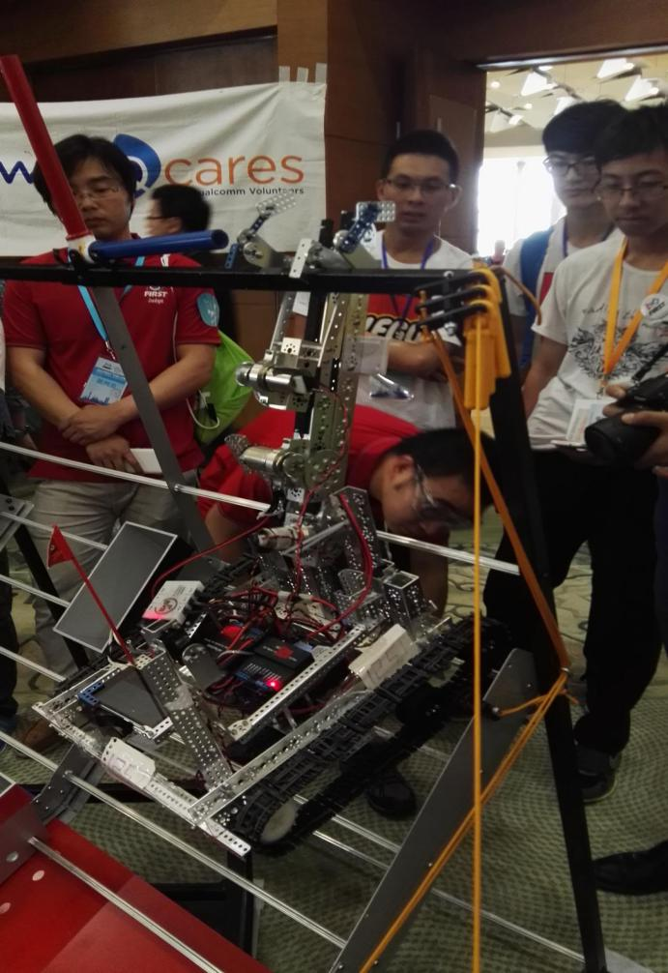

Finally, we replaced the batman’s mechanical hook with more stable racks, though this might not be our initial passion, we are rewarded to consider more about the real functions of the robots of how to use the most efficient and reliable ways to solve real problems.(2016.6)

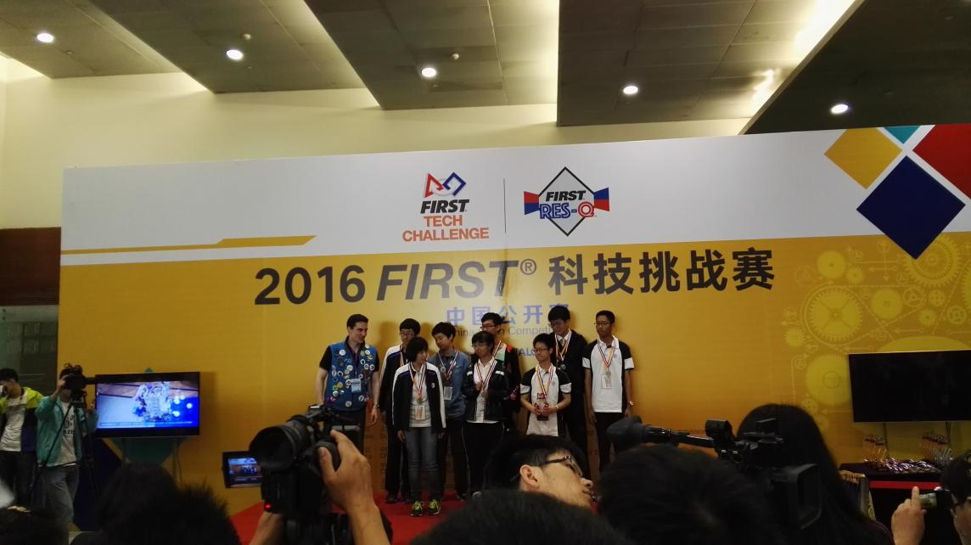

We gain the first price of FTC China Open 2016 (2016.6)

In 2017, I became the coach of the robotic team!

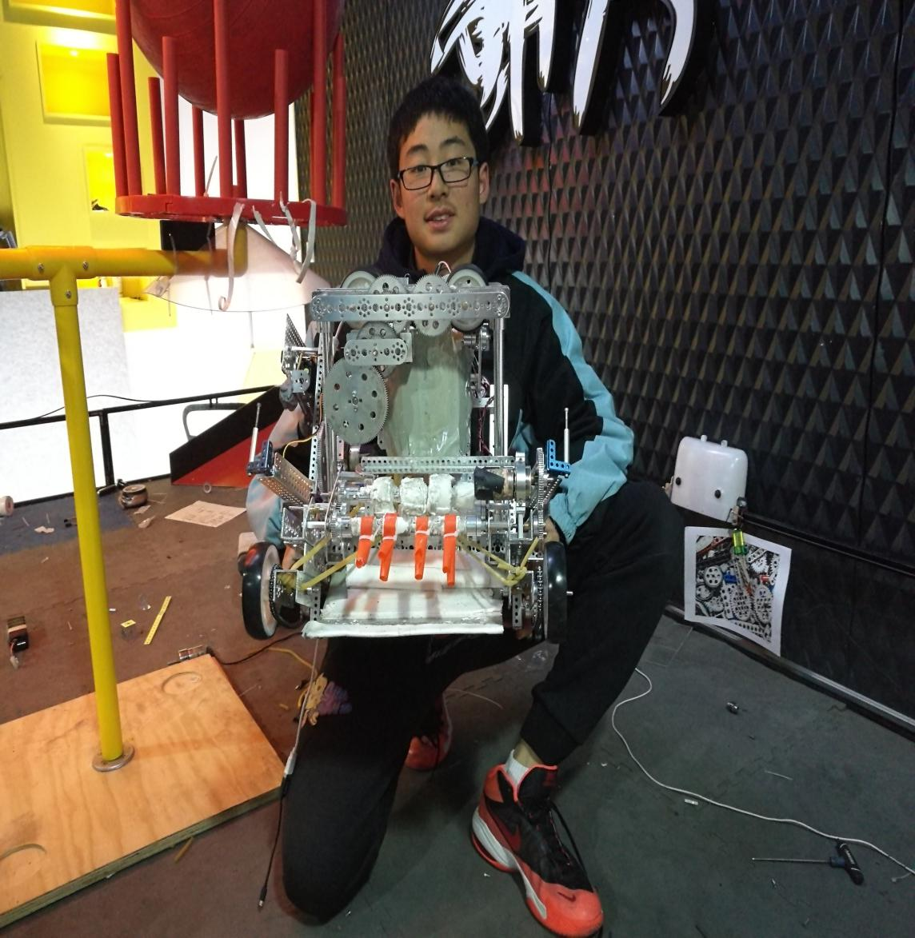

We tried something new!

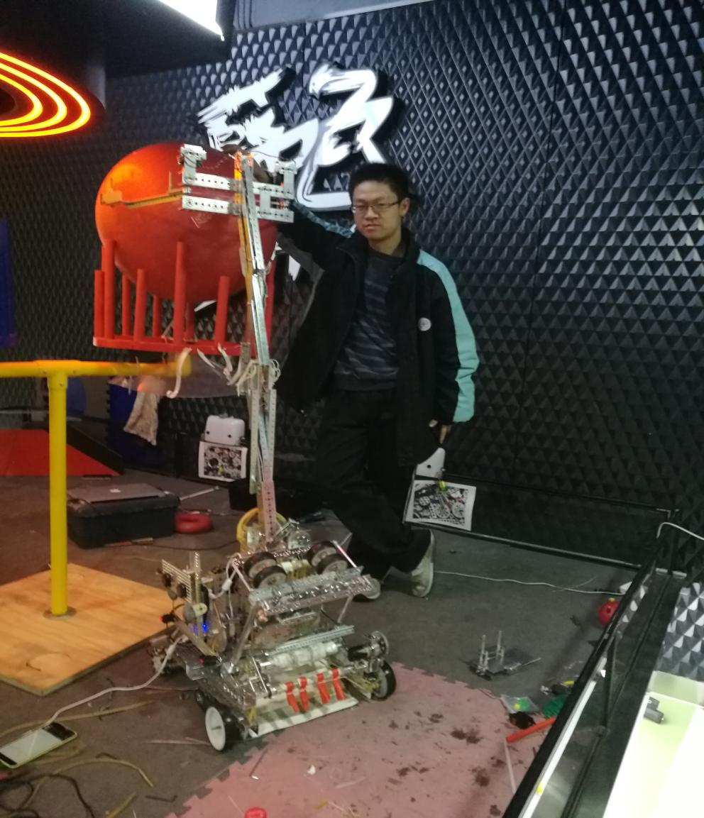

And this time, we get better! Won the Second Place Championship!

