Assignment 1 – DDL and DML (25 pts)

1. Using the provided MS Access database (SalesCo.mdb) please recreate the following objects in an MS SQL Server Database:
   1. Tables
   2. Attributes
2. Run the provided INSERT INTO statements found in the DataInsert.sql script
3. Alter all tables to include referential integrity with cascading updates and deletes. The Primary and Foreign Keys should match the ERD shown below

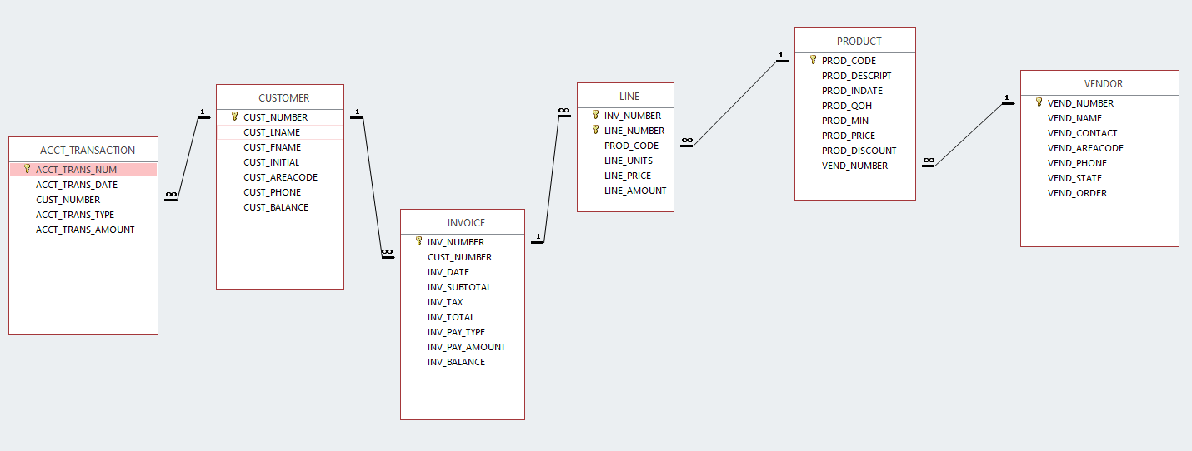

1. Recreate the following two queries found in the MS Access database provided as Views in the MS SQL database
   1. qryCustomer-Invoice-Transactions-Grouped-by-Customer
   2. qryList-all-Purchases-and-Group-by-Customer
2. Create the required DDL to recreate the MS SQL Database in a single script:
   1. Tables
   2. Columns/Attributes
   3. Constraints (PK, FK)
   4. Views

Please submit the following in Brightspace:

1. Screen capture image (database.png) of the MS SQL database and tables
2. Screen capture of the output of the two Views created in your MS SQL database (CustInvoiceQuery.png; Purchases.png)
   1. qryCustomer-Invoice-Transactions-Grouped-by-Customer
   2. qryList-all-Purchases-and-Group-by-Customer
3. A composite script containing SQL code to recreate the database. The script should include the creation of the following database objects:
4. Tables
5. Columns/Attributes
6. Constraints (PK, FK)
7. Views

The assignment is due on Friday, 26 Feb 2021 at midnight.

Grading Rubric

|  |  |  |  |
| --- | --- | --- | --- |
| Grades |  | | |
| 1 | Database Image of Tables Provided (1pt) | | Database Image of Tables not Provided (0 pts) |
| 2 | Both Views (CustInvoiceQuery.png; Purchases.png) Included and showing Correct results in MS SQL (4pts) | Both Views (CustInvoiceQuery.png; Purchases.png) Included but not showing correct results (2pts) | Views not provided (0pts) |
| 3 | 1 pt for each correct (Total pts 20):  Table (Attribute included)-6pts,  Primary Key-6pts,  Foreign Key-6pts,  and View 2pts | | Script not provided (0pts) |