Assignment 2 – MS PowerBI and SSRS (100pts)

**-SSRS-**

1. Create a SSRS Report using the Report Builder. A sample pdf Report is provided (CovidStatus.pdf). You will need to import the MS Excel files provided in Brightspace into MS SQL Server.
2. b. Please import and create a Table for the following data sheet in the CovisData.xls file. Please provide a screen capture of your tables below(5pts).
3. Please provide the SQL code used to create each View listed below (20pts) in a separate sql file (name the file “views.sql”)

|  |  |
| --- | --- |
| vwCases_per10000 | vwDeaths_per10000 |
|  |  |
| vwVaccines_per10000 | 1. vwSummary |
|  |  |

1. In the SSRS Report Builder create the following Data Source connection to your [Covid] Database (3pts):

1. Please create a dataset which gets the last report date from your Cases Table in the Covid Database (2pts):

1. Please create datasets in SSRS Report Builder to the following views (5pts):
   1. Graphical user interface, application

      Description automatically generatedCases
   2. Vaccines
   3. Mortality
   4. Summary
2. Using the datasets previously created, please recreate the attached CovidStatus.pdf (35pts).

**Please submit to BrightSpace both a pdf export of your report as well as your “CovidStatus.rdl” file.**

**-Power BI-**

1. Using the provided dataset on Crimes occurring in Vancouver

[(https://www.kaggle.com/wosaku/crime-in-vancouver?select=crime.csv)](https://www.kaggle.com/wosaku/crime-in-vancouver?select=crime.csv), please import the data into MS SQL Server Please provide a screenshot image of your imported table.

1. Please also include a select query that counts all rows as provided in the image below. The Image provided through BrightSpace should include the expanded columns of the VancouverCrime] table as shown below. (3pts)

1. Create an MS Power BI Report called “**Crime in Vancouver**” and save it to your MS Power BI Reporting Server.(2pts) Please Provide a Screen Capture below of the file.

1. Create 2 pages for your Power Bi Report

Please ensure that the Bar chart is a cumulative percentage for each Year and that all Years are shown. For the Tablix, please only show Years 2010-2017 and exclude all Neighbourhoods with NULL/BLANK Names. The Neighbourhood column should be sorted alphabetically. **Please submit a pdf copy of your report in Brightspace.**

Page 1

* + 1. Crime by Year Bar Chart (10 pts) – showing a bar chart of Year and Offenses. Please include the Legend and data as follows:

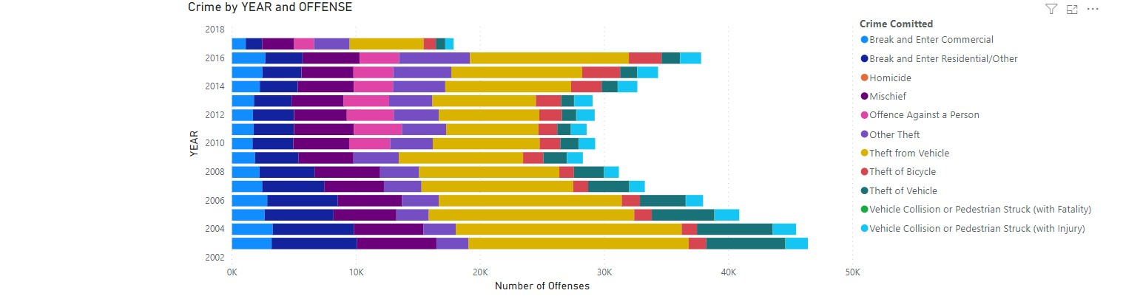

You are required to ensure that your chart, x and y axes are titled exactly as above, and your legend should be on the right and titled **Crime Committed**

* + 1. A picture containing table

       Description automatically generatedPlease Create a Matrix that includes Offense by Year (5pts)

Page 2

Include a Map showing all locations of Crimes occurring in Vancouver (10 pts).

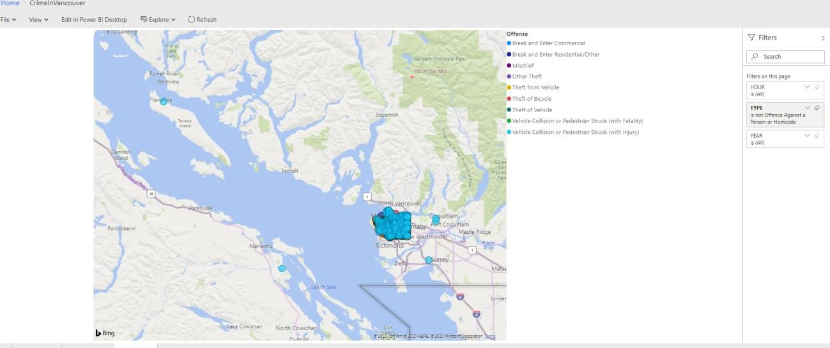

Please ensure that the map can be filtered by: HOUR, CRIME TYPE, and YEAR. The map needs to include a Legend with the Title “Offense”.

Your Brightspace Submission should include the following:

* 1. A screenshot image (png) of VancouverCrime table, and query in your MS SQL Server Database
  2. The sql code to create the 4 views required to produce the CovidStatus.rdl datasets
  3. A screenshot image (png) of your newly created Report on your Power BI Reporting Server
  4. A pdf copy of both the SSRS and PowerBI Reports (CovidStatus.pdf, VancouverCrime.pdf)
  5. Your CrimeInVancouver.pbix and CovidStatus.rdl files

The Assignment 2 will be due on Sun, 14th November @ midnight. If you are not clear on the requirements of this assignment please contact me as soon as possible so that I can help clarify things.