The Microbiome Protocols eBook (MPB) Initiative: Building a bridge to microbiome research

Yong-Xin Liu1,2,3,*, Feng Chen4, Tong Chen5, Yangfen Cheng6, Ye Deng7, Fanglian He8, Meng Li9, Shuang-Jiang Liu10, Hongye Lu4, Tengfei Ma6, Yuan Qin1,2,3, Zhong Wei6, Tao Wen6, Jiqiu Wu11, Jun Yang12, Ruifu Yang13, Zhilin Yuan14, Maosheng Zheng15, Hongwei Zhou16, Huaiqiu Zhu17, Yong-Guan Zhu12, Baoli Zhu10 , Haiyan Chu18,19,*, Yang Bai1,2,3,18,*

1. State Key Laboratory of Plant Genomics, Institute of Genetics and Developmental Biology, Innovation Academy for Seed Design, Chinese Academy of Sciences, Beijing, China
2. CAS Center for Excellence in Biotic Interactions, University of Chinese Academy of Sciences, Beijing, China
3. CAS-JIC Centre of Excellence for Plant and Microbial Science, Institute of Genetics and Developmental Biology, Chinese Academy of Sciences, Beijing, China
4. Peking University School and Hospital of Stomatology, Beijing, China
5. National Resource Center for Chinese Materia Medica, China Academy of Chinese Medical Sciences, Beijing, China
6. Nanjing Agricultural University, Nanjing, China.
7. Research Center for Eco-Environmental Sciences, Chinese Academy of Sciences, Beijing, China
8. Bio-protocol Journal
9. Shenzhen Key Laboratory of Marine Microbiome Engineering, Institute for Advanced Study, Shenzhen University, Shenzhen, China
10. Institute of Microbiology, Chinese Academy of Sciences, Beijing, China
11. Department of Life Sciences, Imperial College London, Silwood Park Campus, Ascot, Berkshire SL5 7PY, UK
12. Key Laboratory of Urban Environment and Health, Institute of Urban Environment, Chinese Academy of Sciences, Xiamen, China
13. State Key Laboratory of Pathogen and Biosecurity, Beijing Institute of Microbiology and Epidemiology, Beijing, China
14. Institute of Subtropical Forestry, Chinese Academy of Forestry, Hangzhou, China
15. College of Environmental Science and Engineering, North China Electric Power University, Beijing, China
16. State Key Laboratory of Organ Failure Research, Microbiome Medicine Center, Division of Laboratory Medicine, Zhujiang Hospital, Southern Medical University, Guangzhou, China
17. Center for Quantitative Biology, Peking University, Beijing, China
18. University of Chinese Academy of Sciences, Beijing, China
19. State Key Laboratory of Soil and Sustainable Agriculture, Institute of Soil Science, Chinese Academy of Sciences, Nanjing, China

Contributing authors are listed in alphabetical order by last name

*Correspondence: [yxliu@genetics.ac.cn](mailto:yxliu@genetics.ac.cn); [hychu@issas.ac.cn](mailto:hychu@issas.ac.cn); [ybai@genetics.ac.cn](mailto:ybai@genetics.ac.cn)

The microbiome is an research area that studies the omics of the microbe1 with rapid development in the past decades, making breakthroughs in the microbiological studies in human2, animals3 and plants4 as hosts, and the environments5. The concept of microbiome has been extended to various fields. Thousands of microbiome articles are published every year, changing our conventional understanding of the microbes in medicine, agriculture, and industry. At present, a series of standardized analysis software and protocols for microbiome studies have been published. More specifically, QIIME26 is an integrated pipeline for microbiome data analysis, Minimum Information about any (x) Sequence (MIxS) is the standard of submitting microbiome sequences7, Critical Assessment of Metagenome Interpretation8 provides the standards of assessing metagenomics software. However, systematic protocol references for wet-lab experiments and data analysis are still lacking. Many problems impede the progress of experiments or analysis in this area, such as the need to optimize the experimental system, the difficulty to compare the results produced by different methods or protocols. To solve these problems, we initiative the Microbiome Protocols eBook (MPB).

The MPB was launched by Bio-protocol editorial office China and WeChat subscription "meta-genome", one of the largest microbiome communities with more than 118,000 members (June 2021). The Bio-protocol journal provides peer-review and open access publication free of charge. The MPB aims to promote the communications and cooperations between researchers and research teams to summarize, share, and dissemination the protocols in the microbiome area. We hope this project will bridge the gaps in microbiome protocols to solve the problems of wet experiments and data analysis, and to prepare for the accumulation of standard data for big data integrated analysis in the near future. In summary, the MPB will greatly facilitate the development of the microbiome area. The project homepage link is <https://bio-protocol.org/bio101/mpb>.

The topics of MPB are the protocols of microbiome, including culturome9, amplicon10, metagenome11, metatranscriptome12, virome13, metaproteome, metabolome, microbe genome, related molecular biology and microbiology experiments, and the upstream and downstream related experiments and analysis of microbiome (Figure 1). According to the research objects, it mainly includes the microbiome in humans, animals, plants, and the environment (Figure 1). According to the research methods, it mainly includes sample preparation, nucleic acid extraction, protein and metabolite extraction, sequencing library preparation, microbial culture and identification, synthetic community, axenic system, data analysis, and general microbiology experiments and analysis (Figure 1).

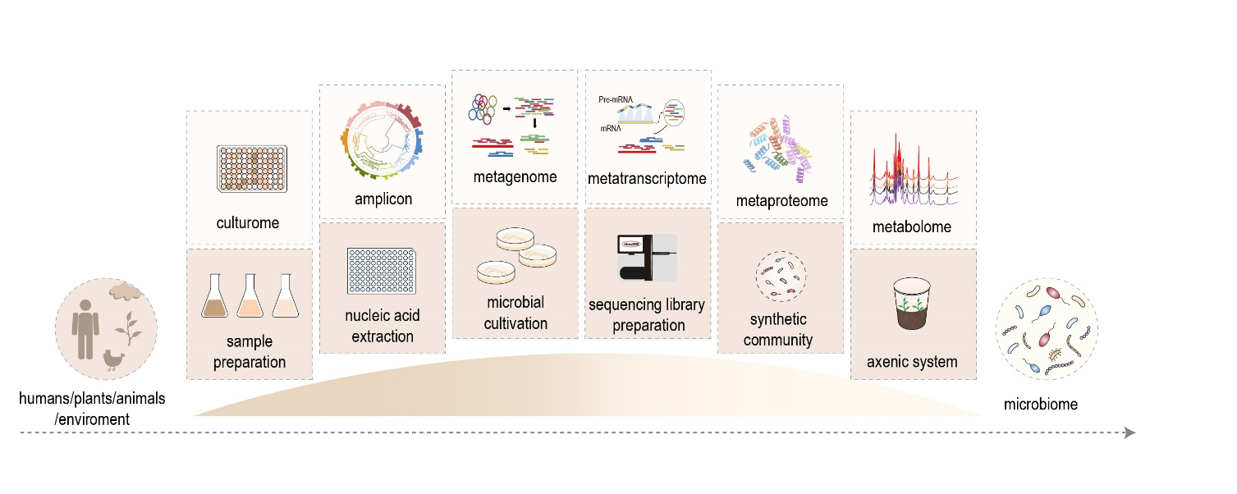

Figure 1. Microbiome Protocols eBook—Building a bridge to microbiome research.

Since the first announcement of MPB in July 2020, more than 200 researchers from more than 100 institutes or universities have been involved in the MPB, including the Institute of Genetics and Developmental Biology, Institute of Soil Science，Institute of Microbiology, Research Center for Eco-Environmental Sciences, and Institute of Urban Environment of Chinese Academy of Sciences, Chinese Academy of Agricultural Sciences, Peking University, Tsinghua University, Zhejiang University, Sun Yat-sen University, China Agricultural University, Shandong University, Yangzhou University, Westlake University, Nanjing Agricultural University, etc. At present, MPB 1st edition has published more than 120 protocols and the collection will be released in August 2021. MPB is open-access, and anyone can access it through various channels such as the Bio-protocol Journal, WeChat, CSDN, etc.

To keep the quality, diversity, and timeliness, the MPB is set up as a long-term project and plan to update biennially. The published protocols can be found on the project homepage. We sincerely invite more researchers to participate in this project. Any protocols related to the microbiome are welcome, especially for the commonly used or cutting-edge protocols. We hope MPB becomes a protocol encyclopedia and helpful tool for microbiome researches.

1 Berg, G. *et al.* Microbiome definition re-visited: old concepts and new challenges. *Microbiome* **8**, 103, doi:10.1186/s40168-020-00875-0 (2020).

2 Almeida, A. *et al.* A unified catalog of 204,938 reference genomes from the human gut microbiome. *Nat. Biotechnol.*, doi:10.1038/s41587-020-0603-3 (2020).

3 Chen, C. *et al.* Expanded catalog of microbial genes and metagenome-assembled genomes from the pig gut microbiome. *Nat. Commun.* **12**, 1106, doi:10.1038/s41467-021-21295-0 (2021).

4 Liu, Y.-X., Qin, Y. & Bai, Y. Reductionist synthetic community approaches in root microbiome research. *Curr. Opin. Microbiol.* **49**, 97-102, doi:10.1016/j.mib.2019.10.010 (2019).

5 Nayfach, S. *et al.* A genomic catalog of Earth’s microbiomes. *Nat. Biotechnol.* **39**, 499-509, doi:10.1038/s41587-020-0718-6 (2021).

6 Bolyen, E. *et al.* Reproducible, interactive, scalable and extensible microbiome data science using QIIME 2. *Nat. Biotechnol.* **37**, 852-857, doi:10.1038/s41587-019-0209-9 (2019).

7 Roux, S. *et al.* Minimum Information about an Uncultivated Virus Genome (MIUViG). *Nat. Biotechnol.* **37**, 29-37, doi:10.1038/nbt.4306 (2019).

8 Meyer, F. *et al.* Tutorial: assessing metagenomics software with the CAMI benchmarking toolkit. *Nat. Protoc.*, doi:10.1038/s41596-020-00480-3 (2021).

9 Zhang, J. *et al.* High-throughput cultivation and identification of bacteria from the plant root microbiota. *Nat. Protoc.* **16**, 988-1012, doi:10.1038/s41596-020-00444-7 (2021).

10 Liu, Y.-X., Chen, T., Zhou, X. & Bai, Y. EasyAmplicon: an easy-to-use, reproducible and cross-platform pipeline for amplicon analysis *Bio-protocol*, e2003641, doi:10.21769/BioProtoc.2003641 (2021).

11 Liu, Y.-X., Liu, F., Chen, T. & Bai, Y. Analysis Pipeline and Frequently Asked Questions of Quality Control and Host Removal in Shotgun Metagenomic Sequencing. *Bio-101*, e2003347, doi:10.21769/BioProtoc.2003347 (2020).

12 Zhang, L., Lian, Z. & Chu, H. Sample pretreatment and data analysis of soil metatranscriptome *Bio-protocol*, e2003543, doi:10.21769/BioProtoc.2003543 (2021).

13 Han, L., Bi, L., Yu, D., Zhang, L. & He, J. Enrichment and DNA extraction of soil virome *Bio-protocol*, e2003702, doi:10.21769/BioProtoc.2003702 (2021).