Microbiome Protocols eBook (MPB) Initiative: Building a bridge to microbiome research.

Yong-Xin Liu1,2,3,*, Haiyan Chu4,5,*, He Fanglian，Yang Bai1,2,3,5, Feng Chen6, Tong Chen7, Yangfen Cheng8, Ye Deng9, Meng Li10, Shuangjiang Liu11, Yuan Qin1,2,3, Zhong Wei8, Jun Yang12, Ruifu Yang13, Zhilin Yuan14, Maosheng Zheng15, Hongwei Zhou16, Huaiqiu Zhu17, Yongguan Zhu12, Baoli Zhu11

1. State Key Laboratory of Plant Genomics, Institute of Genetics and Developmental Biology, Innovation Academy for Seed Design, Chinese Academy of Sciences, Beijing, China
2. CAS Center for Excellence in Biotic Interactions, University of Chinese Academy of Sciences, Beijing, China
3. CAS-JIC Centre of Excellence for Plant and Microbial Science, Institute of Genetics and Developmental Biology, Chinese Academy of Sciences, Beijing, China
4. State Key Laboratory of Soil and Sustainable Agriculture, Institute of Soil Science, Chinese Academy of Sciences, Nanjing, China
5. University of Chinese Academy of Sciences, Beijing, China
6. Bio-protocol Journal
7. Central Laboratory, Peking University School and Hospital of Stomatology, National Clinical Research Center for Oral Diseases, National Engineering Laboratory for Digital and Material Technology of Stomatology, Beijing Key Laboratory of Digital Stomatology, Beijing, China
8. National Resource Center for Chinese Materia Medica, China Academy of Chinese Medical Sciences, Beijing, China
9. Nanjing Agricultural University, Nanjing, China.
10. Research Center for Eco-Environmental Sciences, Chinese Academy of Sciences, Beijing, China
11. Shenzhen Key Laboratory of Marine Microbiome Engineering, Institute for Advanced Study, Shenzhen University, Shenzhen, China
12. Institute of Microbiology, Chinese Academy of Sciences, Beijing, China
13. Key Laboratory of Urban Environment and Health, Institute of Urban Environment, Chinese Academy of Sciences, Xiamen, China
14. State Key Laboratory of Pathogen and Biosecurity, Beijing Institute of Microbiology and Epidemiology, Beijing, China
15. Institute of Subtropical Forestry, Chinese Academy of Forestry, Hangzhou, China
16. College of Environmental Science and Engineering, North China Electric Power University, Beijing, China
17. State Key Laboratory of Organ Failure Research, Microbiome Medicine Center, Division of Laboratory Medicine, Zhujiang Hospital, Southern Medical University, Guangzhou, China
18. Center for Quantitative Biology, Peking University, Beijing, China

*Correspondence: [yxliu@genetics.ac.cn](mailto:yxliu@genetics.ac.cn); [hychu@issas.ac.cn](mailto:hychu@issas.ac.cn);

The microbiome is a field of research on omics of microbe1, and has developed rapidly in the past decades and made breakthroughs in humans2, animals3, plants4, and enviroment5, which is extending various traditional fields, changing the way of understanding of medicine, biology, and geography. At present, a series of standardized analysis software and protocols have been published, such as QIIME6, MicrobiomeAnalyst7, etc., which have greatly accelerated the development of this field. In addition, large-scale microbiome project have been launched, including the Human Microbiome Project, Earth Microbiome Project, and Chinese Academy of Sciences (CAS) Initiative of Microbiome (CMI) for survey microbiome landscape, Minimum Information about any (x) Sequence (MIxS) standard for microbiome sequences8, QIIME 26 for microbiome data analysis, Critical Assessment of Metagenome Interpretation9 for assessing metagenomics software. However, systematic protocols reference for experiment and analysis is still lack. Many colleagues face the problems including optimizing experimental systems impedes progress, study difficult to reproducible, and similar results with different methods are incomparable. In order to solve these problems, we initiative the Microbiome Protocols eBook (MPB).

MPB was launch by WeChat subscription “meta-genome”，which is one of the largest microbiome community has more than 114,000 members (April, 2021). The Bio-protocol journal as the co-founder, provide peer-review, and open access publication with free of charge. The project homepage link is <https://bio-protocol.org/bio101/Special_Issue_info.aspx?siid=48>. MPB aims to promote the communication and cooperation between researchers, and advocate research teams to summary, sharing and dissemination protocols in microbiome field. We hoped this project will fill the gaps in microbiome protocols, solve the problems of experiments and analysis that are difficult to reproducible, promote experimental standardization, prepare for the accumulation of standard data for future big data integrated analysis. In summary, MPB will great facility the development of microbiome field.

The topic of MPB is focus on microbiome protocols, including culturome, amplicon, metagenome, metatranscriptome, virome, metaproteome, metabolome, metaproteome, microbe genome, related molecular biology and microbiology experiments, and upstream and downstream related experiments and analysis of microbiome (Figure 1). According to the research objects, it mainly includes humans, animals, plants, and environment (Figure 1). Classified by research methods, mainly include sample preparation, nucleic acid extraction, protein and metabolite extraction, sequencing library preparation, microbial cultivation and identification, synthetic community, axenic system, data analysis, and general microbiology experiments and analysis (Figure 1).

The primary goals of MPB 1st edition are to generate more than 100 protocols, which cover the major commonly used methods in microbiome. Since first announcement of MPB in July, 2020, more than 200 researchers from 100 Institutes or universities join in it, including the Institute of Genetics and Developmental Biology CAS, Institute of Soil Science CAS，Institute of Microbiology CAS, Research Center for Eco-Environmental Sciences CAS, Institute of Urban Environment CAS, Chinese Academy of Agricultural Sciences, Peking University, Tsinghua University, Zhejiang University, Sun Yat-sen University, Shandong University, Yangzhou University, Westlake University, Nanjing Agricultural University, etc. At present, MPB 1st edition have been were finished peer-review more 150 protocols, and will be published in July 2021. MPB is open-access, and anyone access it through various channels such as the Bio-protocol Journal, WeChat, CSDN, etc.

In order to keep the quality, diversity, and update, the MPB is setup as a long-term project and plan update biennially. The published protocols can be found on the project homepage (<https://bio-protocol.org/bio101/Special_Issue_info.aspx?siid=48>). We sincerely invite more colleagues to participate in this project. Any protocols related to microbiome are welcome, especially focuses on the commonly used or cutting-edge protocols. In the future, we hope MPB became a protocol encyclopedia and useful tools for microbiome research.

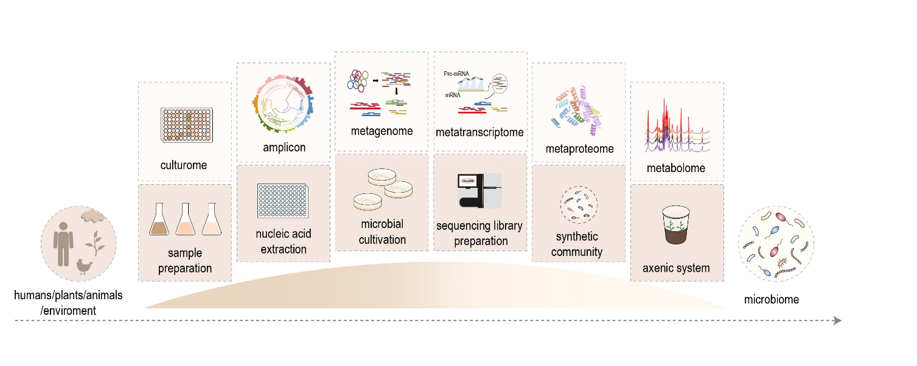

Figure 1. Microbiome Protocols eBook—Building a bridge to microbiome research.

1 Berg, G. *et al.* Microbiome definition re-visited: old concepts and new challenges. *Microbiome* **8**, 103, doi:10.1186/s40168-020-00875-0 (2020).

2 Almeida, A. *et al.* A unified catalog of 204,938 reference genomes from the human gut microbiome. *Nat. Biotechnol.*, doi:10.1038/s41587-020-0603-3 (2020).

3 Chen, C. *et al.* Expanded catalog of microbial genes and metagenome-assembled genomes from the pig gut microbiome. *Nat. Commun.* **12**, 1106, doi:10.1038/s41467-021-21295-0 (2021).

4 Liu, Y.-X., Qin, Y. & Bai, Y. Reductionist synthetic community approaches in root microbiome research. *Curr. Opin. Microbiol.* **49**, 97-102, doi:10.1016/j.mib.2019.10.010 (2019).

5 Nayfach, S. *et al.* A genomic catalog of Earth’s microbiomes. *Nat. Biotechnol.*, doi:10.1038/s41587-020-0718-6 (2020).

6 Bolyen, E. *et al.* Reproducible, interactive, scalable and extensible microbiome data science using QIIME 2. *Nat. Biotechnol.* **37**, 852-857, doi:10.1038/s41587-019-0209-9 (2019).

7 Chong, J., Liu, P., Zhou, G. & Xia, J. Using MicrobiomeAnalyst for comprehensive statistical, functional, and meta-analysis of microbiome data. *Nat. Protoc.* **15**, 799-821, doi:10.1038/s41596-019-0264-1 (2020).

8 Roux, S. *et al.* Minimum Information about an Uncultivated Virus Genome (MIUViG). *Nat. Biotechnol.* **37**, 29-37, doi:10.1038/nbt.4306 (2019).

9 Meyer, F. *et al.* Tutorial: assessing metagenomics software with the CAMI benchmarking toolkit. *Nat. Protoc.*, doi:10.1038/s41596-020-00480-3 (2021).

微生物组实验手册启动：架起各领域通过微生物组学世界的桥梁

【微生物组定义】微生物组是个研究微生物组学的领域，在过去20年快速发展，在人、动物、植物和领域均取得了突破进展。【应用和意义：本领域很重要】迄今为止，每年有万篇相关研究发展，扩展到各传统领域，改变着医学、生物学和地理的传统认识。目前，在分析领域上发表了一系列的标准化流程，如QIIME、USEARCH等极大的加速了本领域了发展。【现状和不足】【微生物组学计划发展历史、现阶段其他计划，但缺少本领域的计划】此外，HMP、EMP、中科院微生物组计划等联合项目成立，专利于基础数据库和焦点问题，但在通用实验方法、个性化的实验和分析等方面操作方法仍缺少系统的实验方法参考资料，限制着广大同行开展本领域研究，同时不同的实验方法屋本领域的方法不统一、实验难重复、和同行研究开展不可比较等众多问题。为解决存在的很多问题，我们发现起的微生物组实验手册项目。

【简介、主题、研究目的】

Bio-protocol中国编辑部联合宏基因组公众号共同发起微生物组实验方法电子书(Microbiome Protocol eBook)项目，旨在促进微生物组领域国内外华人科研团队之间的交流和合作，倡导科研团队注重实验方法的沉淀、分享与传播。希望本电子书填补微生物组领域方法空白，解决实验和分析难重复的问题，推动实验标准化，为积累标准统一的数据和未来大数据整合分析做准备，助力微生物组学研究的发展。

**eBook主题为微生物组(Microbiome)，包括培养组、扩增子、宏基因组、宏转录组、宏代谢组、单菌基因组、相关分子生物学和微生物学实验、以及微生物组学上下游相关实验和分析技术等。按研究对象分类主要包括人、动物、植物、环境、通用、土壤、水体、细菌、真菌、病毒等。按研究方法分类：主要包括样本制备、核酸提取、蛋白和代谢物提取、测序文库制备、微生物培养与鉴定、合成菌群、无菌实验、数据分析、微生物学常用实验和分析等。**

【本项目的概述：参加团队，团队的优势】

MPB第一版的主要目标是发表一百多篇实验方法，涵盖了微生物组中的主要常用方法。 自2020年7月发布MPB项目如集以来，来自100个研究所或大学的200多名研究人员加入了该计划，其中包括遗传与发育生物学研究所（IGDB）CAS，土壤科学研究所CAS，微生物研究所CAS，中国农业科学院（CAAS），生态环境科学研究中心，城市环境研究所等，北京大学，清华大学，浙江大学，中山大学，山东大学，扬州大学，西湖大学，南京农业大学等。 目前，有150多个协议已完成同行评审，而MPB第一版将于2021年7月发布。本项目文章本部开放获取，任何人可通常官网、微信、CSDN等多种途径访问

【本项目、号召、意义】

为了提高本实验手册的质量以及方法的多样化，我们诚邀更多国内外优秀华人同行参与本项目。欢迎您的来稿！创作中和正式发表的方法可以项目主页查阅。在将来，同时重点关注常用方法和前沿方法的征集和约稿。为本领域提供可参考的方法百科全书。。

左侧：人、动物、植物、环境

右侧：微生物组

中间：桥——分上下两层，上层是各组学研究手段(培养组、扩增子、宏基因组、宏转录组、宏蛋白组、宏代谢组……)作为每个桥或石头；下层为各实验方法(**样本制备、核酸提取、测序文库制备、微生物培养、合成菌群、无菌体系**……)。

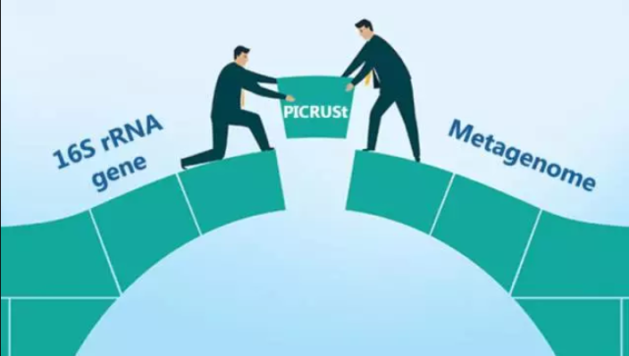

图1. 微生物组实验手册，架起各领域通过微生物组学世界的桥梁。

<https://bio-protocol.org/bio101/Special_Issue_info.aspx?siid=48>