**COMP 353 FINAL REPORT**

Submitted to

Dr. Khaled Jababo  
COMP 353-2182-F  
2018-02-12

By:

Ryan TAYLOR, 40008505  
Vicchika POU, 40033180  
Collin ZHOU, 40033295  
Yongxuan ZHANG, 40084728  
Roy SALIBA, 27381751

Group ID: eec353_2

Concordia University

Dept.of Computer Science

& Software Engineering

# E/R MODEL

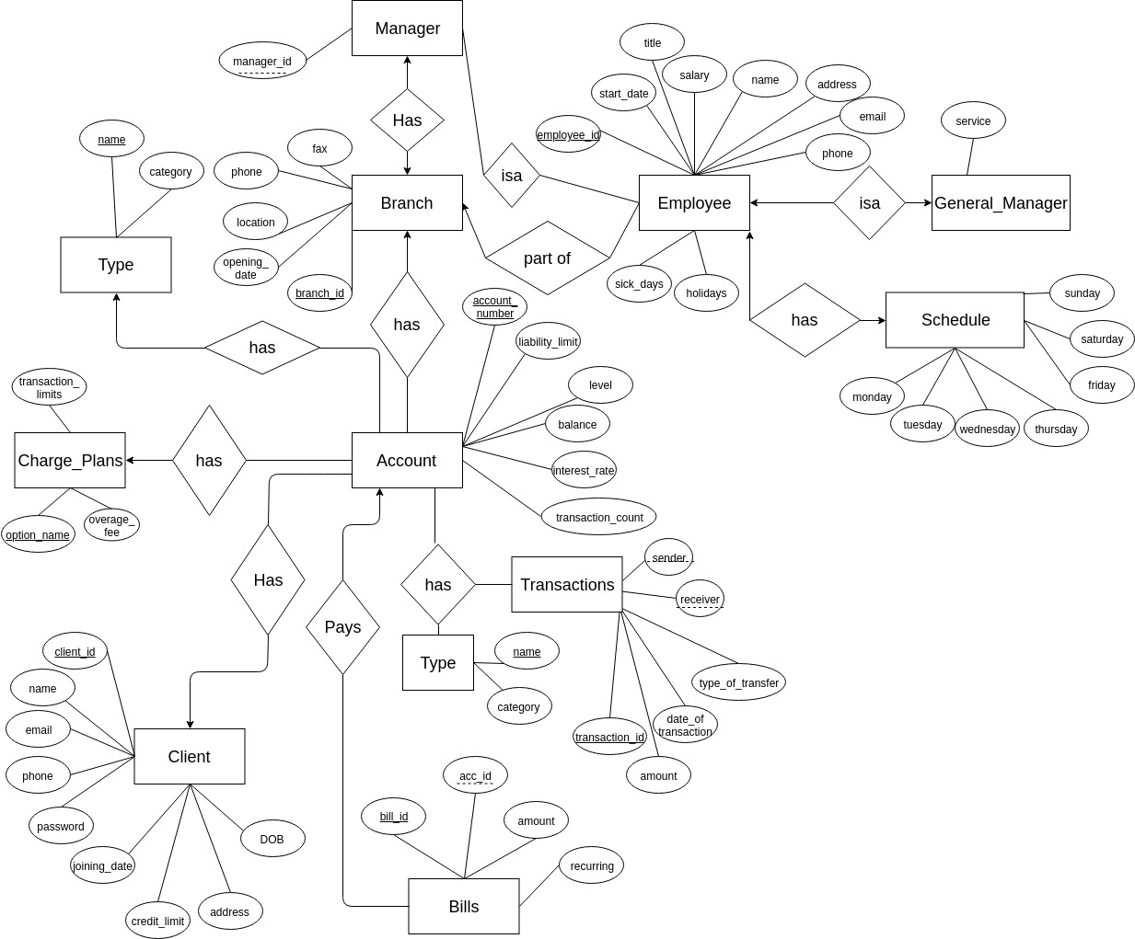

# Relational Model in 3NF

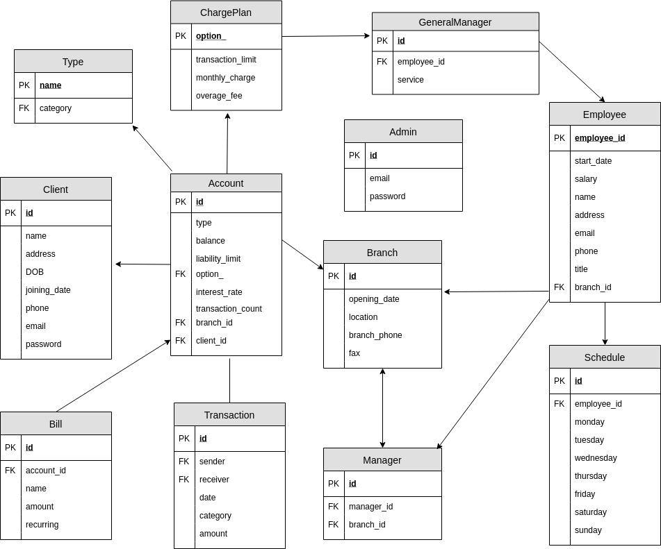

Our current model is a completely new design in comparison to our warm-up project because we felt our original design was heavily lacking in its ability to be implemented. We took into account the comments by the TA in order to make the system adequately fit the requirements. Since then, our knowledge about database organization and design has increased significantly which has resulted in a full redesign and implementation. We disregarded our warm-up project entirely while redesigning this database schema.

# Assumptions

1. All employees have a set shift from 9am to 5pm. They either work on a given day or do not.
2. All branches provide all services.
3. Overage fee is charged on a flat rate monthly basis if transaction limit is exceeded not per transaction.
4. There exists an admin account that has the power to edit/delete and access all database tables and information
5. E-transfers are made to the first available receiver account as real life e-transfers require 2FA authentication and that is outside the scope of this project.
6. Transactions are made from one account to another. In the case of billing, there is a billing account which exists solely to accumulate bill payments made by all clients. The reason for this is because in order to satisfy the requirement of having multiple bills count as one transaction, they must necessarily only have one receiving account. In real life however, billing transactions are not logged as a single transaction, rather they are separate transactions to separate accounts but may be counted as a single transaction in terms of fees.
7. Credit card limits are arbitrarily inserted as clients may have different rules applied to them based on their previous banking history and extraneous factors (eg. credit score at other banks, utility payments etc.)

# User Guide

**1. Sign In Page**

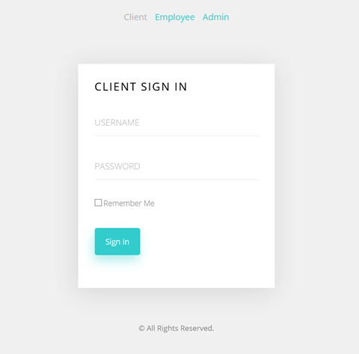

* **In this page client and Employee can sign in with their ID and password. Admin account can be signed in by Email and password.**
* **Simply click the button in the top can switch the sign in page to different user.**

**2. Client Page**

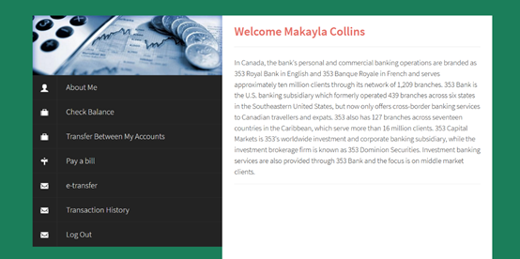

**Application Included:**

* **About Me — Check and edit client information**

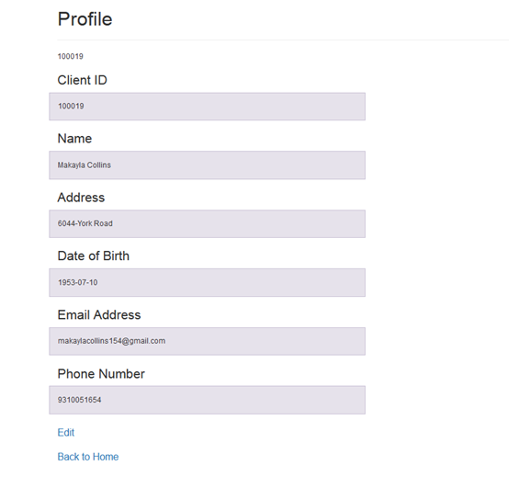

* **Check Balance — See details of the client’s account(number, balance..) and move money within accounts.**

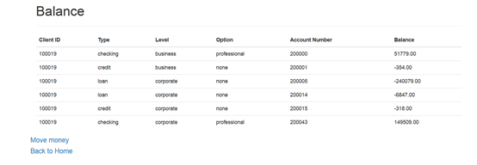

* **Transfer Between My Accounts—Move money within accounts.**
* **Pay a bill — Pay a bill instantly or set regular payment.**

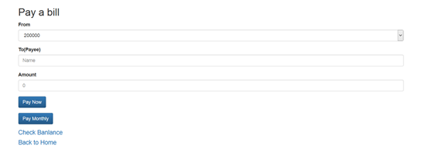

* **E-Transfer — Send money to other clients by using email or phone number.**

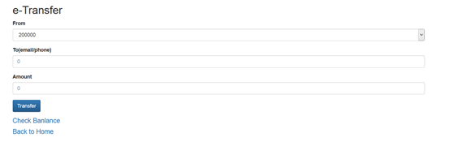

* **Transaction—View the transaction within 10 years. Any e-transfer or pay bill will be added into the transaction history.**

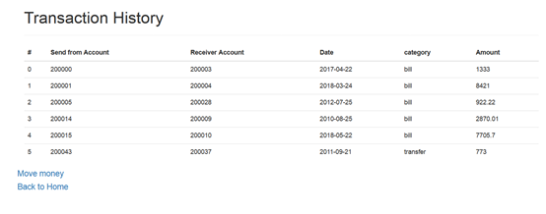

**3.Employee Page**

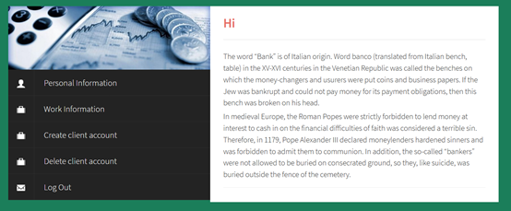

**Application Included:**

* **Personal Information—Check and edit employee information**

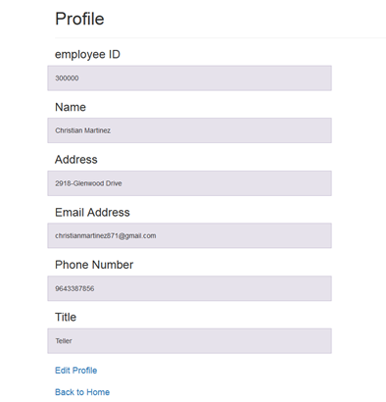

* **Work Information—check work information (salary, schedule, branch id…)**

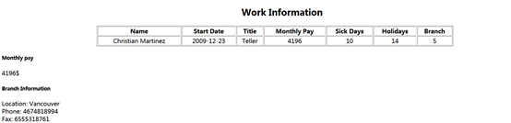

* **Create client account—create accounts for clients by entering corresponding information**

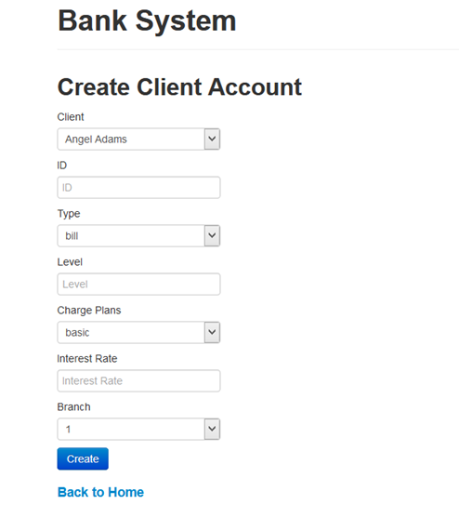

* **Delete client account—delete accounts for clients by entering corresponding information**

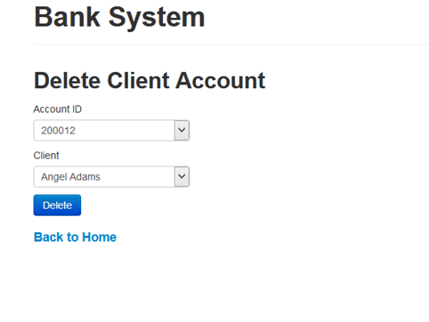

**4. Admin page**

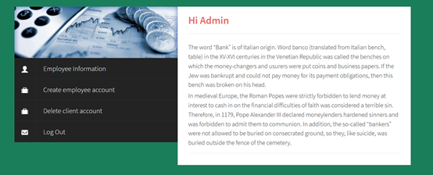

**Application Included:**

* **Employees Information—View and edit all employees’ information.And also delete employee from the database.**

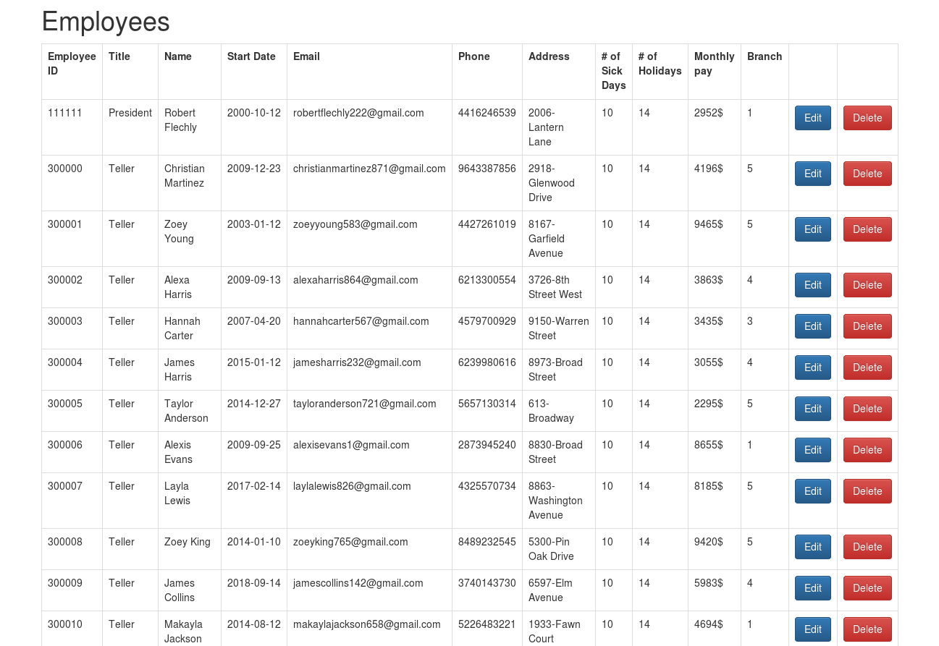

* **Create Employee account—Create account for employees by corresponding information**

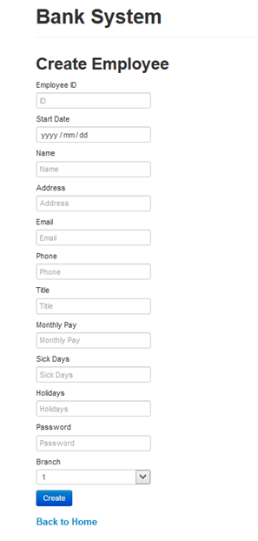

**Note: The UI of Signin and userpage are modified from templates of this website:** [**http://www.cssmoban.com/**](http://www.cssmoban.com/)**.**

**Others are done by ourselves by using bootstrap.**

# Refinement and Future Work

1. **Add forgotten constraints that allow insertion and deletion.**

**Modify the foreign key constraints add “on delete cascade on update cascade”;**

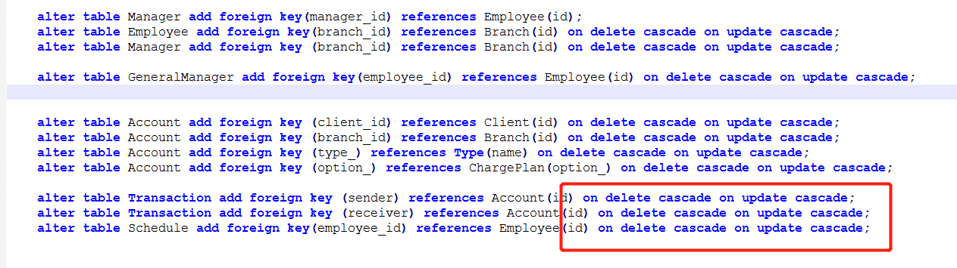

**2. Set limit for transfer money.**

**Before transfer money check the liability limit as well. If (balance-transfer amount)>liability limit then do the update.**

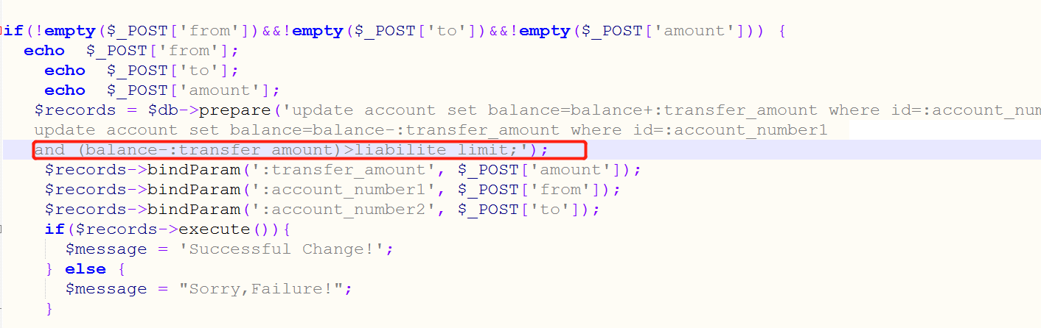

**3. Update transaction history when money is moved.**

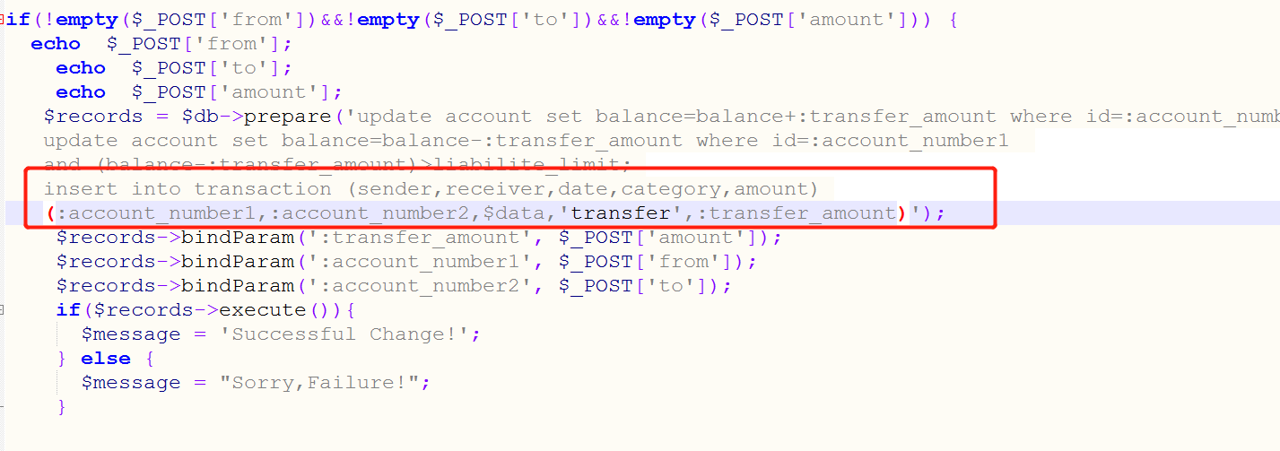

**4. Create basic account for client(Insert into Client table)**

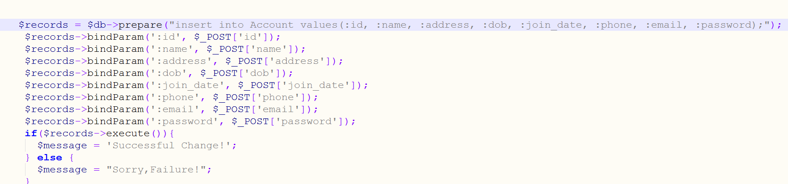

# DDL codes

See zip

# Group Member Roles

**Ryan Taylor**

* Database design and creation
* Scripts to initialize and maintain consistency of the database
* Team organization
* Report
* E/R model and Relational Model

**Collin Zhou**

* E/R model and Relational Model
* Database design and creation

**Yongxuan Zhang and Vicchika Pou and Roy Saliba**

* All the backend by using PHP
* All the User-interface logic and implementation
* Participate in Database design discussion
* Review the sql scripts and correct the errors
* Report writing related to the UI part

