**Playtest Report Document**

for

**<Sushi_Tale>**

**<Playtest1>**

**<Group name: Sushi world>**

**<Spring 2023>**

Introduction 3

Preparation 3

Execution 5

Analysis 7

1. Survey Results, 7

2. Positive discoveries 10

3. Main Issues found 10

4. Improvements, recommendation 10

**Playtest Report Structure**

## Introduction

The game we are working on revolves around a protagonist moving through different rooms obtaining items along the way to defeat a final boss. The different rooms provide different mini-games with different game mechanics and the items obtained along the way will aid the player in making gameplay easier.

## Preparation

For this playtest 1, the team implemented the main field which consists of tiles representing rooms players can enter once.

Rooms include

* a battle room which revolves around the player entering a series of arrow keys according to a generated pattern. Completing the sequence of arrows will cause damage to be dealt to the boss, while failing any key input will result in the player taking damage
* a rest room for players to heal up lost health points or upgrade their obtained items
* a shop room for players to purchase items that can aid in gameplay

1. Objectives of the Playtest

When a player enters a room, two choices for different types of room are generated. This brings about the goal of testing whether the frequencies of certain rooms appearing more often will allow players to reach the final boss’s room smoother.

We are also aiming to test how the arrow battle room performs, whether the time the player has to clear the generated is enough, and how long a player will spend in the room killing the boss.

1. Survey Form Questions
   1. Name of Player
   2. Overall, how Fun was the game?
   3. Did you reach the boss room?
   4. What do you think of the theme of the game?
   5. Was the overall game duration too short, too long, or just right?
   6. Were the instructions and motive of the game clear and concise?
   7. What was the most enjoyable thing that happened to you during the game?
   8. What was the most frustrating thing that happened to you during the game?
   9. Would you like to play the final product again?
   10. Would you be more interested in the game if there were more battle rooms?
   11. Please share anything else you think might help us improve this game.

## Execution

1. 1st Report
   1. Ryan
   2. Edgar
   3. Key notes from Observer
      1. Got used to navigating through the game quickly.
      2. Understood the purpose of the different rooms quickly.
      3. Struggled with the increasing inputs for arrow keys in the battle room.
      4. Dying out a few times, before finally reaching the boss room.
   4. Within the arrow key battle room, as the difficulty gradually increases, the player tends to rush and fail to enter the correct inputs. Player also mentioned that for a final boss battle, it felt lackluster. Due to taking more damage than intended, the player opted for a safer path, choosing the Restroom when possible.
2. 2nd Report
   1. WenJin
   2. Michael
   3. Key Notes
      1. Picked up the game mechanics easily.
      2. Frustrated when failing to complete the set of arrow keys.
      3. Did not use Rest/Shop rooms after entering for the first time.
      4. Got bored after a few rooms.
      5. Enjoyed killing the boss.
   4. Controls and objectives are simple to understand. Player did not really have to use rest/shop as the game was too easy. Player finished sets of arrow keys within 5 sec at most despite having a timer of 10 sec per set. Boss and normal battle room not much difference.
3. 3rd Report
   1. Ashley
   2. Xirui
   3. Key Notes
      1. Asking multiple questions
      2. Did not understand the pros and cons of every room
      3. Enjoyed the arrow keys map the first few times
      4. Choose to battle almost every possible time
      5. Took the shortest possible path
   4. Game still does not have clear and concise instructions. Rooms do not show their pros and cons. Arrow keys map was fun at first, but gets boring after a few times. Player still picks Arrow keys map as other rooms are more boring.
4. 4th Report
   1. Ikmal
   2. Xavier
   3. Key Notes
      1. Understood the game quickly
      2. Took his time through a couple of rooms
      3. Enjoyed upgrading his items
      4. Almost died in one of the battles
   4. The playtester probably has played many similar games and understood the game quickly. Battle room might not be capable of killing the player. Upgrading items can be fun
5. 5th Report
   1. Donald
   2. Jeryl
   3. Key Notes
      1. Said game looked not bad
      2. Did not understand how the arrow keys map work
      3. Died on the first run, and did a second run
      4. Reached the end and thought the game was too easy
   4. Arrow key map is unclear and starts almost instantly. It gives no break and the clueless player would be just stuck in there and die. Boss room has not much of a difficulty compared to the other rooms. The overall theme is great.

## Analysis

### Survey Results,

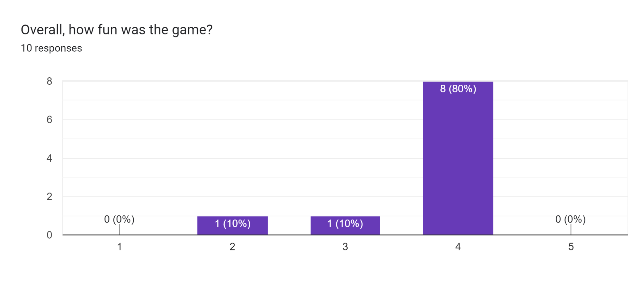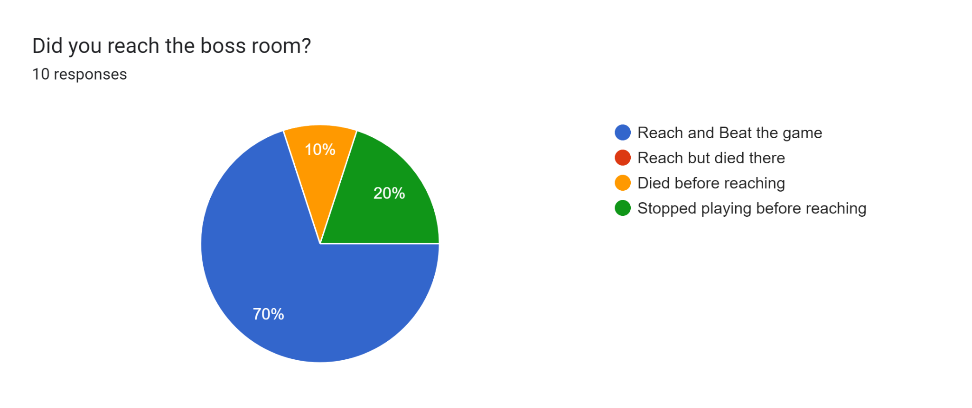Forms response chart. Question title: What do you think of the theme of the game?   
. Number of responses: 10 responses.Forms response chart. Question title: Was the overall game duration too short, too long, or just right?
. Number of responses: 10 responses.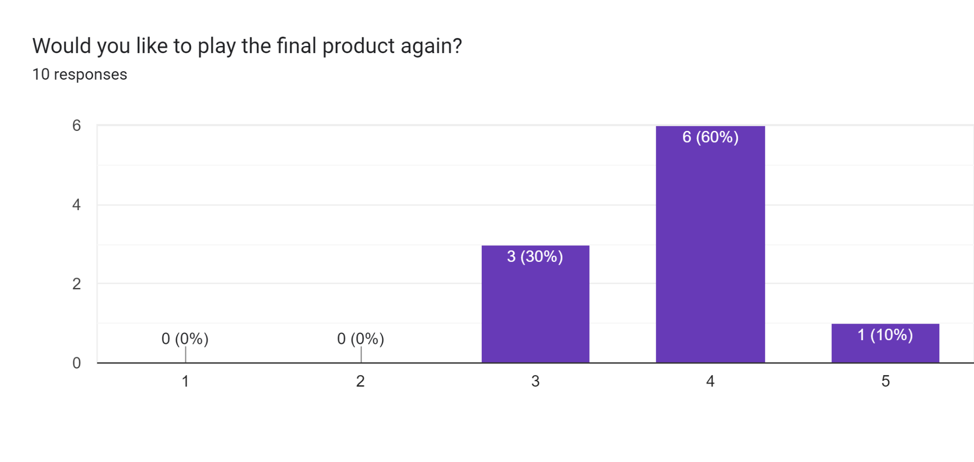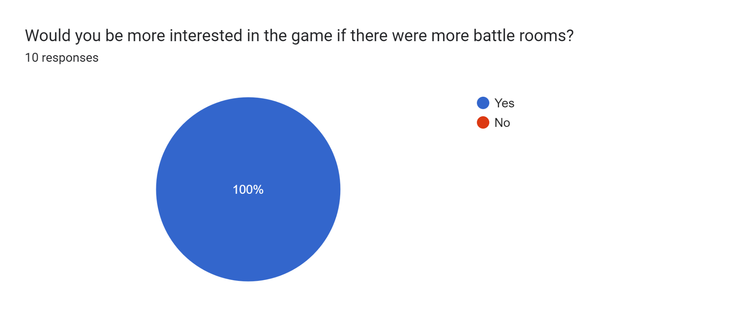

### Positive discoveries

Based on the survey, players found the arrow key mechanic to be very interesting and challenging as the battle goes on. Controls were simple and rooms’ purpose was understood quickly by users. The rest rooms, the upgrading of the items was well received as it is something different from the arrow keys. Most players also found the overall theme to be nice.

### Main Issues found

* 1. Gameplay
     1. Final boss feels lacking as it is a repeat of the previous battle room without anything unique.
     2. Game instructions and goals not very clear
     3. Items obtained by players are not affecting gameplay.
     4. No Audio feedback.
     5. Some Instructions overlap, hard to see.

### Improvements, recommendation

Based on the playtesters’ feedback, many found the final boss to be lackluster. And since there is only 1 form of battle room, the overall gameplay seems stale. Therefore, we think it is important to implement unique mechanics to the final boss room, and more types of battle rooms to engage the player. Final Boss needs to be harder.

Music and sound effects are also important to give audio cues and feedback to the player.

Implement a form of currency for shop.