Using Jupyter Notebooks in VS Code
A Quick-Start Guide for Students

Prerequisites
Before starting, make sure you have the following installed:

- VS Code
- Python 3

Step 1: Install the Jupyter Extension
- Open VS Code.
- Click the Extensions icon in the left sidebar
- Search for "Jupyter" in the search bar.
- Select Jupyter by Microsoft (identifier: ms-toolsai) and click Install.

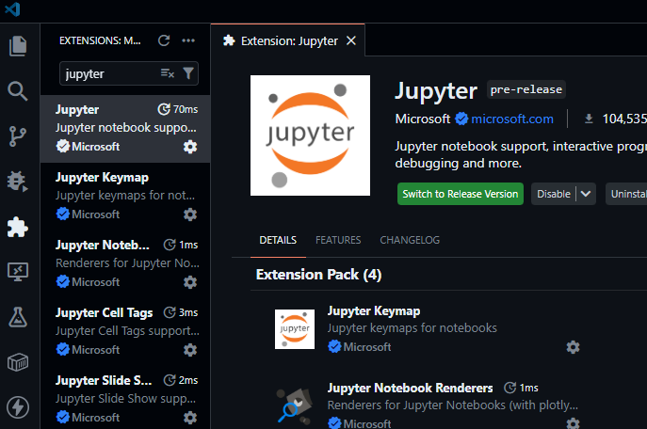
Figure 1: Installing the Jupyter extension from the Extensions Marketplace

💡 The Python extension (ms-python.python) is also recommended and may be installed automatically alongside Jupyter.

Step 2: Install ipykernel
Jupyter needs the ipykernel package to run Python code. Open a terminal in VS Code:

Terminal menu → New Terminal (or press Ctrl+`)

Then run:
pip install ipykernel

Step 3: Create or Open a Notebook

Open an existing notebook
Go to File → Open File → Navigate to folder containing the notebook and select the .ipynb file.

Create a new notebook
Press Ctrl+Shift+P to open the Command Palette, then type and select:
Jupyter: Create New Jupyter Notebook

Step 4: Select a Python Kernel
When the notebook opens, VS Code will automatically detect the kernel or prompt you to select a kernel. Otherwise click "Select Kernel" in the top-right corner and select your Python kernel. (version can varies)

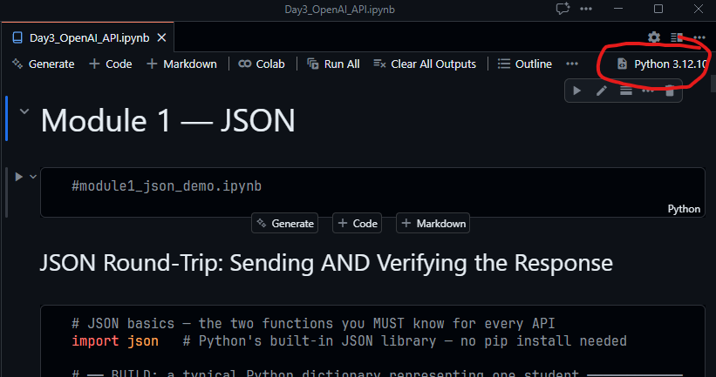
Figure 2: Kernel picker — choose Python Environments, then your Python version
Choose Python Environments… and then select your installed Python version (e.g. Python 3.11, 3.12, or etc).

Step 5: Run Your First Cell
Click inside the first cell and type some Python code, then run it in one of two ways:

- Click the ▶ Run button to the left of the cell, or
- Press Shift+Enter to run and move to the next cell.

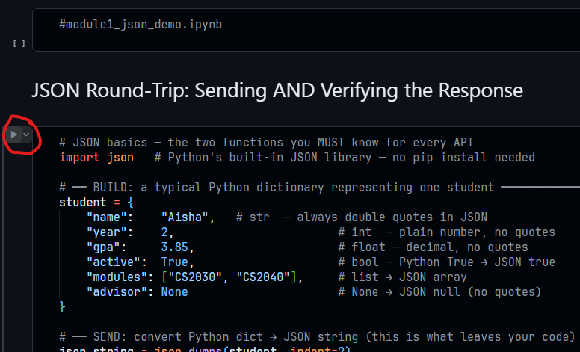
Figure 3: A code cell with output — click ▶ or press Shift+Enter to run

💡 To add a new cell, click '+ Code' below any cell, or press the B key while a cell is selected (but not being edited).

Quick Reference
Action | Shortcut / How To
Run cell | Shift+Enter or click ▶
Run cell, stay in place | Ctrl+Enter
Add cell below | B (when cell is selected)
Add cell above | A (when cell is selected)
Delete a cell | D, D (press D twice)
Open Command Palette | Ctrl+Shift+P
Open Extensions | Ctrl+Shift+X
Open terminal | Ctrl+` (backtick)

