https://project.feishu.cn/xinchengsap/storynew/detail/7136234608
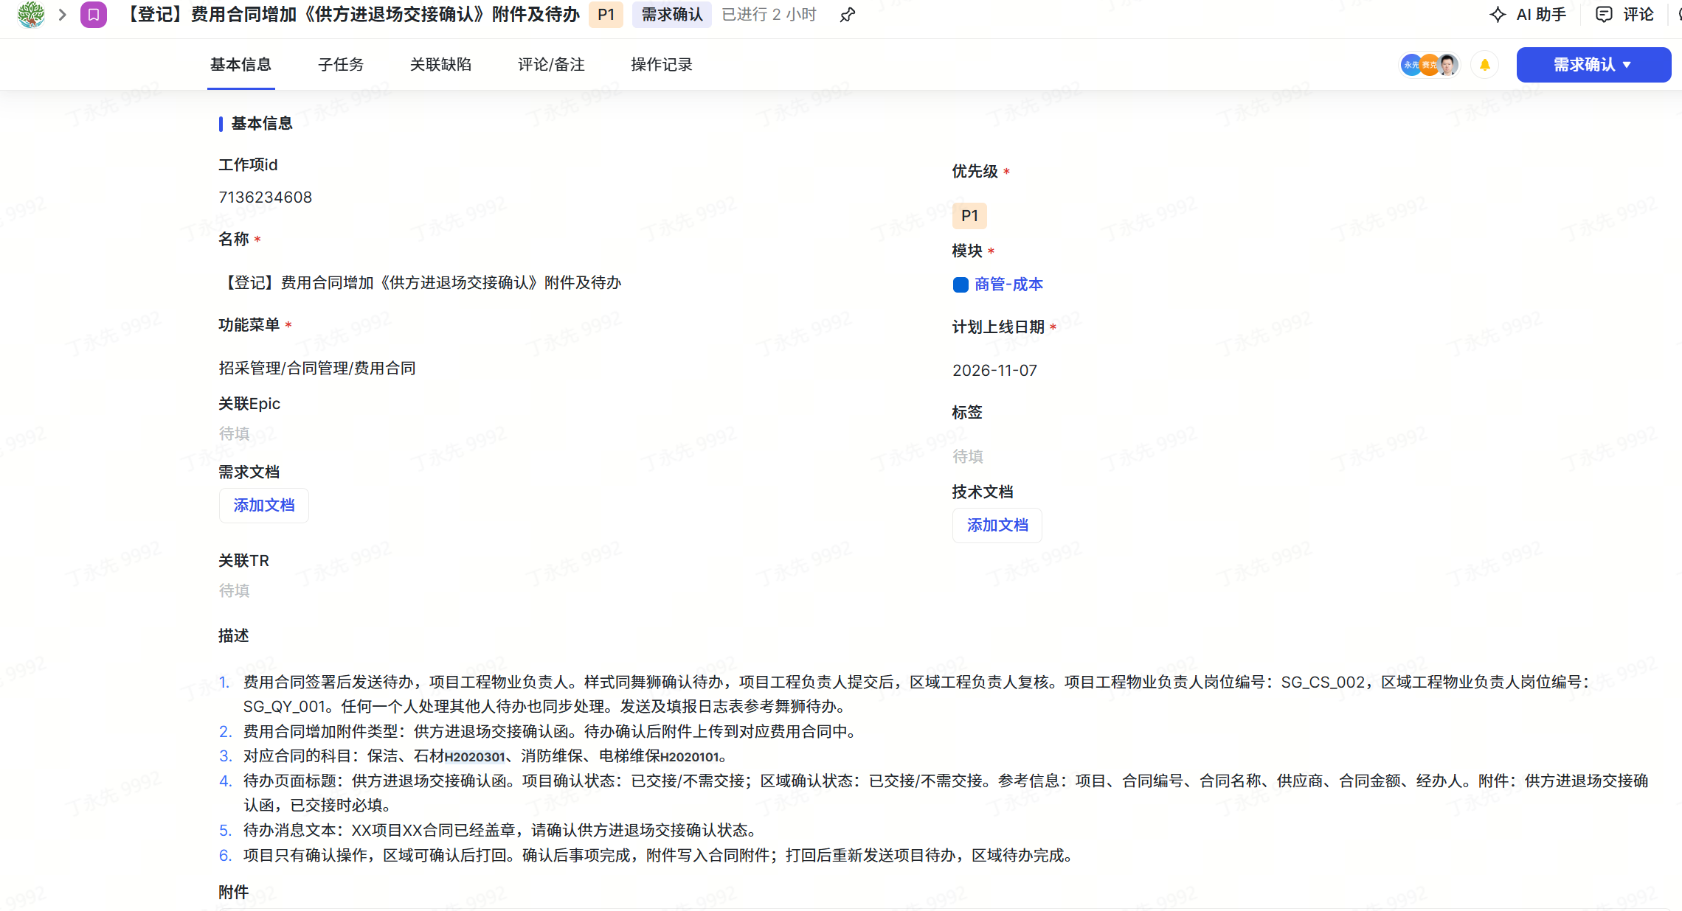
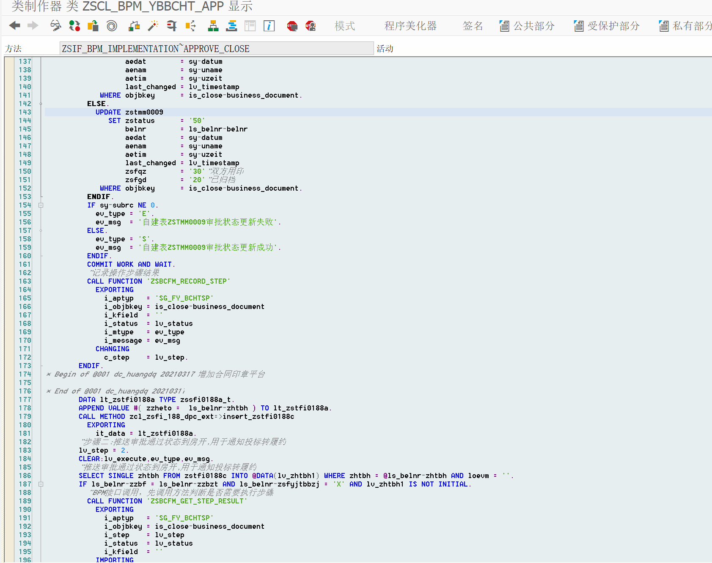
ZFTBC_TASK_CONF待办类型

ZSREFM_SAVE_BO_LINK_FILE1


