CSE 490V Final Project Report

Extended Subtitle

Alexander Mastrangelo and Paul Yoo, University of Washington

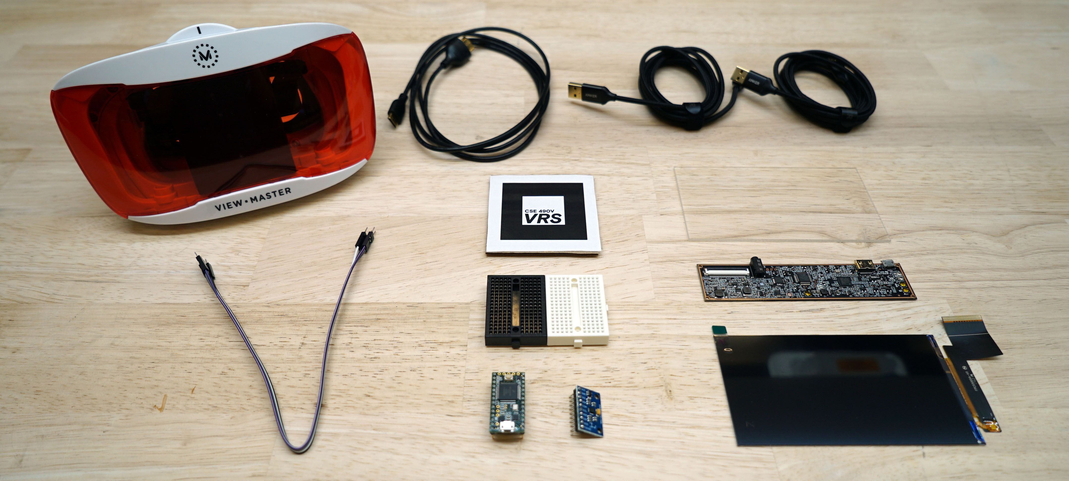

Figure 1: Figure Caption and Image above the caption [In draft mode, Image will not appear on the screen]

ABSTRACT

In this sample-structured document, neither the cross-linking of float elements and bibliography nor metadata/copyright information is available. The sample document is provided in “Draft” mode and to view it in the final layout format, applying the required template is essential with some standard steps.

 Introduction

The purpose of this project is to build a high-accuracy finger tracking for use in VR. We believe good finger tracking is important because it allows players to interact with VR environments without the needing a controller. Although there are many approaches, we chose magnetic tracking in particular because fingers suffer from occulsion, making other approaches such as lighthouse and marker based tracking inadequite. The layout of the magnetometers is based on the Finexus approach designed by Oculus.

1.1 Contributions

1. Built a thing

2. Made a model for solving it

2. Tested accuracy

2 Related Work

FINEXUS!

3 Method

In the below paragraph, it is explained how alt-txt value is placed in **MS Word 2010**. To add alternative text to a picture in Word 2010, follow these steps:

1. In a Word 2010 document, insert a picture.
2. Right click on the inserted picture and select the **Format Picture** option.
3. Select the **Alt Txt** option from the left-side panel options.
4. In the "Title:" and "Description:" text boxes, type the text you want to represent the picture, and then click "Close".

Below are steps to place alt-txt value in **MS Word 2013/2016**. To add alternative text to a picture in Word 2013/2016, follow these steps:

4 Implementation Details

To make it work we had to mount the magnetometers at known positions relative to each other. This was done very carefully as any uncertainty here will break the model. Thankfully the perfboard matched this requirement exactly, as we can just place them at a fixed offset relative to each other. This only works for 3 of the 4 magnetometers required, because the last one is on a different plane than the first 3. In our implementation we chose 8 holes to be the distance between sensors, which is exactly 20.3mm.

[Insert picture here]

The perfboard we used had mounting holes on the sides that we were able to use to stack them on top of each other. This was accomplished by cutting nylon spacers of exactly 18.7mm, 1.6mm shorter than the relative distance between each magnetometer to compensate for the thickness of the perfboard. It’s important to note that the wires and perfboard used were nonmagnetic, as to avoid interfering with the field measured by the sensor.

With this, all four magnetometers were mounted similar to the Finexus configuration, with coordinates of (0,0,0), (20.3,0,0), (0,20.3,0), and (0,0,21.6). The power and voltage pins of each chip were shorted, and the i2c pins were outputted to the sides.

[Insert picture of the stacked thingy here]

Communication with the magnetometers was done over the i2c bus. Since all the magnetometers shared the same i2c bus, we used a TCA9548A to split the i2c bus; allowing us to talk to all the sensors, even though they all share the same address.

[Insert picture of breadboard here]

The calibration procedure is simple, we rotate the sensor in random directions, while keeping them away from anything magnet. We used MotionCal by PJRC to solve for the calibration matrix and biases for each sensor.

Acquiring an electromagnet small enough for this purpose was surprisingly difficult. The only stuff I could find on amazon was solenoids, so to get the magnet I ripped a solenoid apart to get the coil, and then cut the included piston to be a symmetric shape, to ensure the resulting field is that of a magnetic dipole.

[Insert 2 pictures, of before and after]

Finally, to drive the electromagnet we first used a signal generator to make a 60hz sin wave. This sin wave was then fed into the following amplifier circuit to control the current though the electromagnet.

[Insert picture of op-amp circuit diagram]

[Insert picture of op-amp circuit in breadboard]

5 Evaluation of Results

To evaluate the accuracy of the finger tracker, we required a way to know the exact position of the electromagnet. To get this data we used an XY table, which is just translates whatever is on it in the XY plane. We used the following experimental setup to acquire data.

[Insert picture of electromagnet and magnetometers on XY table]

This on its own isn’t adequate because we can only acquire data in a 2d plane. So, to get 3d data the height of the spacers on the corners was adjusted to change the Z position.

[Insert picture of XY table spacers being adjusted]

Then we used this test data to evaluate the accuracy of the model, and obtained the following results.

[Insert chart of actual position vs predicted position]

6 Discussion of Benefits and Limitations

In the below paragraph, it is explained how alt-txt value is placed in **MS Word 2010**. To add alternative text to a picture in Word 2010, follow these steps:

7 Future Work

The next step for this work would be to combine it with a solution to track the 6-DOF of the hand; as well as to mount the magnetometer tracker and electromagnets to a glove that can be worn. Two viable solutions are marker-based tracking, and lighthouse-based tracking.

Another next step would be to acquire faster magnetometers. The biggest weakness of this approach is that the cheap commercial magnetometers IC’s on the market run at only 1khz. Faster magnetometers would enable us to tracking electromagnets running at higher frequencies. This is important because as we increase the frequency of the electromagnet, we decrease the uncertainty of the measurement, greatly improving accuracy.

8 Conclusion

Basically just redo the abstract.

ACKNOWLEDGMENTS

Special thanks to my dad for buying all the parts we needed.

REFERENCES

[1] Patricia S. Abril and Robert Plant, 2007. The patent holder's dilemma: Buy, sell, or troll? *Commun. ACM* 50, 1 (Jan, 2007), 36-44. DOI: <https://doi.org/>10.1145/1188913.1188915.

[2] Sten Andler. 1979. Predicate path expressions. In *Proceedings of the 6th. ACM SIGACT-SIGPLAN Symposium on Principles of Programming Languages (POPL '79)*. ACM Press, New York, NY, 226-236. DOI:https://doi.org/10.1145/567752.567774

Conference Name:ACM Woodstock conference

Conference Short Name:WOODSTOCK’18

Conference Location:El Paso, Texas USA

ISBN:978-1-4503-0000-0/18/06

Year:2018

Date:June

Copyright Year:2018

Copyright Statement:rightsretained

DOI:10.1145/1234567890

RRH: F. Surname et al.

Price:$15.00