

|  |
| --- |
| **Mobile Programming**  **LAB2** |
|  |



|  |
| --- |
| **제출일 2014, 04, 09 전공 소프트웨어학과** |
| **과목 모바일 프로그래밍 이름 유수화** |

Lab2.1

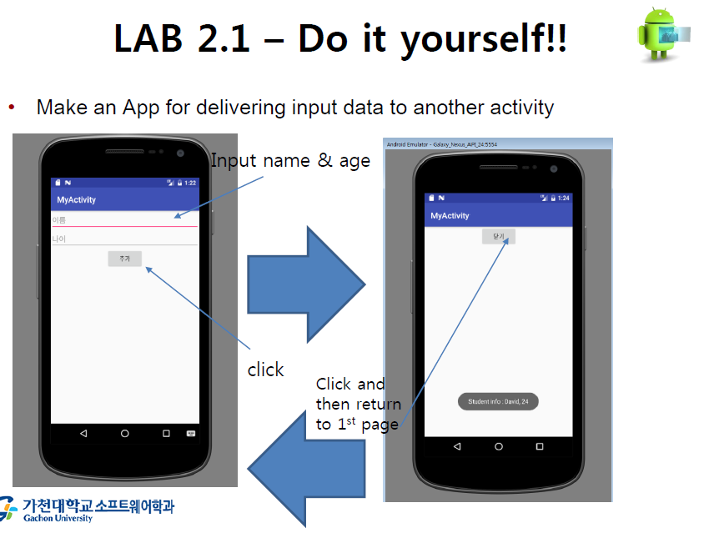

**<acitivity_main.xml>**

<?xml version="1.0" encoding="utf-8"?>  
<LinearLayout xmlns:android="http://schemas.android.com/apk/res/android"  
 xmlns:app="http://schemas.android.com/apk/res-auto"  
 xmlns:tools="http://schemas.android.com/tools"  
 android:layout_width="match_parent"  
 android:layout_height="match_parent"  
 android:orientation="vertical"  
 tools:context="example.com.lab2_1.MainActivity">  
  
 <!-- Input name text-->  
 <EditText  
 android:id="@+id/edit1"  
 android:layout_width="match_parent"  
 android:layout_height="wrap_content"  
 android:hint="이름" />  
 <!-- Input age text-->  
 <EditText  
 android:layout_width="match_parent"  
 android:layout_height="wrap_content"  
 android:hint="나이"  
 android:id="@+id/edit2"/>  
 <!--When you click this button, a new activity(page) opens. -->  
 <Button  
 android:text="추가"  
 android:layout_gravity="center"  
 android:layout_width="wrap_content"  
 android:layout_height="wrap_content"  
 android:id="@+id/butAdd"/>  
  
</LinearLayout>

<MainActivity.java>

package example.com.lab2_1;  
  
import android.content.Intent;  
import android.os.Bundle;  
import android.support.v7.app.AppCompatActivity;  
import android.view.View;  
import android.widget.Button;  
import android.widget.EditText;  
  
public class MainActivity extends AppCompatActivity {  
 EditText Name;  
 EditText Age;  
 Button button1;  
  
 //onCreate() : Called when the activity is first created.  
 @Override  
 protected void onCreate(Bundle savedInstanceState) {  
 super.onCreate(savedInstanceState);  
 setContentView(R.layout.*activity_main*);  
  
 Name = (EditText) findViewById(R.id.*edit1*);  
 Age = (EditText) findViewById(R.id.*edit2*);  
 button1 = (Button) findViewById(R.id.*butAdd*);  
  
 //When you click this button, a new activity(page) opens.  
 //Send login name and age through the intent.  
 button1.setOnClickListener(new View.OnClickListener() {  
 @Override  
 public void onClick(View view) {  
 String N = Name.getText().toString();  
 String A = Age.getText().toString();  
  
 Intent intent = new Intent(getApplicationContext(), NewActivity.class);  
 intent.putExtra("loginName", N);  
 intent.putExtra("loginAge", A);  
 startActivity(intent);  
 }  
 });  
 }  
}

**<activity_new.xml>**

<?xml version="1.0" encoding="utf-8"?>  
<LinearLayout  
 xmlns:android="http://schemas.android.com/apk/res/android"  
 xmlns:app="http://schemas.android.com/apk/res-auto"  
 xmlns:tools="http://schemas.android.com/tools"  
 android:layout_width="match_parent"  
 android:layout_height="match_parent"  
 android:orientation="vertical"  
 tools:context="example.com.lab2_1.NewActivity">  
  
 <!-- When you click this button, go back to the previous activity(page). -->  
 <Button  
 android:layout_width="wrap_content"  
 android:layout_height="wrap_content"  
 android:text="닫기"  
 android:layout_gravity="center"  
 android:id="@+id/butClosed"/>  
  
</LinearLayout>

**<NewActivity.java>**

package example.com.lab2_1;  
  
import android.content.Intent;  
import android.os.Bundle;  
import android.support.v7.app.AppCompatActivity;  
import android.view.View;  
import android.widget.Button;  
import android.widget.Toast;  
  
public class NewActivity extends AppCompatActivity {  
  
 //onCreate() : Called when the activity is first created.  
 @Override  
 protected void onCreate(Bundle savedInstanceState) {  
 super.onCreate(savedInstanceState);  
 setContentView(R.layout.*activity_new*);  
  
 //Receive information(login name and age) from previous activity through intent.  
 Intent passedIntent = getIntent();  
 if (passedIntent!=null){  
 String loginName = passedIntent.getStringExtra("loginName");  
 String loginAge = passedIntent.getStringExtra("loginAge");  
  
 //Shows information received from previous activity through toast.  
 Toast.*makeText*(this, "Student info : "+loginName+", "+loginAge, Toast.*LENGTH_LONG*).show();  
 }  
  
 //When you click this button,  
 // this activity(NewActivity.java) is finished  
 // and the go back to the previous activity(page).  
 Button button0 = (Button)findViewById(R.id.*butClosed*);  
 button0.setOnClickListener(new View.OnClickListener(){  
 @Override  
 public void onClick(View view) {  
 finish();  
 }  
 });  
  
  
 }  
}

**<Screen-shot>**

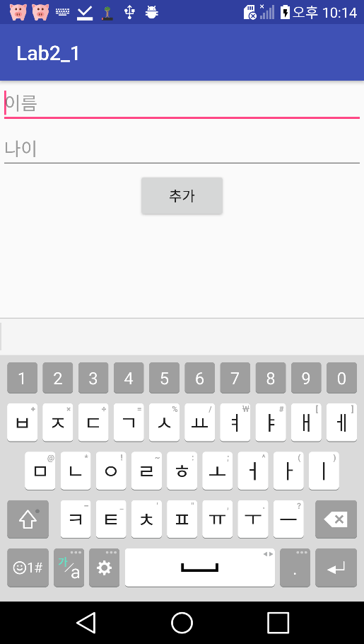 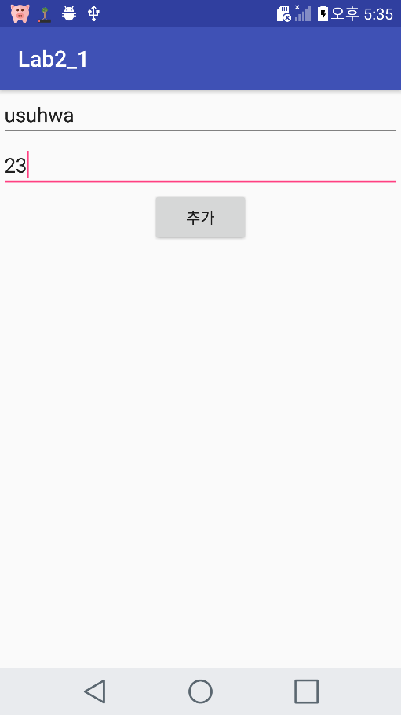

**Initial screen Enter the Input**

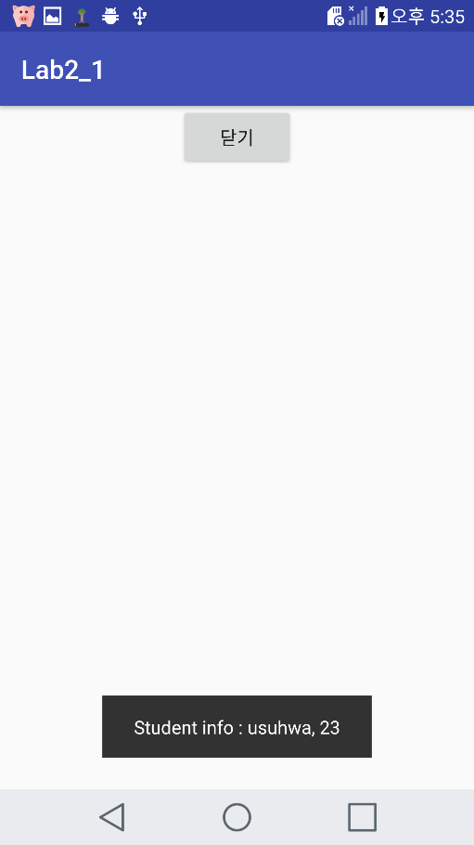 

**Push “추가”button Push “닫기”button**

Lab2.1

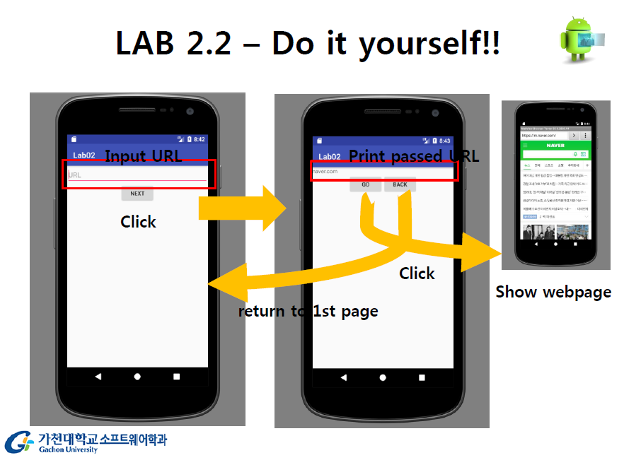

**<acitivity_main.xml>**

<?xml version="1.0" encoding="utf-8"?>  
<LinearLayout  
 xmlns:android="http://schemas.android.com/apk/res/android"  
 xmlns:app="http://schemas.android.com/apk/res-auto"  
 xmlns:tools="http://schemas.android.com/tools"  
 android:layout_width="match_parent"  
 android:layout_height="match_parent"  
 android:orientation="vertical"  
 tools:context="example.com.lab2_2.MainActivity">  
  
 <!-- Input Url text -->  
 <EditText  
 android:id="@+id/editText"  
 android:layout_width="match_parent"  
 android:layout_height="wrap_content"  
 android:hint="URL" />  
 <!--When you click this button, a new activity(page) opens. -->  
 <Button  
 android:id="@+id/nextButton"  
 android:text="NEXT"  
 android:layout_width="wrap_content"  
 android:layout_height="wrap_content"  
 android:layout_gravity="center"/>  
  
</LinearLayout>

**<MainActivity.java>**

package example.com.lab2_2;  
  
import android.content.Intent;  
import android.support.v7.app.AppCompatActivity;  
import android.os.Bundle;  
import android.view.View;  
import android.widget.Button;  
import android.widget.EditText;  
  
public class MainActivity extends AppCompatActivity {  
  
 EditText Url;  
 Button nextBtn; //"NEXT"button  
  
 //onCreate() : Called when the activity is first created.  
 @Override  
 protected void onCreate(Bundle savedInstanceState) {  
 super.onCreate(savedInstanceState);  
 setContentView(R.layout.*activity_main*);  
  
 Url = (EditText) findViewById(R.id.*editText*);  
 nextBtn = (Button) findViewById(R.id.*nextButton*);  
  
 //When you click this button, a new activity(page) opens.  
 //Send Url through the intent.  
 nextBtn.setOnClickListener(new View.OnClickListener() {  
 @Override  
 public void onClick(View view) {  
 String url = Url.getText().toString();  
 Intent intent = new Intent(getApplicationContext(), NewActivity.class);  
 intent.putExtra("Url", url);  
  
 startActivity(intent);  
 }  
 });  
 }  
}

**<activity_new.xml>**

<?xml version="1.0" encoding="utf-8"?>  
<LinearLayout xmlns:android="http://schemas.android.com/apk/res/android"  
 xmlns:app="http://schemas.android.com/apk/res-auto"  
 xmlns:tools="http://schemas.android.com/tools"  
 android:layout_width="match_parent"  
 android:layout_height="match_parent"  
 android:orientation="vertical"  
 tools:context="example.com.lab2_2.NewActivity">  
  
 <!--Print passed Url from MainActivity.java-->  
 <TextView  
 android:id="@+id/textView"  
 android:layout_width="match_parent"  
 android:layout_height="wrap_content" />  
  
 <LinearLayout  
 android:layout_width="wrap_content"  
 android:layout_height="wrap_content"  
 android:layout_gravity="center"  
 android:orientation="horizontal">  
  
 <!-- When you click this button, show web page. -->  
 <!-- If no text on TextView(id textview), then float Toast message-->  
 <Button  
 android:id="@+id/go"  
 android:layout_width="wrap_content"  
 android:layout_height="wrap_content"  
 android:text="GO" />  
  
 <!-- Return to first screen and float Toast message -->  
 <Button  
 android:id="@+id/back"  
 android:layout_width="wrap_content"  
 android:layout_height="wrap_content"  
 android:text="BACK" />  
 </LinearLayout>  
  
</LinearLayout>

**<NewActivity.java>**

package example.com.lab2_2;  
  
import android.content.Intent;  
import android.net.Uri;  
import android.os.Bundle;  
import android.support.v7.app.AppCompatActivity;  
import android.view.View;  
import android.widget.Button;  
import android.widget.TextView;  
import android.widget.Toast;  
  
public class NewActivity extends AppCompatActivity {  
  
 TextView textView;  
 Button goBtn;  
 Button backBtn;  
  
 //onCreate() : Called when the activity is first created.  
 @Override  
 protected void onCreate(Bundle savedInstanceState) {  
 super.onCreate(savedInstanceState);  
 setContentView(R.layout.*activity_new*);  
  
 textView = (TextView) findViewById(R.id.*textView*);  
 goBtn = (Button) findViewById(R.id.*go*);  
 backBtn = (Button) findViewById(R.id.*back*);  
  
 //Receive information(url) from previous activity through intent.  
 final Intent passdIntent = getIntent();  
 final String passedUrl = passdIntent.getStringExtra("Url");  
 textView.setText(passedUrl);  
  
 //When you click this GO button, show web page.  
 //If there are no text on TextView, then float Toast message.  
 goBtn.setOnClickListener(new View.OnClickListener() {  
 @Override  
 public void onClick(View view) {  
 if (!passedUrl.isEmpty()){  
 Intent intent = new Intent(Intent.*ACTION_VIEW*, Uri.*parse*("http://"+passedUrl));  
 startActivity(intent);  
 }else  
 {  
 Toast.*makeText*(getApplicationContext(), "주소를 다시 입력해주세요.", Toast.*LENGTH_LONG*).show();  
  
 }  
 }  
 });  
  
 //When you click BACK button, return to first screen and float Toast message.  
 backBtn.setOnClickListener(new View.OnClickListener(){  
 @Override  
 public void onClick(View view) {  
 Toast.*makeText*(getApplicationContext(), "뒤로가기 버튼을 눌렀습니다", Toast.*LENGTH_LONG*).show();  
 finish();  
  
 }  
 });  
  
 }  
}

**<Screen-shot>**

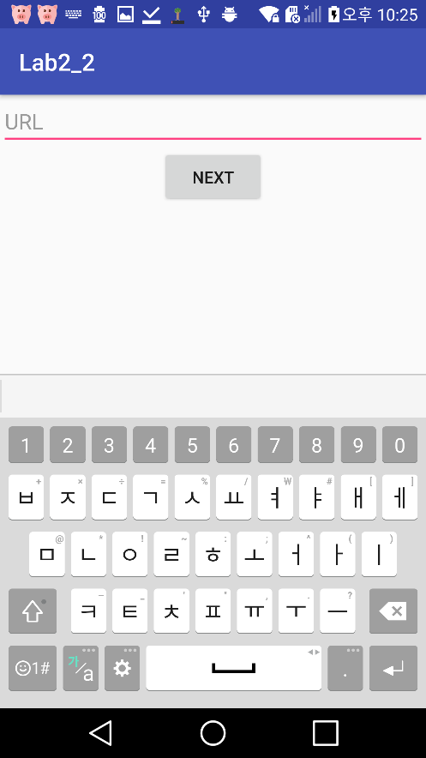 **<- initial screen**

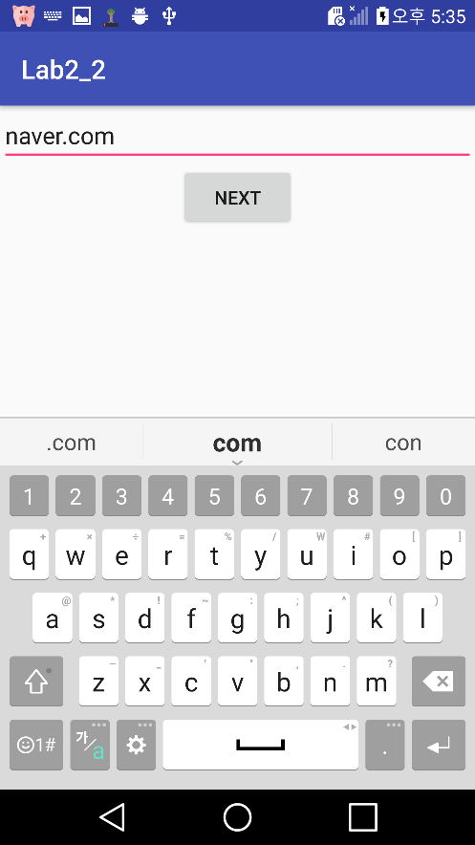 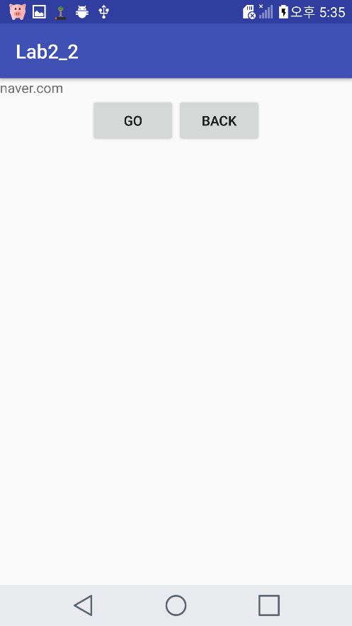

**Enter the input and then click “NEXT”button.**

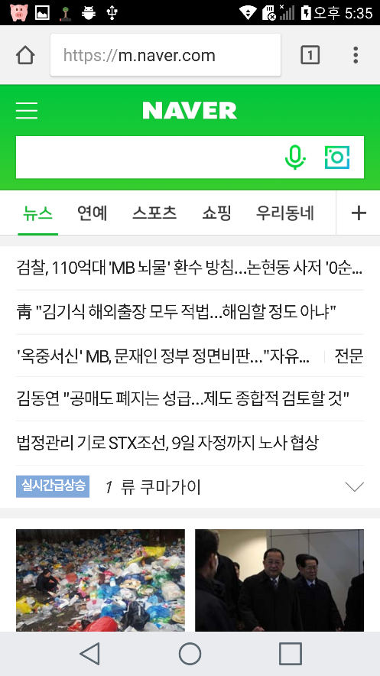 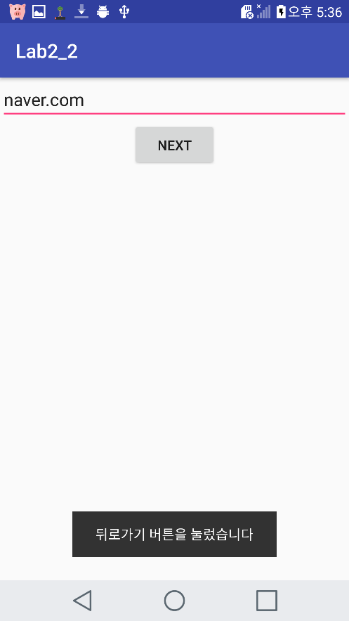

**Click “GO” button. Click “BACK” button.**

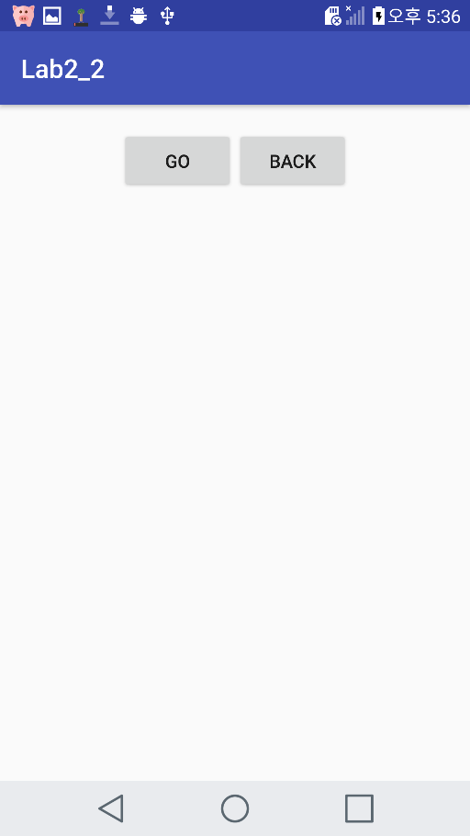 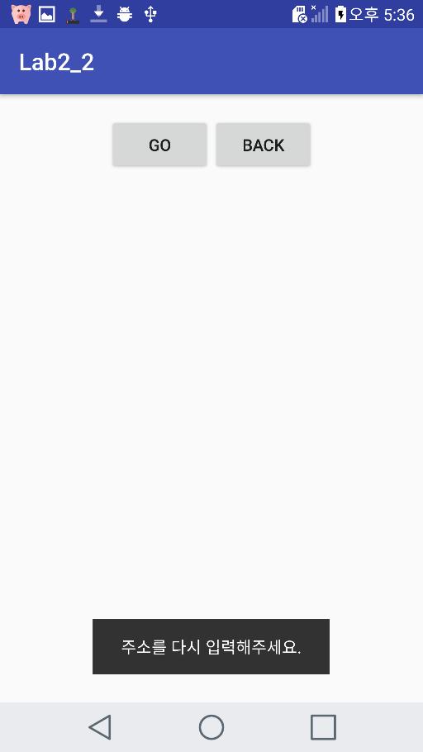

**If there are no text, When you cick “GO”button, then float Toast message**

**<Github address>**

**https://github.com/YooSuhwa/Mobile-Programming.git**