

|  |
| --- |
| **Mobile Programming**  **LAB4** |
|  |



|  |
| --- |
| **제출일 2014, 05,12 전공 소프트웨어학과** |
| **과목 모바일 프로그래밍 이름 유수화** |

**Lab4.1**

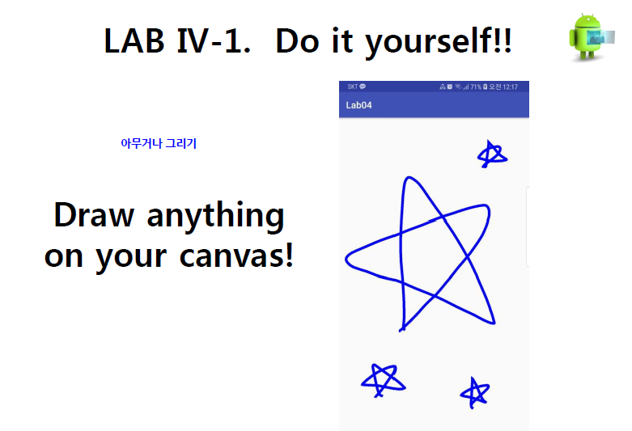

**MainActivity.java**

package example.com.lab4_1;  
  
import android.content.Context;  
import android.graphics.Canvas;  
import android.graphics.Color;  
import android.graphics.Paint;  
import android.graphics.Path;  
import android.os.Bundle;  
import android.support.v7.app.AppCompatActivity;  
import android.view.MotionEvent;  
import android.view.View;  
import android.widget.LinearLayout;  
  
public class MainActivity extends AppCompatActivity {  
  
  
 @Override  
 protected void onCreate(Bundle savedInstanceState) {  
 super.onCreate(savedInstanceState);  
 //Container layout to combine views  
 LinearLayout ll = new LinearLayout(this);  
 MyView vm = new MyView(this);  
 //Included MyView in Linear layout  
 ll.addView(vm);  
 setContentView(ll);  
 }  
 protected class MyView extends View {  
 Paint pnt = new Paint();  
 Path path = new Path();  
 public MyView (Context context){  
 super(context);  
 }  
  
 // Draw on screen  
 @Override  
 protected void onDraw(Canvas canvas) {  
 super.onDraw(canvas);  
  
 // Set the color, width and style of the paint  
 pnt.setColor(Color.*BLUE*);  
 pnt.setStrokeWidth(8);  
 pnt.setStyle(Paint.Style.*STROKE*);  
  
 //Set canvas's color  
 canvas.drawColor(Color.*WHITE*);  
 //Draw the stored path  
 canvas.drawPath(path, pnt);  
 }  
  
 @Override  
 public boolean onTouchEvent(MotionEvent event) {  
  
 float X = event.getX();  
 float Y = event.getY();  
  
 // Move the position X, Y instead of drawing the path  
 if (event.getAction() == MotionEvent.*ACTION_DOWN*)  
 path.moveTo(X,Y);  
  
 // Draw a line according to the path moved  
 else if (event.getAction() == MotionEvent.*ACTION_MOVE*)  
 path.lineTo(X,Y);  
 //else if (event.getAction() == MotionEvent.ACTION_UP)  
  
 invalidate();  
 return true;  
 }  
 }  
}

**activity_main.xml**

<?xml version="1.0" encoding="utf-8"?>  
  
<!--Linear Layout-->  
<LinearLayout  
 xmlns:android="http://schemas.android.com/apk/res/android"  
 android:id="@+id/linear"  
 android:layout_width="match_parent"  
 android:layout_height="match_parent"  
 android:orientation="vertical">  
  
</LinearLayout>

**Screen-shot**

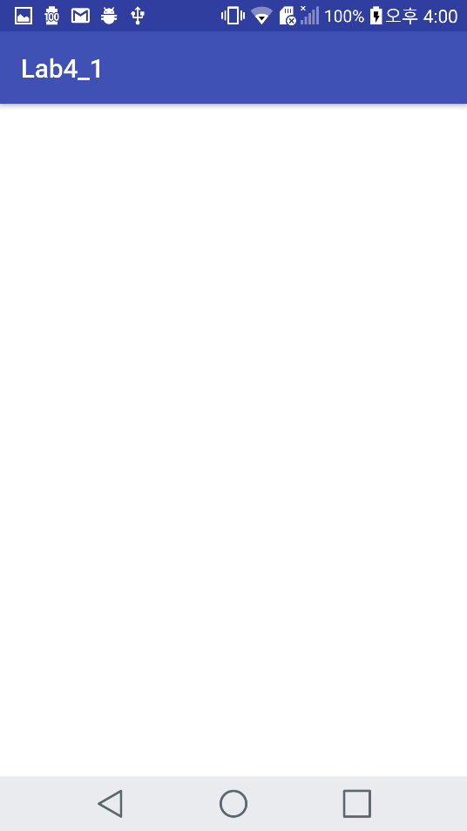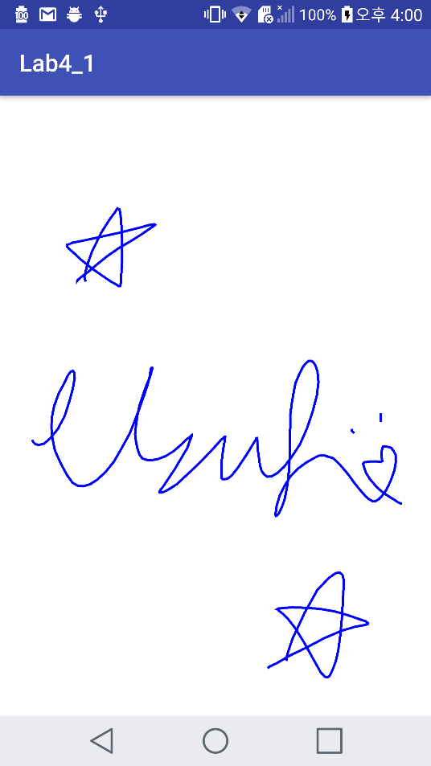

**Initial screen Draw my signature on canvas.**

**Lab4.2**

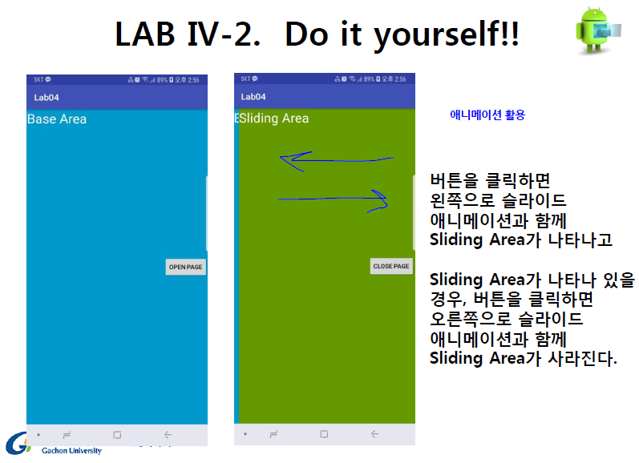

**MainActivity.java**

package example.com.lab4_2;  
  
import android.os.Bundle;  
import android.support.v7.app.AppCompatActivity;  
import android.view.View;  
import android.view.animation.Animation;  
import android.view.animation.AnimationUtils;  
import android.widget.Button;  
import android.widget.LinearLayout;  
  
public class MainActivity extends AppCompatActivity {  
  
 LinearLayout ll;  
  
 //onCreate() : Called when the activity is first created.  
 @Override  
 protected void onCreate(Bundle savedInstanceState) {  
 super.onCreate(savedInstanceState);  
 setContentView(R.layout.*activity_main*);  
  
 ll = (LinearLayout) findViewById(R.id.*ll2*);  
 Button button1 = (Button) findViewById(R.id.*openB*);  
 Button button2 = (Button) findViewById(R.id.*closeB*);  
  
 // When you click this button(OPEN PAGE),  
 // a Layout(Sliding Area) appears with sliding animation on the left. "<-"  
 button1.setOnClickListener(new View.OnClickListener() {  
 @Override  
 public void onClick(View view) {  
 Animation animation = AnimationUtils.*loadAnimation*(  
 getApplicationContext(), R.anim.*translate*);  
 ll.setVisibility(View.*VISIBLE*);  
 ll.startAnimation(animation);  
  
 }  
 });  
 // When you click this button(CLOSE PAGE),  
 // A Layout(Sliding Area) disappears with sliding animation on the right. "->"  
 button2.setOnClickListener(new View.OnClickListener() {  
 @Override  
 public void onClick(View view) {  
 Animation animation = AnimationUtils.*loadAnimation*(  
 getApplicationContext(), R.anim.*translate_closed*);  
 //ll.setVisibility(View.VISIBLE);  
 ll.startAnimation(animation);  
 ll.setVisibility(View.*GONE*);  
  
 }  
 });  
  
 }  
}

**activity_main.xml**

<?xml version="1.0" encoding="utf-8"?>  
  
<!-- This Frame layout include two linear layout. -->  
<FrameLayout xmlns:android="http://schemas.android.com/apk/res/android"  
 xmlns:app="http://schemas.android.com/apk/res-auto"  
 xmlns:tools="http://schemas.android.com/tools"  
 android:layout_width="match_parent"  
 android:layout_height="match_parent"  
 tools:context="example.com.lab4_2.MainActivity">  
  
 <!-- This linear layout include text view and button -->  
 <LinearLayout  
 android:id="@+id/ll1"  
 android:layout_width="match_parent"  
 android:layout_height="match_parent"  
 android:background="#7353ff"  
 android:orientation="horizontal">  
  
 <TextView  
 android:layout_width="wrap_content"  
 android:layout_height="wrap_content"  
 android:layout_weight="1"  
 android:text="Base Area"  
 android:textSize="25dp" />  
  
  
 <!-- When you click this button, a Layout(Sliding Area) appears with sliding animation on the left. "<-" -->  
 <Button  
 android:id="@+id/openB"  
 android:layout_width="wrap_content"  
 android:layout_height="wrap_content"  
 android:layout_gravity="center_vertical|right"  
 android:text="OPEN PAGE" />  
 </LinearLayout>  
  
 <!-- This linear layout include text view and button -->  
 <LinearLayout  
 android:id="@+id/ll2"  
 android:layout_width="match_parent"  
 android:layout_height="match_parent"  
 android:background="#36d721"  
 android:orientation="horizontal"  
 android:visibility="gone">  
  
 <TextView  
 android:layout_width="wrap_content"  
 android:layout_height="wrap_content"  
 android:layout_weight="1"  
 android:text="Sliding Area"  
 android:textSize="25dp" />  
  
 <!-- When you click this button, A Layout(Sliding Area) disappears with sliding animation on the right. "->" -->  
 <Button  
 android:id="@+id/closeB"  
 android:layout_width="wrap_content"  
 android:layout_height="wrap_content"  
 android:layout_gravity="center_vertical|right"  
 android:text="CLOSE PAGE" />  
 </LinearLayout>  
  
</FrameLayout>

**translate.xml**

<?xml version="1.0" encoding="utf-8"?>  
<set xmlns:android="http://schemas.android.com/apk/res/android"  
 android:interpolator="@android:anim/linear_interpolator">  
  
 <!-- A Layout(Sliding Area) appears with sliding animation on the left. "<-" -->  
 <translate  
 android:fromXDelta="100%p"  
 android:toXDelta="0%p"  
 android:duration = "1000" />  
</set>

**translate_closed.xml**

<?xml version="1.0" encoding="utf-8"?>  
<set xmlns:android="http://schemas.android.com/apk/res/android">  
  
 <!-- A Layout(Sliding Area) disappears with sliding animation on the right. "->" -->  
 <translate  
 android:fromYDelta="0%"  
 android:toXDelta="100%p"  
 android:duration = "1000" />  
</set>

**Screen-shot**

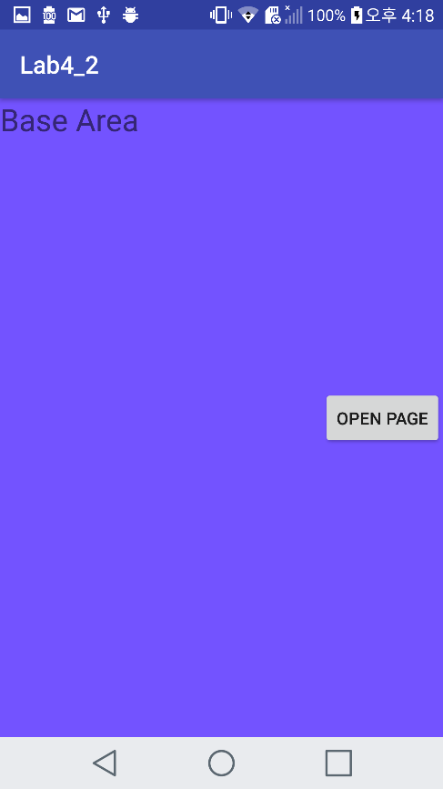 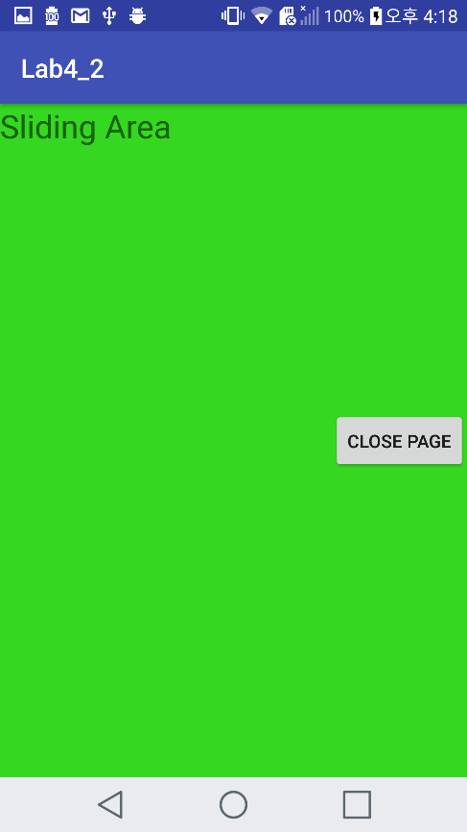

**(Initial) Base screen**  **Sliding Area screen**

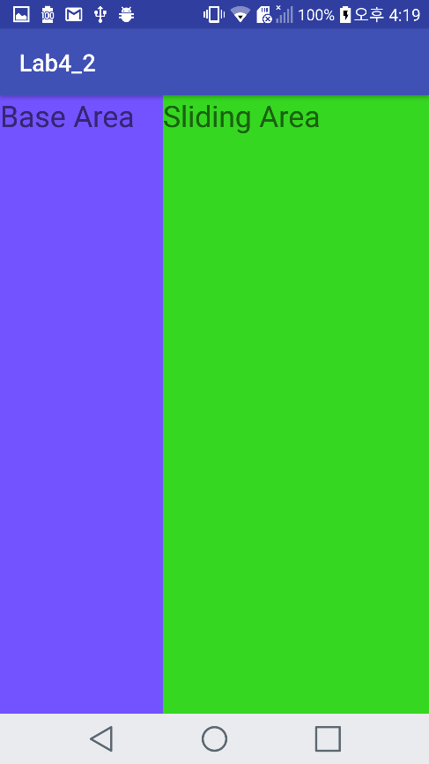 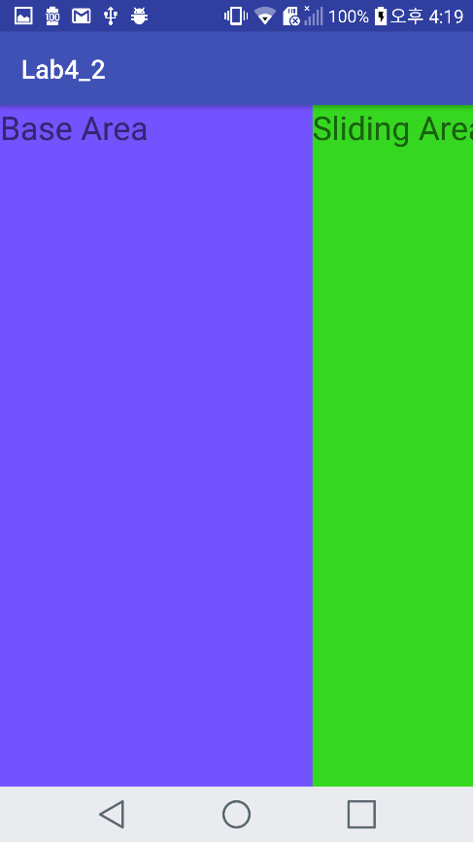

**Sliding Animation (push OPEN PAGE button / CLOSE PAGE button)**

**<Github address>**

**https://github.com/YooSuhwa/Mobile-Programming.git**