

|  |
| --- |
| **Mobile Programming**  **LAB5** |
|  |



|  |
| --- |
| **제출일 2014, 05,22 전공 소프트웨어학과** |
| **과목 모바일 프로그래밍 이름 유수화** |

**Lab 5.1**

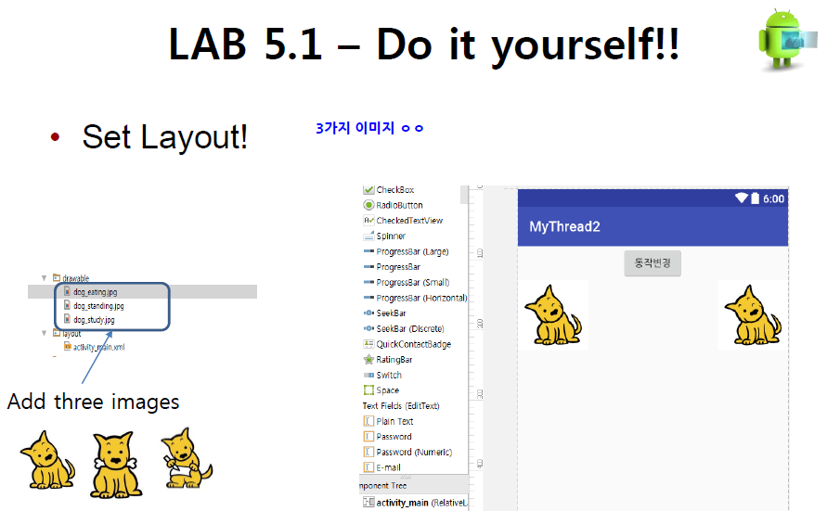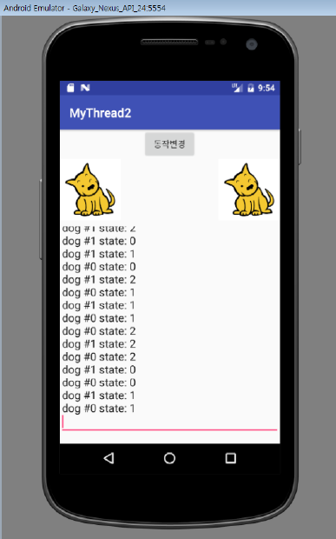

**MainActivity.java**

package example.com.lab5_1;  
  
import android.os.Bundle;  
import android.os.Handler;  
import android.support.v7.app.AppCompatActivity;  
import android.view.View;  
import android.widget.Button;  
import android.widget.EditText;  
import android.widget.ImageView;  
  
import java.util.ArrayList;  
  
public class MainActivity extends AppCompatActivity {  
  
 ImageView imageView1, imageView2;  
 EditText editText;  
 Button button;  
 Handler handler = new Handler();  
  
 // onCreate() : Called when the activity is first created.  
 @Override  
 protected void onCreate(Bundle savedInstanceState) {  
 super.onCreate(savedInstanceState);  
 setContentView(R.layout.*activity_main*);  
  
 imageView1 = (ImageView) findViewById(R.id.*imageView1*);  
 imageView2 = (ImageView) findViewById(R.id.*imageView2*);  
 editText = (EditText) findViewById(R.id.*editText*);  
 button = (Button) findViewById(R.id.*button*);  
  
 //When you click this button(동작변경),  
 // the image of a dog on each threads changes from one image to another at random.  
 button.setOnClickListener(new View.OnClickListener() {  
 @Override  
 public void onClick(View view) {  
  
 //thread0 is image of the left dog.  
 DogThread thread0 = new DogThread(0);  
 thread0.start();  
  
 //thread1 is image of the right dog.  
 DogThread thread1 = new DogThread(1);  
 thread1.start();  
 }  
 });  
  
 }  
  
  
 //Design DogThread  
 class DogThread extends Thread {  
  
 // The stateIndex is the index for three dog images  
 // that change in the thread0/thread1.  
 private int stateIndex;  
 // The dogIndex is the index of for each dog image  
 // on the left and right sides of the screen(thread0/thread1 itself).  
 private int dogIndex;  
  
 //The ArrayList stores three dog images.  
 ArrayList<Integer> image = new ArrayList<Integer>();  
  
 public DogThread(int index) {  
 dogIndex = index;  
  
 image.add(R.drawable.*dog1*);  
 image.add(R.drawable.*dog2*);  
 image.add(R.drawable.*dog3*);  
 }  
  
 //Run method in DogThread  
 public void run() {  
 {  
 stateIndex = 0;  
 for (int i = 0; i < 9; i++) {  
 //A message for printing.  
 final String msg = "dog #" + dogIndex + "state : " + stateIndex;  
  
 handler.post(new Runnable() {  
 @Override  
 public void run() {  
 // Shows the state of the dog image.  
 editText.append(msg + "\n");  
  
 //Change image  
 if (dogIndex == 0) {  
 imageView1.setImageResource(image.get(stateIndex));  
  
 } else if (dogIndex == 1) {  
 imageView2.setImageResource((image.get(stateIndex)));  
 }  
 }  
 });  
  
 try {  
 //To change the image in random time.  
 int sleepTime = getRandomTime(500, 3000);  
 Thread.*sleep*(sleepTime);  
  
 } catch (InterruptedException ex) {  
 ex.printStackTrace();  
 }  
 stateIndex++;  
  
 if (stateIndex >= image.size())  
 stateIndex = 0;  
  
 }  
  
 }  
 }  
  
 //Can get the time randomly  
 public int getRandomTime(int min, int max) {  
 return min + (int) (Math.*random*() * (max - min));  
 }  
 }  
}

**activity_main.xml**

<?xml version="1.0" encoding="utf-8"?>  
<RelativeLayout  
 xmlns:android="http://schemas.android.com/apk/res/android"  
 android:layout_width="match_parent"  
 android:layout_height="match_parent">  
  
 <!-- When you click this button(동작변경),  
 The picture of a dog on both threads changes from one picture to another at random.-->  
 <Button  
 android:layout_width="wrap_content"  
 android:layout_height="wrap_content"  
 android:text="동작 변경"  
 android:id="@+id/button"  
 android:layout_centerHorizontal="true"  
 android:layout_alignParentTop="true"  
 android:gravity="center"/>  
  
 <!-- Picture of the left dog. -->  
 <ImageView  
 android:layout_below="@+id/button"  
 android:id="@+id/imageView1"  
 android:src="@drawable/dog1"  
 android:layout_width="wrap_content"  
 android:layout_height="wrap_content" />  
  
 <!-- Picture of the right dog. -->  
 <ImageView  
 android:layout_below="@+id/button"  
 android:id="@+id/imageView2"  
 android:layout_alignParentRight="true"  
 android:src="@drawable/dog1"  
 android:layout_width="wrap_content"  
 android:layout_height="wrap_content" />  
  
 <!-- Shows the state of the dog picture. -->  
 <EditText  
 android:id="@+id/editText"  
 android:layout_below="@+id/imageView1"  
 android:layout_width="match_parent"  
 android:layout_height="wrap_content" />  
</RelativeLayout>

**Screen-shot**

**Initial screen**

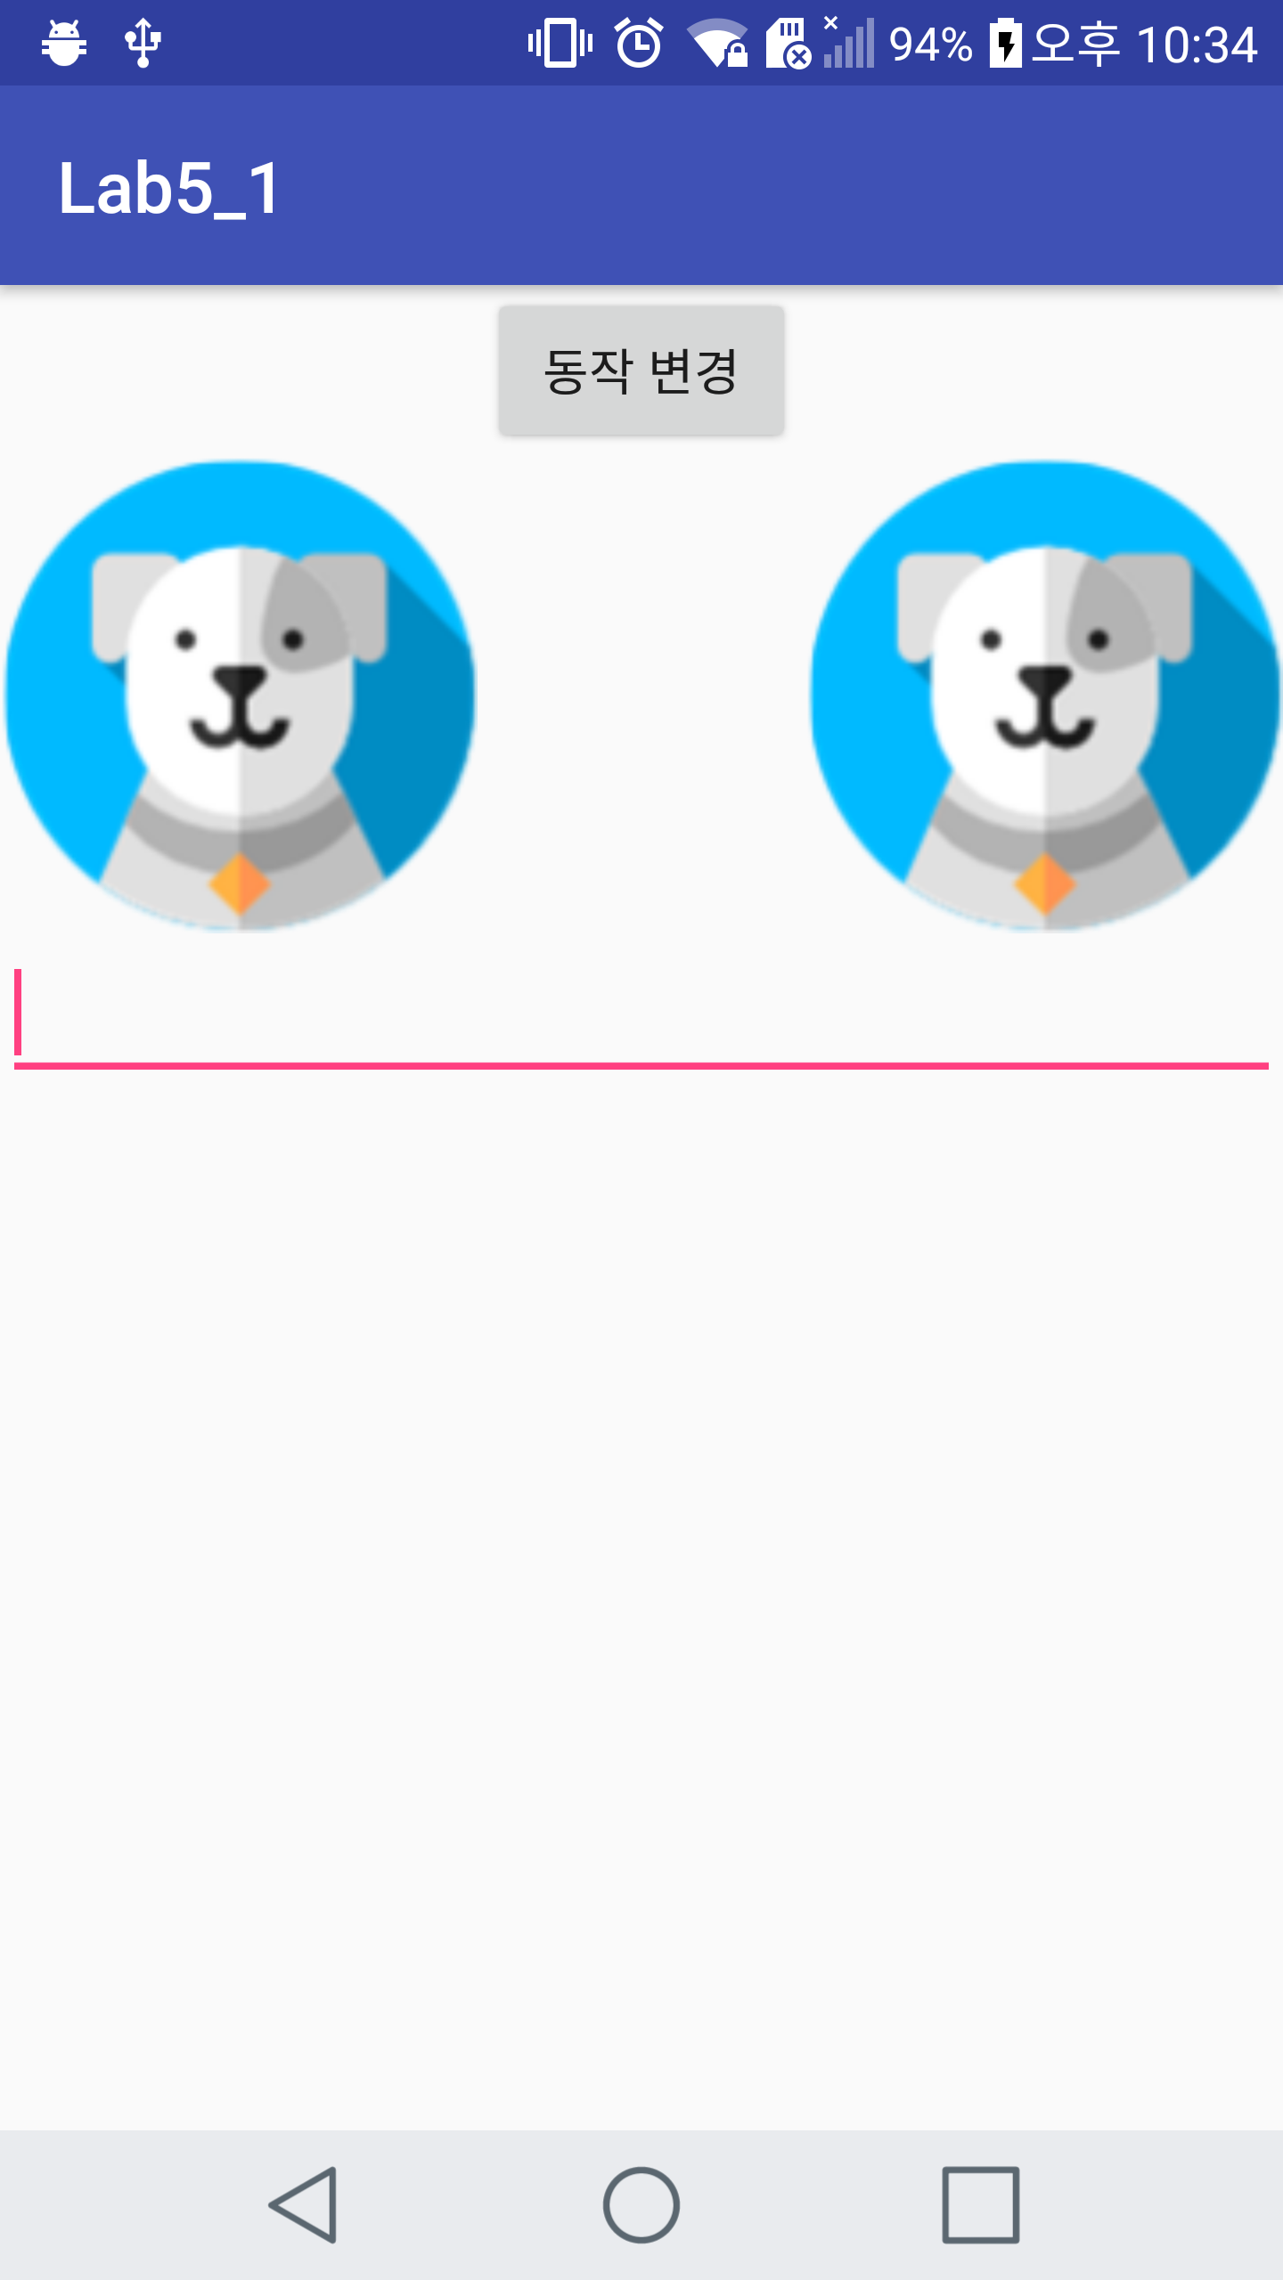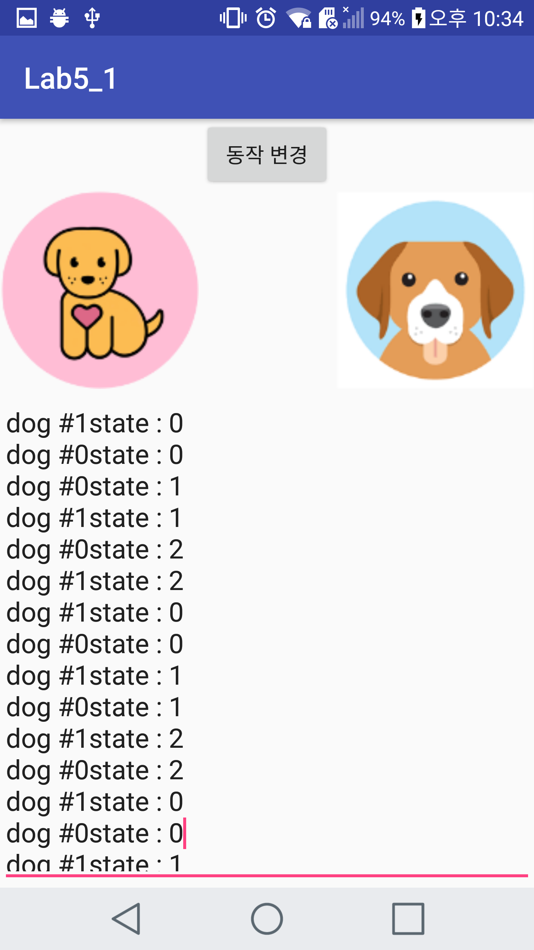

**Push button**

**Lab 5.2**

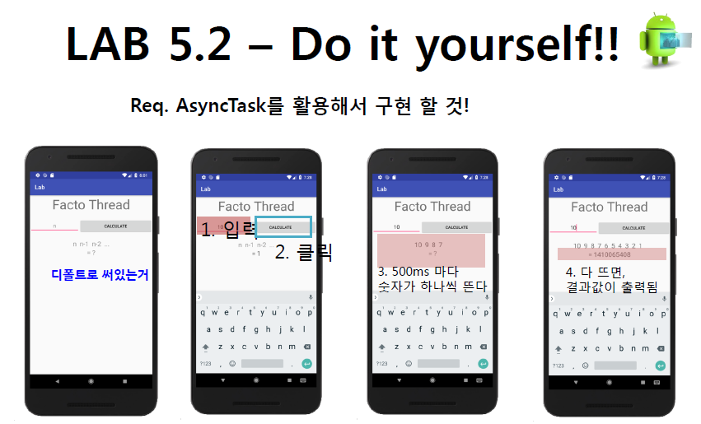

**MainActivity.java**

package example.com.lab5_2;  
  
import android.os.AsyncTask;  
import android.os.Bundle;  
import android.support.v7.app.AppCompatActivity;  
import android.view.View;  
import android.widget.Button;  
import android.widget.EditText;  
import android.widget.TextView;  
  
public class MainActivity extends AppCompatActivity {  
  
 TextView textView, result;  
 private String input;  
 EditText editText;  
  
 // onCreate() : Called when the activity is first created.  
 @Override  
 protected void onCreate(Bundle savedInstanceState) {  
 super.onCreate(savedInstanceState);  
 setContentView(R.layout.*activity_main*);  
  
 textView = (TextView) findViewById(R.id.*textView*);  
 Button button = (Button) findViewById(R.id.*button*);  
 editText = (EditText) findViewById(R.id.*input*);  
 result = (TextView) findViewById(R.id.*result*);  
  
 // When you click this button(CALCULATE),  
 // Do a factorial calculation on the number entered in the editText.  
 button.setOnClickListener(new View.OnClickListener() {  
 @Override  
 public void onClick(View view) {  
 input = editText.getText().toString();  
 //Starts the FactoThread  
 new FactoThread().execute();  
 }  
 });  
  
  
 }  
  
 // This Threads is FactoThread  
 // that do the factorial calculation on the number entered in the editText.  
 private class FactoThread extends AsyncTask<Void, Integer, Void> {  
 private int facto;  
 private int n;  
  
 // onPreExecute() - Invoked on the UI thread before the task is executed.  
 // Initialize the factorial result to 1.  
 // The value entered by the user via editText is stored in n.  
 @Override  
 protected void onPreExecute() {  
 facto = 1;  
 n = Integer.*parseInt*(input);  
 }  
  
  
 // doInBackground() - Invoked after onPreExecute() finishes executing.  
 // Contains the coding instruction which should be performed in a background thread.  
 // One digit appears every 500 ms, and the factorial calculation is performed.  
 @Override  
 protected Void doInBackground(Void... params) {  
 for (int i = n; i > 0; i--) {  
 try {  
 Thread.*sleep*(500);  
 facto *= i;  
 //Invokes onProgressUpdate();  
 publishProgress(i);  
 } catch (Exception e) {  
 }  
 }  
 return null;  
  
 }  
  
  
 //onProgressUpdate() - Invoked on the UI thread after a call to publishProgress.  
 //Show one digit appears every 500 ms on the UI.  
 @Override  
 protected void onProgressUpdate(Integer... values) {  
 textView.append(" " + values[0].intValue());  
 }  
  
 //onPostExecute() - Synchronize itself again with the user interface thread and allows to update it.  
 //Show the final factorial result on the UI.  
 @Override  
 protected void onPostExecute(Void aVoid) {  
 result.setText("= " + facto);  
 }  
 }  
}

**activity_main.xml**

<?xml version="1.0" encoding="utf-8"?>  
<LinearLayout  
 xmlns:android="http://schemas.android.com/apk/res/android"  
 android:layout_width="match_parent"  
 android:orientation="vertical"  
 android:layout_height="match_parent">  
  
 <TextView  
 android:layout_gravity="center"  
 android:layout_width="wrap_content"  
 android:layout_height="wrap_content"  
 android:text="Facto Thread"  
 android:textSize="35dp"  
 />  
  
 <!-- This linear layout include editText and button. -->  
 <LinearLayout  
 android:orientation="horizontal"  
 android:layout_width="match_parent"  
 android:layout_height="wrap_content">  
  
 <!-- Enter a number from the user. -->  
 <EditText  
 android:id="@+id/input"  
 android:hint="n"  
 android:gravity="center"  
 android:layout_width="wrap_content"  
 android:layout_height="wrap_content"  
 android:layout_weight="1"/>  
  
 <!-- When you click this button(CALCULATE),  
 Do a factorial calculation on the number entered in the editText(@+id/input). -->  
 <Button  
 android:id="@+id/button"  
 android:layout_width="wrap_content"  
 android:layout_height="wrap_content"  
 android:text="CALCULATE"  
 android:layout_weight="1"/>  
 </LinearLayout>  
  
 <!-- Show one digit appears every 500 ms. -->  
 <TextView  
 android:id="@+id/textView"  
 android:gravity="center"  
 android:layout_marginTop="10dp"  
 android:layout_gravity="center"  
 android:hint="n n-1 n-2 ..."  
 android:layout_width="match_parent"  
 android:layout_height="wrap_content" />  
  
 <!-- Show the final factorial result.-->  
 <TextView  
 android:id="@+id/result"  
 android:gravity="center"  
 android:layout_gravity="center"  
 android:text="= ?"  
 android:layout_width="match_parent"  
 android:layout_height="wrap_content" />  
  
  
</LinearLayout>

**Screen-shot**

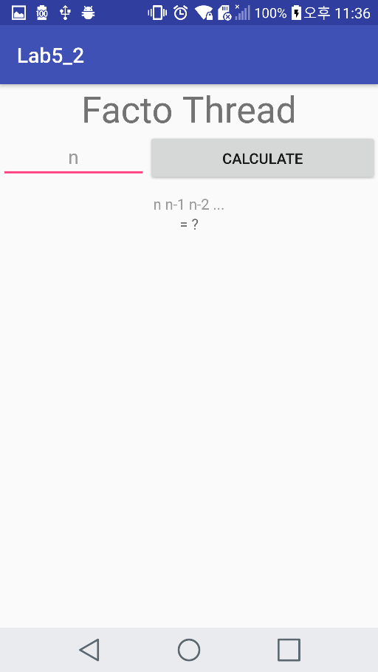  **Initial screen**

**Push button ->**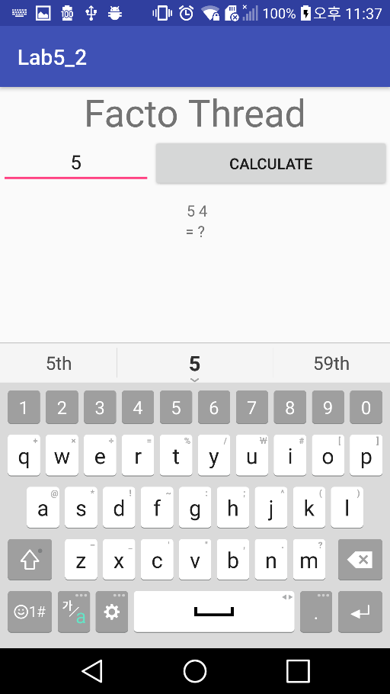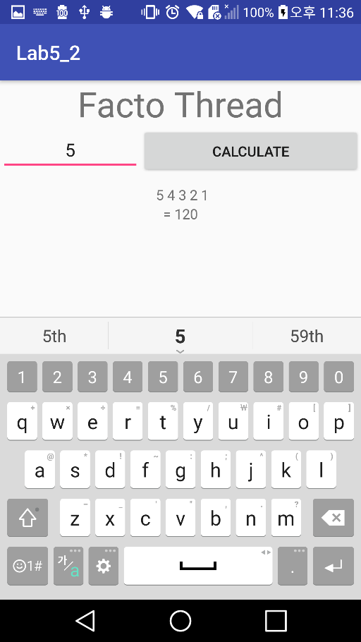

**<Github address>**

**https://github.com/YooSuhwa/Mobile-Programming.git**