

|  |
| --- |
| **Mobile Programming**  **LAB6** |
|  |



|  |
| --- |
| **제출일 2018, 06,02 전공 소프트웨어학과** |
| **과목 모바일 프로그래밍 이름 유수화** |

**Lab 6-1**

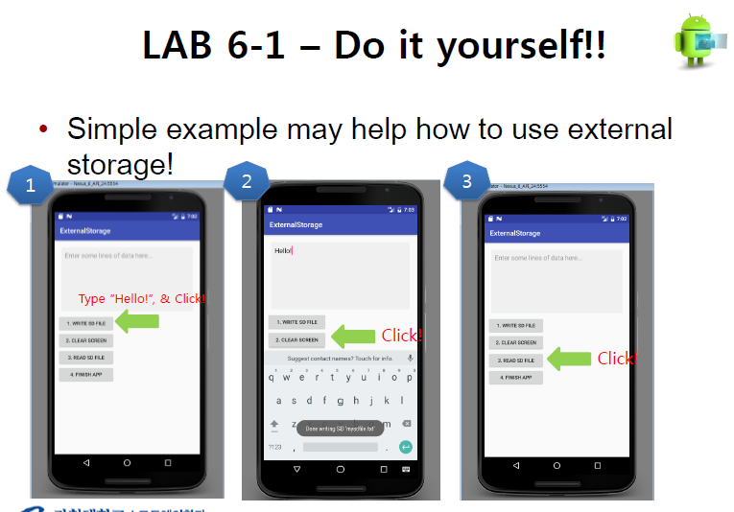

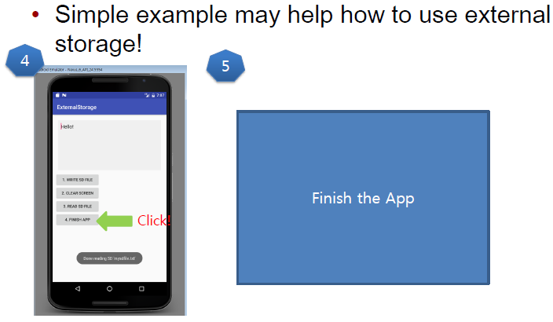

**MainActivity.java**

package example.com.lab6_1;  
  
import android.os.Bundle;  
import android.os.Environment;  
import android.support.v7.app.AppCompatActivity;  
import android.view.View;  
import android.widget.Button;  
import android.widget.EditText;  
import android.widget.Toast;  
  
import java.io.BufferedReader;  
import java.io.File;  
import java.io.FileNotFoundException;  
import java.io.FileReader;  
import java.io.FileWriter;  
import java.io.IOException;  
  
public class MainActivity extends AppCompatActivity {  
  
 String inputData;  
 EditText edit;  
  
 // onCreate() : Called when the activity is first created.  
 @Override  
 protected void onCreate(Bundle savedInstanceState) {  
 super.onCreate(savedInstanceState);  
 setContentView(R.layout.*activity_main*);  
  
 Button write = (Button) findViewById(R.id.*ButWrite*);  
 Button clear = (Button) findViewById(R.id.*ButClear*);  
 Button read = (Button) findViewById(R.id.*ButRead*);  
 Button finish = (Button) findViewById(R.id.*ButFinish*);  
  
 edit = (EditText) findViewById(R.id.*txtData*);  
  
 //When you click this button(WRITE SD FILE),  
 // WRITE user input text in EXTERNAL storage.  
 write.setOnClickListener(new View.OnClickListener() {  
 @Override  
 public void onClick(View v) {  
 inputData = edit.getText().toString();  
   
 File file = new File(Environment.*getExternalStorageDirectory*(), "textfile.txt");  
 try {  
 FileWriter fw = new FileWriter(file, false);  
 fw.write(inputData);  
 fw.close();  
 } catch (IOException e) {  
 e.printStackTrace();  
 }  
 Toast.*makeText*(MainActivity.this, "Done writing SD 'mysdfile.txt", Toast.*LENGTH_SHORT*).show();  
  
 }  
 });  
  
 //When you click this button(CLEAR SCREEN),  
 // CLEAR content of edit text  
 clear.setOnClickListener(new View.OnClickListener() {  
 @Override  
 public void onClick(View v) {  
  
 edit.setText("");  
 }  
 });  
  
 //When you click this button(READ SD FILE),  
 // READ content in EXTERNAL storage  
 read.setOnClickListener(new View.OnClickListener() {  
 @Override  
 public void onClick(View v) {  
 String path = Environment.*getExternalStorageDirectory*() + "/textfile.txt";  
 try {  
 BufferedReader reader = new BufferedReader(new FileReader(path));  
 String data = null;  
 data = reader.readLine();  
  
 StringBuffer buf = new StringBuffer();  
  
 while (data != null) {  
 buf.append(data);  
 data = reader.readLine();  
  
 }  
 edit.setText(buf.toString() + "\n");  
  
 reader.close();  
  
  
 } catch (FileNotFoundException e) {  
 e.printStackTrace();  
 } catch (IOException e) {  
 e.printStackTrace();  
 }  
  
 }  
 });  
  
 //When you click this button(FINISH APP),  
 // FINISH this lab6 app.  
 finish.setOnClickListener(new View.OnClickListener() {  
 @Override  
 public void onClick(View v) {  
 finish();  
 }  
 });  
 }  
}

**activity_main.xml**

<?xml version="1.0" encoding="utf-8"?>  
<LinearLayout xmlns:android="http://schemas.android.com/apk/res/android"  
 android:layout_width="match_parent"  
 android:layout_height="match_parent"  
 android:orientation="vertical">  
  
 <EditText  
 android:id="@+id/txtData"  
 android:layout_width="match_parent"  
 android:layout_height="180dp"  
 android:layout_margin="10dp"  
 android:background="#55dddddd"  
 android:gravity="top"  
 android:hint="Enter some lines of data here..."  
 android:padding="10dp"  
 android:textSize="18sp" />  
  
 <!-- When you click this button(WRITE SD FILE),  
 WRITE user input text in EXTERNAL storage. -->  
 <Button  
 android:id="@+id/ButWrite"  
 android:layout_width="150dp"  
 android:layout_height="wrap_content"  
 android:text="1. WRITE SD FILE" />  
  
 <!-- When you click this button(CLEAR SCREEN),  
 CLEAR content of edit text -->  
 <Button  
 android:id="@+id/ButClear"  
 android:layout_width="150dp"  
 android:layout_height="wrap_content"  
 android:text="2. CLEAR SCREEN" />  
  
 <!-- When you click this button(READ SD FILE),  
 READ content in EXTERNAL storage -->  
 <Button  
 android:id="@+id/ButRead"  
 android:layout_width="150dp"  
 android:layout_height="wrap_content"  
 android:text="3. READ SD FILE" />  
  
 <!-- When you click this button(FINISH APP),  
 FINISH this lab6 app. -->  
 <Button  
 android:id="@+id/ButFinish"  
 android:layout_width="150dp"  
 android:layout_height="wrap_content"  
 android:text="4. FINISH APP" />  
  
</LinearLayout>

**Screen-shot**

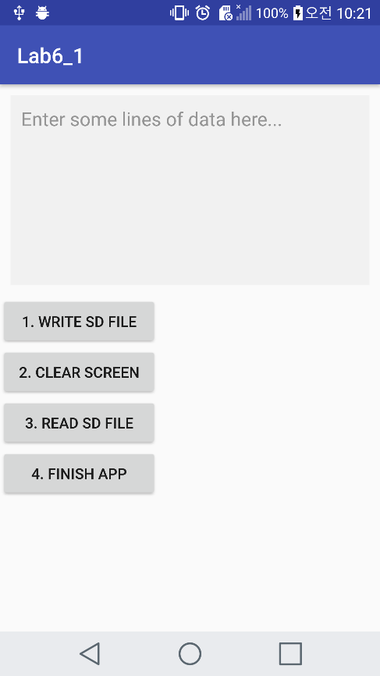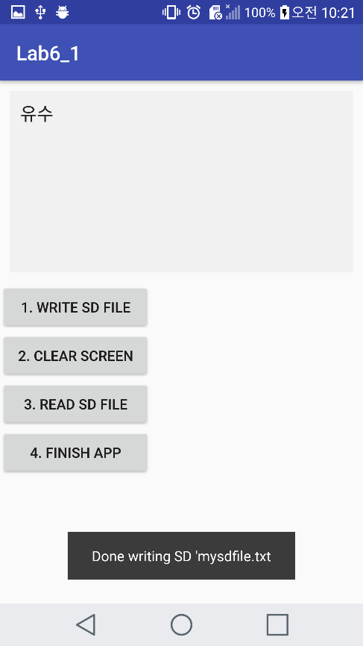

**Initial screen Push WRITE SD FILE button**

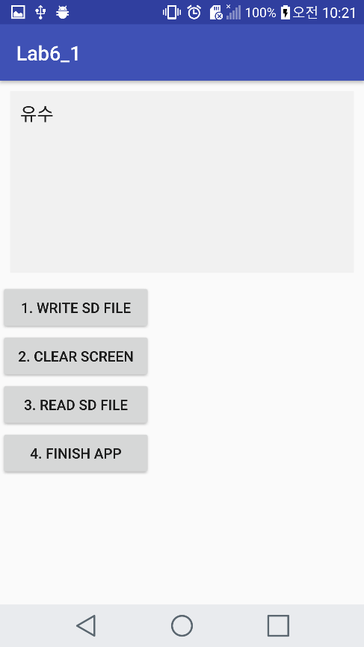

**Push CLEAR SCREEN button Push READ SD FILE button**

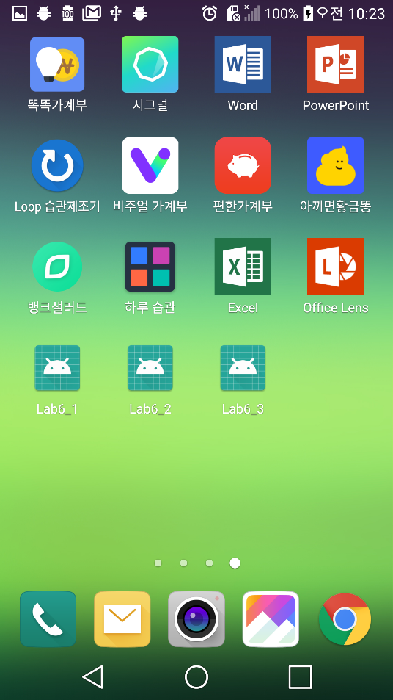 **Push FINISH APP button**

**Lab 6-2**

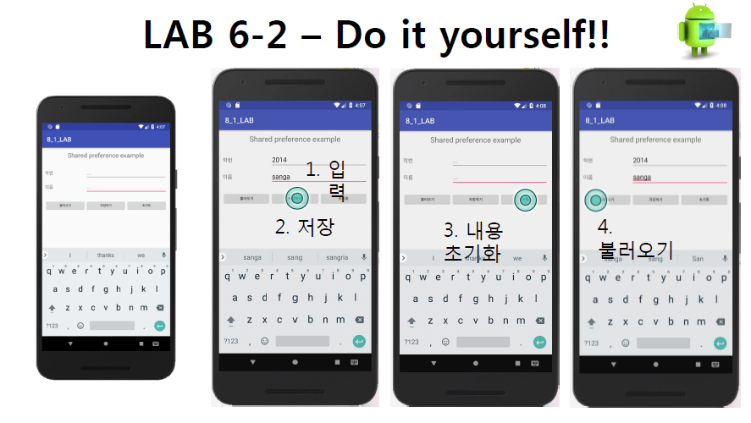

**MainActivity.java**

package example.com.lab6_2;  
  
import android.content.SharedPreferences;  
import android.os.Bundle;  
import android.support.v7.app.AppCompatActivity;  
import android.view.View;  
import android.widget.Button;  
import android.widget.EditText;  
  
public class MainActivity extends AppCompatActivity {  
 String inputSn = "", inputName = "";  
 EditText editSn;  
 EditText editName;  
 SharedPreferences sh_Pref;  
 SharedPreferences.Editor toEdit;  
  
 // onCreate() : Called when the activity is first created.  
 @Override  
 protected void onCreate(Bundle savedInstanceState) {  
 super.onCreate(savedInstanceState);  
 setContentView(R.layout.*activity_main*);  
  
 Button bool = (Button) findViewById(R.id.*BtnBool*);  
 Button save = (Button) findViewById(R.id.*BtnSave*);  
 Button init = (Button) findViewById(R.id.*ButInit*);  
  
 editSn = (EditText) findViewById(R.id.*sn*);  
 editName = (EditText) findViewById(R.id.*name*);  
  
  
 //When you click this button(불러오기),  
 // Data is received using Shared preference.  
 bool.setOnClickListener(new View.OnClickListener() {  
 @Override  
 public void onClick(View v) {  
  
 applySharedPreference();  
 }  
 });  
  
 // When you click this button(저장하기),  
 // Data is saved in Shared preference.  
 save.setOnClickListener(new View.OnClickListener() {  
 @Override  
 public void onClick(View v) {  
  
 inputSn = editSn.getText().toString();  
 inputName = editName.getText().toString();  
 sharedPrefernces();  
 }  
 });  
  
 //When you click this button(초기화),  
 // CLEAR content of edit texts  
 init.setOnClickListener(new View.OnClickListener() {  
 @Override  
 public void onClick(View v) {  
 editName.setText("");  
 editSn.setText("");  
 }  
 });  
  
  
 }  
  
 // In each entry of the form <Key-value> the key is student number and name  
 // and value must be a primitive data type.  
 //To save  
 public void sharedPrefernces() {  
 sh_Pref = getSharedPreferences("Lab6_2", *MODE_PRIVATE*);  
 toEdit = sh_Pref.edit();  
 toEdit.putString("number", inputSn);  
 toEdit.putString("name", inputName);  
 toEdit.commit();  
 }  
  
 //To load data (retrieve)  
 public void applySharedPreference() {  
 sh_Pref = getSharedPreferences("Lab6_2", *MODE_PRIVATE*);  
 if (sh_Pref != null && sh_Pref.contains("number")) {  
 String sn = sh_Pref.getString("number", "00000000");  
 editSn.setText(sn);  
 String name = sh_Pref.getString("name", "noname");  
 editName.setText(name);  
 }  
 }  
}

**activity_main.xml**

<?xml version="1.0" encoding="utf-8"?>  
<TableLayout xmlns:android="http://schemas.android.com/apk/res/android"  
 android:layout_width="wrap_content"  
 android:layout_height="wrap_content"  
 android:stretchColumns="*">  
  
 <TableRow>  
  
 <TextView  
 android:layout_span="3"  
 android:gravity="center"  
 android:text="Shared preference example"  
 android:textSize="20dp" />  
  
 </TableRow>  
  
 <TableRow android:layout_marginTop="20dp">  
  
 <TextView android:text="학번" />  
  
 <EditText  
 android:id="@+id/sn"  
 android:layout_span="2"  
 android:hint="..." />  
 </TableRow>  
  
 <TableRow android:layout_marginTop="20dp">  
  
 <TextView android:text="이름" />  
  
 <EditText  
 android:id="@+id/name"  
 android:layout_span="2"  
 android:hint="..." />  
 </TableRow>  
  
 <TableRow>  
  
 <!-- When you click this button(불러오기),  
 Data is received using Shared preference.-->  
 <Button  
 android:id="@+id/BtnBool"  
 android:layout_width="wrap_content"  
 android:layout_height="wrap_content"  
 android:text="불러오기" />  
  
 <!-- When you click this button(저장하기),  
 Data is saved in Shared preference-->  
 <Button  
 android:id="@+id/BtnSave"  
 android:layout_width="wrap_content"  
 android:layout_height="wrap_content"  
 android:text="저장하기" />  
  
 <!-- When you click this button(초기화),  
 CLEAR content of edit texts -->  
 <Button  
 android:id="@+id/ButInit"  
 android:layout_width="wrap_content"  
 android:layout_height="wrap_content"  
 android:text="초기화" />  
 </TableRow>  
</TableLayout>

**Screen-shot**

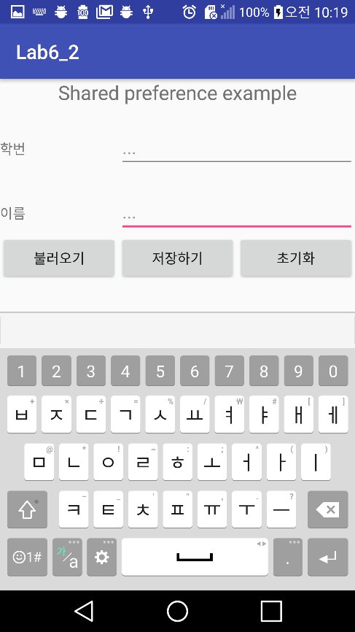 **Initial screen**

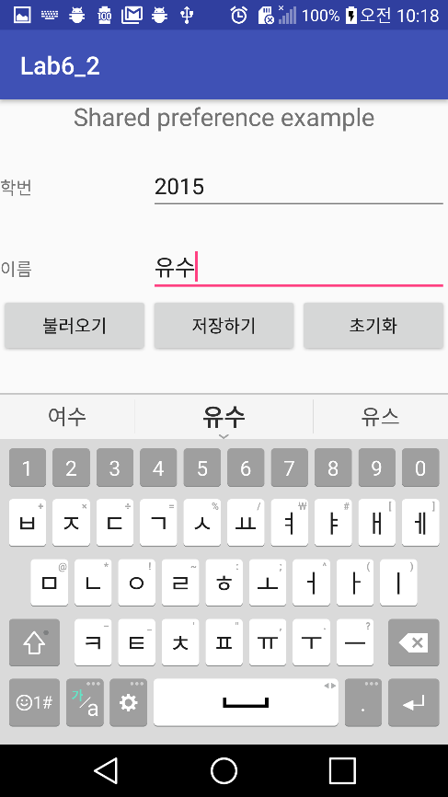

**Enter the content and push 저장하기 button**

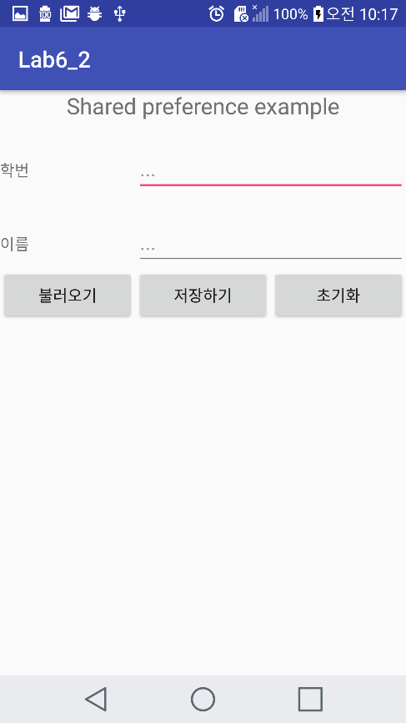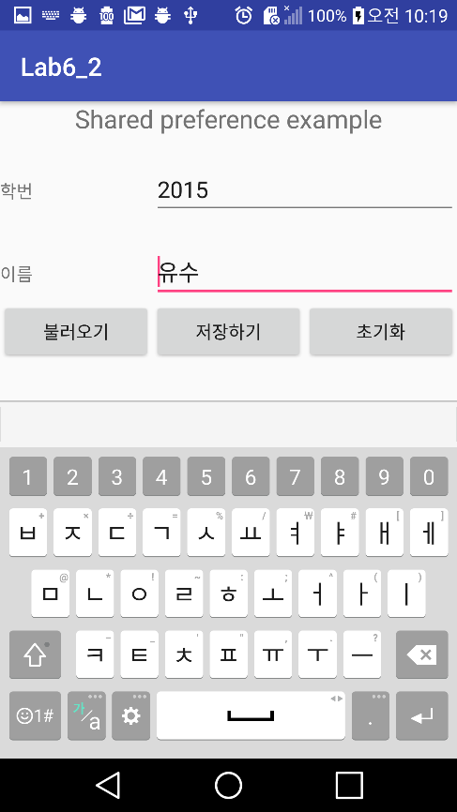

**Push 초기화 button Push 불러오기 button**

**Lab 6-3**

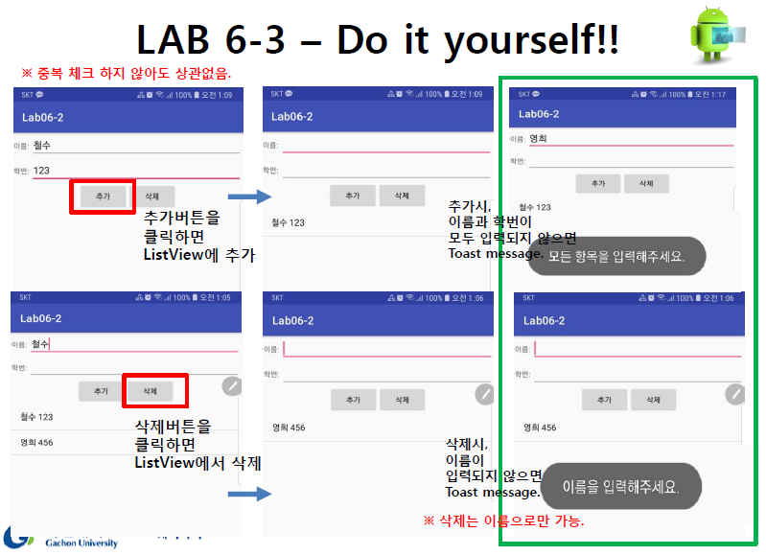

**MainActivity.java**

package example.com.lab6_3;  
  
 import android.content.ContentValues;  
 import android.database.Cursor;  
 import android.database.sqlite.SQLiteDatabase;  
 import android.os.Bundle;  
 import android.support.v7.app.AppCompatActivity;  
 import android.text.TextUtils;  
 import android.view.View;  
 import android.widget.ArrayAdapter;  
 import android.widget.Button;  
 import android.widget.EditText;  
 import android.widget.ListView;  
 import android.widget.Toast;  
  
public class MainActivity extends AppCompatActivity {  
  
 SQLiteDatabase db;  
 MySQLiteOpenHelper helper;  
 String name, sn, dname;  
 EditText editName, editSn;  
 ListView listView;  
 String[] studentInfo;  
  
 //onCreate() : Called when the activity is first created.  
 @Override  
 protected void onCreate(Bundle savedInstanceState) {  
 super.onCreate(savedInstanceState);  
 setContentView(R.layout.*activity_main*);  
  
 editName = (EditText) findViewById(R.id.*name*);  
 editSn = (EditText) findViewById(R.id.*sn*);  
 Button add = (Button) findViewById(R.id.*BtnAdd*);  
 final Button delete = (Button) findViewById(R.id.*BtnDelete*);  
 listView = (ListView) findViewById(R.id.*listview*);  
  
 helper = new MySQLiteOpenHelper(MainActivity.this, "lab6", null, 1);  
  
 // When you click this button(추가),  
 // add at ListView.  
 add.setOnClickListener(new View.OnClickListener() {  
 @Override  
 public void onClick(View view) {  
  
 //Check whether the user entered the name and student number.  
 if (!(isEmptyName() && isEmptySn())) {  
 // If you don't enter your name and student number when you add it, a toast message is displayed.  
 Toast.*makeText*(MainActivity.this, "모든 항목을 입력해주세요", Toast.*LENGTH_SHORT*).show();  
 return;  
 }  
  
 name = editName.getText().toString();  
 sn = editSn.getText().toString();  
 // Log.d("suh", name+sn);  
  
 //Insert data at SQLite database.  
 insert(name, sn);  
 invalidate();  
 }  
 });  
  
 // When you click this button(삭제),  
 // remove data from ListView.  
 delete.setOnClickListener(new View.OnClickListener() {  
 @Override  
 public void onClick(View view) {  
  
 //Check whether the user entered the name.  
 if (!isEmptyName()) {  
 // If you don't enter your name when you delete it,  
 //a toast message is displayed.  
 Toast.*makeText*(MainActivity.this, "이름을 입력해주세요", Toast.*LENGTH_SHORT*).show();  
 return;  
 }  
  
 //Delete data such as user input name.  
 dname = editName.getText().toString();  
 deleteM(dname);  
  
 invalidate();  
 }  
  
 });  
  
  
 }  
  
 //Insert data at SQLite database.  
 public void insert(String name, String sn) {  
 db = helper.getWritableDatabase();  
 ContentValues values = new ContentValues();  
  
 values.put("name", name);  
 values.put("studentNo", sn);  
 // Log.d("suh","name"+ name+"sn"+sn);  
 db.insert("student", null, values);  
 }  
  
 //Delete data  
 public void deleteM(String name) {  
 //Deletes data with the same name entered by the user.  
 db = helper.getWritableDatabase();  
 db.delete("student", "name=?", new String[]{name});  
 }  
  
 //Check whether the user entered the student number.  
 public boolean isEmptySn() {  
 if (TextUtils.*isEmpty*(editSn.getText().toString())) {  
 return false;  
 }  
  
 return true;  
 }  
  
 //Check whether the user entered the name.  
 public boolean isEmptyName() {  
  
 if (TextUtils.*isEmpty*(editName.getText().toString())) {  
 return false;  
 }  
  
 return true;  
 }  
  
  
 // load all data from SQLite database.  
 public void select() {  
 db = helper.getReadableDatabase();  
 Cursor c = db.query("student", null, null, null, null, null, null);  
  
 // Log.d("suh","select dd");  
 studentInfo = new String[c.getCount()];  
  
 int count = 0;  
 while (c.moveToNext()) {  
  
 studentInfo[count] = c.getString(c.getColumnIndex("name")) + " " + c.getString(c.getColumnIndex("studentNo"));  
 // Log.d("suh","요깅");  
 count++;  
 }  
 c.close();  
  
 }  
  
 //Show data at list view  
 public void invalidate() {  
 select();  
 ArrayAdapter<String> adapter = new ArrayAdapter<>(this, android.R.layout.*simple_list_item_1*, studentInfo);  
 //Log.d("suh","invalidate");  
 listView.setAdapter(adapter);  
 }  
  
}

**activity_main.xml**

<?xml version="1.0" encoding="utf-8"?>  
<LinearLayout  
 xmlns:android="http://schemas.android.com/apk/res/android"  
 android:layout_width="match_parent"  
 android:layout_height="match_parent"  
 android:orientation="vertical"  
 >  
 <TableLayout  
 android:stretchColumns="1"  
 android:layout_width="match_parent"  
 android:layout_height="wrap_content">  
 <TableRow>  
 <TextView  
 android:text="이름: "/>  
 <EditText  
 android:id="@+id/name"/>  
 </TableRow>  
  
 <TableRow>  
 <TextView  
 android:text="학번: "/>  
 <EditText  
 android:id="@+id/sn"/>  
 </TableRow>  
  
 </TableLayout>  
  
 <LinearLayout  
 android:layout_width="match_parent"  
 android:layout_height="wrap_content"  
 android:gravity="center_horizontal"  
 android:orientation="horizontal">  
  
 <!-- When click the 추가 button, add at ListView. -->  
 <Button  
 android:id="@+id/BtnAdd"  
 android:layout_width="wrap_content"  
 android:layout_height="wrap_content"  
 android:layout_gravity="center"  
 android:text="추가" />  
  
 <!-- When click the 삭제 button, remove from ListView. -->  
 <Button  
 android:id="@+id/BtnDelete"  
 android:text="삭제"  
 android:layout_width="wrap_content"  
 android:layout_height="wrap_content" />  
 </LinearLayout>  
  
 <!-- The data stored in SQLite is shown in this list view. -->  
 <ListView  
 android:id="@+id/listview"  
 android:layout_width="match_parent"  
 android:layout_height="wrap_content">  
 </ListView>  
</LinearLayout>

**MySQLiteOpenHelper.java**

package example.com.lab6_3;  
  
import android.content.Context;  
import android.database.sqlite.SQLiteDatabase;  
import android.database.sqlite.SQLiteOpenHelper;  
  
*/**  
 * Created by lg on 2018-05-07.  
 */*public class MySQLiteOpenHelper extends SQLiteOpenHelper {  
  
  
 public MySQLiteOpenHelper(Context context, String name, SQLiteDatabase.CursorFactory factory, int version) {  
 super(context, name, factory, version);  
 // call super() to initialize underlying database.  
 // *TODO Auto-generated constructor stub* }  
  
 //Create table student  
 @Override  
 public void onCreate (SQLiteDatabase db) {  
 // *TODO Auto-generated method stub* String sql ="create table student ("+  
 "_id integer, "+  
 "name text, "+  
 "studentNo text);";  
 db.execSQL(sql);  
 }  
  
 //make a modification to the tables structures.  
 @Override  
 public void onUpgrade(SQLiteDatabase db, int oldVersion, int newVersion) {  
 String sql = "drop table if exists student";  
 db.execSQL(sql);  
 onCreate(db);  
 }  
}

**Screen-shot**

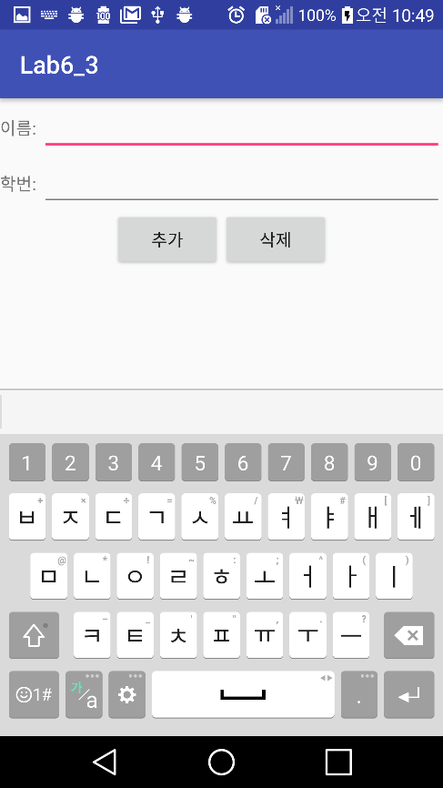 **Initial screen**

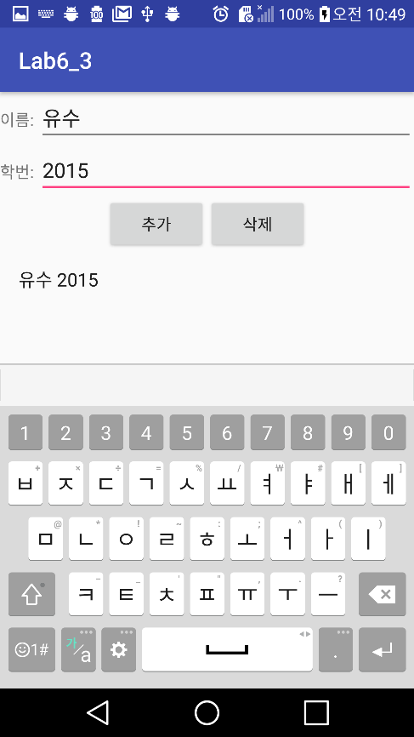 **Enter유수 2015 and push 추가 button**

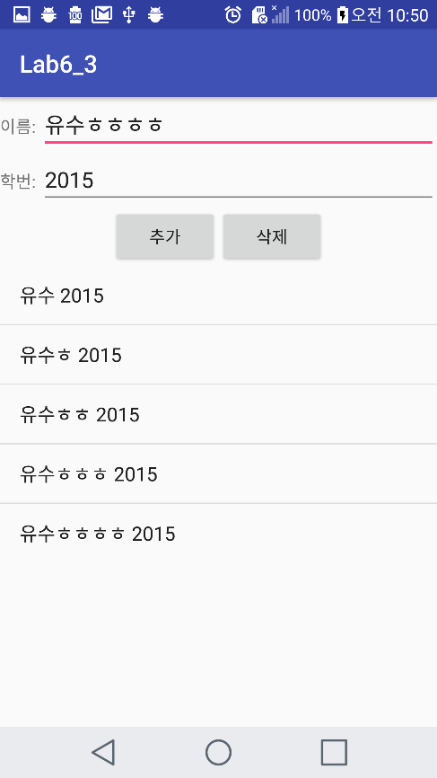

Enter유수ㅎ 2015, 유수ㅎㅎ 2015, 유수ㅎㅎㅎ2015, 유수ㅎㅎㅎㅎ 2015 and each push 추가 button

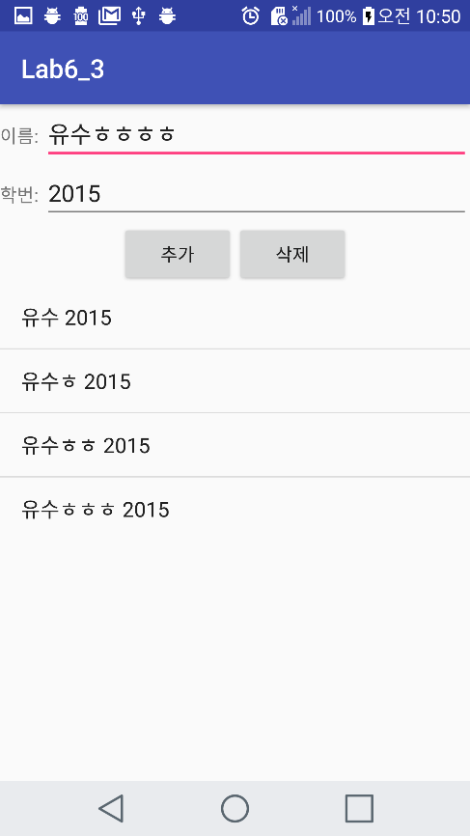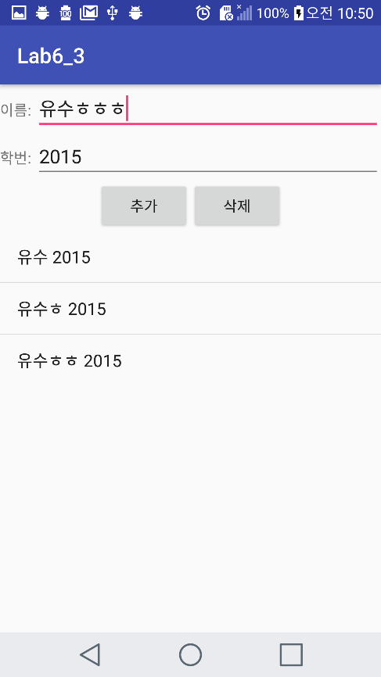

**유수ㅎㅎㅎㅎ and 유수 ㅎㅎㅎ delete**

**Also**

**1.** If you don't enter your name and student number when you add it, a toast message is displayed.

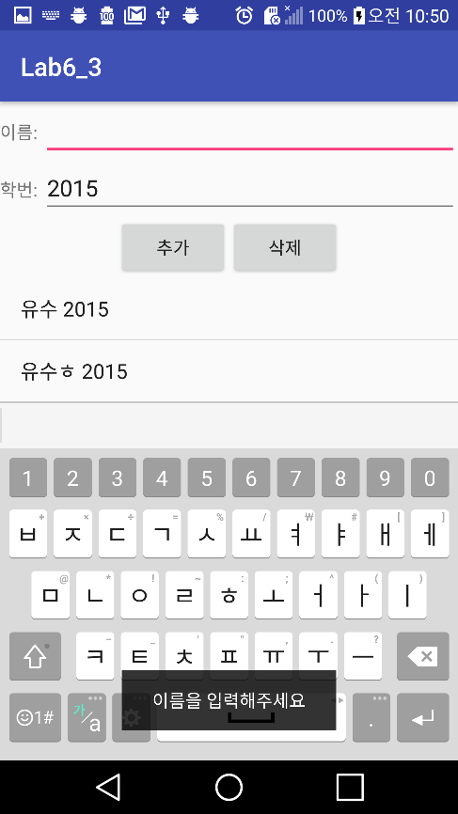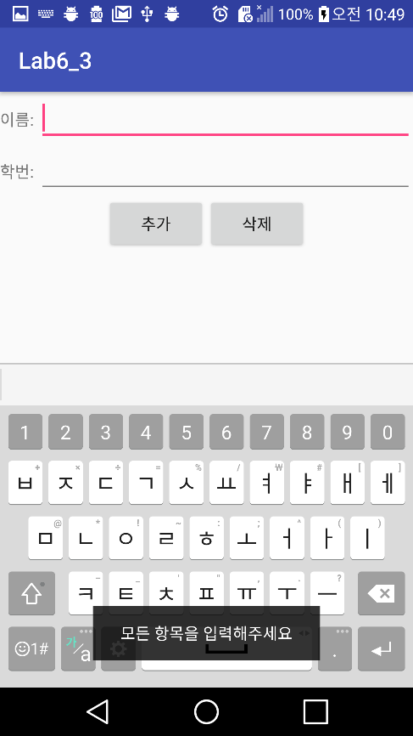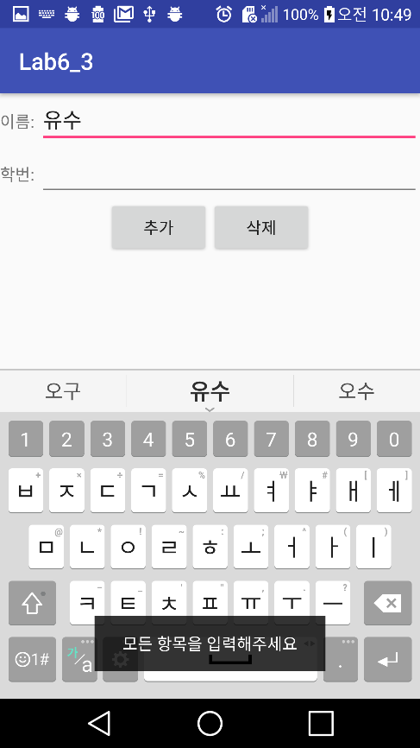

**2.** If you don't enter your name when you delete it,

a toast message is displayed.

**<Github address>**

**https://github.com/YooSuhwa/Mobile-Programming.git**