CO2 Debugging and Optimisation Task
Student Name: S.Yoogesh
Register No.: 192424024

Scope and Reproducibility
This report follows the supplied assessment brief and preserves the original algorithmic structure when correcting defects. It includes the original buggy module, a corrected reference module, an optimised module, separate pseudocode for all four functions, a test harness, benchmark CSV files, execution logs, graphs and this report. Timing results are environment-specific; operation counts are the primary evidence.

(a) Reproduce and Identify the Defects — 10 marks
The supplied code has nine defect sites, counted as the assessment prompt specifies. The closest-pair initialisation/comparison and pair-loop design are treated as separate defects because they independently cause the wrong result.
# / Function | Faulty code or condition | Root cause and impact | Correction
1 sort_alerts | while j > 0 | Index 0 is never compared or shifted; the first alert can remain out of order. | Use j >= 0.
2 sort_alerts | alerts[j] = key | Writes key into the predecessor slot instead of the insertion slot; may overwrite/duplicate and lose the shifted item. | Write alerts[j + 1] = key.
3 is_blocked | return False when IP matches | Membership result is inverted, so blocked IPs are reported as allowed. | Return True on match.
4 is_blocked | else: return False inside loop | First nonmatching item ends search, so later blocklist entries are never checked. | Return False only after the loop.
5 find_signature | range(n - m) | Excludes the final valid alignment; pattern at end is missed, and if n==m there are no iterations. | Use range(n - m + 1).
6 find_signature | if j == m - 1 after loop | When a mismatch occurs at the last pattern character, j still equals m-1 and a false hit is appended. | Use an explicit full-match condition, e.g. j == m.
7 closest_logins | min_dist = 0 and if d > min_dist | Finds the farthest non-identical pair, not the closest pair. | Initialise best squared distance to infinity and minimise.
8 closest_logins | for j in range(len(events)) | Examines self-pairs and each unordered pair twice; redundant work obscures pair uniqueness. | Use j from i+1 to n-1.
9 closest_logins | sqrt each pair / no <2 guard | Square roots are unnecessary for comparisons; zero/one event returns an invalid pair/distance. | Compare squared distances and return (None,None) when n<2; take one sqrt at end.

Actual vs Expected Output on Supplied Test Data
Expected sorted alerts: [('A2', 9), ('A4', 9), ('A3', 5), ('A1', 3), ('A5', 1)]. Equal-severity A2 must remain before A4.
Expected blocklist results: 10.0.0.9 → True; 10.0.0.5 → True; 8.8.8.8 → False.
Expected signature hits in 'FAILFAIXFAIL' for 'FAIL': [0, 8].
Expected closest pair for the supplied events is the pair at indices (0,5), coordinates (2,3) and (3,4), distance √2 ≈ 1.414 km.
The original module is executed and its output is preserved in Supporting_Files/execution_logs.txt. It can raise an UnboundLocalError for an empty pattern because the loop does not assign j; the corrected/optimised modules define the empty-pattern convention explicitly.

(b) Root Causes and Systematic Debugging — 12 marks

Insertion-sort trace
Start: A1:3, A2:9, A3:5, A4:9, A5:1. Insert A2:9: compare A1:3, shift it right, insert A2 at index 0. Insert A3:5: shift A1:3 but stop before A2:9, giving A2:9, A3:5, A1:3. Insert A4:9: strict '<' means A3 and A2 are not shifted for equal severity; A2 stays before A4. Insert A5:1: no shift is needed. Final stable order: A2, A4, A3, A1, A5.

String alignment trace
For log FAILFAIXFAIL (length 12) and pattern FAIL (length 4), candidate starts are 0 through 8 inclusive. Start 0 matches all four characters; starts 1–7 fail before a complete match; start 8 matches all four. Therefore hits=[0,8]. The original upper bound omits start 8. A separate full-match condition is needed because a mismatch on the final character leaves j=m−1.

Boundary tests
- Empty blocklist: any IP returns False.
- Pattern at final valid position: find_signature('abcXYZ','XYZ') returns [3].
- Pattern longer than log: find_signature('abc','longer') returns [].
- Equal severities: stable sorting preserves input order among ties.
- Fewer than two login events: closest_logins([]) and closest_logins([(1,2)]) return (None,None).
- Overlapping matches: find_signature('aaaa','aa') returns [0,1,2].
- Blocklist positive and negative cases both checked.
Each correction is represented in Source_Code/corrected.py and the optimised implementation is checked with assertions by running Source_Code/optimized.py. The output log captures the baseline, corrected and optimised executions.

(c) Optimise the Corrected Module — 10 marks
Sorting: retain stable insertion sort when each incoming batch is nearly sorted; it is adaptive and has low overhead. For 50,000 alerts arriving as a large random batch, Python's stable Timsort via sorted(alerts, key=lambda x: -x[1]) is generally the practical production choice, while insertion sort is kept here to satisfy the debugging task and exploit near-order.
Blocklist: convert the blocklist to a set once. This costs O(B) preprocessing and O(B) memory, then expected O(1) average membership per query, instead of O(B) per query.
String matching: use KMP for all occurrences. Its LPS preprocessing avoids comparing characters again after a mismatch and gives O(n+m) time, O(m) auxiliary memory. The corrected brute-force implementation is retained separately for debugging comparison.
Closest pair: compare squared distances, inspect only j>i, and take one square root at the end. This halves the pair count relative to the original n² loops, but remains Θ(n²). No safe generic pruning is added to the exact pair scan because arbitrary 2D input order provides no bound that lets us discard pairs without additional spatial assumptions/indexing. At 8,000 points it still performs 31,996,000 unique-pair checks. A production redesign for larger workloads should use a proven divide-and-conquer or spatial-index algorithm.

(d) Before/After Complexity and Experiments — 10 marks
Function | Original | Corrected | Optimised
sort_alerts | O(n²), but incorrect | Best O(n), worst O(n²) | Insertion O(n) best / O(n²) worst; Timsort alternative O(n log n)
is_blocked | O(B) but wrong | O(B) scan | O(B) build then expected O(1) query
find_signature | O(nm), incorrect bounds/match test | O(nm), correct | KMP O(n+m), O(m) space
closest_logins | O(n²) sqrt per ordered pair | O(n²) unique pairs, squared distances | O(n²) unique pairs; no safe generic pruning in this scan

Closest-pair distance computations
Events n | Original n² | Unique pairs n(n−1)/2 | Observed optimised count | Runtime (s)
1000 | 1000000 | 499500 | 499500 | 0.054
2000 | 4000000 | 1999000 | 1999000 | 0.216
4000 | 16000000 | 7998000 | 7998000 | 0.882
8000 | 64000000 | 31996000 | 31996000 | 3.391
The optimised counts match n(n−1)/2 exactly. At n=8,000 the original loop would compute 64,000,000 distances; the corrected loop computes 31,996,000, a reduction of about 50.0%. Measured time grew from about 0.054 s at 1,000 to 3.391 s at 8,000 on this environment, consistent with quadratic growth.

Insertion-sort comparisons: nearly sorted vs random
Alerts n | Nearly sorted comparisons | Nearly sorted shifts | Random comparisons | Random shifts
1000 | 4501 | 3502 | 208599 | 207601
5000 | 115755 | 110756 | 5069590 | 5064593
10000 | 510875 | 500876 | 20338344 | 20328346
The generated severity values are discrete (1–5), so many equal keys occur. Stable insertion sort still performs far fewer comparisons on nearly sorted data than on random data, although random comparison counts rise quadratically. Results depend on the specific test data; operation counts are more reproducible than timing.
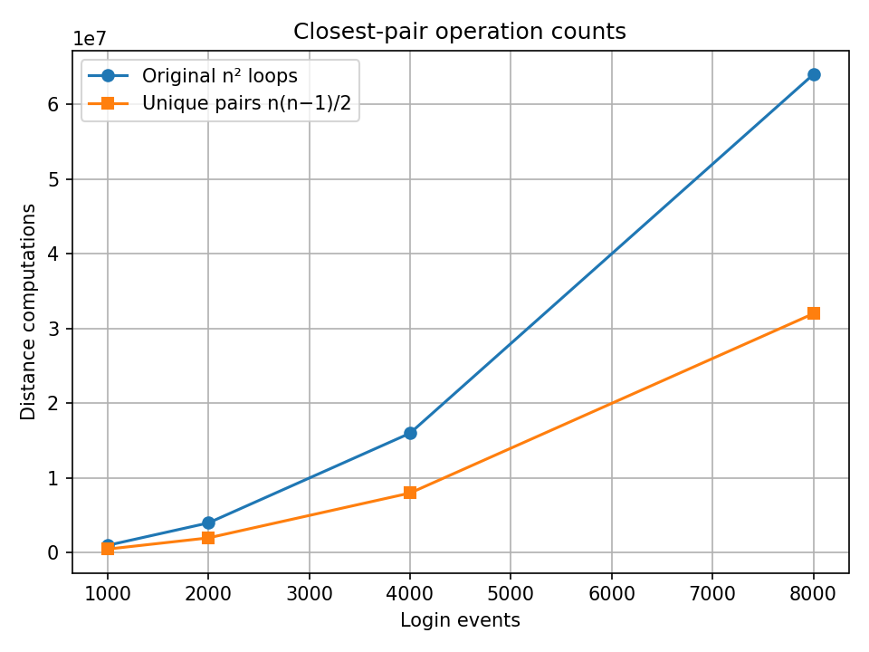
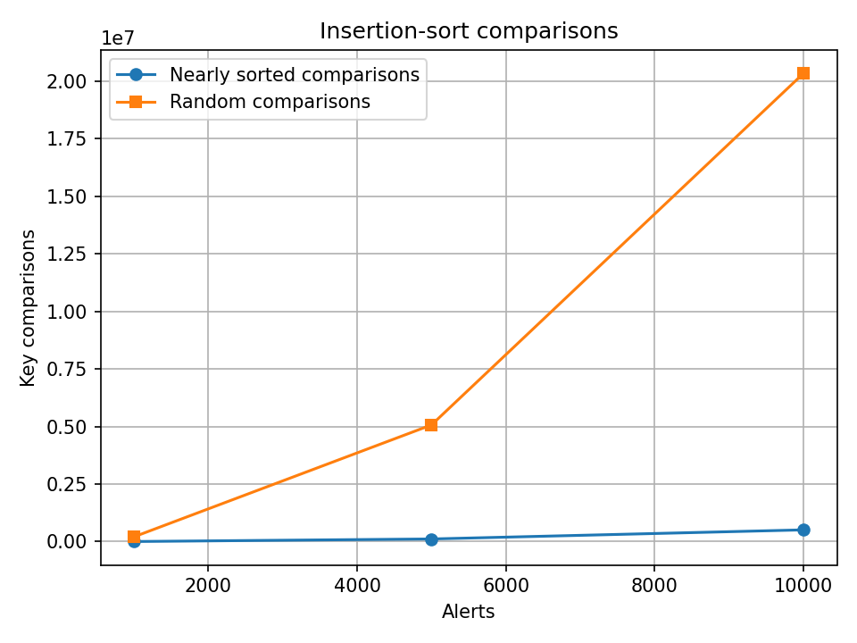

(e) Production-quality Code and Repository — 8 marks
Source_Code contains original_buggy.py, corrected.py and optimized.py. The optimised file includes docstrings, comments, and run_tests() assertions covering all four functions and required boundary cases. Pseudocode is separated into four files. Supporting_Files contains benchmark CSVs, graphs and execution logs. README.md provides run instructions.

Conclusion
The production failures came from incorrect loop bounds, early returns, incorrect boolean results, incorrect insertion positions, wrong optimisation direction, and duplicate/self-pair enumeration. The fixes were validated with explicit expected outputs and boundary tests. The optimisations reduce repeated lookup and string-scan costs substantially; closest-pair pair enumeration is improved by a constant factor but still requires a more advanced exact algorithm for substantially larger workloads.

