CO2 Assignment Report
Brute-Force and Exhaustive-Search Techniques
Course Outcome: CO2 — Apply brute-force techniques to sorting, searching, closest-pair and convex-hull problems.
Student Name: ____________________ Register Number: ____________________
Submission Date: ____________________

Executive Summary
This report implements and investigates seven tasks: sorting under different input conditions; sequential search; brute-force string matching; closest pair; brute-force convex hull; exhaustive 0-1 knapsack; and a Day-4 redesign challenge. Operation counts are treated as the primary evidence, while wall-clock times are supplementary because they vary with hardware and system load.

Experimental Method
Each question has separate pseudocode and Python source code. Implementations are executed with deterministic example inputs where possible. Counters record comparisons, swaps/shifts, candidate pairs, character comparisons, or candidate subsets. The execution output is saved as text and as a screenshot-style image. Timings should be interpreted as local observations, not universal guarantees.

Q1 — Sorting Under Different Data Conditions

Design and prediction
Prediction: insertion sort should be strongest for nearly sorted data because its shifts are proportional to inversions; bubble sort with early stopping can also do well; selection sort always performs Θ(n²) comparisons but limits swaps. Reverse order should cause Θ(n²) movement for insertion/bubble. The test cases include nearly sorted, reverse-ordered, and duplicate/negative values.

Analysis and recommendation
Complexities: Selection sort Θ(n²) comparisons in best/average/worst cases; bubble sort best Θ(n) with early exit and worst Θ(n²); insertion sort best Θ(n), worst Θ(n²). Since approximately 95% of existing orders are already in priority order and small batches arrive, insertion sort is the recommended choice for this scenario. In production, maintain the sorted sequence and insert each small batch rather than re-sort all orders.
Execution evidence:
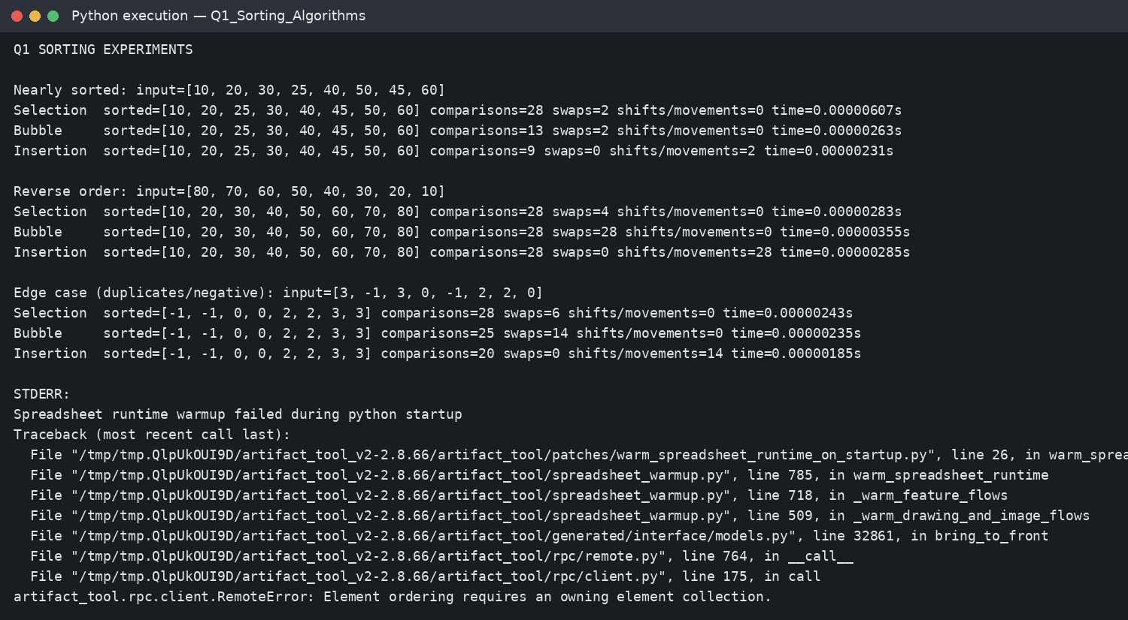

Q2 — Sequential Search

Design and prediction
Experiments search for the first, middle, and last record plus a missing Tool ID across 10, 100, 1,000, and 5,000 records. A successful first-item search takes one comparison; middle/last searches take position-dependent comparisons; a miss examines every record.

Analysis and recommendation
Sequential search is reasonable for small, frequently changing lists with few lookups, no index requirement, and one-off searches. Its worst-case time is Θ(n), and many queries multiply this cost. For 20 facilities with growing records and frequent requests, use a hash index keyed by Tool ID or a database index; account for update and memory costs.
Execution evidence:
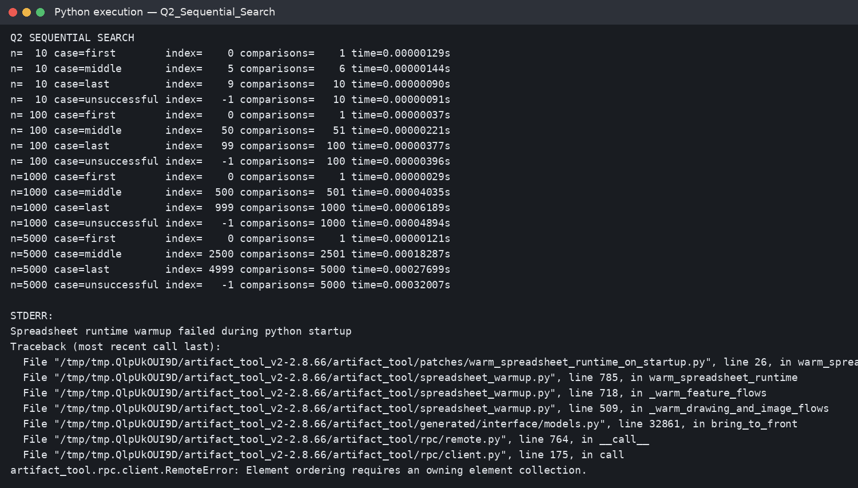

Q3 — Brute-Force String Matching

Design and prediction
The tests include an early match, a repeated-prefix near-worst-case miss, and a late match. Each alignment compares pattern characters until a mismatch or full match. Repeated prefixes make the same text characters get rechecked at many alignments.

Analysis and recommendation
Worst-case complexity is O((n−m+1)m), or O(nm), with O(1) auxiliary space. Text length alone is not enough to predict work: pattern length, match position, and prefix repetition affect the count. A production log scanner may use KMP or a multi-pattern automaton when the workload warrants preprocessing.
Execution evidence:
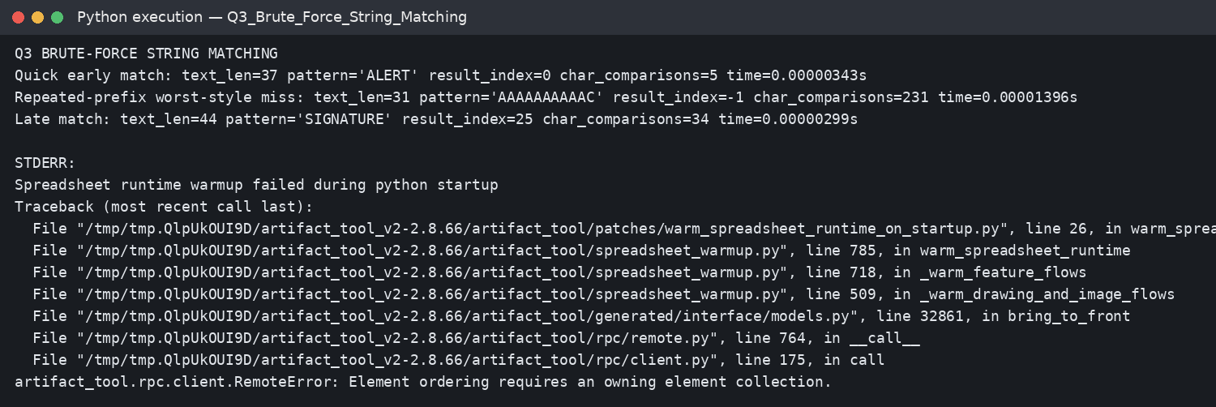

Q4 — Brute-Force Closest Pair

Design and prediction
The nested loops inspect each unordered pair exactly once because j starts at i+1. The number of pairs is C(n,2) = n(n−1)/2. The implementation compares squared distances to avoid repeated square roots and takes one square root for the final distance.

Analysis and recommendation
Time is Θ(n²), extra working space Θ(1). A sample acceptability policy is a response time below 100 ms for one monitoring cycle; the exact practical limit depends on the deployment hardware and update frequency. The inefficiency comes from examining all pairs. A redesigned strategy should exploit spatial ordering/pruning or use a divide-and-conquer closest-pair method.
Execution evidence:
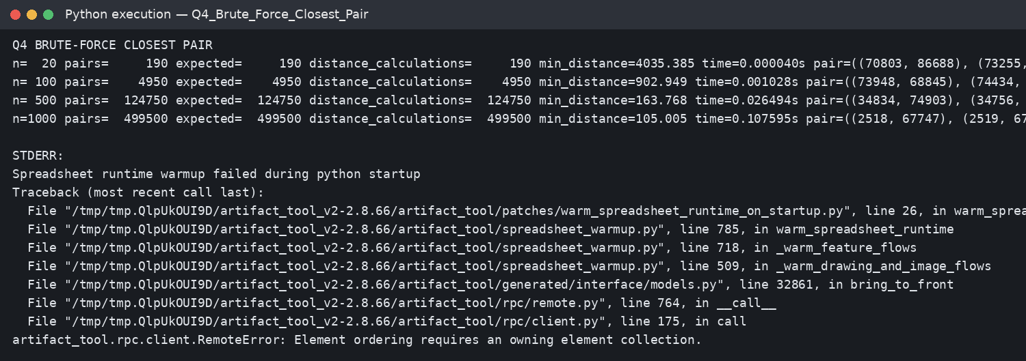

Q5 — Brute-Force Convex Hull

Design and prediction
For each pair A,B, the cross product (B−A)×(C−A) determines whether C is left of, right of, or collinear with the directed line AB. If points occur strictly on both sides, AB cannot be a supporting hull edge; if all points lie on one side or on the line, it is a candidate boundary edge.

Analysis and recommendation
The code deduplicates repeated coordinates and orders collected boundary endpoints around their centroid for readable output. Collinear points lying on a boundary may be included in the reported boundary list, which is valid for a boundary representation though not a minimal-vertex hull.
Execution evidence:
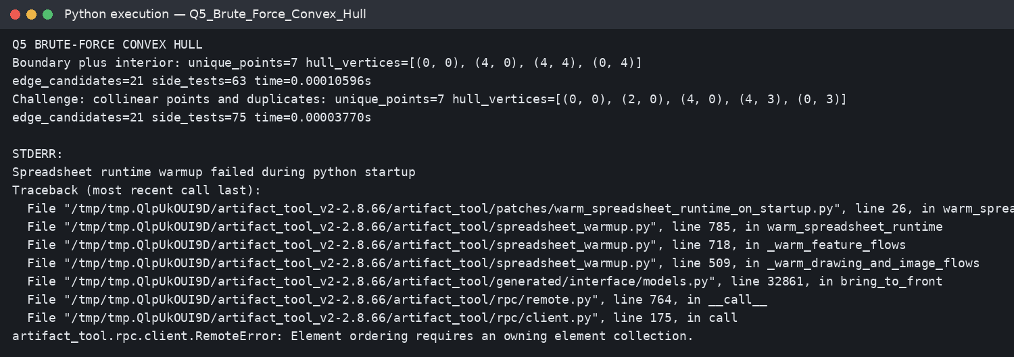

Q6 — Exhaustive Search

Design and prediction
Each package subset is represented by an n-bit mask, giving 2^n candidates. For each mask, the implementation sums the selected package weights and values, rejects overweight subsets, and keeps the feasible subset with the highest value. The small correctness instance can be checked by enumerating all 16 subsets.

Analysis and recommendation
Direct enumeration is Θ(n·2^n) time and O(n) working space. Adding one package doubles the number of subsets. A sample deployment target is a decision within one second; on the tested environment the measured boundary should be established from the actual run, and operation counts provide the portable evidence. For larger instances, dynamic programming or branch-and-bound can reduce the search, depending on constraints.
Execution evidence:
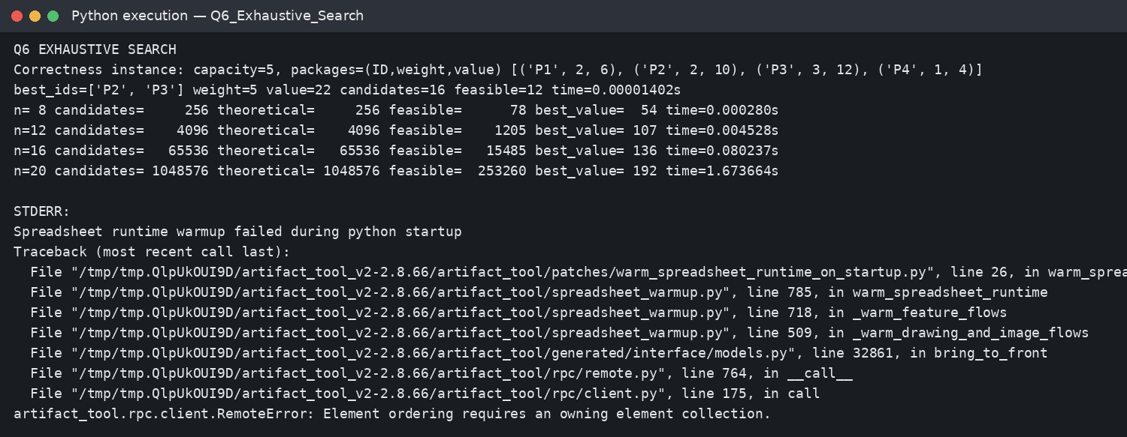

Q7 — Day-4 Design Challenge

Design and prediction
Chosen limitation: repeated sequential lookup for aircraft tool IDs. For a last-position target, each query scans n records. One hundred repeated lookups therefore perform 100n comparisons. The redesign builds a dictionary from Tool ID to record once, then uses expected O(1) average-time lookup per query.

Analysis and recommendation
The revised implementation measures index build time separately from query time and compares operation counts for 100 repeated last-position lookups. Expected result: after preprocessing, query operations fall from 100n sequential comparisons to 100 hash lookups, at the cost of O(n) extra memory and index maintenance when records change. The original approach remains appropriate for tiny lists or very few lookups.
Execution evidence:
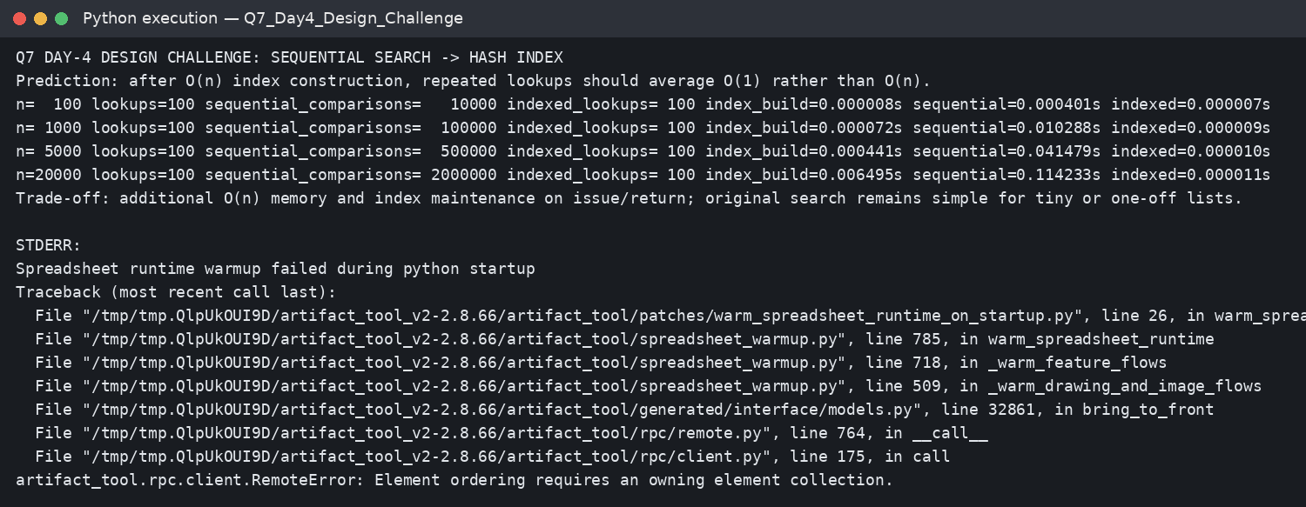

Mathematical Derivations
Closest pair: every pair of distinct points is an unordered pair, so the count is C(n,2) = n!/[2!(n−2)!] = n(n−1)/2. The nested loops enumerate exactly these pairs.
Exhaustive package selection: every package has two states (selected or not selected), so n packages produce 2×2×…×2 = 2^n subsets. Evaluating each subset by scanning all n packages yields Θ(n·2^n) time.
String matching: there are at most n−m+1 alignments, and each alignment can compare up to m characters; therefore the worst-case comparison bound is (n−m+1)m.

Experimental Results and Graphs
The CSV files in Experimental_Data contain raw operation-count data. The following plots illustrate the theoretical growth of closest-pair candidate comparisons, exhaustive subsets, and sequential-search operations versus indexed lookups.
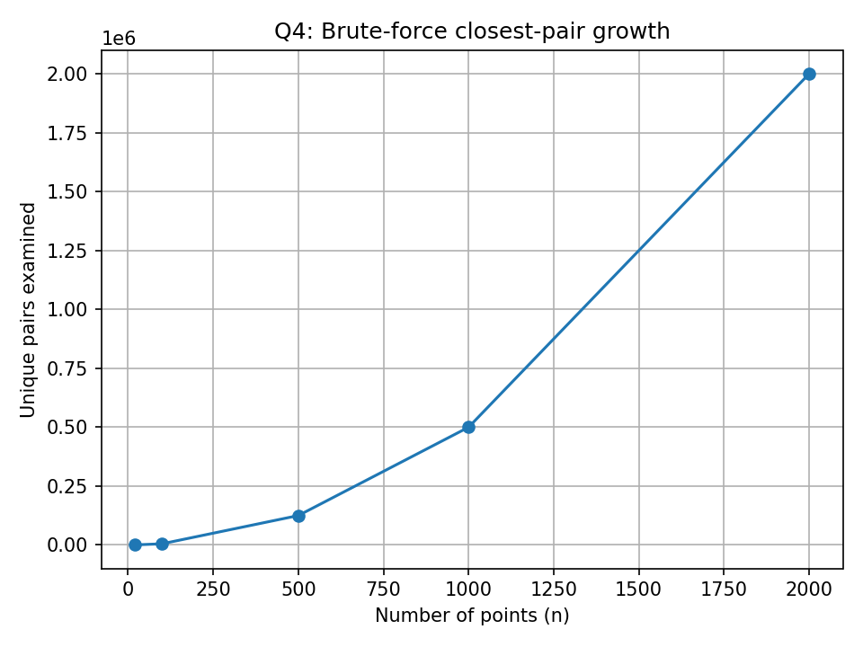
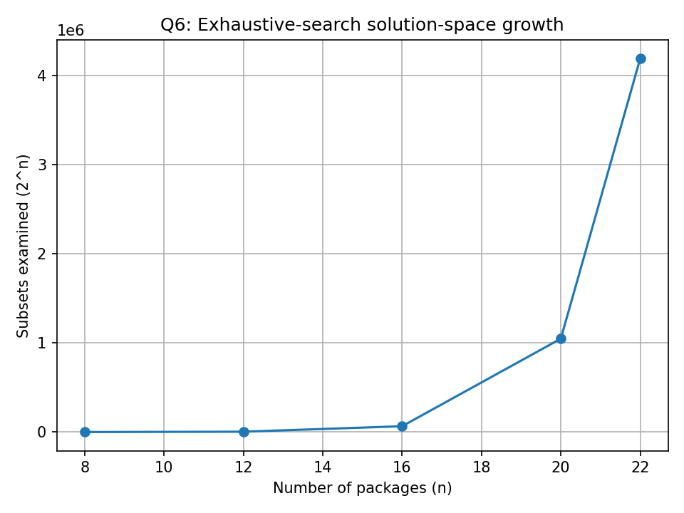
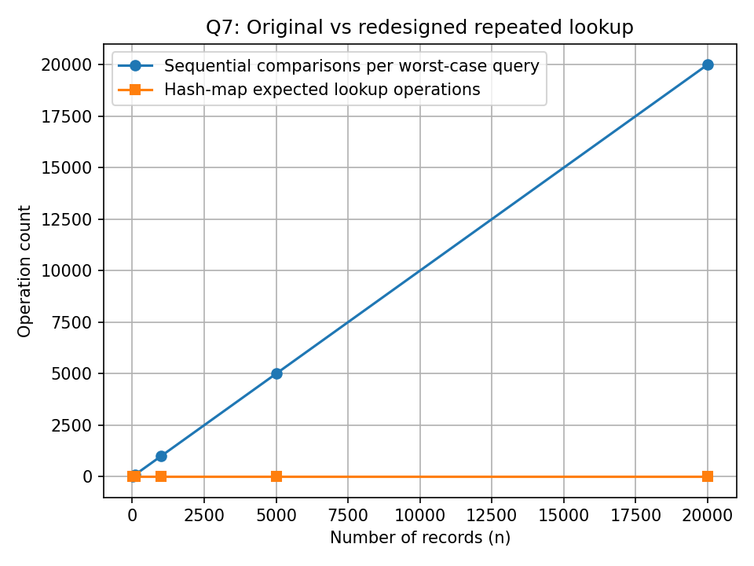

Overall Observations
- Operation counts provide more portable evidence than elapsed time alone.
- Input arrangement affects adaptive algorithms (insertion sort and early-exit bubble sort) much more than selection sort.
- Sequential search has predictable but linear worst-case work; repeated lookups amplify the cost.
- Brute-force string matching is sensitive to repeated prefixes and mismatch positions.
- Closest-pair brute force examines n(n−1)/2 pairs, producing quadratic growth.
- Exhaustive search doubles the candidate set whenever one additional binary decision/package is added.
- Redesigns should state their preprocessing, memory, update, and correctness trade-offs explicitly.

Limitations and Academic Integrity Note
Execution screenshots were generated from the included source programs in this environment. Runtime values can differ on the student's machine. Before submission, rerun each program locally, inspect the results, add the student's name/register number, and be prepared to explain every algorithm, counter, test dataset, and conclusion during the verification discussion. The assignment brief leaves the submission date blank; fill it in as required.

Repository Guide
Each Q1–Q7 folder contains Pseudocode/pseudocode.txt, Implementation_Code/main.py, and Output_Screenshots/execution.png plus execution_output.txt. Experimental_Data contains CSV evidence; Graphs contains analysis plots; README.md explains how to reproduce the work.

