
Department of Computer Science and Engineering
Course Code & Name | CSA06 – Design and Analysis of Algorithms
Assessment | CO1 – Assessment Tool 1: IT Application-Based Problem Solving – Scalability Audit of an E-Commerce Platform
Course Outcome Assessed | Determine algorithm efficiency using asymptotic notations and mathematical techniques including Master Theorem and substitution method.
Student Reg. No. | 192424024
Student Name | S.Yoogesh

IT APPLICATION-BASED PROBLEM
Scenario – Scalability Audit of “ShopSphere”, an Online Shopping Platform: ShopSphere is a growing e-commerce platform whose product catalogue currently holds n = 100,000 products and is expected to reach n = 1,000,000 within a year. Before the expansion, the CTO has asked you, as the platform’s algorithm engineer, to audit five back-end modules, predict how each will behave as n grows, and recommend which modules must be redesigned. The modules are described below.
Module M1 – Duplicate-Listing Detector: Sellers sometimes upload the same product twice. Every night, the following routine compares every product with every later product.
FOR i ← 0 TO n − 2 DO
FOR j ← i + 1 TO n − 1 DO
IF Product[i].title = Product[j].title AND Product[i].seller =
Product[j].seller THEN
MarkDuplicate(j)
END IF
END FOR
END FOR
Module M2 – API Rate Limiter: The public API audits request windows of doubling size using the routine below. A team member claims that it is Θ(n log n) because the outer loop runs about log n times and the inner loop runs up to n times.
i ← 1
WHILE i < n DO
FOR j ← 0 TO i − 1 DO
Audit(Request[j]) // basic operation
END FOR i ← i × 2
END WHILE
Module M3 – Product Search: Two versions exist. Version S1 scans the unsorted catalogue sequentially until the product is found. Version S2 searches a sorted product index by comparing the key with the middle entry and discarding half the index after each comparison; its comparison count satisfies T(n) = T(n/2) + 1, T(1) = 1.
Module M4 – Recommendation Engine: The engine splits the customer–product data into four parts of size n/2 (because of replicated partitions) and merges the partial results in linear time: T(n) = 4T(n/2) + n. A proposed redesign removes the replication, giving T(n) = 2T(n/2) + n.
Module M5 – Sales Analytics Engine: The analytics engine splits the sales data into halves recursively and sorts the records by revenue at every level, giving T(n) = 2T(n/2) + n log n. Separately, profiling shows that the nightly report generator performs f(n) = 3n² + 10n log n + 50 operations.
- Understand the Problem: For each of the five modules, identify the input size and the basic operation that dominates the running time, explain where it occurs, and state how you expect its execution count to grow as n increases. Justify each choice briefly.
- Analyse the Iterative Modules: For M1, derive the exact number of comparisons as a function of n and state the time and space complexity. For M2, derive the exact number of Audit operations, decide whether the team member’s Θ(n log n) claim is correct and give the tight bound. Verify your M2 result for n = 1,024.
- Solve a Recurrence by Substitution: Solve the recurrence for search version S2 using backward substitution, showing every intermediate step, and derive the exact closed form. State the time complexity and the space complexity of both an iterative and a recursive implementation.
- Apply the Master Theorem: For M4, apply the Master Theorem to both the current design and the proposed redesign, clearly identifying a, b, f(n), n^(log_b a) and the case used, and explain what happens to the running time when the data doubles. For M5, determine whether any of the three standard cases applies to T(n) = 2T(n/2) + n log n; if not, derive the complexity using the extended Master Theorem or a recursion tree.
- Analyse Best, Average and Worst Cases: For search versions S1 and S2, identify the input condition that produces the best, average and worst case and give the number of comparisons in each. For S1, derive the average number of comparisons when the probability that the searched product exists is p, and evaluate it for n = 1,000,000 and p = 0.5.
- Prove an Asymptotic Bound: Using the formal definitions, prove that the report generator’s cost f(n) = 3n² + 10n log n + 50 is Θ(n²) by finding constants c , c and n , and show that f(n) is not O(n).
- Scalability Decision: Estimate the number of basic operations and the running time of M1, M2, S2, M4 (both designs) and M5 for n = 1,000,000. Identify the modules that will fail to meet a nightly processing window of 10 minutes, and recommend, with justification, which modules must be redesigned and how.
Solution

(a) Understand the Problem
The input size n is the number of products, requests, index entries, or sales records processed by a module. A basic operation is the key operation whose execution count best represents the algorithm’s growth.
Module | Input size | Dominant operation | Expected growth
M1 — Duplicate detector | Number of products n | Compare each product pair’s title and seller | Θ(n²)
M2 — API rate limiter | Number of requests n | Audit(Request[j]) | Θ(n)
M3 — S1 sequential search | Number of products n | Compare search key with each product | Best Θ(1); average/worst Θ(n)
M3 — S2 binary search | Sorted index entries n | Compare key with middle entry | Θ(log n)
M4 — Current recommendation engine | Customer–product data size n | Four recursive calls and linear merge | Θ(n²)
M4 — Proposed recommendation engine | Customer–product data size n | Two recursive calls and linear merge | Θ(n log n)
M5 — Sales analytics | Number of sales records n | Recursive processing with n log n work per level | Θ(n log² n)

Justification: M1 compares all distinct pairs; M2 sums a geometric series; S1 may scan the catalogue; S2 halves the search range; M4’s number of recursive calls determines whether the recurrence is quadratic or n log n; M5 performs n log n work at each of Θ(log n) levels.

(b) Analyse the Iterative Modules

M1 — Duplicate-Listing Detector
For each i, the inner loop compares Product[i] with every later product. The number of comparisons is:
C(n) = (n − 1) + (n − 2) + … + 1 = n(n − 1)/2
C(1,000,000) = 499,999,500,000 comparisons
Time complexity: Θ(n²). Auxiliary space: O(1), excluding the catalogue and duplicate-mark storage.

M2 — API Rate Limiter
The inner loop performs 1, 2, 4, 8, … audits. Let k = floor(log₂(n − 1)); for n ≥ 2, the exact total is:
A(n) = Σ(2ⁱ), i = 0…floor(log₂(n − 1)) = 2^[floor(log₂(n − 1)) + 1] − 1
For n = 1, A(1) = 0. The geometric series is Θ(n), so the team member’s Θ(n log n) claim is incorrect: the inner loop does not run n times on every outer iteration.
A(1,024) = 1 + 2 + 4 + … + 512 = 2¹⁰ − 1 = 1,023 audits

(c) Solve S2 by Backward Substitution
Given T(n) = T(n/2) + 1, with T(1) = 1. Assume n is a power of two.
T(n) = T(n/2) + 1
T(n) = T(n/4) + 2
T(n) = T(n/8) + 3
After k expansions:
T(n) = T(n/2ᵏ) + k
The base case occurs when n/2ᵏ = 1, so k = log₂ n. Applying T(1) = 1 gives:
T(n) = 1 + log₂ n = Θ(log n)
Implementation | Time complexity | Auxiliary space
Iterative binary search | Θ(log n) | O(1)
Recursive binary search | Θ(log n) | O(log n)

For one million entries, log₂(1,000,000) ≈ 19.93, so a binary search needs roughly 20 comparisons in the ideal halving model; exact counts depend on the implementation and stopping convention.

(d) Apply the Master Theorem
For T(n) = aT(n/b) + f(n), compare f(n) with n^(log_b a).

M4 — Current design
T(n) = 4T(n/2) + n
a = 4, b = 2, f(n) = n; n^(log₂ 4) = n². Since f(n) = O(n^(2−1)), Master Theorem Case 1 applies.
T(n) = Θ(n²)

M4 — Proposed design
T(n) = 2T(n/2) + n
a = 2, b = 2, f(n) = n; n^(log₂ 2) = n. Since f(n) = Θ(n), Master Theorem Case 2 applies.
T(n) = Θ(n log n)
Parameter | Current design | Proposed design
a | 4 | 2
b | 2 | 2
f(n) | n | n
n^(log_b a) | n² | n
Case | Case 1 | Case 2
Complexity | Θ(n²) | Θ(n log n)

When data doubles, quadratic work grows by approximately 4×. For the proposed design, the ratio is about 2(1 + 1/log₂ n), approaching 2 as n grows.

M5 — Sales analytics
T(n) = 2T(n/2) + n log n
Here a = 2, b = 2, f(n) = n log n, and n^(log₂ 2) = n. The three basic Master Theorem cases do not directly express this logarithmic factor. The extended case for f(n) = Θ(n^(log_b a) logᵏ n), with k = 1, gives:
T(n) = Θ(n log² n)
Recursion-tree check: the work at level i is proportional to n log₂(n/2ⁱ). Summing over Θ(log n) levels produces n(1 + 2 + … + log₂ n) = Θ(n log² n).

(e) Best, Average and Worst Cases

S1 — Sequential search
Case | Input condition | Comparisons
Best | Target is first | 1
Average successful | Target equally likely at any position | (n + 1)/2
Worst successful | Target is last | n
Unsuccessful | Target is absent | n

S2 — Binary search
Case | Input condition | Comparisons
Best | Target equals the first middle entry checked | 1
Average successful | Target found after average halving steps | Θ(log n)
Worst successful | Target found at deepest search level | Θ(log n)
Unsuccessful | Target absent; search ends on empty range | Θ(log n)

Exact binary-search comparison counts depend on implementation and n. For the idealized recurrence on powers of two, the recurrence gives T(n) = 1 + log₂ n.

S1 expected comparisons when existence probability is p
Assume a successful target is equally likely to occupy any position. A successful search averages (n + 1)/2 comparisons; an unsuccessful search takes n.
E[C] = p((n + 1)/2) + (1 − p)n = n − p(n − 1)/2
For n = 1,000,000 and p = 0.5:
E[C] = 1,000,000 − 0.5(999,999)/2 = 750,000.25
Thus, S1 averages approximately 750,000 comparisons per query under these assumptions. S2 is much more efficient for a sorted index.

(f) Prove an Asymptotic Bound
Given f(n) = 3n² + 10n log₂ n + 50, prove f(n) = Θ(n²) using the formal definition.
Definition: f(n) = Θ(g(n)) if positive constants c₁, c₂, and n₀ exist such that 0 ≤ c₁g(n) ≤ f(n) ≤ c₂g(n) for all n ≥ n₀.
Lower bound: for n ≥ 1, the other terms are nonnegative, so f(n) ≥ 3n². Choose c₁ = 3.
Upper bound: for n ≥ 2, log₂ n ≤ n, so n log₂ n ≤ n². Also, 50 ≤ 50n². Therefore:
f(n) ≤ 3n² + 10n² + 50n² = 63n²
Choose c₂ = 63 and n₀ = 2. Then for all n ≥ 2:
3n² ≤ f(n) ≤ 63n²
Therefore, f(n) = Θ(n²)

Show that f(n) is not O(n)
Assume for contradiction that f(n) ≤ cn for some fixed c > 0 and all sufficiently large n. But f(n) ≥ 3n², so 3n² ≤ cn, which implies 3n ≤ c. This fails for sufficiently large n because c is fixed.
Therefore, f(n) ∉ O(n)

(g) Scalability Decision
At n = 1,000,000, exact counts are available for M1 and M2. M4 and M5 counts below are order-of-growth estimates; exact constants depend on the recurrence’s base case and implementation.
Module | Operation-count estimate | Assessment
M1 | 499,999,500,000 comparisons | Critical quadratic bottleneck
M2 | 1,048,575 audits | Linear and scalable
S2 | About 20–21 comparisons per query | Highly scalable
M4 current | Order of 10¹² operations | Quadratic bottleneck
M4 proposed | Order of 19,931,569 operations | Improved to n log n
M5 | Reference scale n(log₂ n)² ≈ 397,267,000 | Θ(n log² n); benchmark actual cost

Illustrative runtime estimates
For comparison only, assume a sustained throughput of 100 million basic operations per second. This is not a measurement of ShopSphere’s hardware.
Module | Estimated runtime | 10-minute window?
M1 | About 5,000 seconds (83.3 minutes) | No
M2 | About 0.0105 seconds | Yes
S2 | About 0.0000002 seconds per search | Yes
M4 current | Order of 10,000 seconds (166.7 minutes) | No
M4 proposed | About 0.20 seconds at the reference scale | Yes, subject to validation
M5 | About 4 seconds at the reference scale | Likely, under this assumption

Runtime estimates are illustrative. Real performance depends on database and disk I/O, network delays, memory, synchronization, concurrency, implementation constants, and the precise number of operations.

Recommended actions
Priority | Module | Recommendation and justification
1 — Highest | M1 | Replace all-pairs comparisons with a hash-based index keyed by normalized title and seller ID. Expected work can approach Θ(n), assuming efficient hashing.
2 | M4 | Remove unnecessary replication and use two recursive halves with linear merging, reducing Θ(n²) to Θ(n log n). Validate correctness and reliability.
Maintain | M2 | Keep the algorithm; its true complexity is Θ(n), not Θ(n log n). Monitor production performance.
Maintain | S2 | Keep binary search and maintain a sorted index; account for index-update costs.
Monitor | M5 | Benchmark before redesigning. Optimize repeated sorting if actual runtime or workload growth threatens the nightly window.

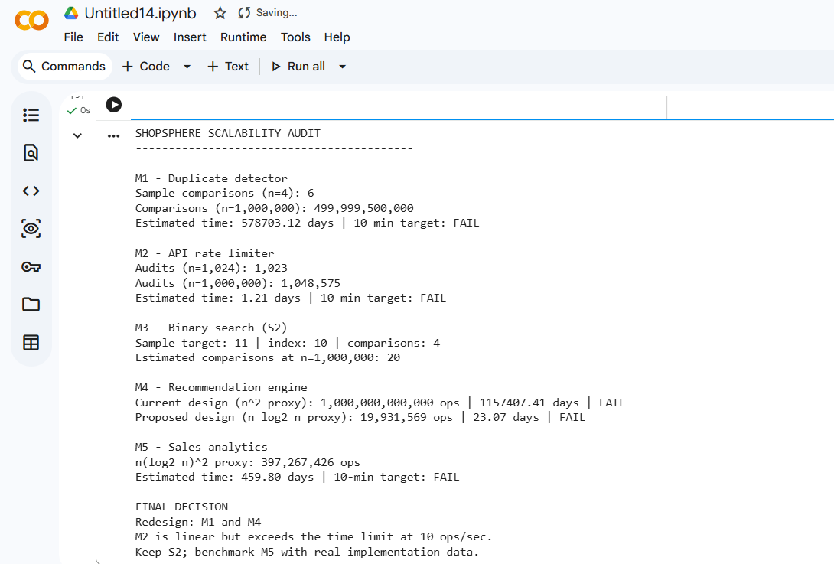

Conclusion
ShopSphere should redesign M1 first and the current M4 recommendation engine next. M2 and S2 have scalable growth rates. M5 should be validated with realistic benchmarks before deciding whether further optimization is required. Algorithmic complexity provides the first audit, but production-like timing tests are necessary to confirm the 10-minute service target.

Rubrics – Application-Based Question
Criteria | Weightage (%) | Level 4 –  Exemplary | Level 3 – Proficient | Level 2 –  Developing | Level 1 –  Beginning
Understanding of Problem Context | 20 | Clearly understands the problem and accurately identifies all requirements | Good  understanding with minor gaps | Basic understanding; some requirements unclear | Poor understanding or misinterpretation of the problem
Application of  Concepts | 30 | Accurately applies appropriate concepts to solve complex problems | Applies relevant concepts correctly with minor errors | Applies basic concepts with limited accuracy | Fails to apply appropriate concepts
Problem-Solving Approach | 20 | Logical, wellstructured, and efficient approach | Mostly logical approach with minor gaps | Basic approach with  some inconsistencies | Illogical or unclear approach
Accuracy of Solution | 20 | Completely correct solution with proper justification | Mostly correct with minor errors | Partially correct solution | Incorrect or incomplete solution
Clarity | 10 | Clear, wellorganized, and properly explained solution | Understandable with minor clarity issues | Limited clarity and explanation | Poorly presented and difficult to understand
Mark Evaluation:
Criteria | Weightage (%) | Level 4 –  Exemplary | Level 3 – Proficient | Level 2 –  Developing | Level 1 –  Beginning
Understanding of Problem Context | 20
Application of  Concepts | 30
Problem-Solving Approach | 20
Accuracy of Solution | 20
Clarity | 10
Total Marks

Code of Conduct
I S.Yoogesh certify that this submission is my original work and that I have adhered to the guidelines specified for this assessment. I understand that any violation of academic integrity rules will result in disciplinary action.
Signature of the Student: S.Yoogesh Date:11.10.2026

