Tutorial 2
Q)Implement calculator program using multithread server.Each user will be served by different thread.At the end the server will respond with all the calculations done by the specific user.
Theory:
Multithreading is a Java feature that allows concurrent execution of two or more parts of a program for maximum utilization of CPU. Each part of such program is called a thread. So, threads are light-weight processes within a process.
Threads can be created by using two mechanisms :
1. Extending the Thread class
2. Implementing the Runnable Interface
Here we have extended the Thread class.
A data output stream lets an application write primitive Java data types to an output stream in a portable way. An application can then use a data input stream to read the data back in.
Constructor:
- DataOutputStream (OutputStream out) : Creates a new data output stream to write data to the specified underlying output stream.
Important Funtions:
- void flush() : Flushes this data output stream.
- int size () : Returns the current value of the counter written, the number of bytes written to this data output stream so far.
- void writeUTF (String str) : Writes a string to the underlying output stream using modified UTF-8 encoding in a machine-independent manner.
A data input stream enable an application read primitive Java data types from an underlying input stream in a machine-independent way(instead of raw bytes). That is why it is called DataInputStream – because it reads data (numbers) instead of just bytes.
- An application uses a data output stream to write data that can later be read by a data input stream. Data input streams and data output streams represent Unicode strings in a format that is a slight modification of UTF-8.
- DataInputStream is not necessarily safe for multithreaded access. Thread safety is optional and is the responsibility of users of methods in this class.
Constructor:
- DataInputStream(InputStream in) : Creates a DataInputStream that uses the specified underlying InputStream.
The java.io.DataInputStream.readUTF() method reads in a string that has been encoded using a modified UTF-8 format. The string of character is decoded from the UTF and returned as String.

JUnit: It is a unit testing framework for the Java programming language. JUnit has been important in the development of test-driven development, and is one of a family of unit testing frameworks which is collectively known as xUnit that originated with SUnit.
JUnit is linked as a JAR at compile-time; the framework resides under package junit.framework for JUnit 3.8 and earlier, and under package org.junit for JUnit 4 and later.

Class Diagram:

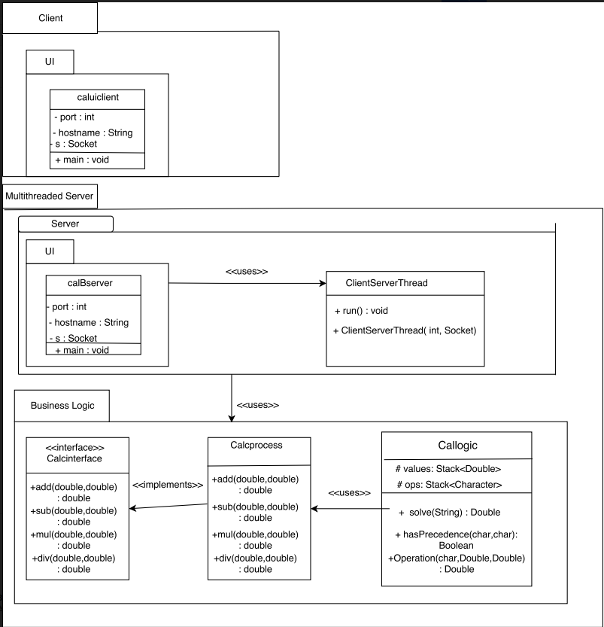

Program:
import java.io.*;
import java.net.*;
public class caluiclient {

public static void main(String[] args) {
// TODO Auto-generated method stub
String host="127.0.0.1";
int portno=8885;

try{
Socket socket=new Socket(host,portno);
DataInputStream inStream=new DataInputStream(socket.getInputStream());
DataOutputStream outStream=new DataOutputStream(socket.getOutputStream());
BufferedReader br=new BufferedReader(new InputStreamReader(System.in));
String clientMessage="",serverMessage="";
while(!clientMessage.equals("bye")){
System.out.println("Enter number :");
clientMessage=br.readLine();
outStream.writeUTF(clientMessage);
outStream.flush();
serverMessage=inStream.readUTF();
System.out.print(serverMessage);
}
while(true)
{
serverMessage=inStream.readUTF();
if(serverMessage.equals("done"))
{
break;
}
System.out.println(serverMessage);
}
outStream.close();
outStream.close();
socket.close();
}catch(Exception e){
System.out.println(e);
}
}

}
import java.net.*;
import java.io.*;
public class calBserver {

public static void main(String[] args) {
// TODO Auto-generated method stub
String host="127.0.0.1";
int portno=8885;
System.out.println("Server Started!!");
try {
//server open socket
ServerSocket ss=new ServerSocket(portno);
int counter=0;
while(true)
{
Socket s=ss.accept();
counter++;
System.out.println("Client: "+String.valueOf(counter)+" is connected to the server");
ClientServerThread cst=new ClientServerThread(counter,s);
cst.start();
}
}
catch(Exception e)
{

}
}
}
package BusinessLogic;

public interface calcinterface {

public double add(double a,double b);
public double sub(double a,double b);
public double mul(double a,double b);
public double div(double a,double b);
}
package BusinessLogic;

public class Calcprocess implements cali {
public double add(double a,double b)
{
return a+b;
}
public double sub(double a,double b){return a-b;}
public double mul(double a,double b){return a*b;}
public double div(double a,double b){return a/b;}
}

package BusinessLogic;
import java.net.*;
import java.util.*;
import java.io.*;
class callogic
{
public int evaluate(String expression)
{
char[] tokens = expression.toCharArray();

// Stack for numbers: 'values'
Stack<Integer> values = new Stack<Integer>();

// Stack for Operators: 'ops'
Stack<Character> ops = new Stack<Character>();

for (int i = 0; i < tokens.length; i++)
{
// Current token is a whitespace, skip it
if (tokens[i] == ' ')
continue;

// Current token is a number, push it to stack for numbers
if (tokens[i] >= '0' && tokens[i] <= '9')
{
StringBuffer sbuf = new StringBuffer();
// There may be more than one digits in number
while (i < tokens.length && tokens[i] >= '0' && tokens[i] <= '9')
sbuf.append(tokens[i++]);
values.push(Integer.parseInt(sbuf.toString()));
}

// Current token is an opening brace, push it to 'ops'
else if (tokens[i] == '(')
ops.push(tokens[i]);

// Closing brace encountered, solve entire brace
else if (tokens[i] == ')')
{
while (ops.peek() != '(')
values.push(Operation(ops.pop(), values.pop(), values.pop()));
ops.pop();
}

// Current token is an operator.
else if (tokens[i] == '+' || tokens[i] == '-' ||
tokens[i] == '*' || tokens[i] == '/')
{
// While top of 'ops' has same or greater precedence to current
// token, which is an operator. Apply operator on top of 'ops'
// to top two elements in values stack
while (!ops.empty() && hasPrecedence(tokens[i], ops.peek()))
values.push(Operation(ops.pop(), values.pop(), values.pop()));

// Push current token to 'ops'.
ops.push(tokens[i]);
}
}

// Entire expression has been parsed at this point, apply remaining
// ops to remaining values
while (!ops.empty())
values.push(Operation(ops.pop(), values.pop(), values.pop()));

// Top of 'values' contains result, return it
return values.pop();
}

// Returns true if 'op2' has higher or same precedence as 'op1',
// otherwise returns false.
public boolean hasPrecedence(char op1, char op2)
{
if (op2 == '(' || op2 == ')')
return false;
if ((op1 == '*' || op1 == '/') && (op2 == '+' || op2 == '-'))
return false;
else
return true;
}

// A utility method to apply an operator 'op' on operands 'a'
// and 'b'. Return the result.
public int Operation(char op, int b, int a)
{
switch (op)
{
case '+':
return add(b,a);
case '-':
return sub(a,b);
case '*':
return mul(a,b);
case '/':
return div(a,b);
}
return 0;
}

}
public class ClientServerThread extends Thread{
int clientnumber=0;
Socket client;
ArrayList<String> express=new ArrayList<String>();
ArrayList<String> res=new ArrayList<String>();
ClientServerThread(int a,Socket b)
{
client=b;
clientnumber=a;
}
public void run()
{
try
{
DataInputStream dis=new DataInputStream(client.getInputStream());
DataOutputStream dos=new DataOutputStream(client.getOutputStream());
String expression="";
while(true)
{
expression=dis.readUTF();
if(expression.equals("bye"))
{
System.out.println("Client: "+clientnumber+" is exiting!!");
dos.writeUTF("Client: "+String.valueOf(clientnumber)+" is exiting!!");
dos.writeUTF("Server sending all the result calculated to client: "+clientnumber);
dos.flush();
for(int i=0;i<express.size();i++)
{
dos.writeUTF(express.get(i)+"="+res.get(i));
}
dos.writeUTF("done");
dos.flush();
dis.close();
dos.close();
client.close();
}
else
{
System.out.println("Client: "+String.valueOf(clientnumber)+" sent string: "+expression);
Calculate cal=new Calculate();
int result=cal.evaluate(expression);
dos.writeUTF("");
dos.flush();
express.add(expression);
res.add(String.valueOf(result));
System.out.println("From server to client "+clientnumber+" result is: "+String.valueOf(result));
}

}
}
catch(Exception e)
{
System.out.println(e.getStackTrace());
}
}

}

JUnit Test Cases:
import static org.junit.Assert.*;

import org.junit.Test;
import BusinessLogic.callogic;

public class TestCalci {
double delta = 0.000000002;
@Test
public void test1() {
Callogic bl = new Callogic();
double actual = bl.solve("1 + 7");
double expected = 8;
assertEquals(actual, expected, delta);
}
@Test
public void test2() {
Callogic bl = new Callogic();
double actual = bl.solve("3 - 2");
double expected = 1;
assertEquals(actual, expected, delta);
}
@Test
public void test3() {
Callogic bl = new Callogic();
double actual = bl.solve("2 * 2");
double expected = 4;
assertEquals(actual, expected, delta);
}
@Test
public void test4() {
Callogic bl = new Callogic();
double actual = bl.solve("1 / 2");
double expected = 0.5;
assertEquals(actual, expected, delta);
}
@Test
public void test5() {
Callogic bl = new Callogic();
double actual = bl.solve("3 + 3 * 4");
double expected = 15;
assertEquals(actual, expected, delta);
}
@Test
public void test6() {
Callogic bl = new Callogic();
double actual = bl.solve("6 + 3 - 4");
double expected = 5;
assertEquals(actual, expected, delta);
}
@Test
public void test7() {
Callogic bl = new Callogic();
double actual = bl.solve("2 + 8 / 4");
double expected = 4;
assertEquals(actual, expected, delta);
}
@Test
public void test8() {
Callogic bl = new Callogic();
double actual = bl.solve("2 + 3 * 4 / 5");
double expected = 4.4;
assertEquals(actual, expected, delta);
}
@Test
public void test9() {
Callogic bl = new Callogic();
double actual = bl.solve("2 + 3 * 4 - 5");
double expected = 9;
assertEquals(actual, expected, delta);
}
@Test
public void test10() {
Callogic bl = new Callogic();
double actual = bl.solve("( 3 + 3 ) * 5");
double expected = 30;
assertEquals(actual, expected, delta);
}
@Test
public void test11() {
Callogic bl = new Callogic();
double actual = bl.solve("( 5 - 3 ) * 5");
double expected = 10;
assertEquals(actual, expected, delta);
}
@Test
public void test12() {
Callogic bl = new Callogic();
double actual = bl.solve("-( 2 * 3 ) / 5");
double expected = -1.2;
assertEquals(actual, expected, delta);
}
@Test
public void test13() {
Callogic bl = new Callogic();
double actual = bl.solve("( 2 + 3 ) / ( 2 - 3 )");
double expected = -5;
assertEquals(actual, expected, delta);
}
@Test
public void test14() {
Callogic bl = new Callogic();
double actual = bl.solve("( 2 * 3 ) + ( 2 / 5 )");
double expected = 6.4;
assertEquals(actual, expected, delta);
}
@Test
public void test15() {
Callogic bl = new Callogic();
double actual = bl.solve("2.5 + 3.2 * 5.5");
double expected = 20.1;
assertEquals(actual, expected, delta);
}
@Test
public void test16() {
Callogic bl = new Callogic();
double actual = bl.solve("( 2.8 * 3.6 ) - 4.4");
double expected = 5.68;
assertEquals(actual, expected, delta);
}
@Test
public void test17() {
Callogic bl = new Callogic();
double actual = bl.solve("2.2 * 2 / 4.2");
double expected = 1.047619;
assertEquals(actual, expected, delta);
}
@Test
public void test18() {
Callogic bl = new Callogic();
double actual = bl.solve("4 / 0 * 5");
double expected = 3;
assertEquals(actual, expected, delta);
}
@Test
public void test19() {
Callogic bl = new Callogic();
double actual = bl.solve("4+3*5");
double expected = 19;
assertEquals(actual, expected, delta);
}
@Test
public void test20() {
Callogic bl = new Callogic();
double actual = bl.solve("2*10/5");
double expected = 4;
assertEquals(actual, expected, delta);
}

}

