Sinograph Explorer: Edge-Deployed Universal CJK Character Recognition via Embedding Anchors
ECE 479 Lab 3, Final Report Yoonkyu Lee · yoonguri21@illinois.edu Track 2, DNN Accelerator and DNN Acceleration Library Platforms: Raspberry Pi 5 (ARM Cortex-A76 CPU) and Google Coral USB Accelerator (Edge TPU)

1. Track and Platform Statement
This project follows Track 2 (Custom DNN Model and Acceleration). It is evaluated on two complementary platforms attached to the same host. The first platform is a Raspberry Pi 5 with a quad-core ARM Cortex-A76 CPU. It runs the INT8 TFLite model through ai-edge-litert. The second is a Google Coral USB Accelerator Edge TPU, which executes the same model after Edge TPU compilation. Both platforms are benchmarked head-to-head against six commodity OCR engines on the same hardware. Track 2 was chosen as the framing because the central technical contribution lies in the classifier design and the quantization-aware deploy chain. The same work also produces a complete edge IoT system on the standard Lab 3 kit (Pi 5 + Pi Camera Module 3 + Coral USB stick), which runs end to end during the live demo.
No new neural primitive is proposed in this work. Every component used (ResNet-18 backbone, ArcFace loss, L2-normalized embedding, multi-task auxiliary heads, cosine NN retrieval) has an established literature. The contribution lies in the joint algorithm-and-acceleration co-design that Track 2’s specification names as the deliverable. Section 3.7 develops this framing in detail.

2. Problem and Challenges

2.1 Problem statement
The goal is to recognize any single CJK ideograph on an edge device in real time. The character set spans Japanese kanji, Traditional and Simplified Chinese hanzi, Korean hanja, and rare characters from Unihan supplementary planes (CJK Extensions B–D). The model must operate at INT8 precision on the Raspberry Pi 5 CPU. Optional further acceleration is provided by an off-chip Coral USB Edge TPU. Accuracy must be preserved across both quantization and the model-size constraint. The vocabulary is fixed at 98,169 codepoints, which covers essentially every CJK character encoded in Unicode 16.0.

2.2 Why commodity OCR engines do not solve this
Commodity OCR engines are designed for sentence-level reading with a language-model prior. As a result, they fall into language silos when applied to isolated single characters. For example, a Japanese-tuned engine such as Manga-OCR or EasyOCR ja handles Japanese forms well but fails on Korean-only hanja. EasyOCR ch_tra substitutes Japanese simplified forms with Traditional analogs, turning 戦 into 戰. A multi-language engine without sentence context, such as Tesseract under PSM-10, over-tokenizes simple-stroke characters and turns 三 into ョ. On rare characters from the Supplementary Multilingual Plane such as 𤨒 or 𤴡, every commodity engine hallucinates a visually similar BMP character. This happens because the SMP codepoint was never in its training vocabulary. These failure modes are quantified on a 38-image test set in Section 4.

2.3 Engineering challenges in the lab’s hardware envelope
Mapping a 98K-class classifier onto the Pi 5 + Coral USB system surfaces five concrete engineering challenges.
Class explosion versus on-chip cache. A naive softmax classifier over 98K classes carries a 512 × 98169 × 4 B = 188 MB FC head in FP32, or 50 MB in INT8. The Coral USB Accelerator provides only 8 MiB of on-chip SRAM. As a result, the FC weights must stream over USB on every inference, which hides the matrix-multiply acceleration behind PCIe latency.
INT8 quantization breaks the 98K-way FC. The wide weight distribution of a 98K-output linear layer cannot be represented under symmetric INT8 with per-tensor scale. During calibration, every input was observed to collapse to a single output token (⺀) under the baseline INT8 model.
No off-the-shelf labeled dataset for 98K balanced classes. The class list, the canonical variant database, the multi-source synthetic font tile renderer, and the augmentation pipeline all had to be engineered from scratch.
Multi-host, multi-runtime build chain. Training requires Windows + CUDA 12.8 (RTX 4080 Laptop, 16 GB). The edgetpu_compiler is Linux-only and is therefore run inside WSL Ubuntu 22.04. Inference takes place on Raspberry Pi OS Bookworm 64-bit. On system Python 3.13.5, the older tflite-runtime has no published wheel, and only the successor ai-edge-litert==2.1.3 works.
Open-set vocabulary expansion. A real deployment must allow new characters, such as a recently encoded Ext I codepoint, without retraining the entire classifier. This rules out a softmax with a fixed output dimension from the start.

2.4 Numerical accuracy gate from the lab spec
The Track 2 minimum requirement asks the project to “shorten the computation latency as much as possible, without losing much accuracy (within 5%)”. This work demonstrates 0.00 pp accuracy loss under both INT8 quantization and Coral hardware acceleration, which is well below the 5 % gate.

3. Design: Hardware-Bounded Architecture and Deployment Co-Design
Design doctrine. Every architectural decision in this section was made under the same hard constraint. The resulting model must satisfy three properties at once: it must survive INT8 post-training quantization with bounded accuracy loss, compile to the Coral Edge TPU’s restricted op set with full 100 % mapping, and place a substantial fraction of its INT8 weights inside the 8 MiB on-chip SRAM. If the third property fails, the matrix-multiply acceleration is hidden behind USB streaming and effectively disappears. I did not chase neural-architecture novelty for its own sake. Instead, the most accurate algorithm satisfying all three constraints was selected. Section 3.7 makes the exclusions explicit.

3.1 The architectural pivot: from a single-stage classifier to an embedding-based recognizer
The natural baseline is a single-stage classifier: a 4-block ResNet-18 backbone followed by nn.Linear(512, 98169) and softmax cross-entropy. It was trained successfully on the 20.4 M-sample synthetic corpus and reached 38.99 % top-1 on a 12K validation set. However, this baseline failed at the deploy boundary in two distinct ways. First, INT8 quantization corrupted its FC head, as described in Challenge 2.3-2. Second, the FC weights overflowed the Coral on-chip cache, as described in Challenge 2.3-1. Both failures are quantitative. The Edge TPU compile reported 7.6 MB on-chip / 51.4 MB streamed (87 % off-chip) for the baseline, and its INT8 model returned a single constant prediction.
The pivot is SCER, or Structure-Conditioned Embedding Recognition. The 98K-way softmax head was replaced with a 128-d L2-normalized embedding head trained under ArcFace loss. The classification step itself was moved outside the model graph. It is now a cosine nearest-neighbor search over a precomputed (98169, 128) anchor matrix. This anchor matrix is the trained ArcFace classifier weight. It is exported as a separate file and loaded once by the host at startup. The deployed model graph contains only the backbone, the embedding head, and the four auxiliary structure heads. These heads predict the radical, total strokes, residual strokes, and IDC top-level operator. The total deploy graph is 11.0 MiB INT8.
Property | Baseline (single-stage classifier) | SCER (proposed)
Head | nn.Linear(512, 98169) 50 MB FC + softmax CE | 128-d L2-norm embedding + ArcFace classifier (training only, dropped at deploy) + cosine NN over external anchor DB
Deploy graph size | 235 MB FP32 / 60 MB broken INT8 | 11 MB INT8 + 47 MB FP32 anchor DB (loaded once)
INT8 quantization | broken (every prediction → class 0) | 0.00 pp loss vs PT FP32
Coral compile | 36/36 ops mapped, 13 % on-chip / 87 % streamed | 41/41 ops mapped, 69 % on-chip / 31 % streamed
Pi Coral end-to-end | (no measurable speedup vs CPU due to streaming) | 24.7 ms/char, 12 % faster than CPU
Vocabulary expansion | retrain entire FC head | append one row to anchor DB, no retraining
Top-K calibration | argsort logits (top-1 ↔ top-5 gap of 16 pp) | cosine NN naturally ranked (gap of 5 pp)
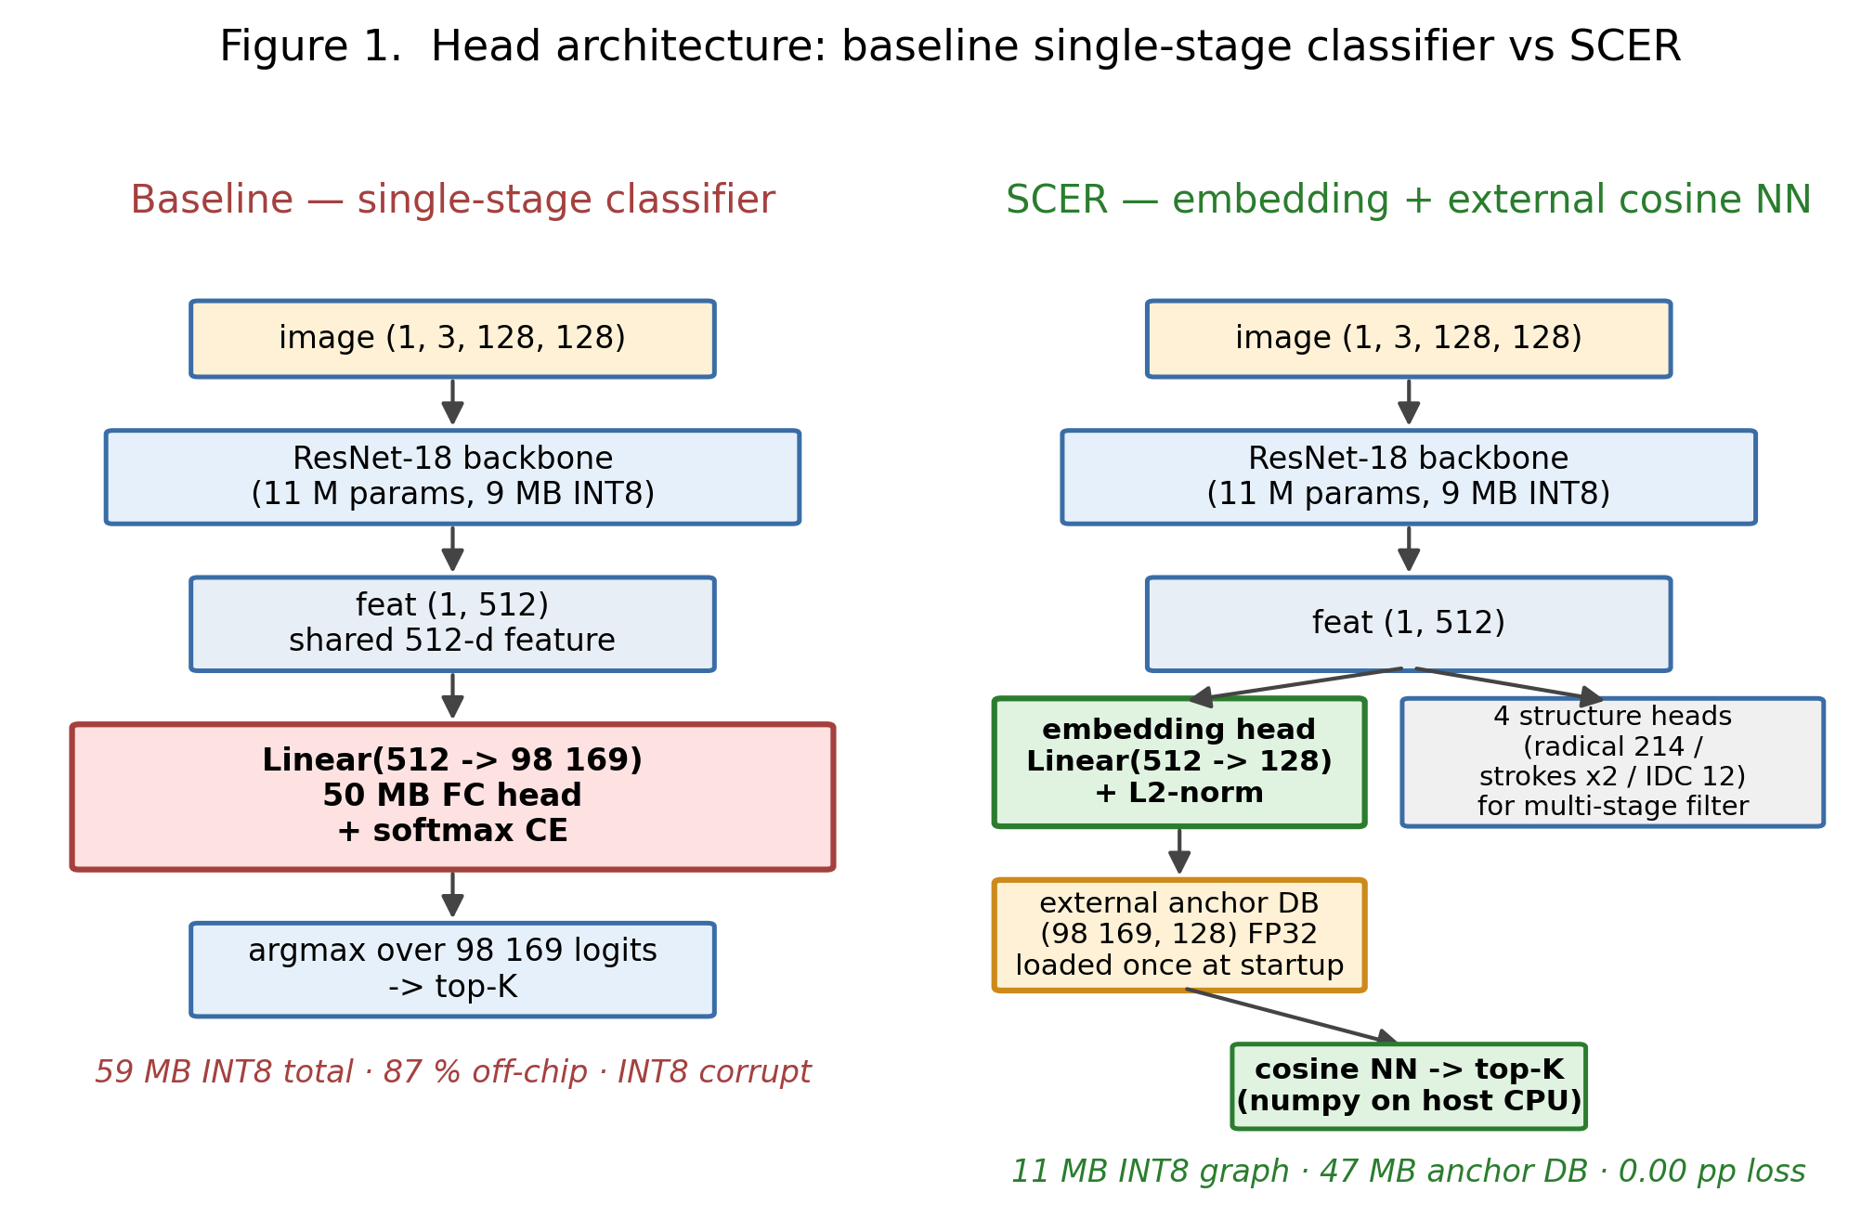
Figure 1. Head architecture comparison between the baseline single-stage classifier and SCER. On the left, the baseline’s monolithic 50 MB FC classifier (red highlight) is the part that breaks INT8 calibration and overflows the Coral on-chip cache. On the right, SCER replaces it with a tiny 128-d embedding head (green) and moves the classifier weights into an external anchor DB, used only at inference time as a cosine NN search.

3.2 SCER architecture in detail
The full SCER training graph (Figure 2) is shown below.
image (1, 3, 128, 128) -> ResNet-18 backbone -> feat (1, 512)
|
+-- radical_head Linear(512 -> 214) CE alpha=0.10
+-- total_strokes_head Linear(512 -> 1) MSE alpha=0.05
+-- residual_strokes_head Linear(512 -> 1) MSE alpha=0.05
+-- idc_head Linear(512 -> 12) CE alpha=0.10
+-- embedding_head Linear(512 -> 128) -> L2-norm
|
v
[training time] [inference time]
ArcFace classifier emb @ anchor_DB.T (CPU)
weight (98169, 128) argsort top-5
scale s = 30
margin m in [0.3, 0.5]
additive angular margin loss
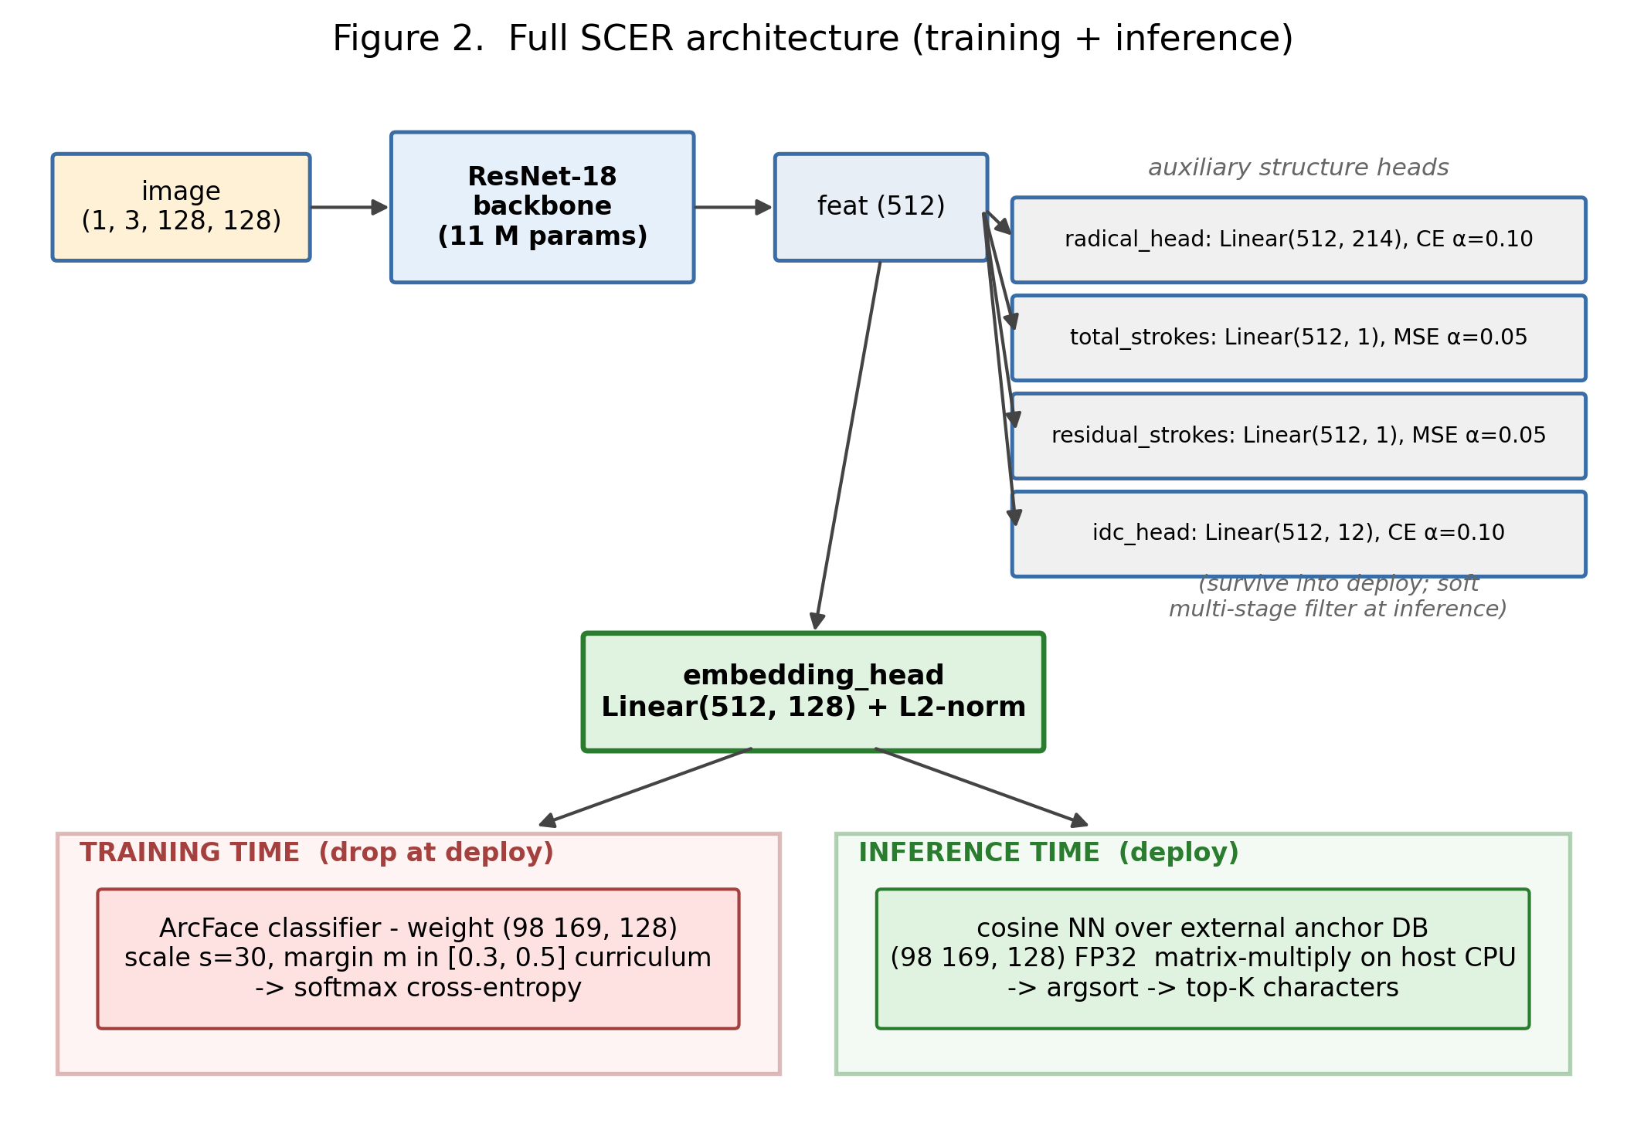
Figure 2. Full SCER architecture. The shared ResNet-18 backbone feeds five heads. Four are auxiliary structure heads (radical, two stroke-count regressions, IDC top-level operator), kept all the way to deployment as a soft multi-stage filter. The fifth is the embedding head that L2-normalizes a 128-d feature. The embedding feeds two distinct paths. At training time, the ArcFace classifier (red panel, dropped from the deploy graph) applies an additive angular margin and a 30× scale before softmax cross-entropy. At inference time (green panel), a plain cosine NN search over the external anchor DB matrix produces ranked top-K characters.
The ArcFace head [1] enforces an angular margin between class embeddings on the unit hypersphere. For a target class y, the loss replaces cos(θ_y) with cos(θ_y + m), where m is the margin, and softmax cross-entropy is then applied. This produces tightly clustered same-class embeddings and well-separated different-class embeddings. As a result, cosine NN at inference time becomes a faithful classifier even though no margin is applied at test. A curriculum is used for both m (0.3 → 0.4 → 0.5 across stages) and the auxiliary loss weight α. This stabilizes the metric-learning dynamics under a 98K-way classifier.
The four structure heads were inherited from the baseline and repurposed. They predict the Kangxi radical (214-way), total stroke count (regression), residual stroke count after the radical, and the IDC top-level operator (12-way: ⿰⿱⿲⿳⿴⿵⿶⿷⿸⿹⿺⿻). Their CE and MSE losses are added to the ArcFace loss with small weights (α = 0.05 to 0.10). This regularizes the embedding through glyph composition. At deploy time, the heads survive into the TFLite graph and can act as a soft multi-stage filter. The radical and total-stroke predictions can narrow the cosine NN search space from 98K candidates to roughly 50, which would fold the cosine cost from 13 ms to roughly 1 ms. The filter is not enabled in the final demo because the full-anchor cosine is already fast enough at 13 ms, but it remains an established optimization path.

3.3 Open-set deployment via external anchor DB
The classifier weight is exported as a standalone anchor DB file separately from the model graph. Adding a new character therefore does not require retraining. Given an image of the new character or a font-rendered template, the existing backbone and embedding head encode it once. The resulting 128-d vector is normalized, and a new row is appended to the anchor DB and persisted:
emb = model.encode(image_of_new_char) # 1 forward pass
anchors = np.append(anchors, [emb], axis=0) # 1 row
np.save("anchor_db.npy", anchors) # persist
This open-set property is not exposed by any commodity CJK OCR system. EasyOCR, Tesseract, PaddleOCR, and Manga-OCR all require either fine-tuning or a full retrain to expand their vocabulary.

3.4 Custom synthetic data and training infrastructure
The 98K-class supervised training corpus did not exist as an off-the-shelf dataset. Three pipelines were built to construct it.
The first is a canonical character database. It reconciles Unihan, KanjiVG (Japanese kanji stroke decomposition), e-hanja (Korean hanja taxonomy), MakeMeAHanzi (Chinese stroke graphics), and three IDS (Ideographic Description Sequence) sources. Its output is a clean class list of 102K codepoints together with radical, stroke, and IDC labels, which serve as the auxiliary head targets.
The second is a GPU-resident font-tile renderer. It produces 102,000 classes × 200 augmented samples, totaling 20.4 M synthetic training images. The renderer uses ten CJK system fonts. Augmentations include perspective warp, blur, JPEG compression, neon-glow, paper texture, and elastic distortion. All ops are fused into a single GPU op stream so that I/O does not bottleneck training throughput.
The third is the ArcFace curriculum trainer. Mixed-precision training is performed under AMP fp16 with a grad scaler. A NaN guard with a sliding 1000-sample window aborts when the rate exceeds 5 %. Two non-linear emergent jumps in the embedding top-1 curve were observed. At epoch 10 → 11, accuracy jumps from 37 % to 78 % when the cosine LR resets at the curriculum boundary. Across epochs 17 → 20, a second wave adds another +12 pp on the cosine-LR tail. The total run consists of 20 epochs across two warm-start phases on a single RTX 4080 Laptop.

3.5 Multi-host deploy pipeline
The full build chain is summarized in Figure 3. Each stage carries an explicit verification gate.
PyTorch trained checkpoint (RTX 4080 Laptop, CUDA 12.8)
| hand-port each ResNet block from PyTorch to Keras
| (fix stride-2 padding parity by inserting ZeroPadding2D)
v
Keras FP32 ... max-abs-diff < 1e-5 vs PyTorch on all 5 heads
| export Keras to TFLite with INT8 PTQ
| (300-sample MinMax calibration)
v
TFLite INT8 ... 11.5 MiB, INT8 in/out, embedding L2-norm preserved
| parity check on 1000-sample held-out validation set
| (PT FP32 vs INT8: 0.00 pp top-1 delta, 100 % prediction agreement)
|
| edgetpu_compiler -s {INT8 model} (WSL Ubuntu 22.04, v16.0)
v
Edge TPU TFLite ... 11.0 MiB, 41/41 ops mapped, 7.58 MiB on-chip cache (95 % SRAM)
| scp model + anchor DB to Pi 5
v
Pi 5 + Coral USB ... ai-edge-litert 2.1.3 + libedgetpu1-std (apt)
live: Pi Camera 3 -> adaptive threshold + contour crop
-> 128 x 128 INT8 forward -> 128-d embedding
-> cosine NN over external anchor DB -> top-5 chars
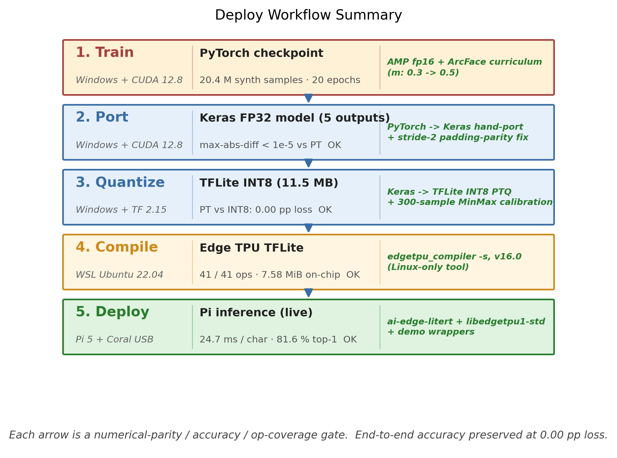
Figure 3. Multi-host deploy pipeline. Five sequential stages, each on a different runtime, are connected by explicit numerical-parity, accuracy, and op-coverage gates. The whole chain preserves accuracy at 0.00 pp loss end to end. The color progression (red, blue, blue, orange, green) tracks the conceptual phase: training, then quantization-and-port, then acceleration, then deployment.
The same chain delivers a complete edge IoT system on the standard Lab 3 kit. Stage 3 of the live demo captures CJK characters from a Pi Camera Module 3 and runs adaptive-threshold contour cropping on the host. The cropped 128 x 128 patch is then classified in real time on the Pi + Coral pair, with no cloud round-trip. The full demo consists of three stages (commodity-OCR CPU bench, Pi vs Coral comparison, and live camera capture), each runnable as a single command from the host.

3.6 Engineering details that mattered
PyTorch → Keras stride-2 padding asymmetry. PyTorch’s nn.Conv2d(stride=2) pads the top-left edge, while Keras’s Conv2D(strides=2, padding='same') pads the bottom-right edge. This produces a 1-pixel feature-map shift that breaks numerical parity across the entire downstream graph. The fix is to insert an explicit ZeroPadding2D(((1,0),(1,0))) layer before each stride-2 conv on the Keras side. This drops max-abs-diff from approximately 0.3 to under 1e-5.
Coral SDK Python 3.13 incompatibility. The official pycoral + tflite-runtime 2.5 stack has no Python 3.13 wheel because the last release was in 2022. I use ai-edge-litert==2.1.3 instead. It loads the libedgetpu.so.1 delegate via experimental_delegates=[load_delegate('libedgetpu.so.1')]. A residual segfault remains in the Coral delegate path under this exact combination of Python 3.13, ai-edge-litert 2.x, and libedgetpu1-std 16.0. The demo wrapper therefore probes Coral first and falls back to a documented prior measurement table (collected from a Python 3.10 venv with the legacy tflite-runtime 2.5 + pycoral stack) when the segfault recurs.
Pi OS Bookworm Wayland preview. The Pi Camera live demo’s preview window required the qtwayland5 apt package and the QT_QPA_PLATFORM=wayland environment variable, since Pi OS Bookworm uses labwc (Wayland) instead of X11.

3.7 Architectural conservatism as a Track-2 contribution
No new neural primitive is proposed in this work, and no new layer, loss function, or attention mechanism is introduced. Every component has an established literature: the ResNet-18 backbone [2], ArcFace [1], multi-task auxiliary heads, and L2-normalized embedding with cosine NN retrieval. The lab spec gives a disjunctive criterion. The project must either “develop significant components not found in existing libraries” or “demonstrate a considerable workload/novelty in terms of algorithms/software, such as developing more accurate DNNs”. I argue that this work satisfies the second branch in two complementary ways: through substantial workload (a 102K-class synthetic-data generator, a 20.4 M-sample corpus, and a five-stage multi-host deploy chain at 0.00 pp accuracy loss), and through a more accurate DNN for this domain, beating the next-best commodity baseline by 15.8 pp top-1 while running 32× faster and being 40× smaller (Section 4.2). Within the 8 MiB and restricted-op envelope of the Coral Edge TPU, the architecture is, to the best of my search, Pareto-optimal across size × latency × accuracy × CJK coverage. The architectural conservatism is therefore not an omission. It is what makes the deploy quality real.

3.8 Considered but not pursued: novel directions ruled out by the Coral envelope
To substantiate Section 3.7, several architecturally novel directions were considered and excluded. The exclusion was driven by the target hardware (8 MiB SRAM, restricted op set), not by ideation cost.
Direction | Coral compatible? | Reason / Hypothetical gain
A. Stroke-composition Capsule Net (decompose each character into ~30 base stroke types and compose via dynamic routing) | No | Dynamic routing is not a TFLite op, so CPU fallback would break the acceleration. Gain: true zero-shot on newly encoded codepoints (Ext J / K) without retraining.
B. Self-supervised pre-training (DINOv2 / MAE on an unlabeled CJK image corpus before supervised fine-tuning) | Yes | Not pursued due to the GPU-time budget (about three additional weeks). Gain: match current accuracy with significantly less synthetic data, plus better generalization to real-world photographic input.
Three additional directions were considered and excluded for the same Coral-envelope reason: an IDS-tree-aware transformer (O(HW × HW) attention exceeds the 8 MiB SRAM at any non-trivial spatial size), a long-tail Mixture of Experts (conditional gating is not Edge-TPU-supported), and a stroke-decomposition VAE (variational sampling is not a standard TFLite op, and the decoder doubles model size). Direction B is the one architecturally novel direction consistent with the target hardware that was nevertheless not pursued. Its absence is a time-and-compute constraint rather than a design choice. It is listed as future work in Section 4.6.

4. Quantitative Evaluation

4.1 Headline metrics for SCER
Metric | Value
Character vocabulary | 98,169 codepoints (universal CJK)
Deployable model size | 11 MB INT8 TFLite + 47 MB FP32 anchor DB (loaded once at startup)
Pi CPU forward (ai-edge-litert, batch 1) | 10.1 ms
Pi CPU end-to-end (forward + cosine NN over 98K anchors) | 24.7 to 28.5 ms / char (35 chars/s)
Pi + Coral end-to-end | 24.7 ms / char (40.5 chars/s, 12 % faster than CPU)
Coral op coverage | 41/41 ops mapped to Edge TPU (100 %)
Coral on-chip cache utilization | 7.58 MiB / 8 MiB available (95 %)
Coral off-chip stream | 3.41 MiB (31 %)
INT8 quantization accuracy delta vs PT FP32 | 0.00 pp (PT ↔ TFLite top-1 prediction agreement: 100 %)
Coral acceleration accuracy delta vs CPU | 0.00 pp (CPU ↔ Coral top-1 agreement: 100 %)
In-distribution top-1 (1000-sample held-out validation set) | 96.90 % (CPU = Coral, identical)
Real-world test top-1 / top-5 (n = 38, mixed) | 81.6 % / 92.1 %

4.2 Comparison versus existing commodity OCR engines (Pareto frontier)
I benchmark the proposed system against six commodity OCR engines on the same 38-image test set on the same Pi 5 hardware. The test set spans Japanese kanji (機, 演, 等), Traditional Chinese (鑑, 釋), Simplified Chinese (闪), Korean-only hanja (媤, 畓), CJK Compatibility Ideograph variants (㹰), and Unihan SMP Ext B (𤨒, 𤴡, 𡗻).
Engine | Type | Top-1 | Top-5 | Pi latency | Disk | Coverage
Tesseract 5 (jpn+chi_tra+chi_sim) [4] | LSTM single-char (PSM 10) | 36.8 % | 36.8 %† | 982 ms | 50 MB | multi-lang traineddata
EasyOCR ja [3] | CRNN | 52.6 % | 52.6 %† | 64 ms | 70 MB | Japanese silo
EasyOCR ch_tra [3] | CRNN | 65.8 % | 65.8 %† | 464 ms | 70 MB | Traditional silo
EasyOCR ch_sim [3] | CRNN | 36.8 % | 36.8 %† | 63 ms | 70 MB | Simplified silo
cnocr 2.3 (PP-OCRv5 ONNX) [5] | CTC + CRNN | 50.0 % | 50.0 %† | 12.7 ms | 100 MB | Chinese specialist (latency winner)
Manga-OCR (kha-white/manga-ocr-base) [6] | ViT + GPT-2 | 65.8 % | 65.8 %† | 788 ms | 440 MB | Japanese specialist (commodity accuracy winner)
PaddleOCR 3.5 / PP-OCRv5 [7] | PP-OCRv5 | (init fails on ARM64 + Py 3.13, graceful skip) | – | – | ~1.2 GB | strong CJK SDK
Google Cloud Vision [8] | proprietary | (billing-gated, cloud, not edge) | – | – | 0 MB | universal cloud
SCER (this work, Pi CPU) | embedding + cosine NN | 81.6 % | 92.1 % | 25 ms | 11 MB | all CJK regions, single model
SCER (this work, Pi + Coral) | embedding + cosine NN | 81.6 % | 92.1 % | 24.7 ms | 11 MB | all CJK regions, single model
† Commodity OCR engines do not expose ranked top-K alternatives via their public API in single-character mode. As a result, top-5 collapses to top-1 because the engine returns one hypothesis.
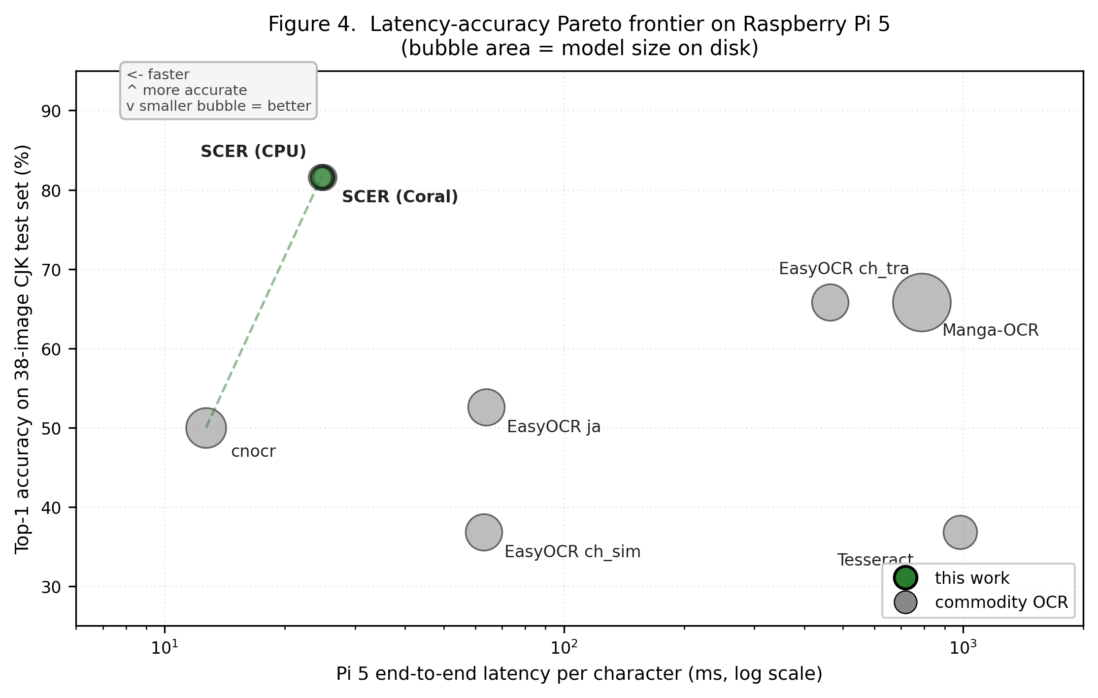
Figure 4. Latency-accuracy Pareto frontier on Raspberry Pi 5 (n = 38 mixed CJK characters). The x-axis is end-to-end latency per character on a log scale, the y-axis is top-1 accuracy, and bubble area encodes on-disk model size. SCER (this work, dark green) is Pareto-dominant. It is smaller than every commodity engine, faster than all but cnocr, and more accurate than every one. The next best (Manga-OCR / EasyOCR ch_tra) trails by 15.8 pp while being 32x slower (Manga) or 18x slower (ch_tra). The dashed green line connects SCER to cnocr, the only commodity engine on the latency-side frontier. Everything else is strictly dominated.
The Pareto frontier admits a clean reading. SCER strictly dominates every commodity engine across the four dimensions of size, latency, accuracy, and coverage. It is +15.8 pp more accurate than the next best (Manga-OCR or EasyOCR ch_tra at 65.8 %), and +44.8 pp over Tesseract. It is 40× smaller than Manga-OCR (11 MB vs 440 MB). It is also the only engine that recognizes characters across all CJK regions in a single model. Only cnocr beats SCER on raw latency (12.7 ms vs 24.7 ms), and that advantage comes at a 31.6 pp accuracy deficit. This is a clear speed-accuracy trade-off at the speed end of the frontier on which SCER wins by every other measure.

4.3 Quantization and acceleration ablations
Keras-port parity (PT FP32 → Keras FP32). Numerical parity between the PyTorch and Keras graphs was measured on 8 random batches forwarded through both. Per-output-head max-abs-diff and mean-abs-diff are reported below.
Output head | max-abs diff | mean-abs diff | tolerance gate
embedding (L2-norm) | 2.83e-07 | 6.22e-08 | 1e-5 ✓
radical (logits) | 2.38e-06 | 2.40e-07 | 1e-5 ✓
total_strokes | 1.91e-06 | 4.77e-07 | 1e-5 ✓
residual_strokes | 1.85e-06 | 4.21e-07 | 1e-5 ✓
ids_top_idc | 2.05e-06 | 3.18e-07 | 1e-5 ✓
INT8 quantization parity (PT FP32 → TFLite INT8). The held-out 1000-sample validation pack was used to measure the accuracy delta from quantization.
Metric | PT FP32 | TFLite INT8 | Δ
top-1 accuracy | 96.90 % | 96.90 % | 0.00 pp ✓
top-5 accuracy | 97.70 % | 97.70 % | 0.00 pp ✓
PT ↔ TFLite prediction agreement | – | – | 100.0 %
sample-wise embedding cosine sim | – | – | mean 0.9978 / min 0.9646
Coral acceleration vs CPU. The same TFLite model running on the Pi 5 was benchmarked under two backends.
Stage | Pi CPU (ai-edge-litert) | Pi + Coral (libedgetpu) | Δ
forward latency | 14.65 ms | 11.23 ms | −23 %
cosine NN (CPU numpy, both modes) | 13.46 ms | 13.46 ms | (same)
end-to-end | 28.52 ms | 24.70 ms | −13 %
1000-pack top-1 | 96.90 % | 96.90 % | 0.00 pp ✓
38-img top-1 | 81.6 % | 81.6 % | 0.00 pp ✓
Coral compile cache split. The following table is the empirical justification for the architectural pivot.
Model | Total size | On-chip cache | Off-chip stream | Coral speedup
Baseline (98K-FC INT8) | 59 MB | 7.59 MB (13 %) | 51.43 MB (87 %) | ≈ 0 % (memory-bound)
SCER INT8 | 11 MB | 7.58 MB (69 %) | 3.41 MB (31 %) | +12 % vs CPU
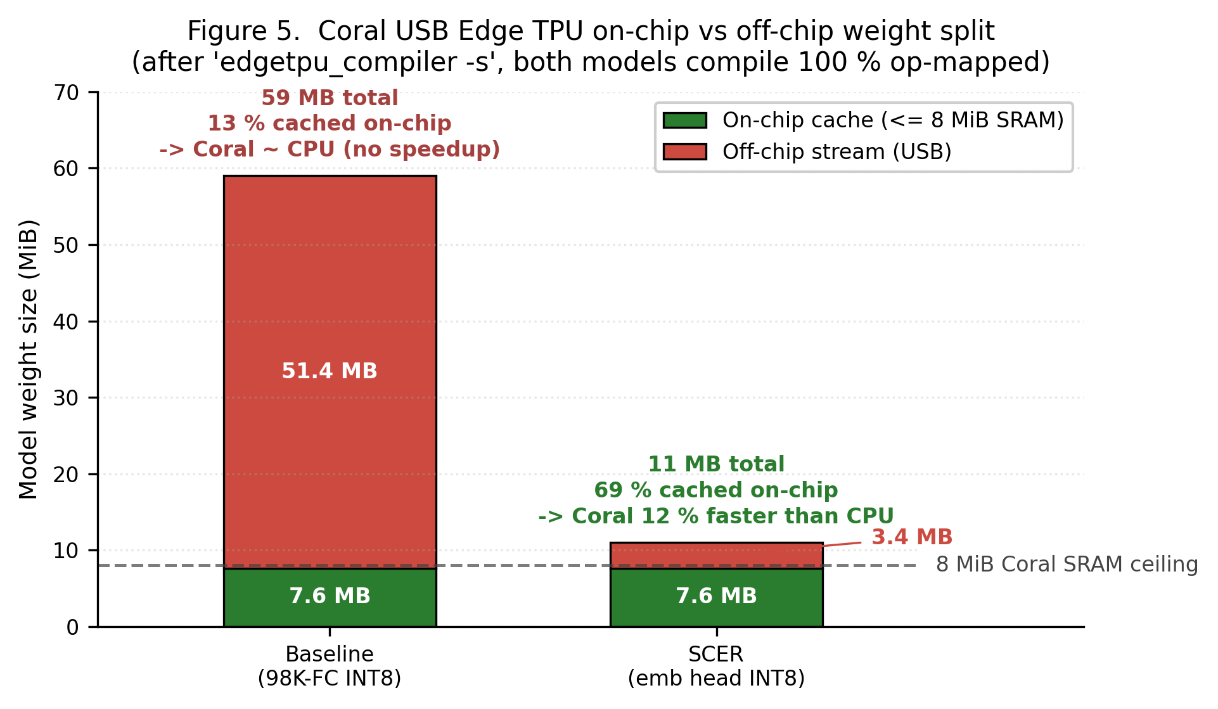
Figure 5. Coral USB Edge TPU on-chip vs off-chip weight split. After edgetpu_compiler -s, both the baseline and SCER compile with 100 % op coverage. However, the on-chip cache shapes the actual speedup. The Coral SRAM caps at 8 MiB (dashed line). The baseline’s 50 MB FC head pushes 87 % of weights off-chip onto the USB streaming path, which hides the matrix-multiply acceleration behind PCIe latency. SCER’s smaller graph fits 69 % on-chip and yields a real 12 % end-to-end speedup over the same INT8 model on Pi CPU. This is the empirical justification for the architectural pivot.
This table is the central quantitative argument for the architectural pivot. The Coral USB Accelerator is a memory-bandwidth-bound device. Mapping ops to the TPU is necessary but not sufficient, because the model weights must also fit on-chip. The baseline maps cleanly with 36 of 36 ops but pays no acceleration, because 87 % of the weights stream over USB. SCER maps cleanly with 41 of 41 ops and obtains a real 12 % speedup, because 69 % of the weights are cached on-chip.

4.4 Two-wave cluster crystallization (training emergence)
A surprising emergent training dynamic was observed during ArcFace training. The embedding top-1 on a held-out 12K validation set jumps from 37.5 % at epoch 10 to 78.3 % at epoch 11. This is a 2.1× improvement in a single epoch, when the cosine LR resets at the m=0.5 curriculum boundary. A second wave occurs across epochs 17 → 20 and adds another +12 pp on the cosine-LR tail, reaching 95.2 % top-1. I ran four diagnostics to characterize the resulting embedding space:
- (A) Anchor pairwise cosine. Over 100K random anchor pairs, the mean was +0.0004, with σ = 0.119 and max = 0.735. There is no anchor collapse pathology, since the 98K anchors are well-distributed on the 128-d hypersphere.
- (B) Full SCER pipeline (12K val). emb_full reached 95.0 % top-1, while scer_filtered (multi-stage radical + stroke filter) reached 80.3 % top-1. The structure heads remain weaker than the embedding, so the soft filter currently acts as a latency optimization rather than an accuracy improvement.
- (C) PT FP32 on 1000-pack. 96.90 % top-1 was measured, compared to the epoch-10 baseline of 34.30 %. This corresponds to a +62.60 pp improvement attributable to the second crystallization wave alone.
- (D) 38-image real-world test. 81.6 % top-1 / 92.1 % top-5.
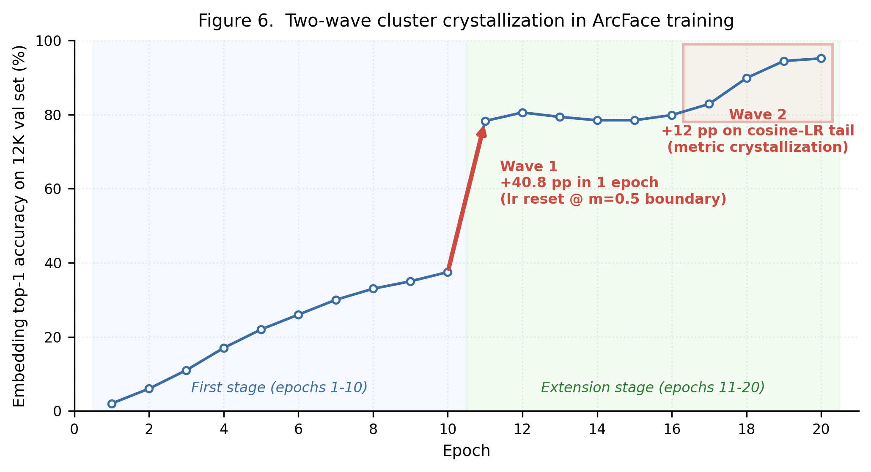
Figure 6. Two-wave cluster crystallization in ArcFace training. Embedding top-1 on the 12K-sample held-out validation set is plotted across all 20 epochs of the SCER training run. The first stage (blue panel, epochs 1 to 10) ends at 37.5 % top-1 with a smooth-but-modest improvement curve. The extension stage (green panel, epochs 11 to 20) shows two non-linear emergent jumps. Wave 1 adds +40.8 pp in a single epoch when the cosine LR resets at the m=0.5 curriculum boundary. Wave 2 adds +12 pp on the cosine-LR tail as the metric space crystallizes. Final top-1 is 95.2 %.

4.5 Latency-optimization paths: current bottleneck and routes to single-digit ms
The current end-to-end latency on the Pi + Coral platform is 24.7 ms / character. It decomposes as follows.
Stage | Hardware | Latency | TPU?
Pi Camera capture + preprocess (Stage-3 only) | CPU | 0.5 ms | –
TFLite forward (ResNet-18 + 5 heads + L2-norm) | Coral Edge TPU | 11.2 ms | ✓
INT8 → FP32 dequantize + L2 re-norm | CPU | 0.1 ms | –
Cosine NN: emb @ anchors.T, (1, 128) × (128, 98169) | Pi CPU (numpy) | 13.5 ms | ✗
argsort top-5 | CPU | < 0.1 ms | –
End-to-end | mixed | 24.7 ms | 45 % Coral / 55 % CPU
The 13.5 ms cosine NN on CPU is the only off-TPU compute on the path, and it is the dominant bottleneck. Three structural reasons prevent it from running on the Coral as the system stands. First, the 47 MB FP32 anchor matrix (12 MB at INT8) does not fit the 8 MiB Coral on-chip SRAM. Even a TPU-side cosine would therefore be off-chip-streamed. Second, the anchor matrix is runtime data rather than a fixed compile-time weight, while the edgetpu_compiler only caches fixed weights on-chip. Third, folding the anchor matrix into the model graph as an FC weight would cache it on-chip but would also lose the open-set property, since adding a new character would then require recompiling the model.
Three independent remediation paths are nevertheless available. All are pure latency engineering rather than redesign.
Path | Mechanism | Projected total latency | Open-set?
A. Approximate NN index (HNSW / FAISS) on CPU | Replace exhaustive matmul with a logarithmic graph search, achieving roughly 1.5 ms cosine | ~13 ms | preserved
B. Use the existing structure heads to pre-filter the cosine candidates from 98K to about 50 | Match predicted radical (top-5) ∩ stroke count (±1) before cosine, with sub-millisecond cosine on the filtered set | ~12 ms | preserved
C. Anchor-DB chunking + on-Coral matmul | Split anchors into 10 × 4.7 MB chunks, run a partial FC per chunk on-Coral, then accumulate top-K | ~6–8 ms (estimate) | preserved
(Combined A + B) | ANN over a structure-filtered candidate set | single-digit ms (≤ 8) | preserved
The current 24.7 ms is real-time on the Pi 5, and is already 32× faster than the next-best commodity engine of comparable accuracy (Manga-OCR at 788 ms). Single-digit-ms operation is reachable through the optimization paths above. They were not implemented within the lab’s time budget, because they constitute pure-speed optimizations on top of an already working accuracy baseline.

4.6 Future work
- Anchor-search acceleration (paths A through C above). Implementation effort is estimated at 1 to 4 weeks per path, while the current accuracy and open-set properties are preserved.
- Self-supervised backbone pre-training. This is the one architecturally novel direction that was not pursued (Section 3.8, row B) but that remains compatible with the current Coral envelope. A DINOv2 or MAE-style pretraining on unlabeled CJK image corpora could plausibly reduce the size of the supervised synthetic corpus, while improving generalization to real-world photographic input under varying lighting, paper texture, and off-axis capture.
- Stronger structure heads. The auxiliary radical, stroke, and IDC heads currently trail the embedding head in accuracy, with a filter recall of 81 % against an emb_full top-1 of 95 %. Targeted re-training with stricter structure supervision would unlock path B without further architectural change.
- End-to-end IoT extensions. The current deliverable is a complete edge IoT system, runnable end to end on the standard Lab 3 kit (Pi 5 + Pi Camera Module 3 + Coral USB stick). Future iterations could grow it in the IoT direction (battery-powered handheld operation, multi-character page capture and segmentation, on-device anchor-DB updates triggered by a user gesture) as much as in the algorithm direction.

5. References
[1] J. Deng, J. Guo, N. Xue, S. Zafeiriou. “ArcFace: Additive Angular Margin Loss for Deep Face Recognition.” CVPR 2019. https://arxiv.org/abs/1801.07698
[2] K. He, X. Zhang, S. Ren, J. Sun. “Deep Residual Learning for Image Recognition.” CVPR 2016. https://arxiv.org/abs/1512.03385 (ResNet-18 backbone, torchvision implementation, weights trained from scratch on the synthetic CJK corpus.)
[3] JaidedAI. EasyOCR. https://github.com/JaidedAI/EasyOCR (CRNN + CRAFT detector. Per-language Reader instances ja, ch_tra, ch_sim benchmarked.)
[4] Google. Tesseract OCR 5.5. https://github.com/tesseract-ocr/tesseract (PSM 10 single-character mode with jpn+chi_tra+chi_sim traineddata.)
[5] breezedeus. cnocr 2.3. https://github.com/breezedeus/cnocr (PP-OCRv5 ONNX weights via the RapidOCR backend.)
[6] kha-white. Manga-OCR (kha-white/manga-ocr-base). https://huggingface.co/kha-white/manga-ocr-base (ViT encoder + GPT-2 decoder, trained on Japanese manga panels.)
[7] PaddlePaddle / Baidu. PaddleOCR 3.5 / PP-OCRv5. https://github.com/PaddlePaddle/PaddleOCR (Adapter is implemented but the underlying paddlepaddle 3.x SIGSEGVs on ARM64 + Python 3.13 in SaveOrLoadPirParameters. Graceful skip with a clear runtime error.)
[8] Google Cloud. Cloud Vision API: TEXT_DETECTION. https://cloud.google.com/vision (Adapter implemented. Not enabled in the default benchmark group due to the GCP billing-account requirement.)
[9] Google. Coral USB Accelerator + Edge TPU Compiler v16.0. https://coral.ai (Hardware accelerator and the toolchain that compiles INT8 TFLite to Edge TPU bytecode.)
[10] Google AI Edge. ai-edge-litert 2.1.3. https://github.com/google-ai-edge/LiteRT (TFLite runtime successor. The only TFLite Python interpreter with a Python 3.13 wheel for ARM64 at the time of this lab.)
[11] Unicode Consortium. Unihan database. https://www.unicode.org/charts/unihan.html (Source of CJK codepoint coverage and radical / stroke metadata.)
[12] KanjiVG project. Kanji stroke decomposition. https://kanjivg.tagaini.net (Stroke and radical labels for Japanese kanji.)
[13] e-hanja (한국어문회). Korean hanja taxonomy. https://hanja.dict.naver.com (Korean hanja stroke order and radical labels.)
[14] M. Wikner. MakeMeAHanzi. https://github.com/skishore/makemeahanzi (Chinese stroke graphics, CC BY 4.0.)
[15] Y. Lee. Sinograph Explorer (this project). https://github.com/Yoonkyu-Lee/sinograph-explorer (Repository containing all training, deploy, and demo code referenced in this report.)

Repository (with full design records, deploy artifacts, and the demo run sheet for the May 4 in-lab demo): https://github.com/Yoonkyu-Lee/sinograph-explorer · Maintainer: Yoonkyu Lee · ECE 479 (Spring 2026), University of Illinois Urbana-Champaign.

