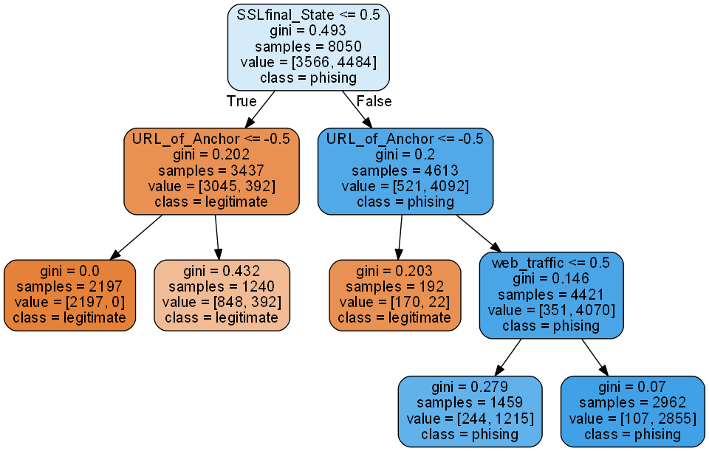1.

2.

* Check if use https and Issuer Is Trusted &and Age of Certificate≥ 1 Years or Using https and Issuer Is Not Trusted
  + If **YES**, check if % of URL Of Anchor <31%.
    - If **YES** then the website is LEGITIMATE
    - If **NO** then it also should be LEGITIMATE, but with lower confidence
  + If **NO**, check if % of URL Of Anchor <31%.
    - If **YES** then the website is LEGITIMATE
    - If **NO**, check the traffic on the website and Alexa database
      * If the website **HAS** significant traffic or **IS** recognised by Alexa database, then still it can be PHISING
      * If the website **HAS NO** significant traffic or **IS NOT** recognised by Alexa database, then with high confidence it is PHISING

3.

The accuracy is 91%

4.

**from** **sklearn** **import** datasets, model_selection, svm, metrics

**import** **numpy** **as** **np**

**import** **pandas** **as** **pd**

**import** **threading**

**from** **sklearn.model_selection** **import** train_test_split

**from** **sklearn** **import** tree

**import** **matplotlib.pyplot** **as** **plt**

**from** **sklearn** **import** preprocessing **as** pp

*##Prepare data##*

filename=r'phishing.csv'

data_train=pd.read_csv(filename,index_col=**None**,na_values='?',sep = ';')

data_train=data_train.dropna()

colnames = data_train.columns.get_values()

print("**\n**DESCRIBE DATA:**\n**",data_train.describe())

data_train.shape

DESCRIBE DATA:

having_IP_Address URL_Length Shortining_Service having_At_Symbol \

count 11055.000000 11055.000000 11055.000000 11055.000000

mean 0.313795 -0.633198 0.738761 0.700588

std 0.949534 0.766095 0.673998 0.713598

min -1.000000 -1.000000 -1.000000 -1.000000

25% -1.000000 -1.000000 1.000000 1.000000

50% 1.000000 -1.000000 1.000000 1.000000

75% 1.000000 -1.000000 1.000000 1.000000

max 1.000000 1.000000 1.000000 1.000000

double_slash_redirecting Prefix_Suffix having_Sub_Domain \

count 11055.000000 11055.000000 11055.000000

mean 0.741474 -0.734962 0.063953

std 0.671011 0.678139 0.817518

min -1.000000 -1.000000 -1.000000

25% 1.000000 -1.000000 -1.000000

50% 1.000000 -1.000000 0.000000

75% 1.000000 -1.000000 1.000000

max 1.000000 1.000000 1.000000

SSLfinal_State Domain_registeration_length Favicon ... \

count 11055.000000 11055.000000 11055.000000 ...

mean 0.250927 -0.336771 0.628584 ...

std 0.911892 0.941629 0.777777 ...

min -1.000000 -1.000000 -1.000000 ...

25% -1.000000 -1.000000 1.000000 ...

50% 1.000000 -1.000000 1.000000 ...

75% 1.000000 1.000000 1.000000 ...

max 1.000000 1.000000 1.000000 ...

popUpWindow Iframe age_of_domain DNSRecord web_traffic \

count 11055.000000 11055.000000 11055.000000 11055.000000 11055.000000

mean 0.613388 0.816915 0.061239 0.377114 0.287291

std 0.789818 0.576784 0.998168 0.926209 0.827733

min -1.000000 -1.000000 -1.000000 -1.000000 -1.000000

25% 1.000000 1.000000 -1.000000 -1.000000 0.000000

50% 1.000000 1.000000 1.000000 1.000000 1.000000

75% 1.000000 1.000000 1.000000 1.000000 1.000000

max 1.000000 1.000000 1.000000 1.000000 1.000000

Page_Rank Google_Index Links_pointing_to_pageStatistical_report \

count 11055.000000 11055.000000 11055.000000 11055.000000

mean -0.483673 0.721574 0.344007 0.719584

std 0.875289 0.692369 0.569944 0.694437

min -1.000000 -1.000000 -1.000000 -1.000000

25% -1.000000 1.000000 0.000000 1.000000

50% -1.000000 1.000000 0.000000 1.000000

75% 1.000000 1.000000 1.000000 1.000000

max 1.000000 1.000000 1.000000 1.000000

Result

count 11055.000000

mean 0.113885

std 0.993539

min -1.000000

25% -1.000000

50% 1.000000

75% 1.000000

max 1.000000

[8 rows x 31 columns]

(11055, 31)

**from** **sklearn.tree** **import** DecisionTreeClassifier

*###MAKE DECISION TREE###*

*#data_train*

X_all = data_train.drop(['Result'], axis=1)

y_all = data_train['Result']

test_size=2050

train_size=8050

X_train, X_test, y_train, y_test = model_selection.train_test_split(X_all, y_all, test_size=test_size, train_size=train_size)

### Notes

On default settings on tree makes bit unbalanced classification. fine tuned min_samples_split value to 1500. min_samples_leaf value tuning didn't really do nothing special between range 2-100 but if it is increased to 200 balance of the classification gets worse.

**from** **sklearn.metrics** **import** confusion_matrix

**from** **sklearn.metrics** **import** precision_score,confusion_matrix,f1_score,classification_report

clf = DecisionTreeClassifier(criterion="gini",

min_samples_split=1500,

min_samples_leaf=50,

splitter='best',

max_depth=3)

clf.fit(X_train, y_train)

pre = clf.predict(X_test)

accuracy_score = metrics.accuracy_score(y_test, pre)

print("accuracy:", accuracy_score)

cf_matrix = confusion_matrix(y_test, pre)

print()

print(pd.crosstab(y_test, pre, rownames=['True'], colnames=['Predicted'], margins=**True**),"**\n**")

print(classification_report(y_test,pre))

accuracy: 0.9102439024390244

Predicted -1 1 All

True

-1 809 85 894

1 99 1057 1156

All 908 1142 2050

precision recall f1-score support

-1 0.89 0.90 0.90 894

1 0.93 0.91 0.92 1156

accuracy 0.91 2050

macro avg 0.91 0.91 0.91 2050

weighted avg 0.91 0.91 0.91 2050

**from** **sklearn.tree** **import** plot_tree

**import** **graphviz**

plt.figure()

plot_tree(clf, filled=**True**,class_names = ['legitimate','phising'])

plt.show()

**from** **sklearn.tree** **import** export_graphviz

*# Export as dot file*

export_graphviz(clf, out_file='tree.dot',

feature_names = colnames[:30],

class_names = ['legitimate','phising'],

rounded = **True**, proportion = **False**,

precision = 2, filled = **True**)

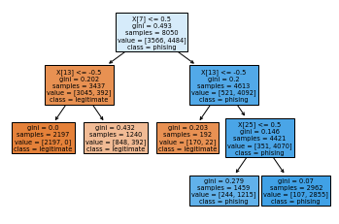

*##Edited plot*

**import** **pydotplus**

**import** **pydot**

**import** **graphviz**

*#Without this graphviz exetables not found*

**import** **os**

os.environ['PATH'] = os.environ['PATH']+';'+os.environ['CONDA_PREFIX']+r"\Library\bin\graphviz"

tree_data = export_graphviz(clf, feature_names=colnames[:30], out_file=**None**,class_names = ['legitimate','phising'], filled=**True**, rounded=**True**)

tree_graph = pydotplus.graph_from_dot_data(tree_data)

tree_graph.set_size('"10,10!"')

tree_graph.write_png('img_treeDot.png')

*#tree_graph.write_pdf("pdf_treeDot.pdf")*

graphviz_graph = graphviz.Source(tree_graph.to_string())

graphviz_graph

<graphviz.files.Source at 0x1ff5f82c808>

Plot is on the top of the document