

WESTERN PACIFIC UNIVERSITY

DEPARTMENT OF COMPUTER AND EMERGING TECHNOLOGIES
CMN224 Software engineering

Task 4 Assembly Checklist: Design & Modelling Deliverable

Kina Ridge Primary School Fee Management System

Name: Hulda Yop
ID: 00239

- Use Case Diagram
Use Case Diagram shows the interaction between the Users of the School Fee Management System. The main protagonists are the Bursar, School Board, Office Assistants, Head Teacher, Parents/Guardians, and Students. The diagram outlines the major services the system provides such as recording payments, generating receipts, handling student records, tracking balances and producing financial reports.

Design Decision
Appropriate access to functions was implemented applying a role-based access approach, enabling each user to access only to functions relevant to his or her responsibilities. This enhances security, accountability and integrity of data in the system.

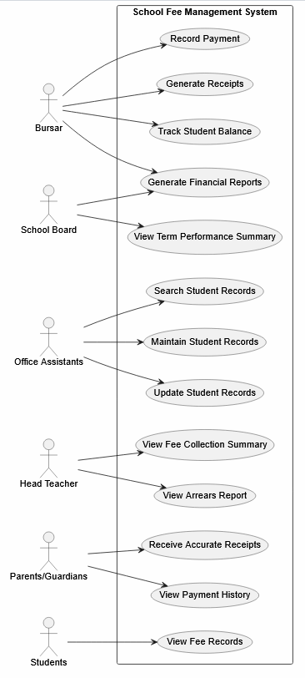

- Class Diagram
The Class Diagram shows the static structure of the School Fee Management System. It defines the major classes such as Student, Parent /Guardian, Payment, Receipt, Financial Report, Bursar, School Board, Head Teacher and Office Assistant. This diagram also indicates relationships, operations and attributes among these classes.

Design Decision
To allow for the separation of financial transactions from receipts, Payment and Receipt were modelled as separate classes. This enhances record keeping and reporting.
Business Rule Represented.
A Student can make multiple Payments (1 to 0..* relationship), while each Payment generates a Receipt. This reflects the real-world fee payment process.
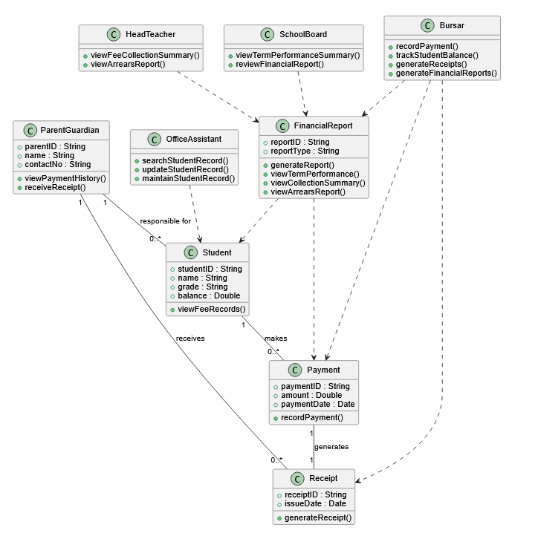
- State Diagram
The State Diagram represents the life cycle of a payment transaction. A payment enters into the Pending state, goes through Recorded and Verified, and can be Receipted, Reconciled, Completed, Rejected, or Refunded depending upon the business situation.

Design Decision
Validation happens prior to the payment is finalized. This means that if there is incorrect or incomplete payment data, it can be detected and rejected before it becomes an issue in financial records.

Business Rule Guard
The transition implements a business rule that prevents invalid transactions from entering the financial records.

Verified Rejected

(Payment details invalid)

The transition from Verified to Rejected includes the guard condition [payment details invalid]. This represents a business rule that requires all payment information to be validated before being accepted. If the entered payment details are incorrect, incomplete, or inconsistent, the transaction is rejected to maintain the accuracy and integrity of the school's financial records.

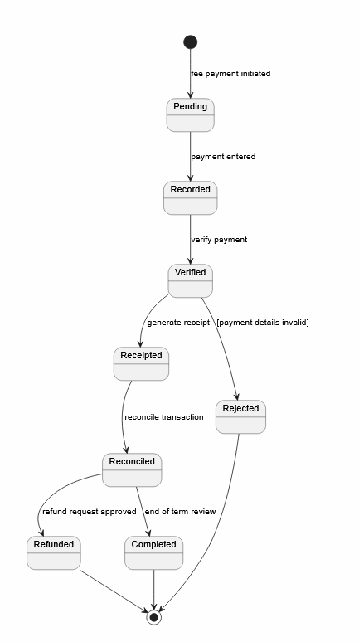
- Activity Diagram
The payment processing workflow is shown in the Activity Diagram. The process starts when the bursar records a payment and saves it locally. The system then looks at whether or not there is a network connection and power. When there is a connection, payment information is synced to the central system. If there is no connectivity, then records are stored locally until connectivity returns.

Design Decision
Support for offline processing was added because there is a possibility of network loss or power outages at school. This will prevent fee payments from being lost and can be synced later once services are available.

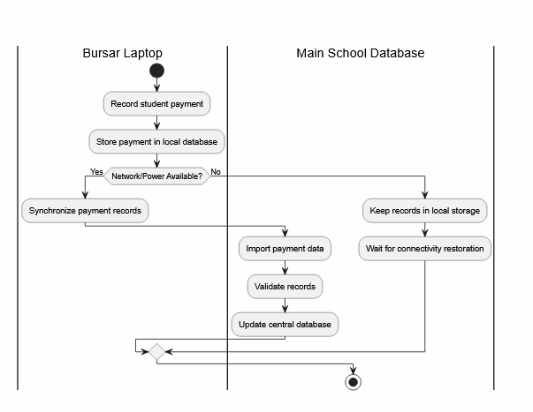

- Deployment Diagram

A Deployment Diagram illustrates the deployment of a software component on the hardware resources. The Fee Tracking Application is stored on the Office Laptop along with other Application Modules: the Authentication Module, the Reporting Module, and the SQLite Database. The application is accessed via the local network from Bursar, Office Assistant and Head Teacher workstations. Receipts are printed on a Network Printer.

Design Decision
A centralised approach with an office laptop and local SQLite database was chosen to minimise the infrastructure cost while still delivering multiple users on the school network.

Consistency with Class Diagram
The deployment view accommodates all major classes

Class | Deployment Location
Student | SQLite Database
Parent / Guardian | SQLite Database
Payment | SQLite Database
Receipt | SQLite Database
Financial Report | Reporting Module / Database
Bursar | Bursar Workstation
Office Assistant | Office Assistant Workstation
Head Teacher | Head Teacher Workstation
School Board | Report Viewing Access

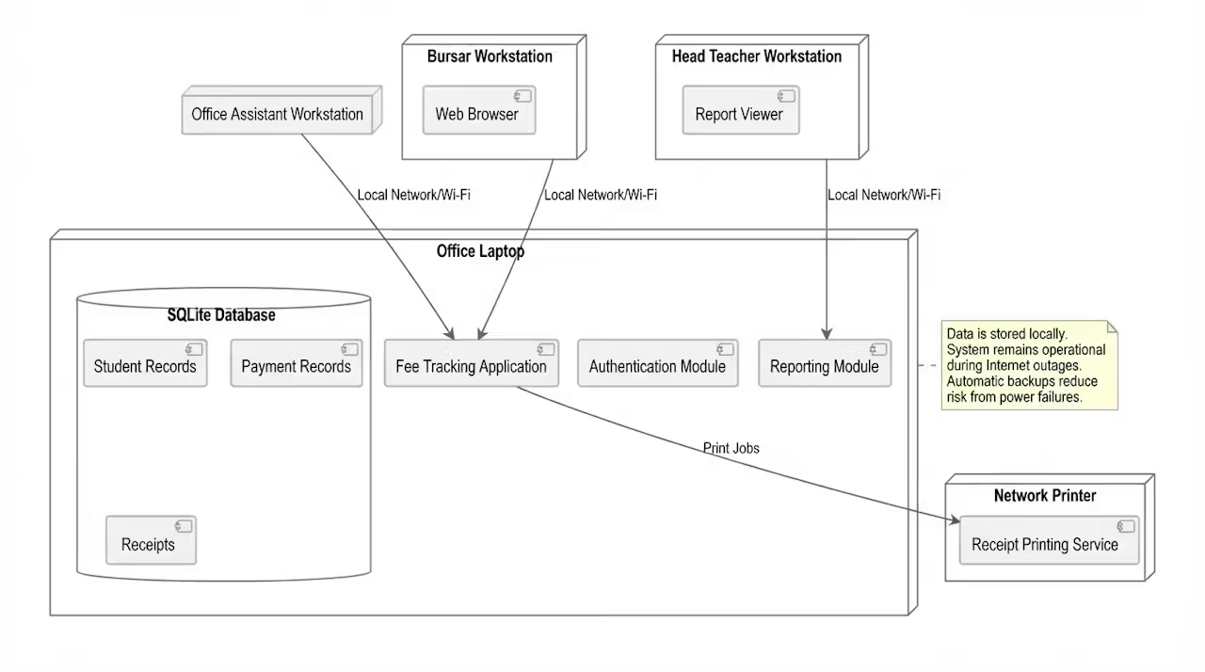

- Package (Architecture) Diagram

The package diagram shows the overall architecture of the School Fee Management System. The system is organized into three layers, the User Interface Layer, which contains the Login Form, Student Management Form, Payment Form, and Reporting Form. The Application Logic Layer, which contains the Authentication Service, Fee Management Service, and Reporting Service. The Data Access Layer, which contains the Student Repository, Payment Repository, and Report Repository connected to the Fee Management Database.

The diagram records the design decision to use a layered architecture, where user interface components communicate through application services before accessing data repositories and the database.
The architecture follows a downward dependency structure with no upward dependency arrows. Communication flows from the User Interface Layer to the Application Logic Layer, then to the Data Access Layer and finally to the Fee Management Database.

User Interface

Application Logic

Data Access

Database

Applied Design -Repository Pattern.

The Repository Pattern is implemented within the Data Access Layer through the Student Repository, Payment Repository, and Report Repository components. These repositories act as intermediaries between the application services and the Fee Management Database, allowing the system to retrieve and store data without requiring the application logic to access the database directly. This pattern is clearly shown in the Package Diagram, where the Application Logic services communicate with the repository components before accessing the Fee Management Database.
The Repository Pattern provides several benefits to the system. It separates business logic from data access operations, reduces code duplication, and simplifies database maintenance. It also improves testing by allowing repository components to be easily replaced or mocked, and it supports future database changes with minimal impact on other parts of the system. As a result, the system becomes more maintainable, flexible, and easier to extend.

Traceability Scenario

The following scenario demonstrates consistency across all diagrams.

Scenario is Parent Pays School Fees

Use Case Diagram
- Bursar performs Record Payment.
- System generates a receipt.

Activity Diagram
- Payment is recorded.
- Data is stored locally.
- Data is synchronized with the central database.

State Diagram
- Payment moves from Pending → Recorded → Verified → Receipted → Reconciled → Completed.

Class Diagram
- Student makes Payment.
- Payment generates Receipt.

Deployment Diagram
- Fee Tracking Application stores the payment in the SQLite Database.
- Receipt is printed using the Network Printer.

Note: The PlantUML source code for all diagrams was committed to GitHub. The Package Diagram and Deployment Diagram source files were committed under the week05/ folder, while the Use Case Diagram, Class Diagram, Activity Diagram, and State Diagram source files were committed under the week09/ folder.

AI Use Declaration

Microsoft Copilot was used to assist with the development and review of the PlantUML code, diagram consistency checking, and drafting the explanatory descriptions included in this report.

