ENSF381 – Lab02

**Section:** L03

**Date:** 2024-01-24

|  |  |  |
| --- | --- | --- |
| Created by: | | |
| First name | Last name | UCID |
| Hongwoo | Yoon | 30113779 |
| Hyunmyung(Steve) | Park | 30067689 |

# 2.3.1

<https://github.com/dbsghddn21/Lab2>

# 3.3.6

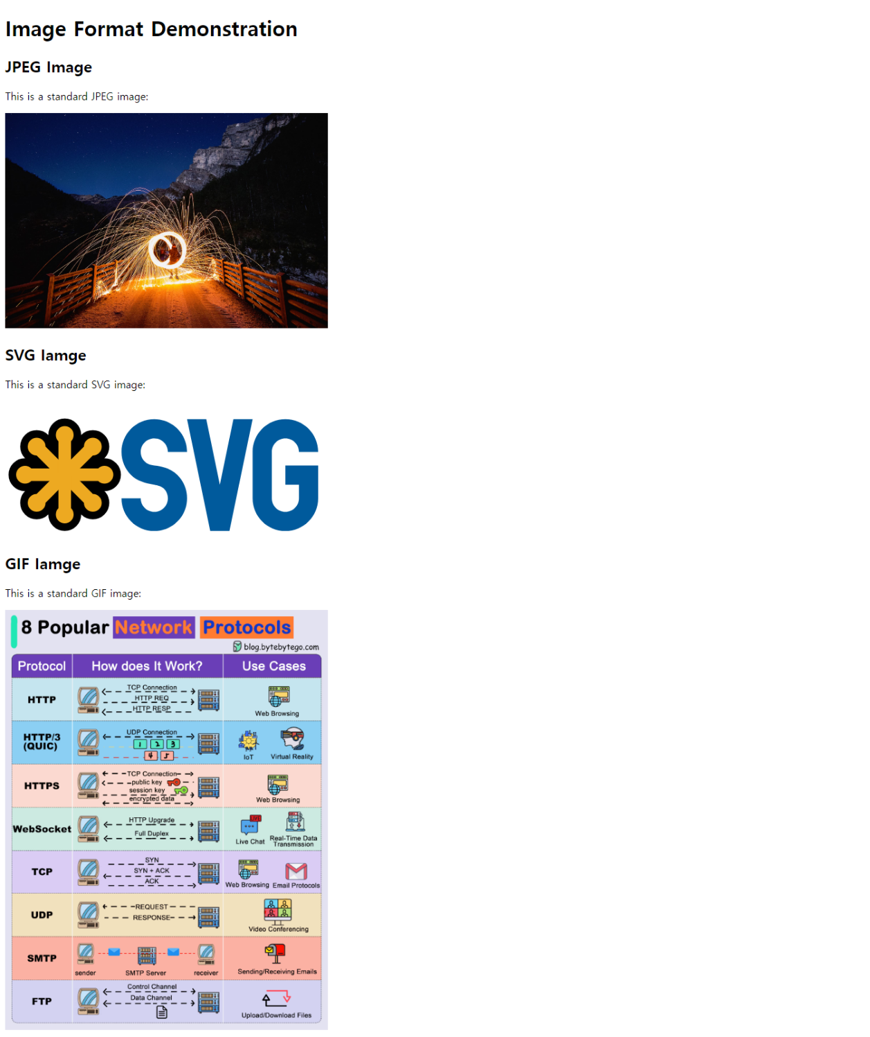

# 4.2.2

# 5.2.3.e

As I open my html file and test my back links, some of them worked but some of them did not. Since we used two different types of src for the hyperlink,

1. <br><a href="index.html">Back to Home</a>
2. <br><a href="./">Back to Home</a>

Number 1 worked since I opened them from my local folder, the exact location of file needed.

Therefore, number 2 does not work on local folder.

Source: From the lecture.

# 5.2.3.f

All of them work since this time we opened the index.html through local host server, the specific location of the file does not need to be redirected to home.

Source: From the lecture.

# 5.3.2

