Un tutorial dice que se usa rgbd (Depth) para pasar a una vara 3D

El parámetro más importante es el focal length, nos dice como tranladar una cordenada de un pixel a distancia.

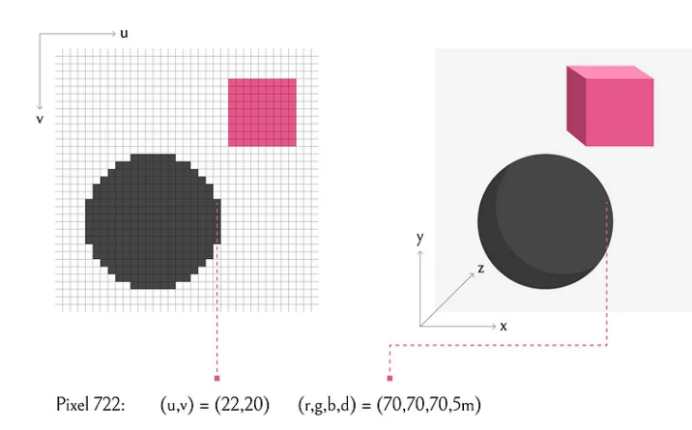

Para una cámara pinole the focal length es la misma para x y y

Usually, fₓ and fᵧ are identical. They can differ though e.g. for non-rectangular pixels of the image sensor, lens distortions, or post-processing of the image.

**Focal Length,**fx**,**fy

The focal length is the distance between the pinhole and the film (a.k.a. image plane). For reasons we'll discuss later, the focal length is measured in pixels. In a true pinhole camera, both fx�� and fy�� have the same value, which is illustrated as f� below.

**Principal Point Offset,**x0**,**y0

The camera's "principal axis" is the line perpendicular to the image plane that passes through the pinhole. Its itersection with the image plane is referred to as the "principal point," illustrated below.

The "principal point offset" is the location of the principal point relative to the film's origin

**Axis Skew,**s

Axis skew causes shear distortion in the projected image.

