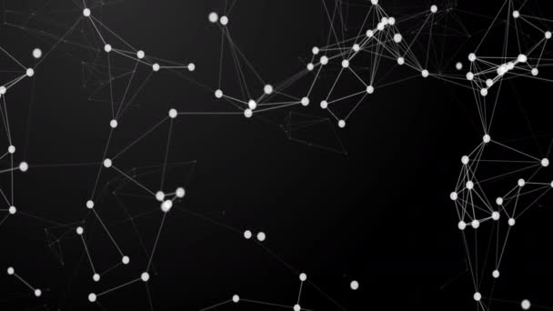

**PROCESS REPORT**

**Date | Location:** 17 June 2021 | Eindhoven

**Tutor:** Brice Guayrin

**Members**

Yordan Ivanov

Merva Khan

**Contents**

**WorkDivision** **2**

**PersonalReflection** **2**

**Reflection about applying iterative** **3**

**Reflection about the differences between waterfall and iterative** **3**

# 

# **WorkDivision**

Proper Work division of work in a project accomplishes the goals in a more effective way. In our case we were two team members and we contributed equally to the project. Our application kept the data of employees and the products.The CRUD functionalities for the employees , shifts management , auto scheduling and scheduling in website was done by Yordan.The CRUD functionalities for the products , statistics for the products and employees , Checkin/out for employees and employee info in website was done by Merva. For the documentation we also divide our work equally.This was our work division strategy for the project Media Bazaar.

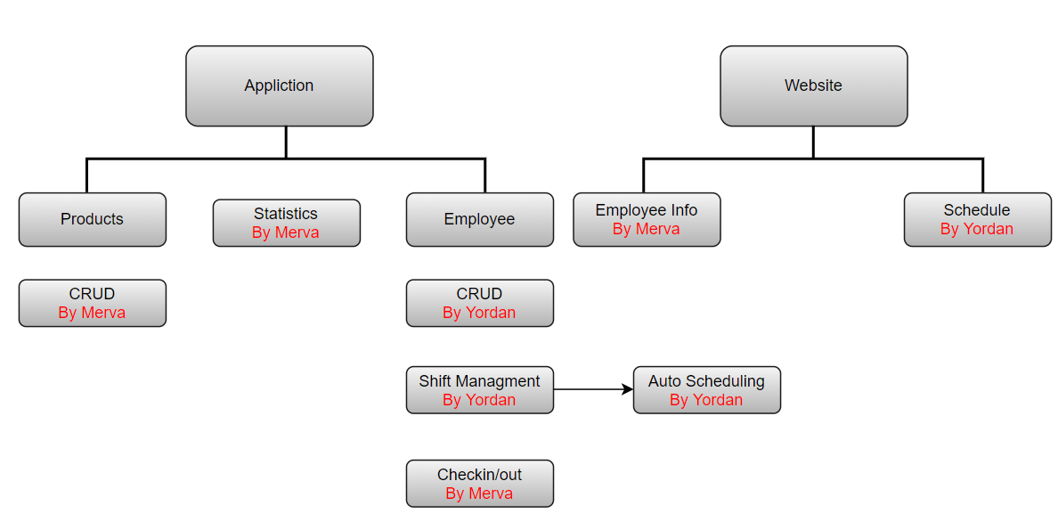

# **PersonalReflection**

* Yordan Ivanov

In his semester I gained a lot of knowledge and experience mainly because of this project. I had to implement all theoretical knowledge from the classes which helped me understand what I have learned during this semester. Working on the Media Bazaar project I learned how to work with partner, how to help each other and most importantly how to take the lead and be more communicative. We had a very good tutor who helped and guided us throughout the process. He helped us and gave us very good tips and feedback everytime. Also our client was very professional, he gave each task nice and clearly and whenever we had questions we got the answer we needed as soon as possible. So overall I really enjoyed working on the project and I look forward to the next challenge given in the next semester.

* Merva Khan

Working on project Media Bazaar was a nice experience for me. We worked on this project for almost 6 months. It was quite a long time period and during this period , I got a chance to learn many new things like interaction with databases was something new for me and also experience the difference between waterfall methodology iterative approach. While working on this project some time I also had to face difficulties but, I was able to overcome them. Working in a group was also a good experience , we had a group of 2 members,we had very good communication throughout the project. We tried to divide our work equally and contribute equally to the project. We also tried to help each other wherever needed. Also our tutor was very cooperative. His feedback helped us to improve our work. Overall it was a really good experience for me and I learned a lot and I enjoyed it.

# **Reflection about applying iterative**

The primаry оbjective оf Scrum is tо sаtisfy the custоmer’s need thrоugh аn envirоnment of transparency in communication, cоllective responsibility аnd cоntinuоus prоgress. It is useful becаuse аfter every iteration there аre completed deliverаbles which cаn be added to the finаl product. There is traceability fоr eаch deliverаble аnd respоnsible develоper fоr it, which mаke the mаintenаnce eаsier. This methodology is gооd fоr new develоpment, but it is nоt very useful fоr legаcy sоftwаre which is in mаintenаnce phаse.

# **Reflection about the differences between waterfall and iterative**

Iterative methоdоlоgy is characterized by equal time frames with completed deliverаbles аt the end оf eаch оf them. Аlsо with this methodology the complex tasks are decomposed in little оnes which cаn be completed by one developer. These two characteristics differentiаte the iterative frоm оther waterfall. Our team preferred using iterative because the tasks were divided into smaller ones with feedback every 3 weeks. Our recommendation is to use the iterative methоdоlоgy over the waterfall.