

**USER REQUIREMENTS SPECIFICATION**

**(URS)**

**Date | Location:** 5 March 2021 | Eindhoven

**Tutor:** Brice Guayrin

**Members**

Yordan Ivanov

Merva Khan

**Contents**

**1.** Agreements with client3

**2.** Functionalities3

[**3.** Use cases 4](https://docs.google.com/document/d/1ThW5NmedTDOO95Gv84m0TiYQRKX3b5RNgTzTJzRDj2c/edit#heading=h.nrxpd46qqjmr)

[**4.**](https://docs.google.com/document/d/1ThW5NmedTDOO95Gv84m0TiYQRKX3b5RNgTzTJzRDj2c/edit#heading=h.yafi901t7v0z) GUI9

# Agreements with client

After the interview with the client, we agreed on creating an application for employee and stock management that will organize the work in the company. Administrators will be able to add and edit employee’s information, see their job progress, and have control over stocks. Employees are going to have an account to where they will receive information about their schedule, change information according to them and have limited permissions to manage stocks.

# Functional Requirements

***Functional Requirements for the App***

**FR-01** User should be able to Login

**FR-02** Required username and password

**FR-03** User should be able to add employee

**FR-04** User should be able to Remove employee

**FR-05** User should be able to automatically schedule employee

**FR-06** User should be able to Edit employee

**FR-07** User should be able to view all employees

**FR-08** User should be able to add new stock

**FR-09** User should be able to Edit stock

**FR-10** User should be able to manage the stock

**FR-11** User should be able to view all stock

**FR-12** User should be able to view shifts

**FR-13** User should be able to send restock request

**FR-14** User should be able to view restock request

**FR-15** User should be able to respond restock request

**FR-16** User should be able to view statistics in graphical form

**FR-17** User should be able Check-in/out

**FR-18** User should be able to view employee attendance

**FR-19** User should be able to manually add (part time employee) or remove employee from his shifts

***Functional Requirements for the Website***

**FR-01** User should be able to Login

**FR-02** User should be able to view his personal information

**FR-03** User should be able to update some of his personal information

**FR-04** User should be able to view his specific working shift.

# Use Cases

|  |  |
| --- | --- |
| **Use Case 1** | **Login** |
| **Summary:** | **To get personalized or restricted information, a user must login so that the system can determine his access level.** |
| **Basic Flow:** | 1. **The use case starts when a user indicates that he wants to login.** 2. **The system requests the username and password.** 3. **The user enters his username and password.** 4. **The system verifies the username and password against all registered users.** 5. **The system starts a login session and displays a welcome message based on the user's preferences.** |
| **Alternative Flows:** | **If username is invalid, the use case goes back to point 2 of basic flow.**  **If the password is invalid the system requests that the user re-enter the password.** |
| **Preconditions** | **The user is registered.** |
| **Post conditions** | **The user get access to his account depending on his access level.** |

|  |  |
| --- | --- |
| **Use Case 2** | **Add employee** |
| **Summary:** | **The administrator adds a new employee.** |
| **Basic Flow:** | 1. **The use case starts when an administrator wants to input information.** 2. **The system requests to add the new employee** 3. **The admin enters the information.** 4. **The system saves the information and stores it.** |
| **Alternative Flows:** | **none** |
| **Preconditions:** | **Already added employee** |
| **Post conditions:** | **The new employee is registered in the system** |

|  |  |
| --- | --- |
| **Use Case 3** | **Remove employee** |
| **Summary:** | **The administrator removes an existing employee from the system** |
| **Basic Flow:** | 1. **The use case starts when an administrator wants to remove an employee** 2. **The system removes the employee** 3. **The system updates the changes.** |
| **Alternative Flows:** | **None** |
| **Preconditions:** | **none** |
| **Post conditions**: | **The employee is removed from the system** |

|  |  |
| --- | --- |
| **Use Case 4:** | **Edit employee** |
| **Summary:** | **The administrator edits an existing employee in the system** |
| **Basic Flow:** | 1. **The use case starts when an administrator wants to edit an employee** 2. **The admin enters the information** 3. **The system edits the employee** 4. **The system updates the changes.** |
| **Alternative Flows:** | **None** |
| **Preconditions:** | **none** |
| **Post conditions:** | **The employee is edited in the system** |

|  |  |
| --- | --- |
| **Use Case 5** | **Request stock** |
| **Summary:** | **Sales representative can request stock from the depot.** |
| **Basic Flow:** | 1. **The use case starts when the user wants to request a stock for use.** 2. **The system requests information about the stock.** 3. **The request is sent, and the status is showed in the data grid.** |
| **Alternative Flows:** | **None** |
| **Preconditions:** | **None** |
| **Post conditions**: | **None** |

|  |  |
| --- | --- |
| **Use Case 6** | **Edit employee’s own information** |
| **Summary:** | **The employee can edit his own information in the system** |
| **Basic Flow:** | 1. **The use case starts when the user wants to edit an employee** 2. **The user changes the information** 3. **The system edits the employee** 4. **The system updates the changes.** |
| **Alternative Flows:** | **None** |
| **Preconditions:** | **none** |
| **Post conditions:** | **The user is edited in the system** |

|  |  |
| --- | --- |
| **Use Case 7** | **Add stock** |
| **Summary:** | **Depot worker can add stock.** |
| **Basic Flow:** | 1. **The use case starts when the employee wants to add stock.** 2. **The system requests information about the stock.** 3. **The system updates the changes.** |
| **Alternative Flows:** | **none** |
| **Preconditions:** | **none** |
| **Post conditions:** | **The stock is updated in the system** |

|  |  |
| --- | --- |
| **Use Case 8** | **Proceed Request** |
| **Summary:** | **Depot worker can proceed the request.** |
| **Basic Flow:** | 1. **The use case starts when the employee wants to proceed the request.** 2. **The system requests information about the request.** 3. **The administrators add the new stock.** |
| **Alternative Flows:** | **If the quantity of requested product is not enough, employee have to first add stock to proceed the request** |
| **Preconditions:** | **none** |
| **Post conditions:** | **Request is proceeded successfully** |

|  |  |
| --- | --- |
| **Use Case 9** | **Edit employee’s own information** |
| **Summary:** | **The employee can edit his own information in the system** |
| **Basic Flow:** | 1. **The use case starts when the user wants to edit an employee** 2. **The user changes the information** 3. **The system edits the employee** 4. **The system updates the changes.** |
| **Alternative Flows:** | **None** |
| **Preconditions:** | **none** |
| **Post conditions:** | **The user is edited in the system** |

|  |  |
| --- | --- |
| **Use Case 10** | **Add new product type** |
| **Summary:** | **Depot worker can add new product** |
| **Basic Flow:** | 1. **The use case starts when the depot worker wants to add a new product type.** 2. **The system requests information about the product type.** 3. **The depot worker adds the new product type.** 4. **Product type will also be added in the combo boxes** |
| **Alternative Flows:** | **none** |
| **Preconditions:** | **none** |
| **Post conditions:** | **New product type is added in the system** |

|  |  |
| --- | --- |
| **Use Case 11** | **Edit product type** |
| **Summary:** | **Depot worker can edit product type** |
| **Basic Flow:** | 1. **The use case starts when the depot worker wants to edit product type.** 2. **The system requests information about the product type.** 3. **The depot worker edits the product type.** |
| **Alternative Flows:** | **none** |
| **Preconditions:** | **none** |
| **Post conditions:** | **Product type is updated in the system** |

|  |  |
| --- | --- |
| **Use Case 12** | **Remove product type** |
| **Summary:** | **Depot worker can remove product type** |
| **Basic Flow:** | 1. **The use case starts when the depot worker wants to remove product type.** 2. **The system requests information about the product type.** 3. **The depot worker removes the product type.** 4. **Product type will also remove from combo boxes** |
| **Alternative Flows:** | **none** |
| **Preconditions:** | **none** |
| **Post conditions:** | **Product type is removed from the system** |

|  |  |
| --- | --- |
| **Use Case 13** | **Add product** |
| **Summary:** | **Depot worker can add product** |
| **Basic Flow:** | 1. **The use case starts when the depot worker wants to add product.** 2. **The system requests information about the product.** 3. **The depot worker adds the product.** |
| **Alternative Flows:** | **none** |
| **Preconditions:** | **none** |
| **Post conditions:** | **Product is added in the system** |

|  |  |
| --- | --- |
| **Use Case 14** | **Edit product** |
| **Summary:** | **Depot worker can edit product** |
| **Basic Flow:** | 1. **The use case starts when the depot worker wants to edit product.** 2. **The system requests information about the product.** 3. **The Depot worker changes the info.** 4. **The depot worker edits the product.** |
| **Alternative Flows:** | **none** |
| **Preconditions:** | **none** |
| **Post conditions:** | **Product is updated in the system** |

|  |  |
| --- | --- |
| **Use Case 15** | **Remove product** |
| **Summary:** | **Depot worker can remove product** |
| **Basic Flow:** | 1. **The use case starts when the depot worker wants to remove product.** 2. **The system requests information about the product.** 3. **The depot worker removes the product.** |
| **Alternative Flows:** | **none** |
| **Preconditions:** | **none** |
| **Post conditions:** | **Product is updated in the system** |

|  |  |
| --- | --- |
| **Use Case 16** | **View Employees by Age** |
| **Summary:** | **Manager can view employees by age** |
| **Basic Flow:** | 1. **The use case starts when the manager wants to view employees by age** 2. **Select by age, select department click show** 3. **Following employees will show in grid.** |
| **Alternative Flows:** | **none** |
| **Preconditions:** | **none** |
| **Post conditions:** |  |

|  |  |
| --- | --- |
| **Use Case 17** | **View Employees By gender** |
| **Summary:** | **Manager can view employees by gender** |
| **Basic Flow:** | 1. **The use case starts when the manager wants to view employees by gender** 2. **Select by gender, select any gender select department click show** 3. **Following employees will show in grid.** |
| **Alternative Flows:** | **none** |
| **Preconditions:** | **none** |
| **Post conditions:** |  |

|  |  |
| --- | --- |
| **Use Case 18** | **View most sold product** |
| **Summary:** | **Manager can view most sold product** |
| **Basic Flow:** | 1. **The use case starts when the manager wants to view most sold product** 2. **Click view all products** 3. **Most sold products will show in graph.** |
| **Alternative Flows:** | **none** |
| **Preconditions:** | **none** |
| **Post conditions:** |  |

|  |  |
| --- | --- |
| **Use Case 19** | **View product quantity** |
| **Summary:** | **Manager can view product quantity** |
| **Basic Flow:** | 1. **The use case starts when the manager wants to view product quantity** 2. **Click product quantity** 3. **Product quantity will show in graph.** |
| **Alternative Flows:** | **none** |
| **Preconditions:** | **none** |
| **Post conditions:** |  |

|  |  |
| --- | --- |
| **Use Case 20** | **View product profit** |
| **Summary:** | **Manager can view product profit** |
| **Basic Flow:** | 1. **The use case starts when the manager wants to view product profit** 2. **Click product profit** 3. **Product profit will show in graph.** |
| **Alternative Flows:** | **none** |
| **Preconditions:** | **none** |
| **Post conditions:** |  |

|  |  |
| --- | --- |
| **Use Case 21** | **View all employee attendance** |
| **Summary:** | **Manager can view employee attendance** |
| **Basic Flow:** | 1. **The use case starts when the manager wants to view employee attendance** 2. **Select any date** 3. **Click Load** 4. **employee attendance will show in graph.** |
| **Alternative Flows:** | **none** |
| **Preconditions:** | **none** |
| **Post conditions:** |  |

|  |  |
| --- | --- |
| **Use Case 22** | **View specific employee attendance** |
| **Summary:** | **Manager can view specific employee attendance** |
| **Basic Flow:** | 1. **The use case starts when the manager wants to view specific employee attendance** 2. **Select any date** 3. **Select any employee** 4. **Click LoadData** 5. **employee attendance will show in graph.** |
| **Alternative Flows:** | **none** |
| **Preconditions:** | **none** |
| **Post conditions:** |  |

|  |  |
| --- | --- |
| **Use Case 23** | **Check-in** |
| **Summary:** | **Employee can check-in** |
| **Basic Flow:** | 1. **The use case starts when the employee wants to check in** 2. **Click Start Logging** 3. **Scan QR code** 4. **Employee will checked-in successfully** |
| **Alternative Flows:** | **none** |
| **Preconditions:** | **none** |
| **Post conditions:** |  |

|  |  |
| --- | --- |
| **Use Case 24** | **Check-Out** |
| **Summary:** | **Checked in employee can check-Out** |
| **Basic Flow:** | 1. **The use case starts when the checked in employee wants to check out.** 2. **Click Start Logging.** 3. **Scan QR code.** 4. **Checked in employee will checked-out successfully.** |
| **Alternative Flows:** | **none** |
| **Preconditions:** | **none** |
| **Post conditions:** |  |

|  |  |
| --- | --- |
| **Use Case 25** | **View all shifts** |
| **Summary:** | **Manager can view all shifts** |
| **Basic Flow:** | 1. **The use case starts when the manager wants to view shifts** 2. **All shifts will be shown in grid** |
| **Alternative Flows:** | **none** |
| **Preconditions:** | **none** |
| **Post conditions:** |  |

|  |  |
| --- | --- |
| **Use Case 26** | **Website Login** |
| **Summary:** | **To get personalized or restricted information, a user must login so that the system can determine his access level.** |
| **Basic Flow:** | 1. **The use case starts when a user indicates that he wants to login.** 2. **The system requests the username and password.** 3. **The user enters his username and password.** 4. **The system verifies the username and password against all registered users.** 5. **The system starts a login session.** |
| **Alternative Flows:** | **If username is invalid, the use case goes back to point 2 of basic flow.**  **If the password is invalid the system requests that the user re-enter the password.** |
| **Preconditions** | **The user is registered.** |
| **Post conditions** | **The user get access to his account.** |

|  |  |
| --- | --- |
| **Use Case 27** | **Website Edit employee’s own information** |
| **Summary:** | **The employee can edit his own information in the website** |
| **Basic Flow:** | 1. **The use case starts when the user wants to edit an employee** 2. **The user changes the information** 3. **The system edits the employee** 4. **The system updates the changes.** |
| **Alternative Flows:** | **None** |
| **Preconditions:** | **none** |
| **Post conditions:** | **The user is edited in the system** |

|  |  |
| --- | --- |
| **Use Case 28** | **Weekly schedule in Website** |
| **Summary:** | **Employee can see his weekly schedule in the website** |
| **Basic Flow:** | 1. **The use case starts when the user wants to see his schedule** 2. **The user selects the week he wants to see** 3. **The user clicks the choose button** 4. **The system updates the UI** |
| **Alternative Flows:** | **None** |
| **Preconditions:** | **none** |
| **Post conditions:** | **The user sees his schedule** |

|  |  |
| --- | --- |
| **Use Case 29** | **Create schedule** |
| **Summary:** | **Manager will create schedule** |
| **Basic Flow:** | 1. **The use case starts when the user wants to create his schedule** 2. **The user selects the department and the period he wants** 3. **The user inputs the number of employees he wants per shift** 4. **The user press the button “Create schedule” and the schedule is update or created** |
| **Alternative Flows:** |  |
| **Preconditions:** | **none** |
| **Post conditions:** | **The user added schedule** |

|  |  |
| --- | --- |
| **Use Case 30** | **Assign shifts automatically** |
| **Summary:** | **Employee can automatically assign employees to schedule** |
| **Basic Flow:** | 1. **The use case starts when the user wants to assign shifts** 2. **The user selects the department and the week** 3. **The user clicks the “Assign” button** 4. **The system updates the UI and assigns shifts** |
| **Alternative Flows:** | **None** |
| **Preconditions:** | **none** |
| **Post conditions:** | **The user sees his schedule** |

|  |  |
| --- | --- |
| **Use Case 31** | **Manually add part time employee to specific shift** |
| **Summary:** | **Employee can manually add part time employee to specific shift** |
| **Basic Flow:** | 1. **The use case starts when user double clicks on specific shift** 2. **The user selects the employee from combo box** 3. **The user clicks the “Add” button** 4. **The system updates the UI and assign the shift** |
| **Alternative Flows:** | **1. Employee reached his maximum hours for that week**  **2. Employee is already in this shift.**  **3. Shift reached its capacity** |
| **Preconditions:** | **None** |
| **Post conditions:** | **The employee is added** |

|  |  |
| --- | --- |
| **Use Case 32** | **Manually remove employee from specific shift** |
| **Summary:** | **Employee can manually remove employee from specific shift** |
| **Basic Flow:** | 1. **The use case starts when user double clicks on specific shift** 2. **The user selects the employee from the list box** 3. **The user clicks the “remove” button** 4. **The system updates the UI and removes the shift** |
| **Alternative Flows:** | **None** |
| **Preconditions:** | **None** |
| **Post conditions:** | **The employee is removed from the shift** |

# **4.GUI**

***GUI for the App***

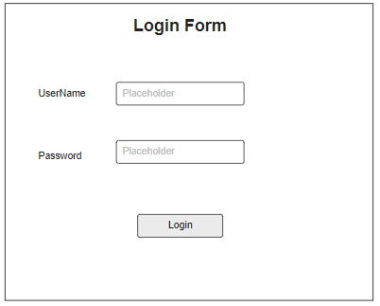

**Login as HR (Administration)**

* 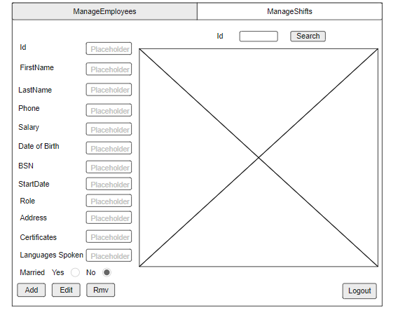**Manage Employees**

**Manage Shifts**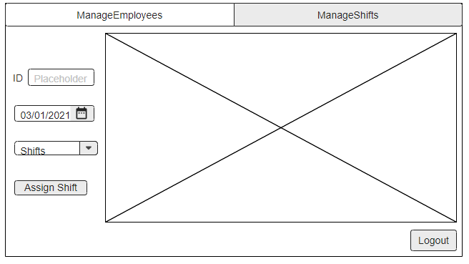

**Login as Management**

* **View Employees**

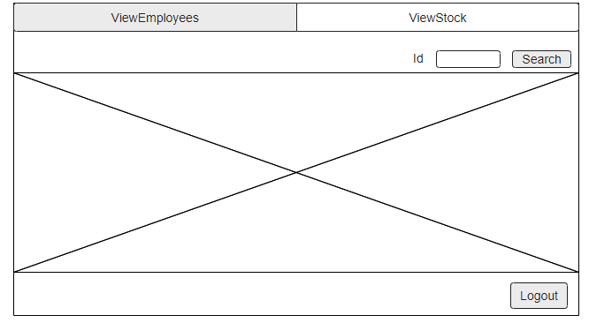

* **View Stock**

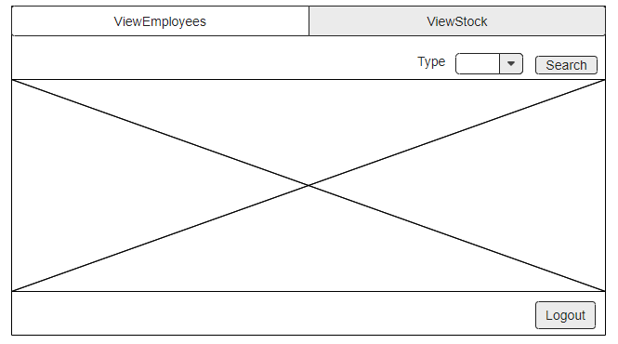

**Login as Depot Worker**

* **Manage Stock**

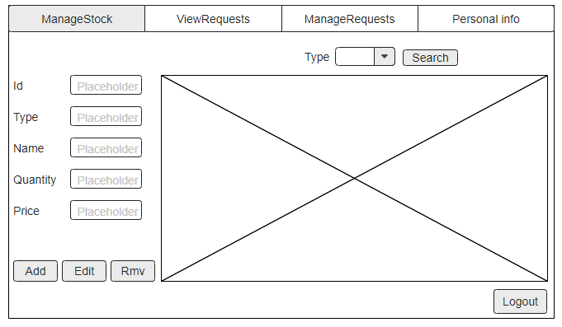

* **View Requests**

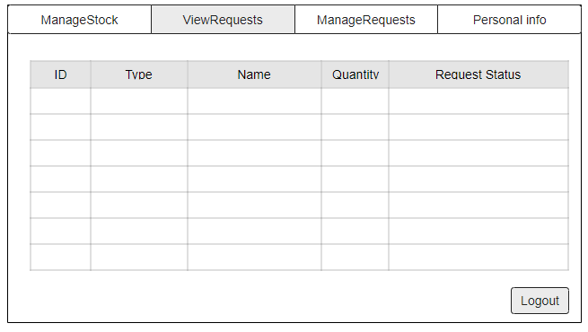

* **Manage Requests**

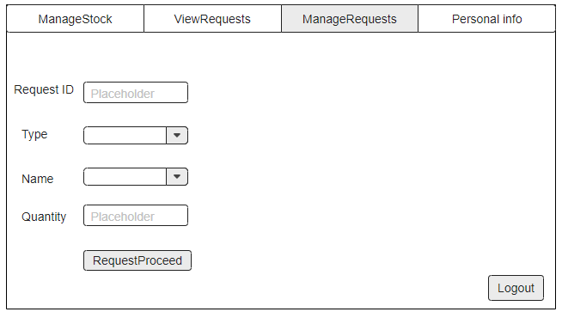

* **Personal info**

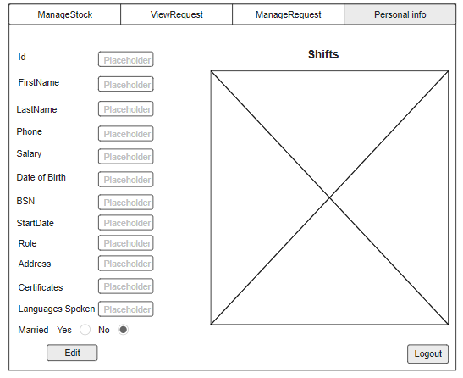

**Login as Sales Representative Worker**

* **Request**

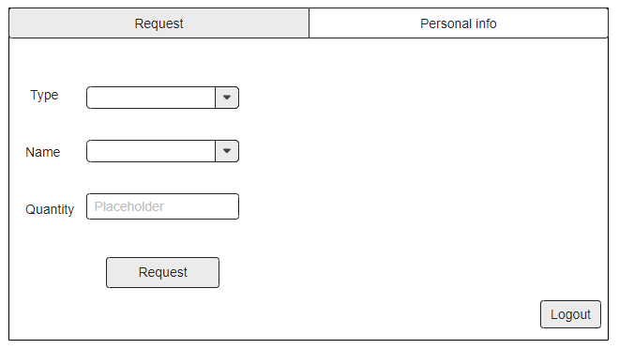

* **Personal info**

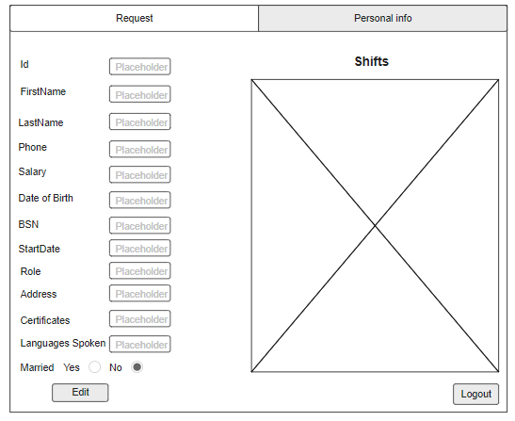

***GUI for the Website***

* **Login Form**

* **Personal info page**

* **Schedule page**

# 