**Dataverse Project**

This Project utilizes powerapps and dataverse integration.

* + I want to be able to view my list of projects that aren’t completed.(isCompleted, no) and filtered by a projectName.
  + Be able to create new project edit existing once and delete.
  + Deleting is setting isDeleted to Yes. I don’t want to remove the project totally.
    - I want to add a project phase for each project with start, end date and phase name.
  + My project and Project Phase has 1 to many relationship.
    - I have a completed status for each phases as well.
    - And deleting or totally removing that phase from my table Remove(tableName, ThisItem).
* For adding details or phase for my project. I can only click on add detail button after saving my main project. (the project must exsist to add details)
* And Finally I want to be able to see and filter the completed and deleted projects in a separate screen

1. **Create a Dataverse Table for Projects**

* In PowerApps and select "Tables."
* Click "New table" and name it "Projects."
* Add the following columns:
  + Project Name (Single line of text, required)
  + Priority (Choice: Low, Medium, High)
  + Initiative Type (Choice: Internal, External)
  + Project Leader (SingleLine of text ) from powerapps side replace the textinput with drop down and set its items to ( Lookup to Users Existing dataverse table)
  + Reference link (url)
  + External Resources (Multiple lines of text)
  + Project Overview (Multiple lines of text)
* Save the table.

1. **Create a Dataverse Table for Project Phases**

* Create a new table named "Project Phases."
* Add the following columns:
  + Project (Lookup to Projects table) created when forming the relationship
  + Phase Name (Single line of text)
  + Start Date (Date and Time)
  + End Date (Date and Time)
  + Status (Choice: Not Started, In Progress, Completed)
* Save the table.

Example:

Screen1:

* 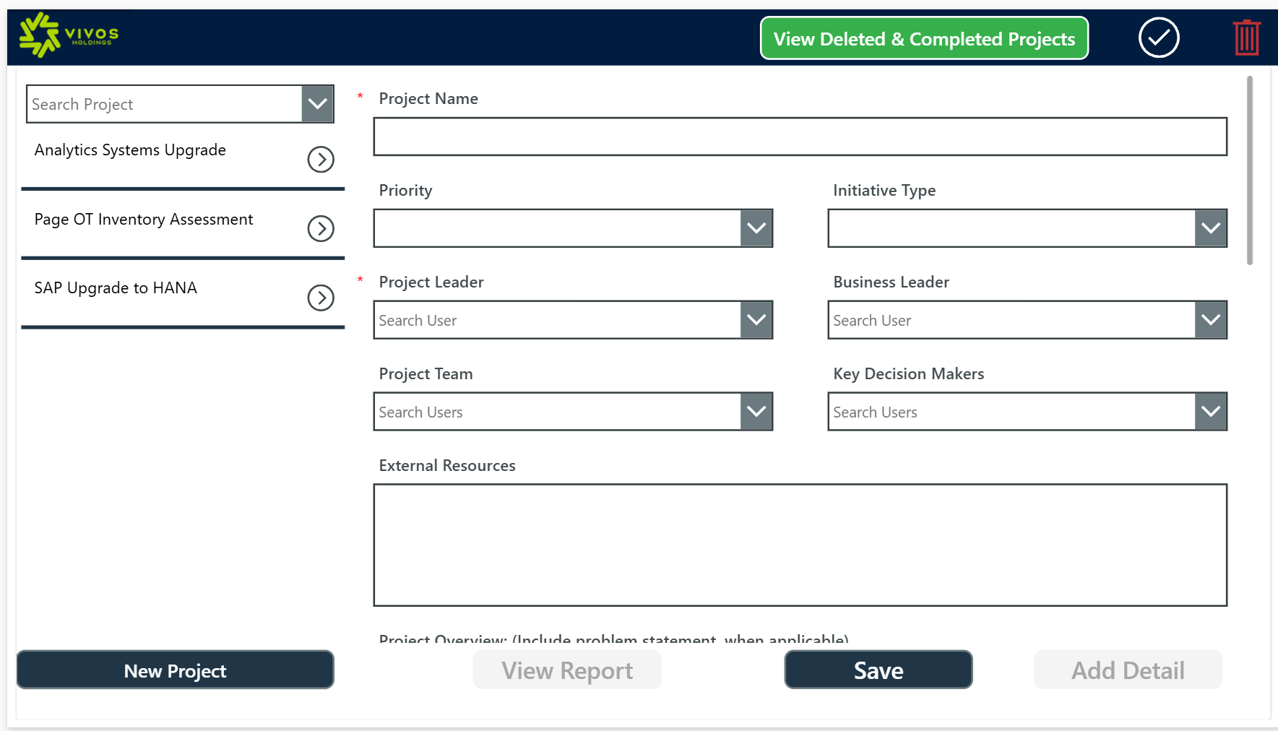
* Screen 2:
* 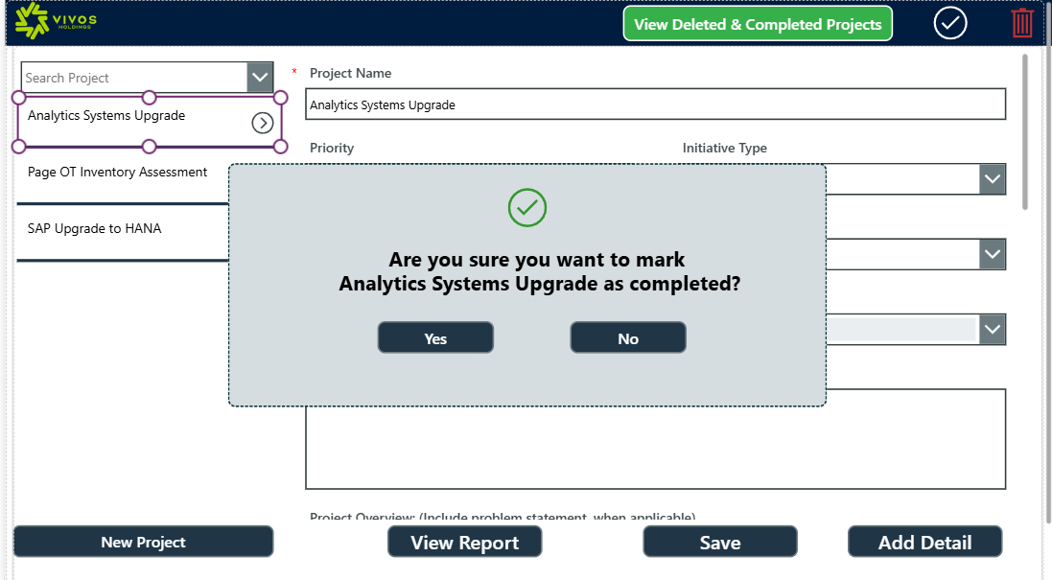
* Screen 3:

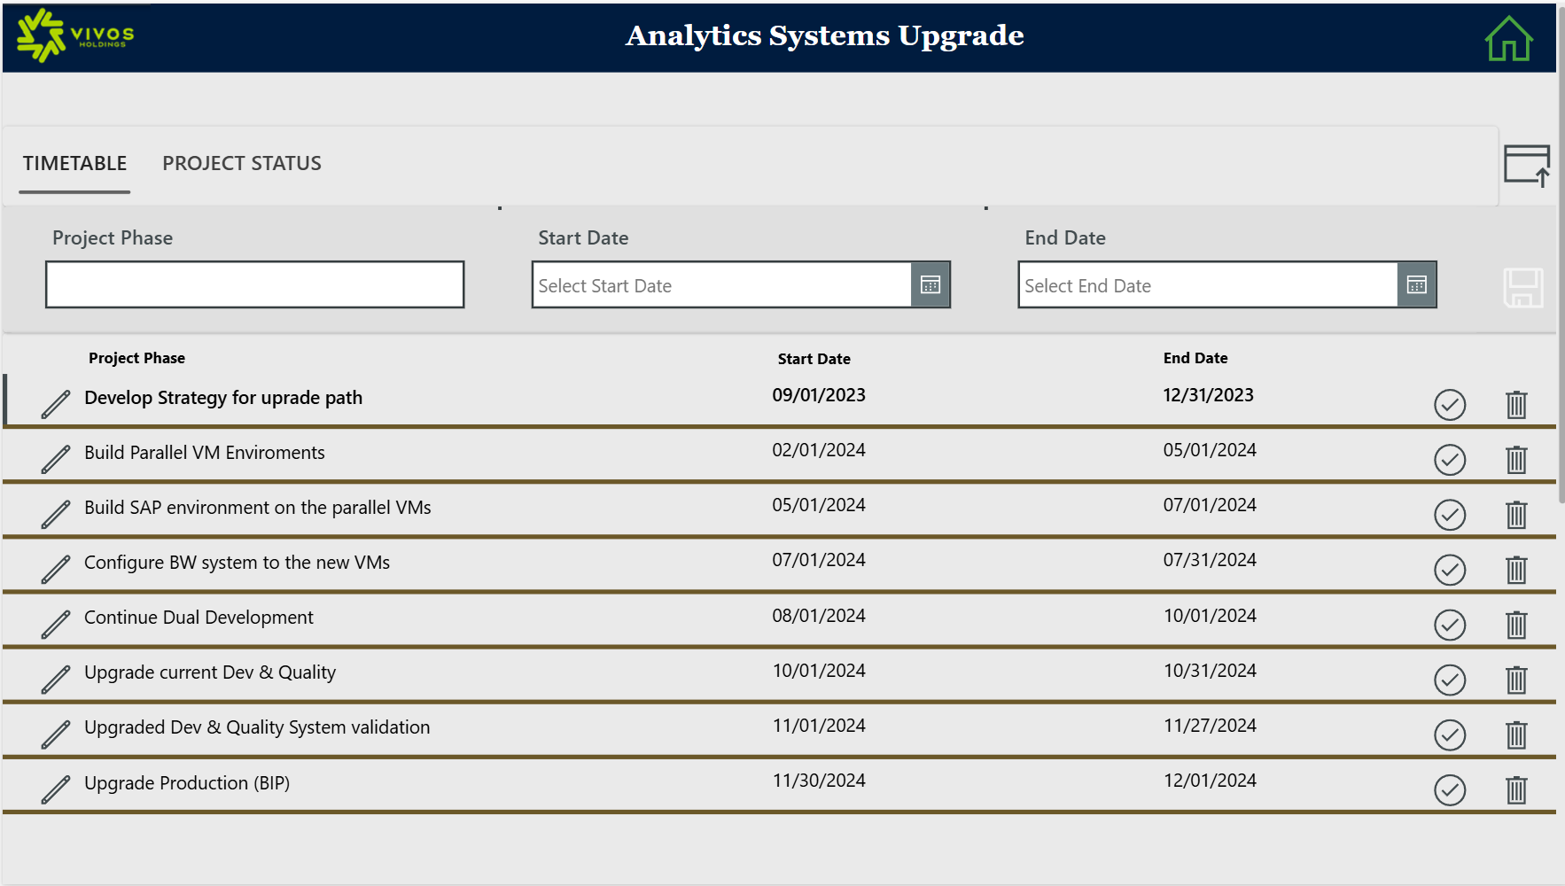

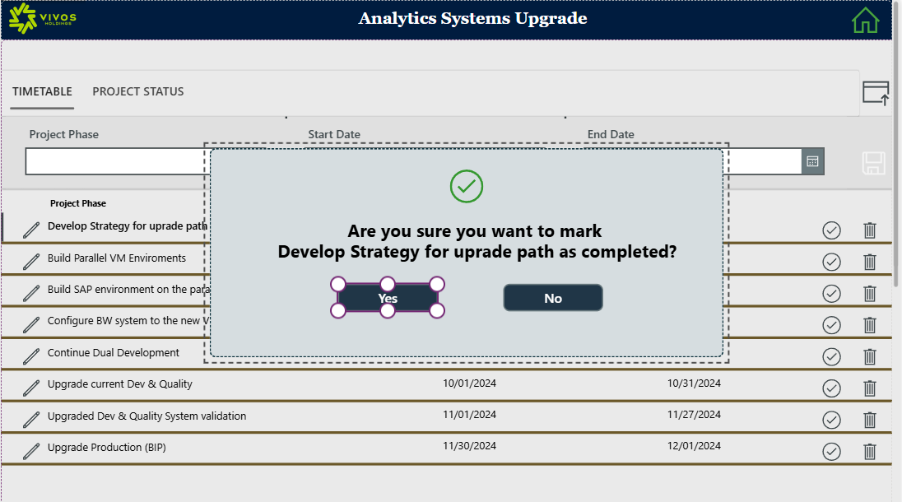

To edit only 1 column from a record without using SubmitForm(FormName) use patch formula below

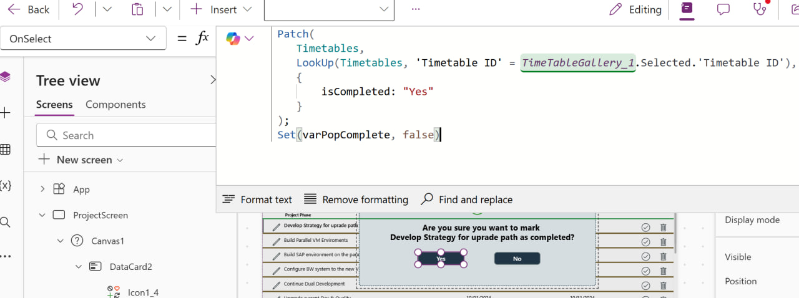

Screen4: View Deleted and Completed Items

