**Share Point**

**Thursday, April 10 (1:30hrs)**

* Start [0:00](https://www.youtube.com/watch?v=Mu6oWtbk9Nc&list=PLoyECfvEFOjZ5avY1R9dcSZ3ZKGmuk1O4&index=1&t=0s)
* Introduction [0:03](https://www.youtube.com/watch?v=Mu6oWtbk9Nc&list=PLoyECfvEFOjZ5avY1R9dcSZ3ZKGmuk1O4&index=1&t=3s)
* SharePoint Overview [0:30](https://www.youtube.com/watch?v=Mu6oWtbk9Nc&list=PLoyECfvEFOjZ5avY1R9dcSZ3ZKGmuk1O4&index=1&t=30s)
* SharePoint Site Structure and Hierarchy [6:01](https://www.youtube.com/watch?v=Mu6oWtbk9Nc&list=PLoyECfvEFOjZ5avY1R9dcSZ3ZKGmuk1O4&index=1&t=361s)
* Accessing SharePoint Sites [9:47](https://www.youtube.com/watch?v=Mu6oWtbk9Nc&list=PLoyECfvEFOjZ5avY1R9dcSZ3ZKGmuk1O4&index=1&t=587s)
* Introduction to Site Navigation [11:38](https://www.youtube.com/watch?v=Mu6oWtbk9Nc&list=PLoyECfvEFOjZ5avY1R9dcSZ3ZKGmuk1O4&index=1&t=698s)
* Site Navigation - Quick Launch Bar, Global Navigation, and More [16:06](https://www.youtube.com/watch?v=Mu6oWtbk9Nc&list=PLoyECfvEFOjZ5avY1R9dcSZ3ZKGmuk1O4&index=1&t=966s)
* Site Permissions [25:14](https://www.youtube.com/watch?v=Mu6oWtbk9Nc&list=PLoyECfvEFOjZ5avY1R9dcSZ3ZKGmuk1O4&index=1&t=1514s)

**Monday, April 14 (2hrs)**

* Edit Navigation
* Sharepoint Hub Site:
* what are hub sites and how to create a hub site
* Why Use Hub Site
* Difference between Hub Site and Sub Site
* How to create Sharepoint List from scratch
* How to create Sharepoint list from Excel

List: <https://youtu.be/EYC_qoSha0s?si=DFurogNPtSXrqsa0>

Hub Sites: https://youtu.be/w4oOCBjhYz4?si=4vefKse9FgwVS3Bp

**Wednesday, April 16 (2hrs)**

* Creating calculated Columns

https://youtu.be/xu0jlp5tJzA?si=MChMlLwq0cWrLwVf

* Creating Lookup Fields

https://youtu.be/jew5rwHAbjk?si=32sgFih_ix1a0aaS

* Site Content Navigation
* Creating Views

https://youtu.be/0ThTys3MX24?si=VRqKPDRyytiN7M0I

* Filtering and grouping Lists

<https://youtu.be/g_W78GJqpts?si=8jHMFzQBJ9ZwErEn>

* Conditional Formatings

**Friday, April 18 (2hrs)**

* Go through the project and review
* Refer all informations

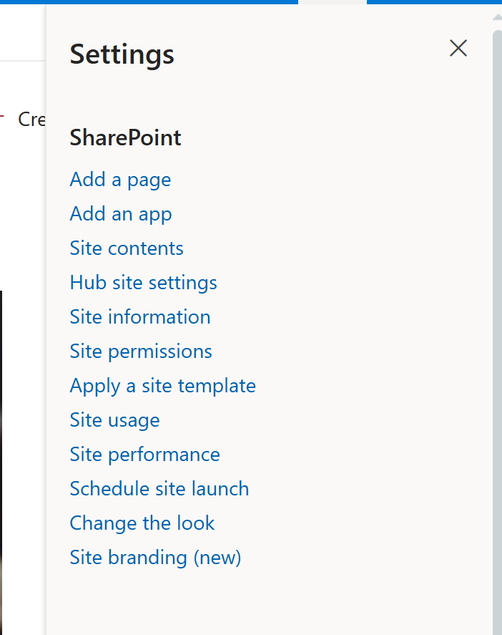

* Adding Apps to sharepoint: [33:28](https://www.youtube.com/watch?v=Mu6oWtbk9Nc&list=PLoyECfvEFOjZ5avY1R9dcSZ3ZKGmuk1O4&index=1&t=2008s)
* Integrating SharePoint with Microsoft Office: [24:57](https://www.youtube.com/watch?v=B7RXGd_PQ70&t=1497s)
* Libraries [48:18](https://www.youtube.com/watch?v=Mu6oWtbk9Nc&list=PLoyECfvEFOjZ5avY1R9dcSZ3ZKGmuk1O4&index=1&t=2898s)
* Creating Libraries and Documents [53:08](https://www.youtube.com/watch?v=Mu6oWtbk9Nc&list=PLoyECfvEFOjZ5avY1R9dcSZ3ZKGmuk1O4&index=1&t=3188s)
* Editing Documents and Folders [59:31](https://www.youtube.com/watch?v=Mu6oWtbk9Nc&list=PLoyECfvEFOjZ5avY1R9dcSZ3ZKGmuk1O4&index=1&t=3571s)

**Monday, April 21 (2hrs)**

* Managing Versions [1:05:02](https://www.youtube.com/watch?v=Mu6oWtbk9Nc&list=PLoyECfvEFOjZ5avY1R9dcSZ3ZKGmuk1O4&index=1&t=3902s)
* Understanding the Check-Out Process [1:14:17](https://www.youtube.com/watch?v=Mu6oWtbk9Nc&list=PLoyECfvEFOjZ5avY1R9dcSZ3ZKGmuk1O4&index=1&t=4457s)
* Content Approval [1:23:46](https://www.youtube.com/watch?v=Mu6oWtbk9Nc&list=PLoyECfvEFOjZ5avY1R9dcSZ3ZKGmuk1O4&index=1&t=5026s)
* Deleted Documents [1:33:42](https://www.youtube.com/watch?v=Mu6oWtbk9Nc&list=PLoyECfvEFOjZ5avY1R9dcSZ3ZKGmuk1O4&index=1&t=5622s)
* Alerts [1:37:11](https://www.youtube.com/watch?v=Mu6oWtbk9Nc&list=PLoyECfvEFOjZ5avY1R9dcSZ3ZKGmuk1O4&index=1&t=5831s)
* Advanced Search [1:45:15](https://www.youtube.com/watch?v=Mu6oWtbk9Nc&list=PLoyECfvEFOjZ5avY1R9dcSZ3ZKGmuk1O4&index=1&t=6315s)
* Sort Filter Group [1:52:08](https://www.youtube.com/watch?v=Mu6oWtbk9Nc&list=PLoyECfvEFOjZ5avY1R9dcSZ3ZKGmuk1O4&index=1&t=6728s)
* Library Views

**Wednesday, April 23 (2hrs)**

* Introduction to Pages: [41:50](https://www.youtube.com/watch?v=B7RXGd_PQ70&t=2510s)
* Creating and Formatting Pages: [43:43](https://www.youtube.com/watch?v=B7RXGd_PQ70&t=2623s)
* Customizing Pages and Other Content: [54:58](https://www.youtube.com/watch?v=B7RXGd_PQ70&t=3298s)
* Adding News Pages and Quick Links: [1:05:14](https://www.youtube.com/watch?v=B7RXGd_PQ70&t=3914s)
* Other Web Parts
* Working with Teams: [1:20:45](https://www.youtube.com/watch?v=B7RXGd_PQ70&t=4845s)
* Assigning Permissions and Access Rights to Team Members: [1:27:58](https://www.youtube.com/watch?v=B7RXGd_PQ70&t=5278s)
* Configuring Site Settings, Navigation, and Search Capabilities: [1:33:13](https://www.youtube.com/watch?v=B7RXGd_PQ70&t=5593s)

**Thursday, April 24(2hrs)**

* Adding Site Columns to Lists: [10:57](https://www.youtube.com/watch?v=bLeo_48nvQM&t=657s)
* Exploring Site Content Type Galleries: [16:01](https://www.youtube.com/watch?v=bLeo_48nvQM&t=961s)
* Creating Content Types: [18:03](https://www.youtube.com/watch?v=bLeo_48nvQM&t=1083s) this
* Adding Site Columns to Content Types: [23:40](https://www.youtube.com/watch?v=bLeo_48nvQM&t=1420s) this
* Using Content Types: [25:26](https://www.youtube.com/watch?v=bLeo_48nvQM&t=1526s) this
* Managing Site Permissions: [30:01](https://www.youtube.com/watch?v=bLeo_48nvQM&t=1801s)
* Stopping Inheriting Permissions: [31:55](https://www.youtube.com/watch?v=bLeo_48nvQM&t=1915s)
* Creating New Groups: [33:56](https://www.youtube.com/watch?v=bLeo_48nvQM&t=2036s)
* Editing Permission Levels: [34:51](https://www.youtube.com/watch?v=bLeo_48nvQM&t=2091s)
* Granting Permissions: [38:35](https://www.youtube.com/watch?v=bLeo_48nvQM&t=2315s)
* Editing Permissions at the List or Library Level: [41:37](https://www.youtube.com/watch?v=bLeo_48nvQM&t=2497s)
* Editing Permissions at the Item Level: [45:00](https://www.youtube.com/watch?v=bLeo_48nvQM&t=2700s)

**Power Apps**

**Day 1: Navigation**

* Adding controls text box drop-down gallery form
* Go through the properties on left top corner and right corner
* Form default modes

**Day 2 Formulas:**

* Filter and LookUp: [Filtering Video](https://youtu.be/XaN1xlzHjUs?si=BhXyvdOQgOJjFb55)
* Collect and ClearCollect : [CollectionVideo](https://youtu.be/7CyZ00GtiWI?si=GA2FQMAFNmSWHxx0)
* Navigate and End

**Day 3 Or And**

**Filter: Display multiple records from datasource(table)**

How to use Filter

Filter(DataSource, ColumnName = DropDownName.Selected.Value)

**LookUp: Display only 1 record**

How to use LookUp

LookUp (DataSource, ColumnName = DropDownName.Selected.Value)

**OR---AND**

|| - Or operator: Needs only 1 value to be true for all the statement to be true

&&= And operator: Needs all values to be true for all the statement to be true.

How to use OR

Filter('Risk Level', Titlle = Dropdoonw.Selected.Title || RLevel= Dropdown.Selected.Rlevel)

How to use AND

Filter('Risk Level', Titlle = Dropdoonw.Selected.Title && RLevel= Dropdown.Selected.Rlevel)

**Day 4: Declaring Variables and powerapp properties**

* add screen and implement risk level
* screen navigation , back icons
* collection
* onselect
* items
* UpdateContext({VariableName: Content})
* Set(varName, Content)
* [Variables](https://youtu.be/yYqrUpCH1Ao?si=pWlf0nvPwuqvvE_F)

**Day 5: Popup with visibility property and if conditions**

* Single line comment
* Basic and advanced if condition
* Popup: [Popup](https://youtu.be/CYVlJ_wPU-Q?si=tEGPMpeMWt4Wi5p1)
* Visibility property

**Day 6: Azure and Sharepoint Customization**

* Create Security group: <SecurityGroupVideo>
* User().Email.. Role Based access
* Sharepoint Integration/ Customization

**Day 7: Dataverse**

* Create tables and columns with each respective dataverse connect with powerapps
* Security Roles

**Power Automate**

* Types Of Flows
* Automatic
* Instant
* Scheduled
* Expressions
* Approval
* Emails
* SharePoint and dataverse (create Item, Delete Item, Update Item) Actions

**PowerBi (Theory and Project)**

**Powr Pages(Theory and Project)**