Connect 4 – Code Dojo

# URLs

* **View Games** : https://connect4core.azurewebsites.net/
* **Documentation** : https://connect4core.azurewebsites.net/swagger/ui/index.html
* **C# Example** : <https://github.com/YorkCodeDojo/Connect4/tree/master/Connect4.ExampleBot>
* **APIs** : https://connect4core.azurewebsites.net/api/something

POST /api/Register

Register your team and returns your unique player ID.

{

"teamName" : "David",

"password" : "Secret",

}

POST /api/NewGame

Clears the board

{

"playerID" : "abcdef...",

}

GET /api/GameState/{playerID}

Returns the current state of the game

POST /api/MakeMove

Places your piece into a column

{

"PlayerID" : "abcde..."

"Password" : "secret"

"ColumnNumber" : 3

}

## Object Structure

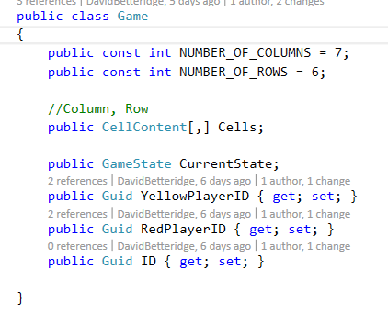 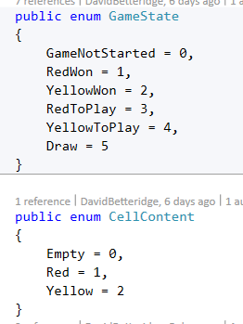

## Sample JSON

{"CurrentState":4,"Cells":[[0,0,0,0,0,0],[0,0,0,0,0,0],[0,0,0,0,0,0],[0,0,0,0,0,0],[0,0,0,0,0,0],[0,0,0,0,0,0],[0,0,0,0,0,0]],"YellowPlayerID":"3f62fd50-ae51-4656-ba8c-830edd7d4bb2","RedPlayerID":"a05bf67c-2bbb-4243-bf18-fe60c52cf4f9","ID":"c3347c13-d55f-4b7c-ad4e-e9cc36f7419c"}

The first column is shown in yellow. The value is red is the bottom row of the second column.