# Minesweeper

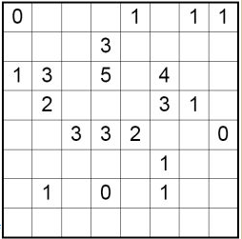

This puzzle has 13 mines

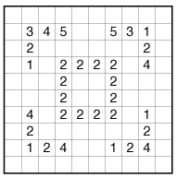

## Sample Games

There are some sample games in

<https://github.com/YorkCodeDojo/Minesweeper/tree/master/SampleGames>.

please add to it. 😊

## Solutions

Please share your solutions by uploading them to github at the end of the evening. There is a guide here – **https://www.yorkdevelopers.org/blog/#HowtoShareCode** if you are unsure how to!