

Heart Disease MLOps Pipeline
Final Report

MLOps Assignment 1
Repository: https://github.com/YorozuyaSakataSan/MLOPS_ASG_1

Submitted by:
Balsure Aniket K (BITS ID: 2024AA05296)
ANANTHAN P (BITS ID: 2024AA05692)
ARYAMANN SINGH (BITS ID: 2024AA05025)
BALAJI R (BITS ID: 2024AA05844)
SAURAV BANSAL (BITS ID: 2023AA05710)

1. Executive Summary
This report documents an end-to-end MLOps pipeline for a heart-disease classification system. The project covers dataset acquisition, exploratory data analysis (EDA), preprocessing, model training and selection, experiment tracking with MLflow, automated testing, CI/CD using GitHub Actions, containerization with Docker, Kubernetes deployment, and monitoring using Prometheus and Grafana. Screenshots for each requirement are included in the repository under the screenshots/ folder.

2. Project Goals and Scope
Goals:
- Build a reproducible ML pipeline (download → EDA → training → inference).
- Track experiments and artifacts with MLflow.
- Automate quality checks via unit tests and CI.
- Package the inference API using Docker and deploy via Kubernetes.
- Expose service health and metrics for operational monitoring.
Out of scope: public cloud deployment (the project provides local access instructions).

3. Repository Structure
Key folders and files:
- src/ : core training and feature engineering code
- api/ : FastAPI inference service
- tests/ : unit tests (pytest)
- notebooks/ : EDA and experimentation notebooks
- k8s/ : Kubernetes manifests
- monitoring/ and docker-compose.monitoring.yml : Prometheus and Grafana setup
- models/ and artifacts/ : saved models and pipeline outputs
- screenshots/ : evidence for each deliverable (EDA, MLflow, CI, Docker, Kubernetes, monitoring)

4. Dataset and Data Acquisition
The pipeline includes a reproducible data download step. A download utility is available at src/heart/data_download.py (refer to README for exact commands). The cleaned dataset is stored under the data/ directory, and preprocessing utilities live under src/heart/.

5. Exploratory Data Analysis (EDA)
EDA was performed in the notebooks/ directory to understand feature distributions, detect missing values, and inspect class balance. Evidence screenshots:
- screenshots/eda/EDA_01_dataset_loaded.png
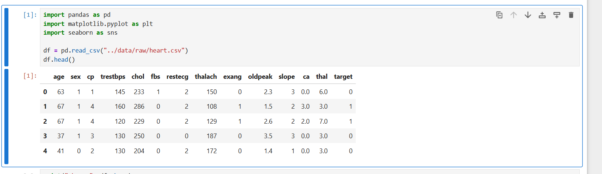
- screenshots/eda/EDA_02_target_distribution.png
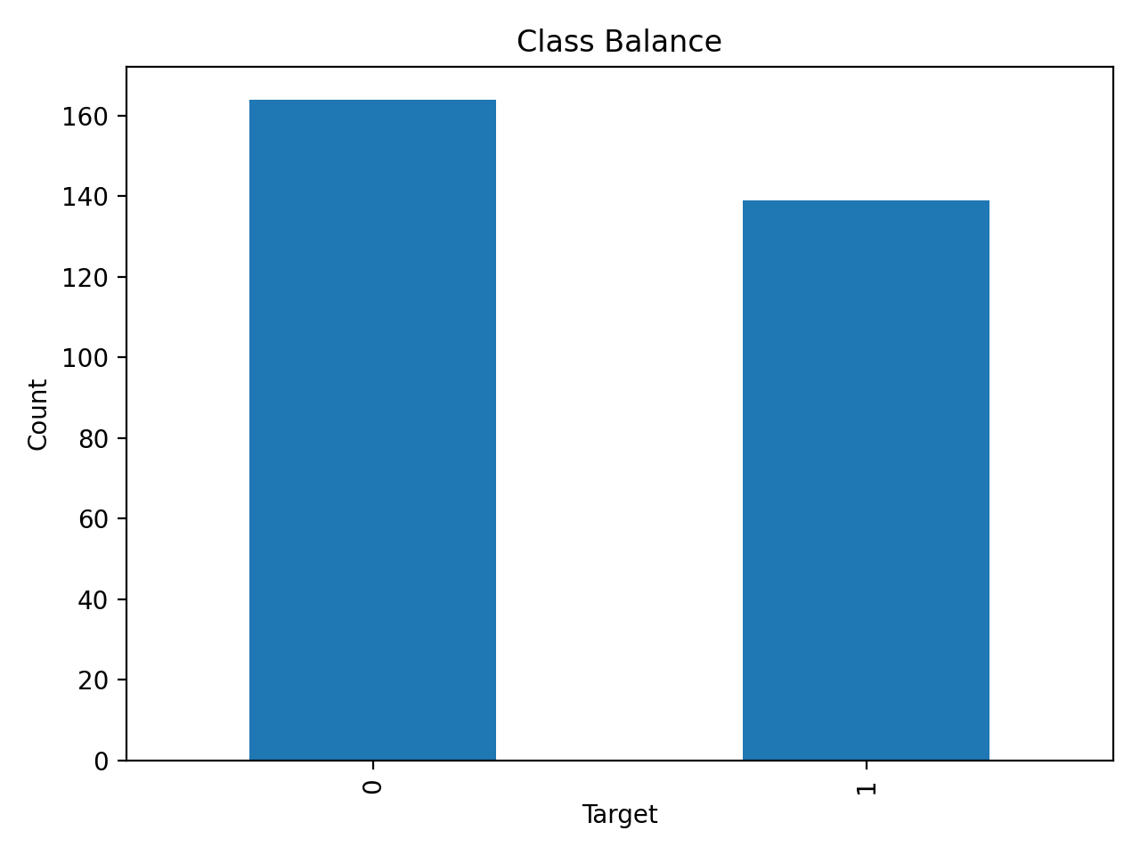
- screenshots/eda/EDA_03_feature_insights.png
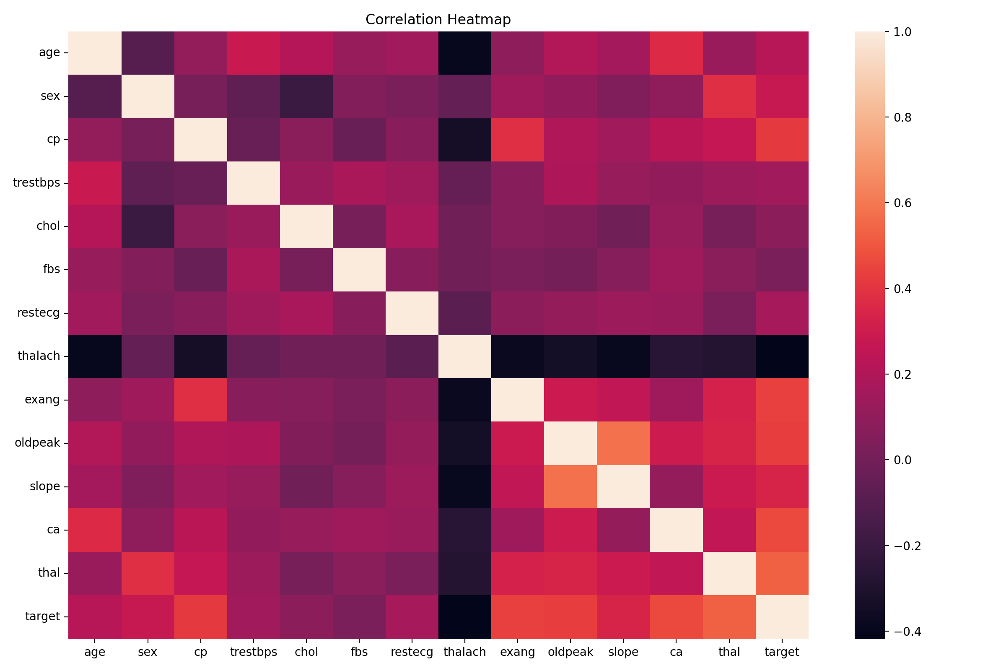

6. Feature Engineering and Preprocessing
Preprocessing is implemented as a scikit-learn compatible pipeline to ensure consistent transformations during both training and inference. The pipeline handles feature selection, train-test splitting, and standardized preprocessing.

7. Model Training and Selection
Model training scripts produce a selected ‘best’ model artifact stored under models/ (e.g., best_model.joblib). The training process logs parameters, metrics, and artifacts in MLflow for reproducibility and comparison. The selected model is loaded by the FastAPI service during startup.

8. Experiment Tracking with MLflow
MLflow is configured using a local SQLite backend (mlflow.db) with artifacts stored under mlruns/. The MLflow UI shows experiment runs and stored artifacts (model binaries, configuration, environment files). Evidence screenshots:
- screenshots/mlflow/MLFLOW_01_runs_list.png
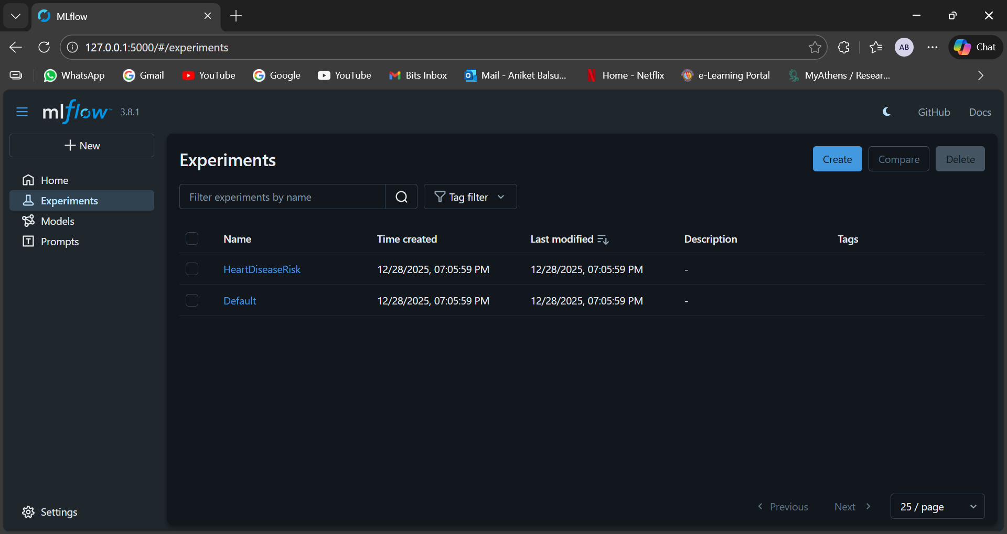

- screenshots/mlflow/MLFLOW_02_run_artifacts.png
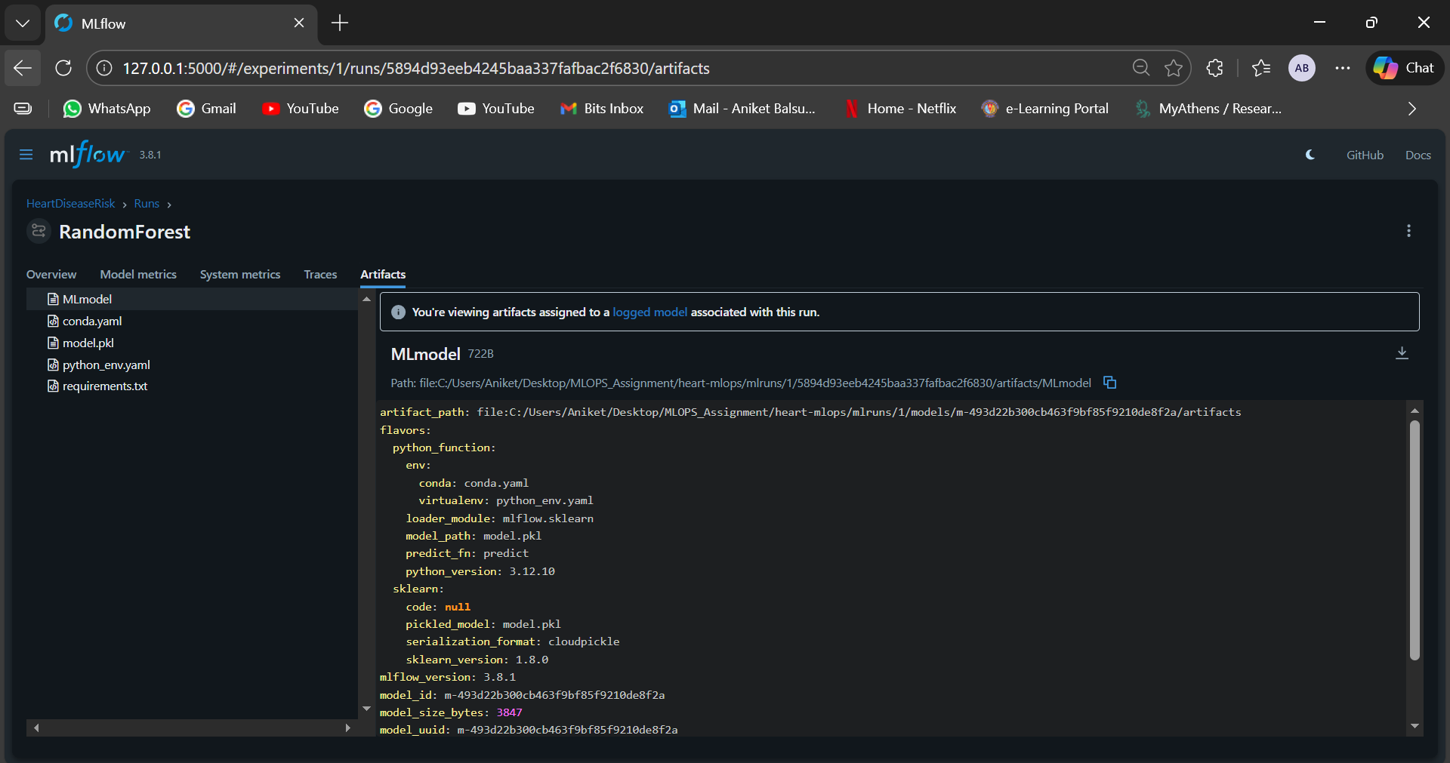

9. Testing Strategy
Unit tests validate preprocessing utilities and critical pipeline functions. Tests are executed via pytest and integrated into CI. Evidence screenshot:
- screenshots/tests/TESTS_01_pytest_pass.png
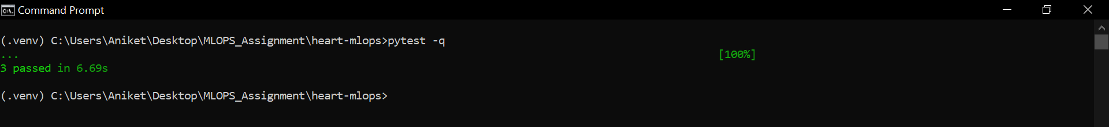

10. CI/CD with GitHub Actions
The project uses GitHub Actions workflows in .github/workflows/ to automate linting, training, testing, and artifact upload. CI provides fast feedback and ensures consistent build quality. Evidence screenshots:
- screenshots/cicd/CICD_01_actions_runs.png
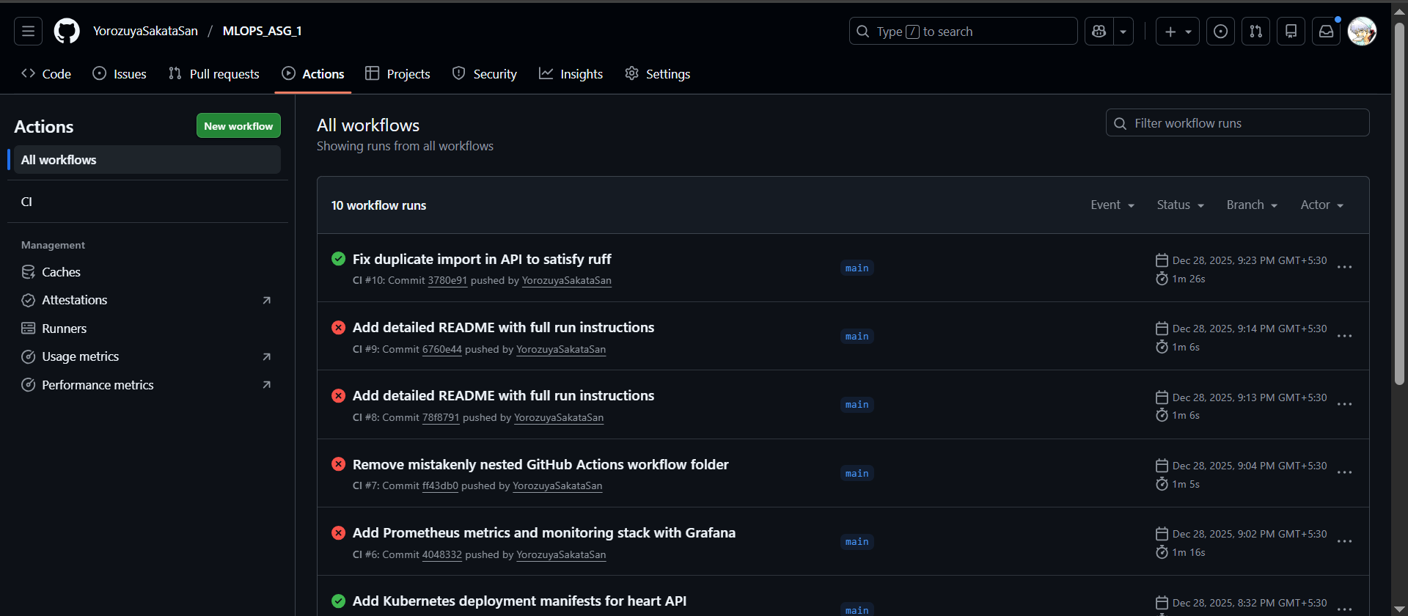

- screenshots/cicd/CICD_02_success_run_details.png
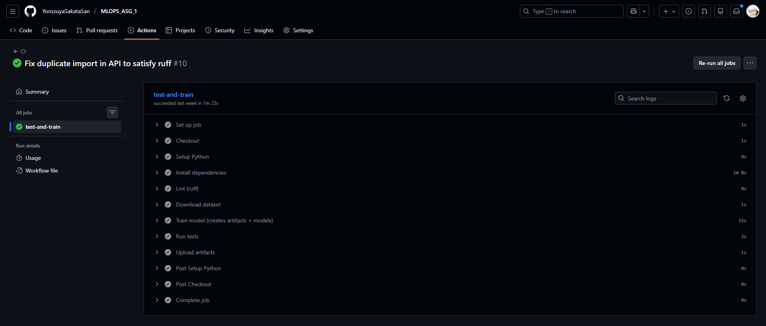

11. Containerization with Docker
The inference API is packaged as a Docker image using the Dockerfile at the repository root. The container exposes FastAPI endpoints for health checks, prediction, and metrics. Evidence screenshots:
- screenshots/docker/DOCKER_01_build.png
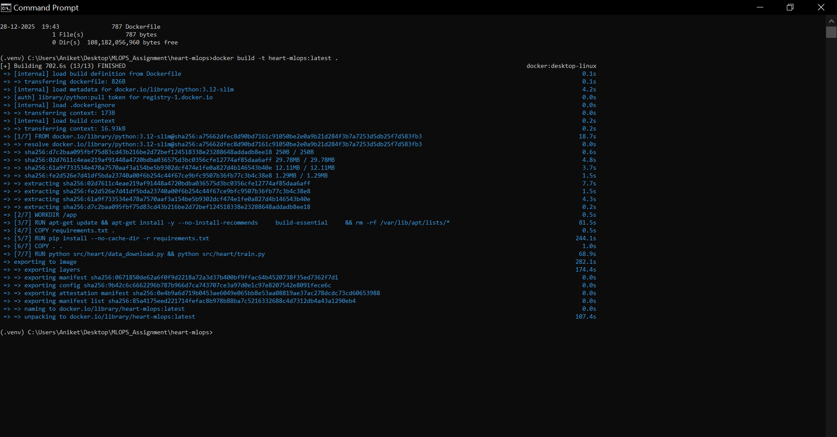

- screenshots/docker/DOCKER_02_swagger_docs.png
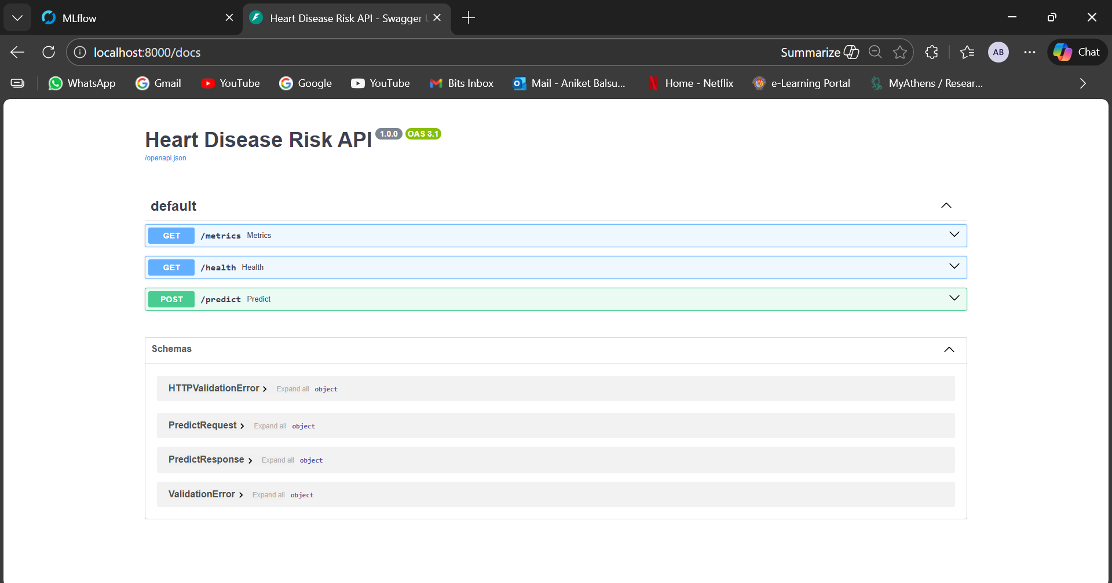

- screenshots/api_proof/API_01_predict_response.png
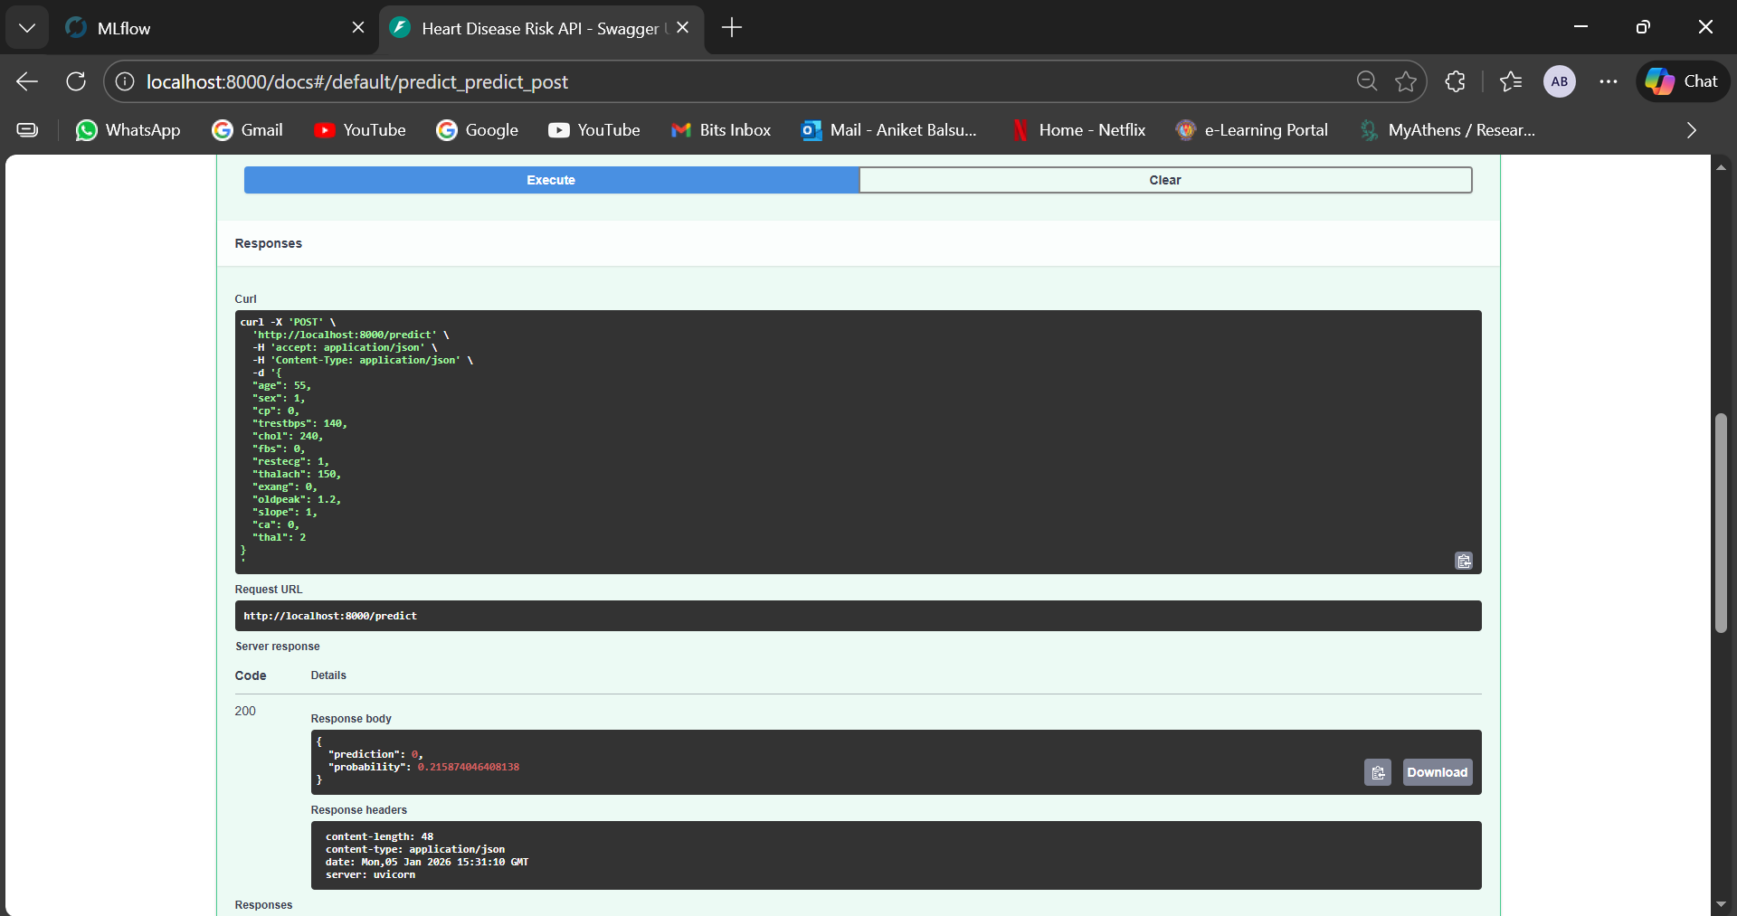

12. API Design and Local Access Instructions
Main endpoints:
- GET /health : service health probe
- POST /predict : model inference
- GET /metrics : Prometheus metrics endpoint
Local Docker run (example):
docker build -t heart-mlops:latest .
docker run --rm -p 8000:8000 heart-mlops:latest
Open: http://localhost:8000/docs

13. Kubernetes Deployment
Kubernetes manifests in the k8s/ folder deploy the API as a Deployment and expose it via a Service. Port-forwarding can be used for local cluster access. Evidence screenshots:
- screenshots/k8s/K8S_01_pods_running.png
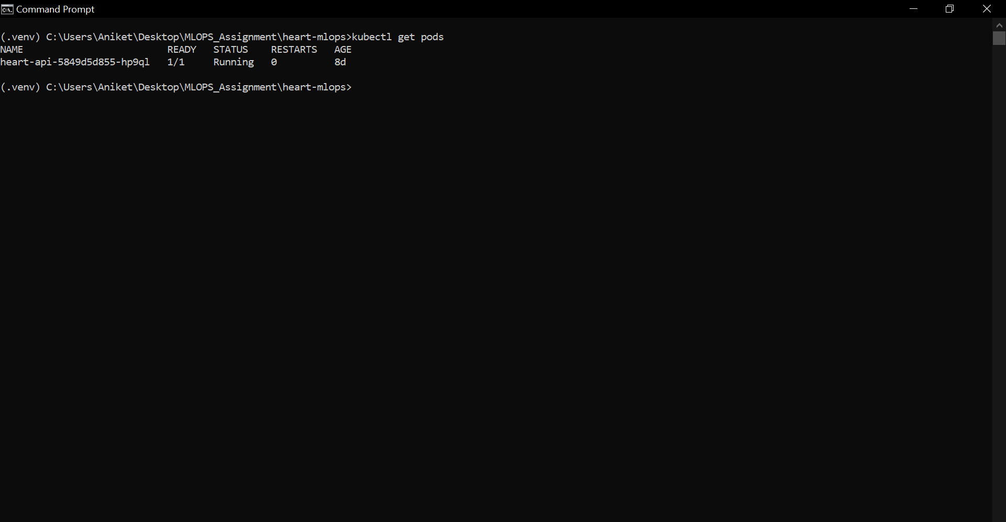

- screenshots/k8s/K8S_02_services.png
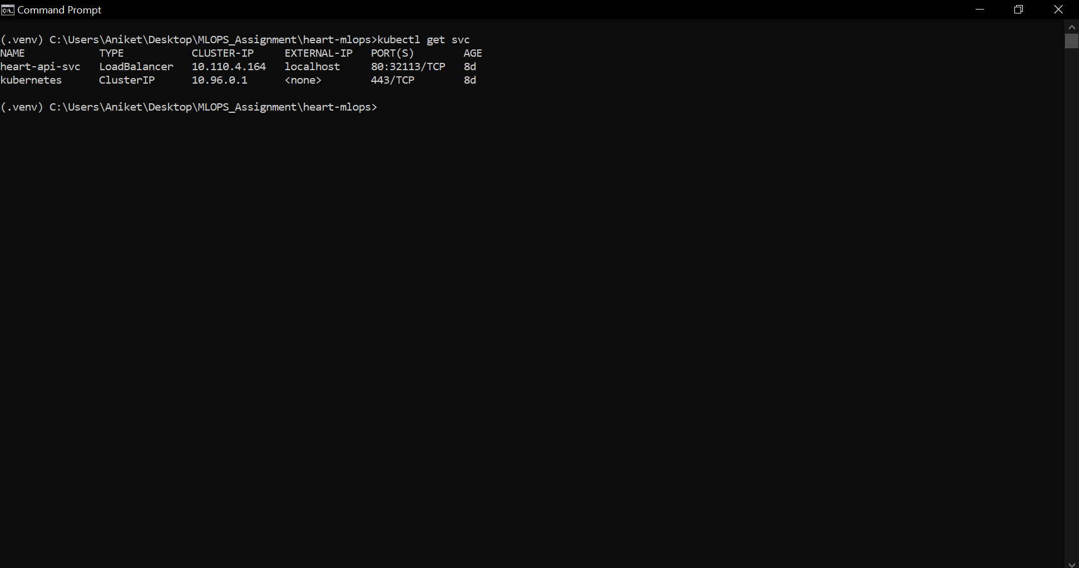

- screenshots/k8s/K8S_03_portforward_docs.png
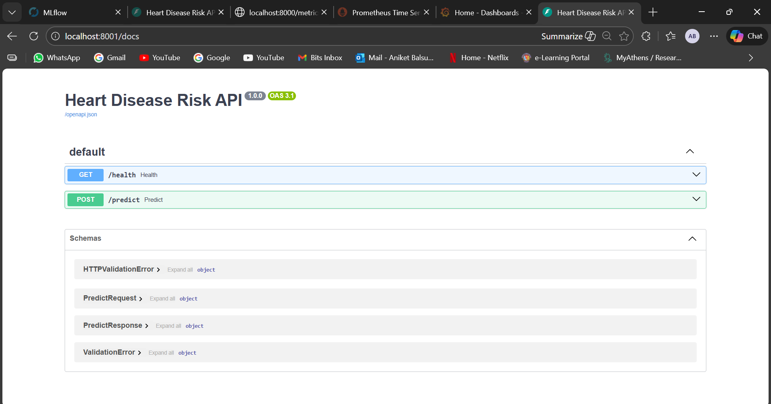

14. Monitoring and Observability
Operational monitoring is implemented using Prometheus scraping the /metrics endpoint and Grafana for visualization. A docker-compose file (docker-compose.monitoring.yml) brings up the API, Prometheus, and Grafana for local testing. Evidence screenshots:
- screenshots/monitoring/MON_01_metrics_endpoint.png
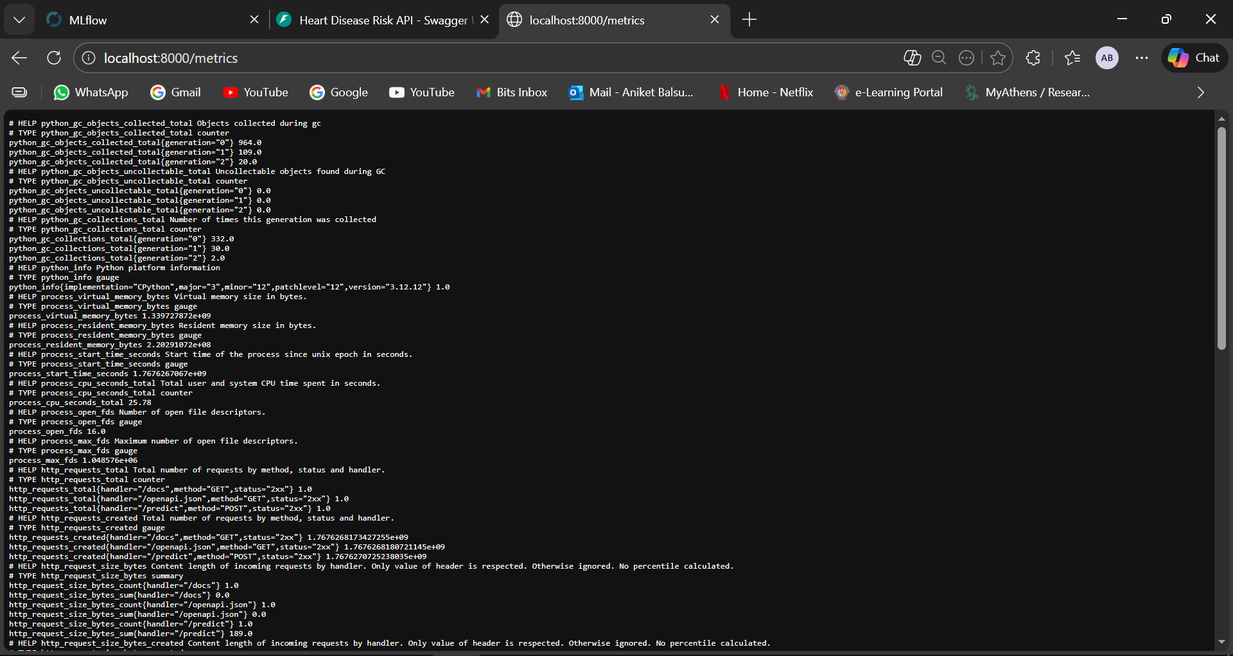

- screenshots/monitoring/MON_02_prometheus_targets.png
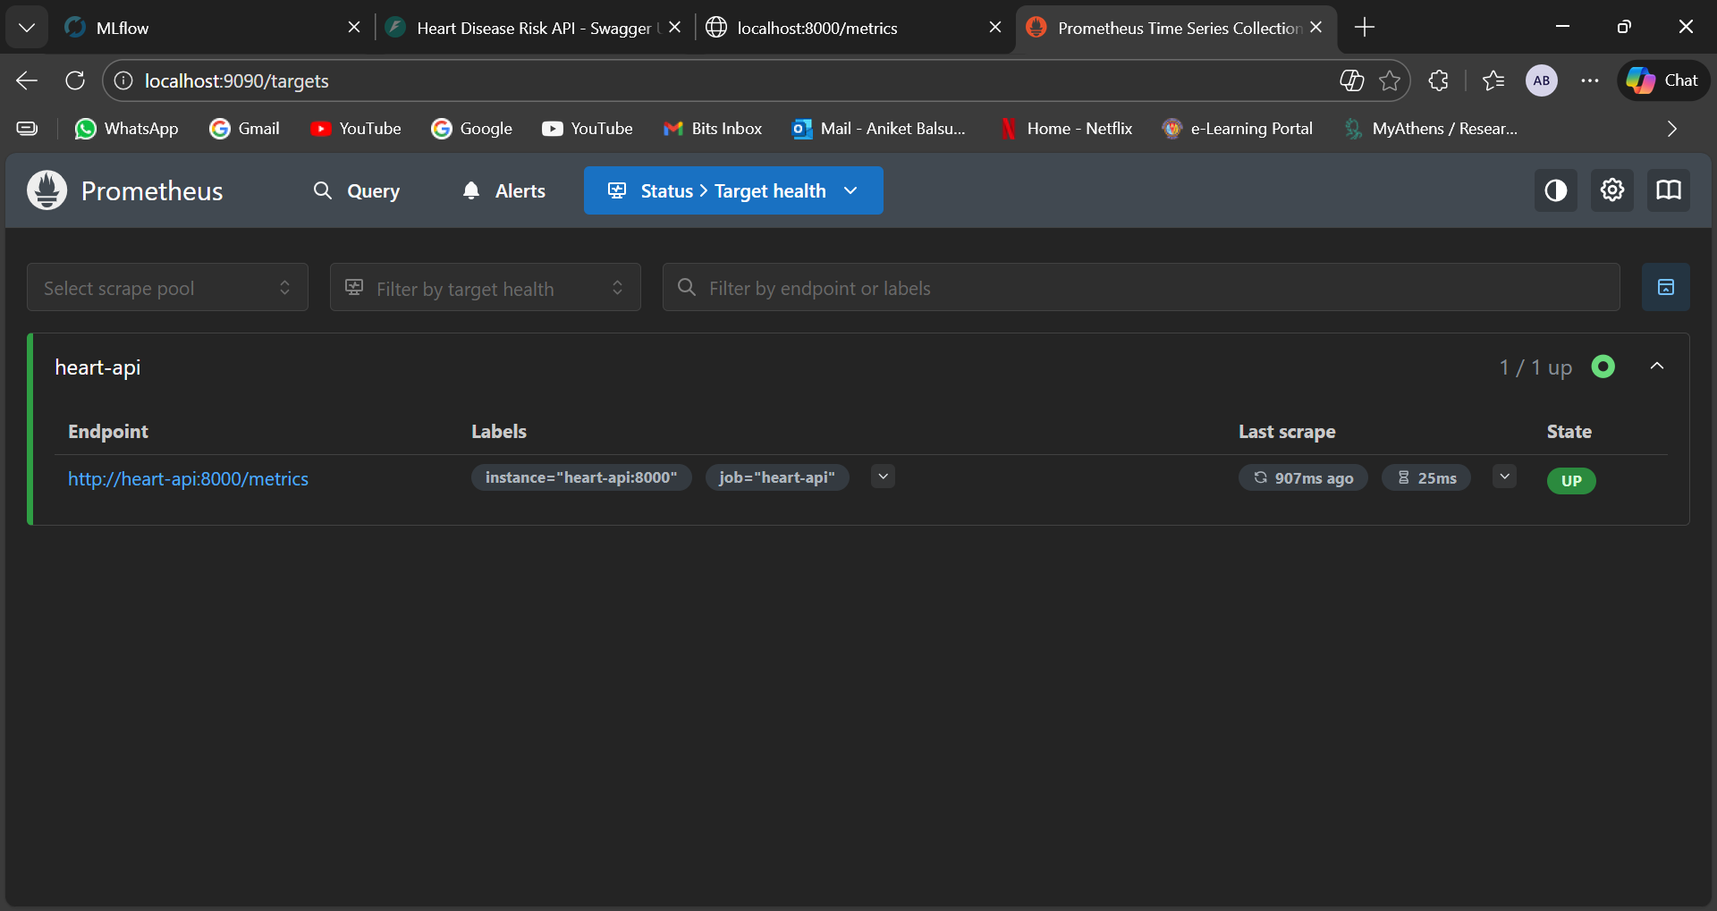

- screenshots/monitoring/MON_03_grafana.png
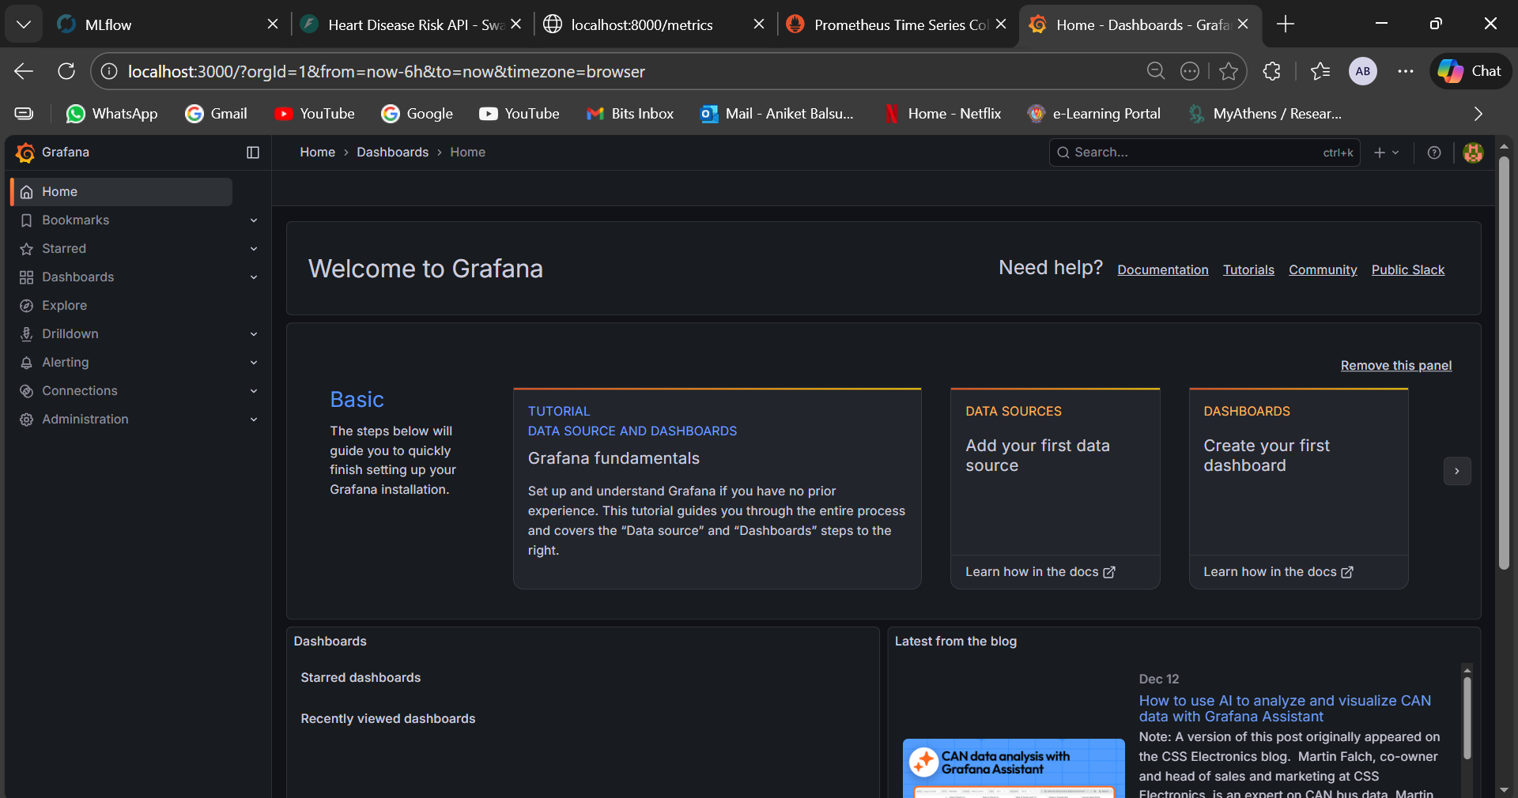

15. Reproducibility Notes
Reproducibility is supported via:
- Pinned Python dependencies in requirements.txt (and container build).
- Deterministic preprocessing through scikit-learn pipelines.
- MLflow tracking of parameters, metrics, and artifacts.
- CI automation for linting and tests.

16. Limitations and Future Improvements
- Add stronger data validation and schema checks (e.g., Great Expectations).
- Add model performance monitoring and drift detection.
- Add staged deployments (dev and prod) and blue-green rollout strategy in Kubernetes.
- Publish the service to a managed cloud platform for a public URL.

Appendix A: Screenshot Index
The screenshots/INDEX.txt file in the repository maps each screenshot to a deliverable requirement.

Appendix B: Command Reference

Run unit tests
pytest -q

Start MLflow UI
mlflow ui --backend-store-uri sqlite:///mlflow.db --default-artifact-root ./mlruns --host 127.0.0.1 --port 5000

Build and run Docker image
docker build -t heart-mlops:latest .
docker run --rm -p 8000:8000 heart-mlops:latest

Start monitoring stack
docker compose -f docker-compose.monitoring.yml up -d

Kubernetes apply
kubectl apply -f k8s/

Kubernetes port-forward
kubectl port-forward svc/heart-api-svc 8001:80

Appendix C: Pipeline Walkthrough (Detailed)
1) Data acquisition downloads the dataset into the data/ folder.
2) EDA notebook validates basic assumptions, checks target distribution, and explores feature relationships.
3) Training builds preprocessing + model pipeline, evaluates candidates, and selects the best model.
4) MLflow records each run with parameters, metrics, and the serialized model artifact.
5) Unit tests validate key functions and are executed locally and in CI.
6) Docker packages the inference API and loads the selected model artifact at startup.
7) Kubernetes manifests deploy the container and expose it via a service.
8) Prometheus scrapes /metrics; Grafana visualizes metrics dashboards.
Operational considerations include stable input schemas, robust error handling for invalid input, and repeatable deployment instructions. The repository README serves as the primary entry point for running the system end-to-end.

