第一次軟體系統作業 M023010011 廖志倫
1. Introduction – 故事大綱 （以文字或圖形描述）
一個不擅長耍心機的商人，在各地旅行經商的邁向有錢人的道路，
即使口才不好，殺價能力薄弱，解戒心不夠，容易被騙，還是能慢慢累積財富吧?
2. Analysis – 做分析的過程與分析結果
商人有兩種基本能力，分別為交涉與警戒，交涉能力，影響殺價跟漲價的幅度，
而警戒則是在，對方的殺價或漲價能力優於自己時，防止被騙，減低損失。
商人分為在城鎮開商店，與各地旅行兩種，殺價及漲價能力有些許不同，同時
旅行商人多了旅行時，經過的距離，影響貨物價錢的能力。
一開始希望設定兩個主人翁，然後隨機決定哪一個主人翁進行交易，但這個程式主要試測操作class﹑繼承等，一些基本功能，隨機的練習在商人的部份也有了，所以就暫時，沒有實作兩個主人翁的設定了(主人翁Holo有宣告，但未實際出場)。

3. Design – 做設計的過程與設計結果
“商人”做為基本的class，private部分有交涉Negotiation及警戒Wariness，
Public部分則為set跟get，用於取得這兩項數值。其分支的城鎮商人與旅行商人，繼承這個class，
在新增其他新的function，像是旅行商人的依距離增加銷售物價格。
遇到哪個商人是隨機的，名稱以X﹑Y﹑Z代表，但即使是同樣名稱，他的交涉能力及戒心也是隨機的。
目前有三城鎮A﹑B﹑C，三城鎮各有一種商品，所以在不同城鎮交易，金額也有所不同。
原先打算將殺價及漲價在商人這個基本class寫好，但是發現旅行商人與城鎮商人兩者的殺價漲價都要修改，便決定移到旅行商人跟城鎮商人的class再定義function了。
4. Programming – 做程式的過程與程式結果
首先判斷現在到哪個城鎮，決定哪種貨物時，因為城鎮名稱是使用string，所以考慮到使用者可能會用大寫﹑小寫，或簡稱表示，所以不論使用者輸入何種，都先統一格式，同樣在買或賣的時候，也需要統一。
買的時候要計算金額，以免購買太多讓財產變為負數。結算之後也要顯示身上財產，以便知道交易結果。
原先只寫出class﹑繼承及交易狀況，也想過用數字編號代替成鎮名稱，方便辨識，但以數字辨識容易出現後續修改上的問題，所以最終還是定string，商人名稱時也是同樣情況。

5. Results – 在程式執行時所產生的故事發展的輸入輸出結果
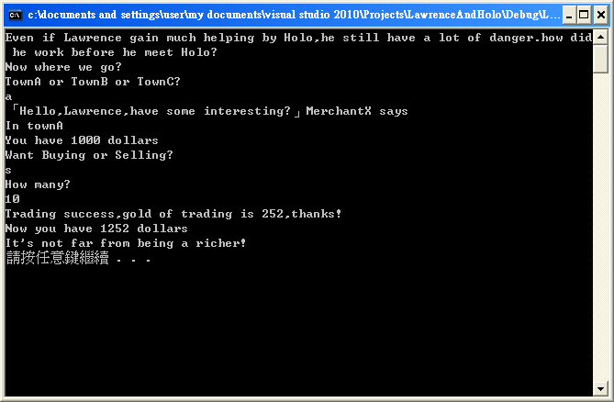
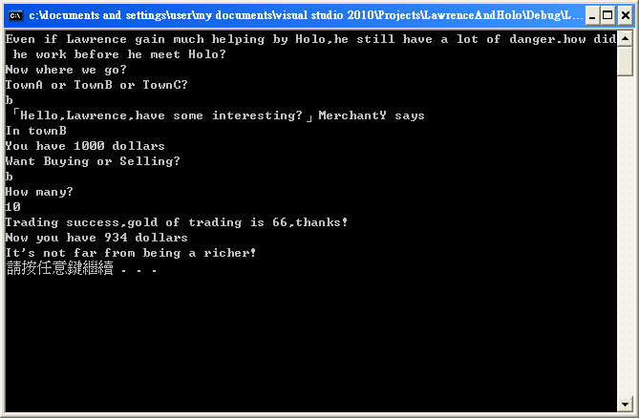
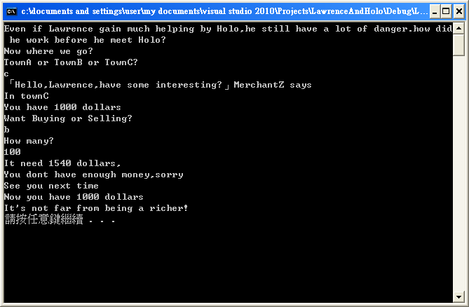

6. Conclusion – 做此作業的討論與心得
上面的結果讓我聯想到大一時的計算機程式，過了這麼久的時間，還是只能用這種視窗及文字顯示結果，有點讓人失望，如果可以，還是希望能以圖片等人性化的介面顯示。
像是APP程式能用XML來呈現view，web也能用HTML來顯現，美觀跟吸引人的程度都遠遠超過這種黑白畫面。

Appendix Code Listing – 列印有註解的程式碼

#include<iostream>
#include<string>
time_t t;
srand((unsigned) time(&t));
TradingMerchant.SetWariness(rand()%10);
TradingMerchant.SetNegotiation(rand()%10);
using namespace std;
//item
string Destination;
char UniformDestination;
double Property=1000;
string Belonging;
int NumOfBelonging=100;
int HolosHelp;
int PriceOfMerchandiseA=50,
PriceOfMerchandiseB=75,
PriceOfMerchandiseC=200;
char RandomMerchant;
int Distance=1;
//function
void NameOfDestination();
void Trade();
char WhichKindOfMerchant();
//class
class BaseMerchand
{
private:
int Wariness;
int Negotiation;
public:
void SetWariness(int Value){Wariness=Value;}
void SetNegotiation(int Value){Negotiation=Value;}
int GetWariness(){return Wariness;}
int GetNegotiation(){return Negotiation;}
//virtual double PriceReduction();
//virtual double PriceRising();
};
class TravelingMerchant : public BaseMerchand
{
public:
double PriceReduction() //override
{
return GetNegotiation()*0.11;
}
double PriceRising() //override
{
return GetNegotiation()*0.13+Traveling(Distance);
}
double Traveling(int Distance){return Distance*0.15;}
};
class TownsMerchant : public BaseMerchand
{
public:
double PriceReduction() //override
{
return GetNegotiation()*0.13;
}
double PriceRising() //override
{
return GetNegotiation()*0.11;
}
};
//People introduction
TravelingMerchant Lawrence,
Holo;
TownsMerchant TradingMerchant;

//Story start
int main()
{
//People introduction detail
Lawrence.SetWariness(2);
Lawrence.SetNegotiation(2);
Holo.SetWariness(9);
Holo.SetNegotiation(9);
//
cout<<"Even if Lawrence gain much helping by Holo,he still have a lot of danger."
<<"how did he work before he meet Holo?"
<<endl
<<"Now where we go?"
<<endl
<<"TownA or TownB or TownC?"
<<endl;
cin>>Destination;
NameOfDestination(); //Uniform the name of Distinction
RandomMerchant=WhichKindOfMerchant();
cout<<"「uHello,Lawrence,have some interesting?」v"
<<"Merchant"
<<RandomMerchant
<<" says"
<<endl;
cout<<"In town"
<<UniformDestination
<<endl;
Trade();
system("pause");

}

void NameOfDestination()
{
if(Destination=="townA"||Destination=="towna"||Destination=="A"||Destination=="a")
{
UniformDestination='A';
}
else if(Destination=="townB"||Destination=="townb"||Destination=="B"||Destination=="b")
{
UniformDestination='B';
}
else if(Destination=="townC"||Destination=="townc"||Destination=="C"||Destination=="c")
{
UniformDestination='C';
}
else if(Destination=="townD"||Destination=="townd"||Destination=="D"||Destination=="d")
{
UniformDestination='D';
}
}

void Trade()
{
double GoldOFTrade=0;
double GoldOFTradeRadio=1;
string KindOfTrading;
int UniformKindOfTrading;
int NumOfTrading;
//TradingMerchant's ability
time_t t;
srand((unsigned) time(&t));
TradingMerchant.SetWariness(rand()%10);
srand((unsigned) time(&t));
TradingMerchant.SetNegotiation(rand()%10);

cout<<"You have "
<<Property
<<" dollars"
<<endl;
cout<<"Want Buying or Selling?"
<<endl;
cin>>KindOfTrading;
if(KindOfTrading=="Buying"||KindOfTrading=="buying"||KindOfTrading=="Buy"||KindOfTrading=="buy"||KindOfTrading=="b"||KindOfTrading=="B") //1 means buying
{
UniformKindOfTrading=1;
}
else if(KindOfTrading=="Selling"||KindOfTrading=="selling"||KindOfTrading=="Sell"||KindOfTrading=="sell"||KindOfTrading=="s"||KindOfTrading=="S") //0 means selling
{
UniformKindOfTrading=0;
}
cout<<"How many?"
<<endl;
cin>>NumOfTrading;

srand((unsigned) time(&t));
int HoloTime=rand()%2; //1 means helping,else 0
switch(UniformKindOfTrading) //0 means selling ; 1 means buying
{
case 0://Lawrence is selling
if(Lawrence.PriceRising()-TradingMerchant.PriceReduction()>0)
{
GoldOFTradeRadio=(Lawrence.PriceRising()-TradingMerchant.PriceReduction())*(10-TradingMerchant.GetWariness())*0.1;
}
else
{
GoldOFTradeRadio=(TradingMerchant.PriceReduction()-Lawrence.PriceRising())*(10-Lawrence.GetWariness())*0.1;
}
break;
case 1://Lawrence is buying
if(TradingMerchant.PriceRising()-Lawrence.PriceReduction()>0)
{
GoldOFTradeRadio=(TradingMerchant.PriceRising()-Lawrence.PriceReduction())*(10-Lawrence.GetWariness())*0.1;
}
else
{
GoldOFTradeRadio=(Lawrence.PriceReduction()- TradingMerchant.PriceRising())*(10-TradingMerchant.GetWariness())*0.1;
}
break;
default :
cout<<"Don't want to trade?"
<<endl
<<"OK,see you next time"
<<endl;
break;
}
switch(UniformDestination)
{
case 'A':
GoldOFTrade=GoldOFTradeRadio*PriceOfMerchandiseA*NumOfTrading;
if(GoldOFTrade<Property)
{
cout<<"Trading success,gold of trading is "
<<GoldOFTrade
<<",thanks!"<<endl;
//0 means selling ; 1 means buying
if(UniformKindOfTrading==0){Property+=GoldOFTrade;}
else{Property-=GoldOFTrade;}
}
else
{
cout<<"It need "
<< GoldOFTrade
<<" dollars,"
<<endl
<<"You dont have enough money,sorry"
<<endl
<<"See you next time"
<<endl;
}
break;
case 'B':
GoldOFTrade=GoldOFTradeRadio*PriceOfMerchandiseB*NumOfTrading;
if(GoldOFTrade<Property)
{
cout<<"Trading success,gold of trading is "
<<GoldOFTrade
<<",thanks!"<<endl;
if(UniformKindOfTrading==0){Property+=GoldOFTrade;}
else{Property-=GoldOFTrade;}
}
else
{
cout<<"It need "
<< GoldOFTrade
<<" dollars,"
<<endl
<<"You dont have enough money,sorry"
<<endl
<<"See you next time"
<<endl;
}
break;
case 'C':
GoldOFTrade=GoldOFTradeRadio*PriceOfMerchandiseC*NumOfTrading;
if(GoldOFTrade<Property)
{
cout<<"Trading success,gold of trading is "
<<GoldOFTrade
<<",thanks!"<<endl;
if(UniformKindOfTrading==0){Property+=GoldOFTrade;}
else{Property-=GoldOFTrade;}
}
else
{
cout<<"It need "
<< GoldOFTrade
<<" dollars,"
<<endl
<<"You dont have enough money,sorry"
<<endl
<<"See you next time"
<<endl;
break;
}
default:
cout<<"You are a Cheater,trading stop!"
<<endl;
}

cout<<"Now you have "
<<Property
<<" dollars"
<<endl
<<"It's not far from being a richer!"
<<endl;
}

char WhichKindOfMerchant()
{
int WhatKind;
time_t t;
srand((unsigned) time(&t));
WhatKind=rand()%3;
switch(WhatKind)
{
case 0 :
return 'X';
case 1 :
return 'Y';
case 2 :
return 'Z';
default :
return 'X';
}
}

